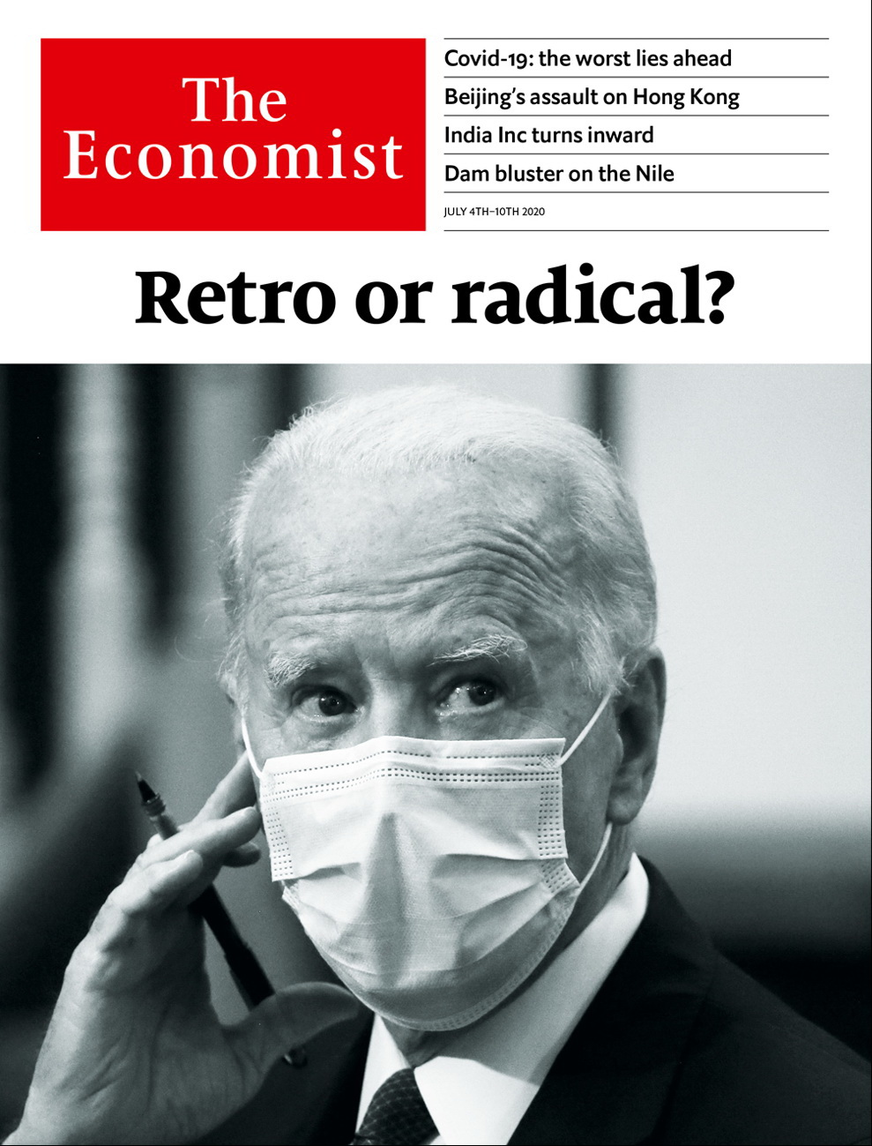

# Table of Contents

The world this week

Politics this week

Business this week

KAL’s cartoon

Leaders

Joe Biden: Retro or radical?

The pandemic: The way we live now

Hong Kong: A safe harbour no more

Investing in India: Inside game

The Nile: Dam bluster

Letters

Letters to the editor: On artificial intelligence, green investing, GDP, gardens, working from home

Briefing

Joe Biden: He persisted

United States

The presidential election: Donald Trump’s uphill battle

State flags: Mississippi changes its colours

John Roberts: Hail to the chief

Capital punishment: Cruel, unusual and costly

The Democratic left: Gathering steam

Intelligence and the president: Pandering to the bear

Lexington: It’s messing with Texas

The Americas

Mexican-American relations: The two amigos

Colombia: Post-party town

Cuba: Neither mulas nor moolah

Bello: Ecuador’s anguish

Asia

The war in Afghanistan: Withdraw first, ask questions later

India and China: Hit them where it hurts us

India’s obsession with TikTok: Fifteen seconds of fame

Feeding Singapore: The rise of the rooftop farmer

Vietnam: Your loss, my grain

Banyan: A charged relationship

China

Hong Kong’s freedoms: The evening of its days

Popular culture: Star wars

Chaguan: The great unifier

Middle East & Africa

The Grand Ethiopian Renaissance Dam: Showdown on the Nile

Malawi’s new president: A lesson in democracy

Another sort of plague: Locusts at the gate

Sierra Leone: Guild of thieves

Facebook and autocrats: With friends like these

Music in the Arab world: Rap the casbah

Europe

Russia: Parade’s end

Turkey: Osman and the snails

France: The president’s dilemmas

Ireland: A new world

Covid-19 and the Nordics: Borderline personalities

Charlemagne: Let expats vote

Britain

Producing a vaccine: Moonshot

Relations with China: Getting off the fence

The economy: V-sign

Infrastructure: Boris digs for victory

Lockdown in Leicester: Not again

Teaching history: War of the poses

Toy soldiers: The lead belt booms

Bagehot: Giving the bureaucrats a rocket

International

The pandemic’s next stage: The new normal

The World If

If the Republicans pivoted on climate: The elephant’s U-turn

If water shortages destabilised China: Trickle-down policies

If climate activists turned to terrorism: Green blood

If carbon removal became the new Big Oil: Big Suck

If covid-19 devastated aviation: Peak plane

If technology tracked all carbon emissions: The rise of carbon surveillance

If mammoths were recreated: Doing the tundra quick-steppe

If nuclear power had taken off: The road not taken

Business

Business in India: All aboard

Meal-delivery wars: Appetite for destruction

Airlines and the climate: Setting a new CORSIA

The Facebook boycott: With a little help from its friends

Nissan: Turning down the volume

Logistics (1): Seeking deliverance

Logistics (2): Droning on

Bartleby: Keep it practical

Schumpeter: The legacy of Chesapeake

Finance & economics

Public finances: The debt toll

Banks and the recession: What if?

Trade finance: Collateral damage

Chinese banking: Xi sank your battleship

Property in America: The house wins

Buttonwood: Zero gravity

Free exchange: A Latin American tragedy

Science & technology

Hydrogen power: Another look in the toy box

Phylloxera: The root of the problem

Books & arts

Urban history: A night at the Cathay

American politics: Orange warning

Secrets and lies: Cherchez les femmes

Television drama: Creative destruction

Home Entertainment: Chekhov in Siberia

Home Entertainment: Hidden depths

Economic & financial indicators

Economic data, commodities and markets

Graphic detail

Covid-19 and lockdowns: Thinking fast and slow

Obituary

Li Zhensheng: Facing it



### Friday, July 3, 2020

|  |  |
| --- | --- |
| The world this week | 3 |
| Leaders | 5 |
| Letters | 1 |
| Briefing | 1 |
| United States | 7 |
| The Americas | 4 |
| Asia | 6 |
| China | 3 |
| Middle East & Africa | 6 |
| Europe | 6 |
| Britain | 8 |
| International | 1 |
| The World If | 8 |
| Business | 9 |
| Finance & economics | 7 |
| Science & technology | 2 |
| Books & arts | 6 |
| Economic & financial indicators | 1 |
| Graphic detail | 1 |
| Obituary | 1 |

|  |  |  |
| --- | --- | --- |
|  | Sections | Leaders |

The world this week

Politics this week

.

Business this week

.

KAL’s cartoon

.

|  |  |  |
| --- | --- | --- |
|  | Sections | Leaders |

|  |  |  |  |
| --- | --- | --- | --- |
|  | Articles | Sections | Next |

# Politics this week

Jul 4th 2020 |

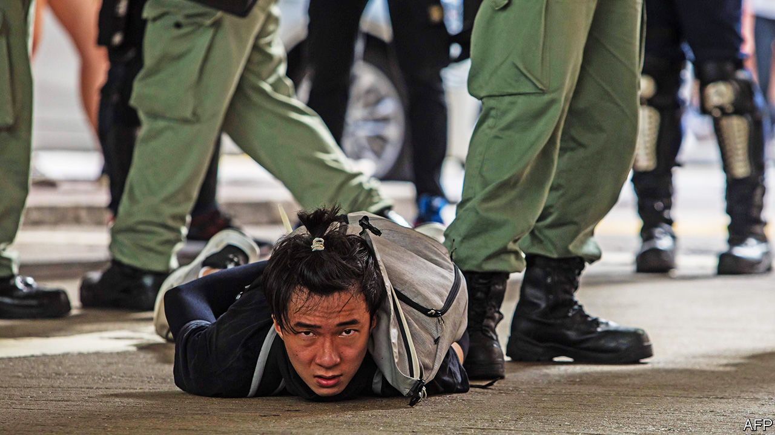

Police in Hong Kong made the first arrests under a draconian national-security law imposed from Beijing. Hong Kongers can now be jailed for life for vaguely defined crimes such as “subversion” or “conspiring” with anyone abroad to provoke “hatred” of the communist regime. Mainland secret police can now operate in Hong Kong. America’s House of Representatives unanimously passed a bill to put sanctions on banks that do business with Chinese officials who implement the crackdown. See [article](https://www.economist.com/node/21788898).

Boris Johnson reiterated his promise that Hong Kongers who were born before 1997, when the territory was handed back to China, could settle in Britain. The handover agreement back then stipulated that the city would retain its basic freedoms until at least 2047. See article.

Following months of talks, the UN Security Council passed a resolution calling for a 90-day global ceasefire to allow war-torn areas to battle covid-19.

India banned 59 apps developed by China’s tech giants, including TikTok, accusing them of threatening the country’s security. The apps have hundreds of millions of users in India. See article.

A terrorist outfit seeking independence for Balochistan, Pakistan’s largest province, claimed responsibility for an attack on the stock exchange in Karachi. The assailants killed three people before they were shot dead by police.

Iran issued an arrest warrant for Donald Trump. It asked Interpol for help in detaining him and 35 others it accuses of involvement in the drone strike that killed Qassem Suleimani in January. Suleimani was an Iranian general who oversaw Shia militias that carried out attacks all over the Middle East. Interpol dismissed Iran’s request.

Scores of people were killed during demonstrations in Ethiopia that erupted after the killing of Hachalu Hundessa, a prominent Oromo musician. His songs helped inspire a protest movement that led to the appointment of Abiy Ahmed as prime minister in 2018.

The leaders of Niger, Burkina Faso, Chad, Mali and Mauritania met to discuss ways of strengthening security to stop a jihadist insurgency in the Sahel. They were joined by Emmanuel Macron, the president of France, and Pedro Sánchez, the prime minister of Spain. France has more than 5,000 troops in the region.

Zimbabwe froze most mobile-money transactions to defend its ailing currency. It also suspended trading on the stock exchange, where traders had been observing share prices to estimate how much the currency is really worth.

Nearly 30 people, thought to be from the New Generation Jalisco drug gang, attacked the armoured car in which Mexico City’s police chief was riding. Two bodyguards and a passerby were killed. In the town of Irapuato, 24 people were slain by gunmen at a drug-rehabilitation centre. One of the government’s central pledges is to reduce gang violence.

Mexican police arrested a new suspect for the murder of 43 students in the southern state of Guerrero in 2014. An earlier report by the government contended that police had handed over the students to a gang, which killed the students and burned their bodies. The report was widely seen as flawed.

The United States-Mexico-Canada Agreement, which replaces the North American Free Trade Agreement (NAFTA), came into force. See article.

Mississippi’s legislature voted to remove the Confederate battle flag from the state flag, which has flown outside the Capitol building since 1894. It is the last state to unstitch the emblem of the Confederacy from official regalia. See [article](https://www.economist.com/united-states/2020/07/04/mississippi-changes-its-colours).

Russians voted in a plebiscite on constitutional reforms. According to the electoral commission, 78% approved a package that includes inflation-proof pensions, a high minimum wage and a ban on gay marriage. It also allows Vladimir Putin to run twice more for president, and to sack judges. Voters had to say yes or no to the whole package. See article.

In France Emmanuel Macron’s party was hammered in the second round of local elections. The Greens won the mayor’s office in a number of big cities; the Socialists handily hung on to Paris. Mr Macron is now under pressure to relaunch his presidency with an extensive reshuffle. See article.

The first round in Poland’s presidential election was inconclusive, a rebuke to the incumbent Andrzej Duda, who is backed by the ruling Law and Justice party. Polls show him running neck and neck with the liberal mayor of Warsaw in the next round.

Ireland got its first-ever coalition government between its two historic main parties, Fianna Fail and Fine Gael. The new prime minister, Micheal Martin, replaced Leo Varadkar, who will return to the office in two years’ time if the coalition lasts that long. See article.

Britain’s prime minister, Boris Johnson, invoked the spirit of Franklin Roosevelt when he announced a “new deal” to rebuild the economy. Many of the “new” projects are already in the pipeline. Mr Johnson has urged his countrymen to go to their local for a pint when pubs reopen on July 4th. See [article](https://www.economist.com/node/21788924).

## Coronavirus briefs

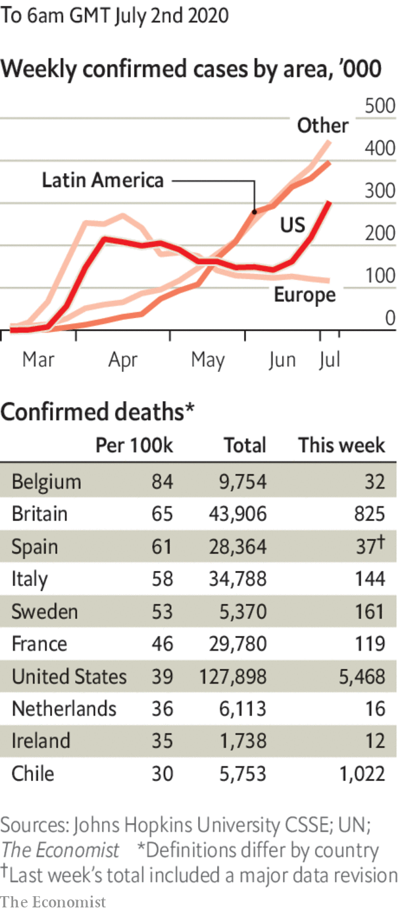

More states in America reimposed lockdowns amid a surge in covid-19. The number of daily cases nationally passed 50,000 for the first time. In California, which had been considered an early success, restaurants and other businesses in 19 counties were ordered to shut. In Arizona, where infections have doubled in the past two weeks, the governor ordered gyms, bars and cinemas to close again for at least a month. See article.

Leicester, a city in Britain, was put back under lockdown as cases there continued to rise, to three times that of the city with the next-highest rate. See article.

The European Union reopened its borders to residents from 14 countries where the virus is under control, such as Canada and New Zealand. The list does not include Brazil, Russia or the United States. China will be added if it reciprocates.

This article was downloaded by calibre from <https://www.economist.com/the-world-this-week/2020/07/04/politics-this-week>

|  |  |  |  |
| --- | --- | --- | --- |
|  | Articles | Sections | Next |

|  |  |  |  |
| --- | --- | --- | --- |
| Previous | Articles | Sections | Next |

# Business this week

Jul 4th 2020 |

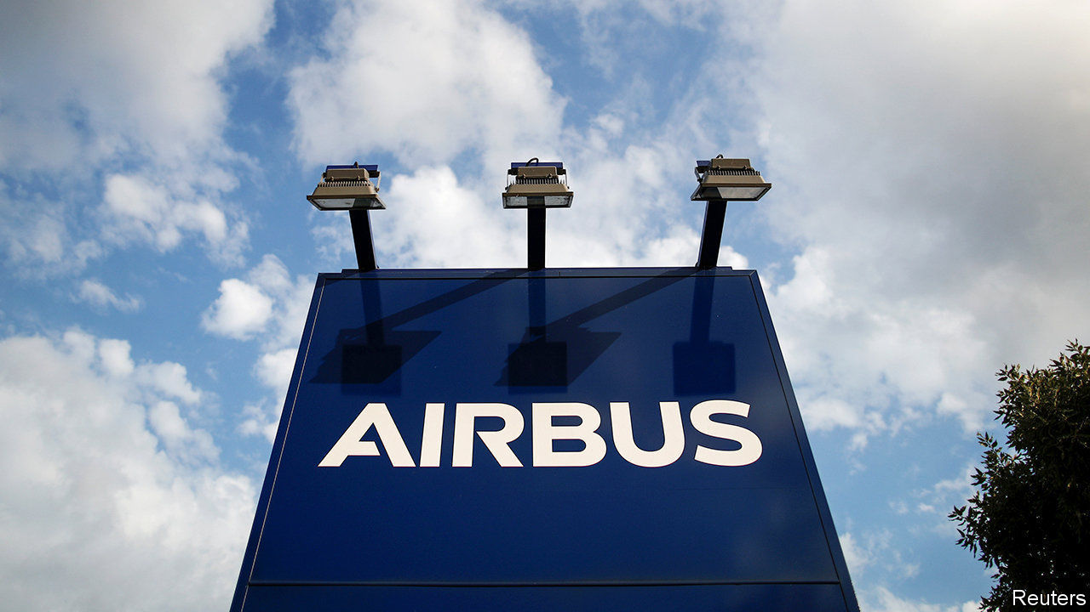

In another dreadful week for workers in the aviation industry, Airbus said it would cut 15,000 jobs, about a tenth of its total, because it does not expect demand for its aircraft to return to pre-covid levels until at least 2023, or possibly 2025. The announcement was lambasted in France, where the government has dispensed a huge rescue package. Aeromexico, Mexico’s biggest international airline, filed for bankruptcy protection. And easyJet, a British carrier, started a consultation on redundancies, which could see 727 pilots lose their jobs. Qantas announced 6,000 jobs cuts.

There was some good news for Virgin Australia, after two months in bankruptcy proceedings, as Bain Capital stepped in to buy the business. Shareholders lost their shirts in the deal, but the airline hopes to fly again in September.

The Federal Aviation Administration confirmed that the first certification flights had been conducted for Boeing’s 737 MAX, which has been grounded for 15 months following two crashes. Although the tests were described as a “milestone” in its rehabilitation, Boeing’s passenger plane won’t be returning to the skies soon; the FAA still has to carry out “a number of key tasks”.

Shell joined the list of big oil and gas companies that have had to write down the value of assets because of falling energy demand and lower oil prices. The company expects to record charges of between $15bn and $22bn in the second quarter related to the writedowns. BP, meanwhile, agreed to sell what is left of its petrochemicals business to Ineos, a privately held firm with a record of taking over the chemical divisions of multinational companies, for $5bn. See article.

Germany became the latest flashpoint for safety concerns at Amazon warehouses during the pandemic, as its workers went on strike. Their union claims that 40 people contracted covid-19 at two sites recently. The online retailer says it has provided enough personal protective equipment.

Meanwhile, Amazon sealed a deal to buy Zoox, a developer of self-driving taxis. Reportedly costing $1.2bn, it is Amazon’s biggest investment in autonomous-vehicle technology, which it may try to adapt for its delivery services.

## Stressful times

Wells Fargo became the first big American bank to cut its dividend in light of the Federal Reserve’s recent stress tests. The central bank banned share buy-back programmes and capped dividends for 33 banks during the third quarter. All large banks will be required to resubmit and update their capital plans later this year to show they can cope with an extreme economic scenario. See article.

Cirque du Soleil filed for bankruptcy protection and laid off 3,500 employees who had been furloughed in March, when it was forced to cancel performances because of covid-19. In other pandemic-related redundancies, SSP Group, which operates food outlets at transport hubs around the world, and is best known in Britain, its home market, for its Upper Crust and Camden Food Co shops, slashed 5,000 jobs. Microsoft announced the permanent closure of all its 83 stores, most of which are in America.

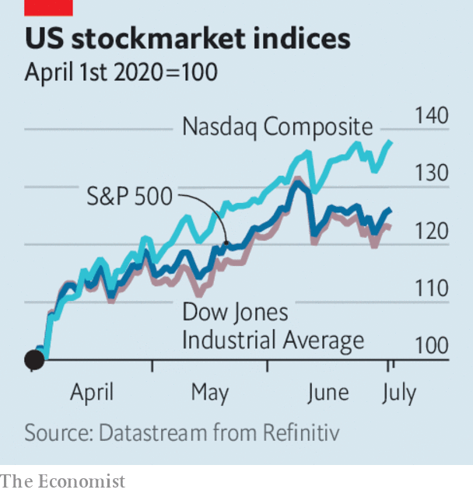

American stockmarkets recorded their best quarter in at least two decades. From April to June the S&P 500 and Dow Jones Industrial Average rose by around 25%, and the Nasdaq by over a third. Most of the gains came in April and May following the market rout in March amid the coronavirus crisis (European stocks actually outperformed the S&P 500 in June). Most share indices are still lower than at the start of the year. The tech-heavy Nasdaq is a notable exception; it has climbed by 10%.

Tesla overtook Toyota to become the world’s biggest carmaker by market capitalisation. The maker of electric vehicles has seen its share price rev up from $225 a year ago to $1,120, giving it a value of more than $205bn. It has yet to turn an annual profit.

In China, Byton, a startup with ambitions to compete against Tesla, suspended production and sent its staff home. Sales of electric and hybrid vehicles have fallen drastically in China following the end of government tax breaks. Byton is one of several Chinese EV startups that investors piled into hoping for rich returns, though it has not delivered a single vehicle.

## Mirror, Mirror on the wall

Mirror, a home-workout business, was snapped up by Lululemon, a maker of snazzy yoga pants, for $500m. Mirror makes body-length wall-mounted smart screens through which exercisers can interact online with buff personal trainers live or on-demand. The pandemic has been a boon for the high-end fitness industry. But once gyms reopen it remains to be seen whether people will still splash out $1,500 for one of Mirror’s screens, or just plod and puff on a treadmill.

This article was downloaded by calibre from <https://www.economist.com/the-world-this-week/2020/07/04/business-this-week>

|  |  |  |  |
| --- | --- | --- | --- |
| Previous | Articles | Sections | Next |

|  |  |  |  |
| --- | --- | --- | --- |
| Previous | Articles | Sections | Next |

# KAL’s cartoon

Jul 4th 2020 |

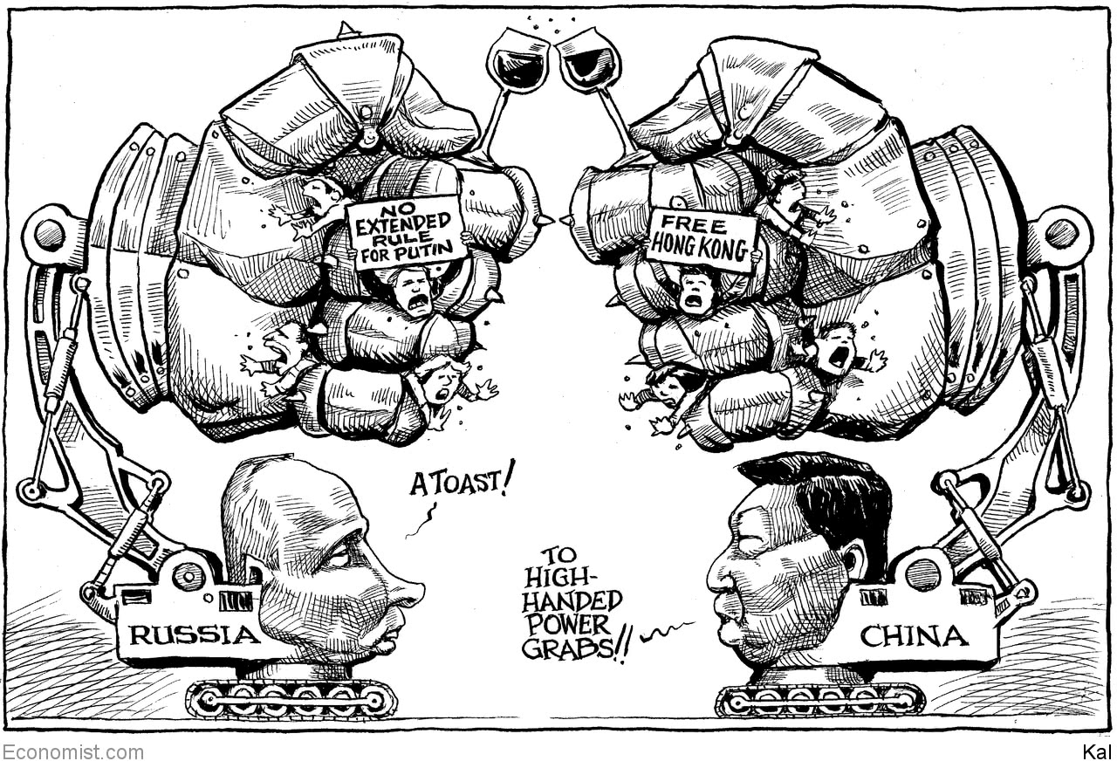

This article was downloaded by calibre from <https://www.economist.com/the-world-this-week/2020/07/04/kals-cartoon>

|  |  |  |  |
| --- | --- | --- | --- |
| Previous | Articles | Sections | Next |

|  |  |  |
| --- | --- | --- |
| The world this week | Sections | Letters |

Leaders

Joe Biden: Retro or radical?

.

The pandemic: The way we live now

.

Hong Kong: A safe harbour no more

.

Investing in India: Inside game

.

The Nile: Dam bluster

.

|  |  |  |
| --- | --- | --- |
| The world this week | Sections | Letters |

|  |  |  |  |
| --- | --- | --- | --- |
|  | Articles | Sections | Next |

#### America’s presidency

# Why Joe Biden’s instinctive caution makes real change possible

How a retro can be radical

Jul 2nd 2020 |

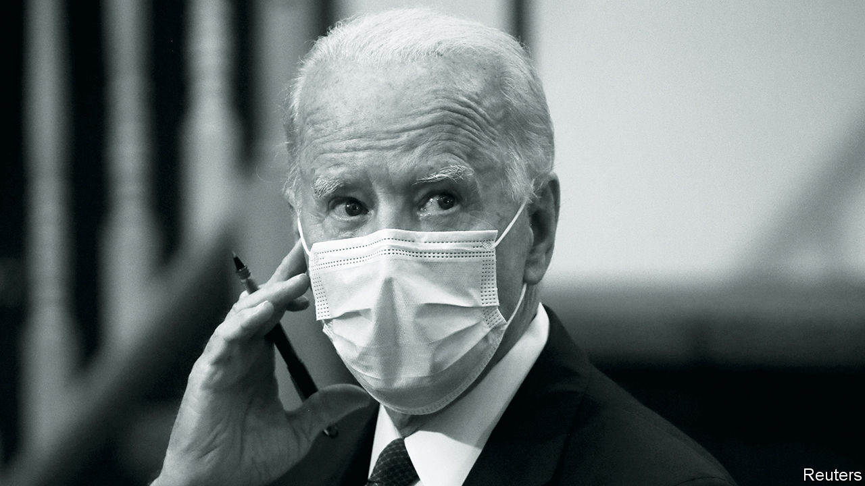

WHEN THE history of the Trump presidency is written, a photo-op in Lafayette Square at the beginning of June might just mark the turning-point. Since he announced his run for the White House in 2015, Donald Trump’s political method has been to maximise at all times the amount of attention directed at him. The Lafayette Square escapade offended Christians, because the president waved a Bible around like a prop. It embarrassed the country’s most senior military commander, who later apologised for joining a political show that involved the tear-gassing of peaceful protesters. More important, it did not work. Rather than being in command, Mr Trump seemed desperate. When power is based on appearances it can slip away suddenly.

Before covid-19 hit America, Mr Trump looked likelier than not to be re-elected, thanks to a relentlessly growing economy. Incumbent presidents almost always win in such circumstances. Our election model made him a narrow favourite, even though he was a few points down in national polls with his rival, Joe Biden. However, the president is now in a deep hole. Mr Biden is up by nine points—more in some polls. He is doing well in battleground states like Florida, Michigan and Wisconsin, and he has strong support among older voters and is doing surprisingly well among white voters who did not go to college. Our model now gives Mr Trump only a roughly 10% chance of winning. The virus has demonstrated something definitively to a large number of persuadable voters: that Mr Trump is just not that good at being a president.

There is a long time until November. Anyone who has lived through the past decade knows that low-probability events need to be taken seriously. If the virus recedes and the economy rebounds Mr Trump’s chances may improve over the coming months. If the virus is still rampant and states have not organised themselves for voting by mail, the contest could be an unpredictable, low-turnout affair. Either way, he will try to exploit the same divisions that have worked in his favour in the past.

For all that, Mr Biden finds himself in landslide territory without having had to do very much to get there (see article). Mr Trump’s flailing has made a Democratic Senate majority possible. That opens up the chances of a highly productive presidency which once seemed inconceivable. Before covid-19 and widespread social unrest, Mr Biden’s candidacy was about restoration—the idea that he could return America and the world to the prelapsarian days of 2016. It transpires that he could have the opportunity to do something big instead.

Mr Trump is already painting this as a threat. He wants to scare voters with warnings that his opponent is a doddering fool who will be taken hostage by dangerous radicals seeking to defund the police and confiscate everybody’s guns. Some Democrats have the opposite fear, of an old patriarch stuck in his centrist ways. And indeed when Mr Biden was first elected to Washington, Elvis Presley was playing in Hawaii and Leonid Brezhnev was general secretary of the Soviet Communist Party. He has survived by adjusting his views on race, sex, religion and other cultural signifiers as the Democratic Party has shifted. How, hot-headed Democrats say, can a man who has followed rather than led be trusted to fix America’s ills?

In fact, both points of view could turn out to be wrong. The dominant theory, on the right and the left, is that change in America is made by the extremes. On the right that has meant Goldwater-ism, the Tea Party and Mr Trump. On the left it has meant the anti-Vietnam movement, social-justice campaigns and Bernie Sanders. There is something to this idea: without these forces dragging him, Mr Biden might not have moved.

But to make lasting change through the federal government you need to win the Senate. And that cannot be done with a candidate at the top of the ticket who frightens the voters. That is the paradox of Mr Biden’s candidacy. Because he has flip-flopped on abortion rights and school desegregation by busing, because he comes across as the grandfather he is, he is viewed with suspicion on the left. Yet that is precisely what makes him reassuring, or at least unfrightening, to voters in states like Montana and Georgia where Democrats must win to gain a majority in the Senate. It is Mr Biden’s caution that opens up the possibility of more change than a real radical would.

That may be even more true in 2020 than in the past. Though Mr Trump’s victory in 2016 was presented, not least by him, as the triumph of the enraged and downtrodden against a broken system, it came after 20 consecutive quarters of falling unemployment, when there were few threats from terrorism at home. This time is different. With 128,000 Americans dead from covid-19 and with unemployment rife, the centrist virtues of decency, experience and a willingness to act on advice from competent people could well seem more alluring.

For a sense of what that means in practice, consider Mr Biden’s platform. His campaign website is a smorgasbord of policy plans, most of which would never happen even if he were to win. But two of them conceivably could.

The first is a public option in health care, allowing Americans to buy health insurance from the government. America has been inching its way towards universal health care, a move that Mr Trump has been unable to reverse. Under a Biden presidency it could come within touching distance. The second policy is a significant reduction in greenhouse-gas emissions. Mr Biden wants to pass legislation to bind America to reaching net-zero emissions by 2050. Add to this Mr Biden’s return to multilateral engagement in foreign policy—which America’s allies would wholeheartedly endorse, and which could begin to steady a chaotic world. Even if Mr Biden accomplished only part of this agenda, the criticisms from the Democratic left would seem churlish.

Some consequential presidents have been accidental radicals. Think of Lyndon Johnson, who took office after JFK’s assassination and passed the Civil Rights Act, or George W. Bush, transformed by 9/11 from a compassionate conservative into a neocon who started two of his country’s longest wars. To have a hope of a transformative presidency, Mr Biden must not misread the paradox on which his future depends. It is by cleaving to the centre that he can best lead America in a new direction. ■

This article was downloaded by calibre from <https://www.economist.com/leaders/2020/07/02/why-joe-bidens-instinctive-caution-makes-real-change-possible>

|  |  |  |  |
| --- | --- | --- | --- |
|  | Articles | Sections | Next |

|  |  |  |  |
| --- | --- | --- | --- |
| Previous | Articles | Sections | Next |

#### The way we live now

# Covid-19 is here to stay. People will have to adapt

The world is not experiencing a second wave: it never got over the first

Jul 4th 2020 |

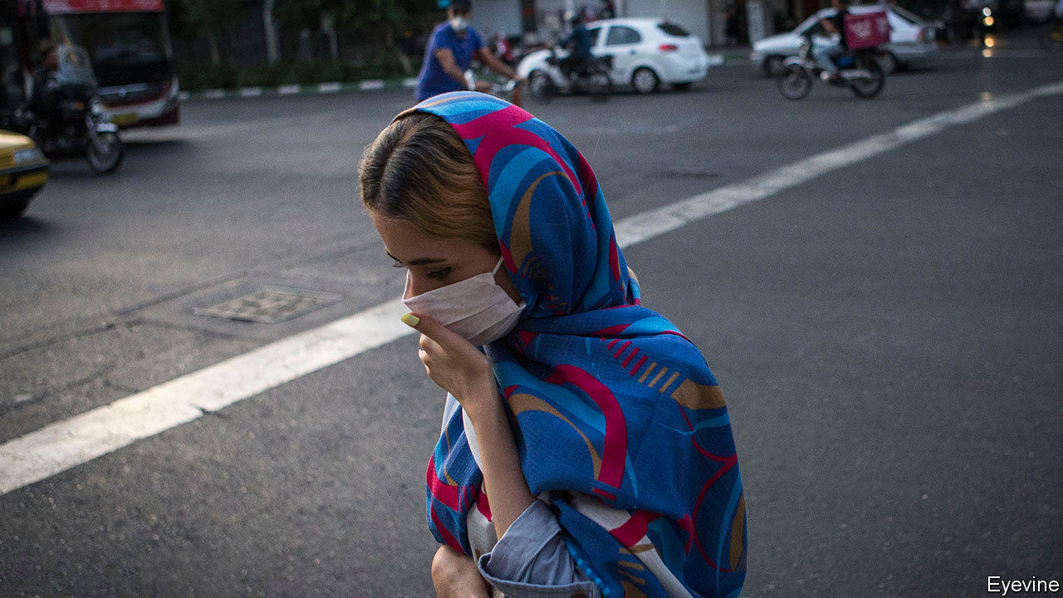

Editor’s note: Some of our covid-19 coverage is free for readers of The Economist Today, our daily [newsletter](https://my.economist.com/user#newsletter). For more stories and our pandemic tracker, see our [hub](https://www.economist.com/news/2020/03/11/the-economists-coverage-of-the-coronavirus)

IT IS ASTONISHING how rapidly the pandemic has spread, despite all the efforts to stop it. On February 1st, the day covid-19 first appeared on our front cover, the World Health Organisation counted 2,115 new cases. On June 28th its daily tally reached 190,000. That day as many new cases were notched up every 90 minutes as had been recorded in total by February 1st.

The world is not experiencing a second wave: it never got over the first. Some 10m people are known to have been infected. Pretty much everywhere has registered cases (Turkmenistan and North Korea have not, though, like Antarctica). For every country such as China, Taiwan and Vietnam, which seems to be able to contain the virus, there are more, in Latin America and South Asia, where it is raging. Others, including the United States, are at risk of losing control or, in much of Africa, in the early phase of their epidemic. Europe is somewhere in between.

The worst is to come. Based on research in 84 countries, a team at the Massachusetts Institute of Technology reckons that, for each recorded case, 12 go unrecorded and that for every two covid-19 deaths counted, a third is misattributed to other causes. Without a medical breakthrough, it says, the total number of cases will climb to 200m-600m by spring 2021. At that point, between 1.4m and 3.7m people will have died. Even then, well over 90% of the world’s population will still be vulnerable to infection—more if immunity turns out to be transient.

The actual outcome depends on how societies manage the disease. Here the news is better. Epidemiologists understand how to stop covid-19. You catch it indoors, in crowds, when people raise their voices. The poor are vulnerable, as are the elderly and those with other conditions. You can contain the virus with three tactics: changes in behaviour; testing, tracing and isolation; and, if they fail, lockdowns. The worse a country is at testing—and many governments have failed to build enough capacity—the more it has to fall back on the other two. Good public health need not be expensive. Dharavi, a slum of 850,000 people in Mumbai, tamed an outbreak (see article).

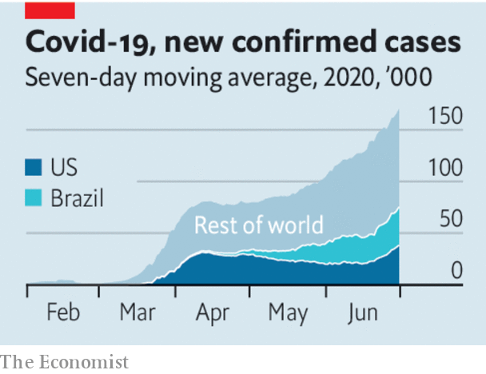

Treatments have improved, thanks to research and dealing with patients. Although mass vaccination is still months away at best (see article), the first therapies are available. More is known about how to manage the disease—don’t rush to put people on respirators, do give them oxygen early. Better treatment helps explain why the share of hospital patients who went on to be admitted to intensive care fell in Britain from 12% at the end of March to 4% in mid to late May.

And economies have adapted. They are still suffering, of course. J.P. Morgan, a bank, predicts that the peak-to-trough decline in the first half of the year in the 39 economies it follows will be around 10% of GDP. But workers stuck in Zoom hell have discovered that they can get a surprising amount done from home. In China Starbucks designed “contactless” ordering, cutting the time customers spend in its coffee shops. Supply chains that struggled now run smoothly. Factories have found ways to stagger shifts, shield staff behind plastic and change work patterns so that personal contact is minimised.

Now that nationwide lockdowns are done, governments can make sensible trade-offs—banning large indoor gatherings, say and allowing the reopening of schools and shops. Sometimes, as in some American states, they will loosen too much and have to reverse course. Others will learn from their mistakes.

The problem is that, without a cure or a vaccine, containment depends on people learning to change their behaviour. After the initial covid-19 panic, many are becoming disenchanted and resistant. Masks help stop the disease, but in Europe and America some refuse to wear one because they see them as emasculating or, worse, Democratic. Thorough handwashing kills the virus, but who has not relapsed into bad old habits? Parties are dangerous but young people cooped up for months have developed a devil-may-care attitude. Most important, as the months drag on, people just need to earn some money. In the autumn, as life moves indoors, infections could soar.

Changing social norms is hard. Just look at AIDS, known for decades to be prevented by safe sex and clean needles. Yet in 2018, 1.7m people were newly infected with HIV, the virus that causes it. Covid-19 is easier to talk about than AIDS, but harder to avoid. Wearing a mask is chiefly about protecting others; the young, fit and asymptomatic are being asked to follow tedious rules to shield the old and infirm.

Changing behaviour requires clear communication from trusted figures, national and local. But many people do not believe their politicians. In countries such as America, Iran, Britain, Russia and Brazil, which have the highest caseloads, presidents and prime ministers minimised the threat, vacillated, issued bad advice or seemed more interested in their own political fortunes than in their country—sometimes all at once.

Covid-19 is here for a while at least. The vulnerable will be afraid to go out and innovation will slow, creating a 90% economy that consistently fails to reach its potential. Many people will fall ill and some of them will die. You may have lost interest in the pandemic. It has not lost interest in you. ■

Editor’s note: Some of our covid-19 coverage is free for readers of The Economist Today, our daily [newsletter](https://my.economist.com/user#newsletter). For more stories and our pandemic tracker, see our [hub](https://www.economist.com/news/2020/03/11/the-economists-coverage-of-the-coronavirus)

This article was downloaded by calibre from <https://www.economist.com/leaders/2020/07/04/covid-19-is-here-to-stay-people-will-have-to-adapt>

|  |  |  |  |
| --- | --- | --- | --- |
| Previous | Articles | Sections | Next |

|  |  |  |  |
| --- | --- | --- | --- |
| Previous | Articles | Sections | Next |

#### A harbour no more

# China’s draconian security law for Hong Kong buries one country, two systems

The regime in Beijing would rather be feared than admired

Jul 2nd 2020 |

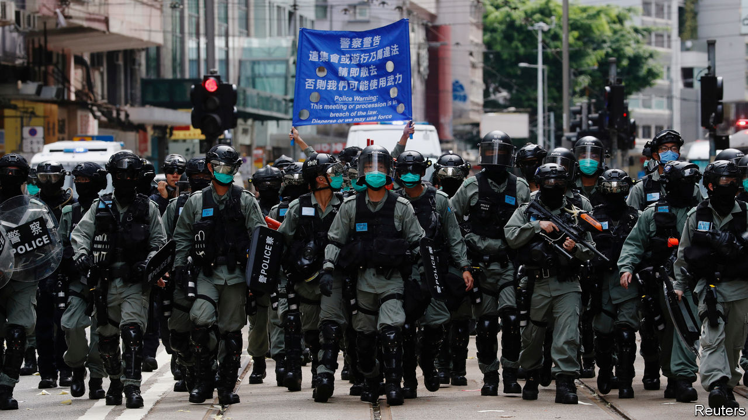

THE CHINESE government is spreading fear in Hong Kong. The first shock came in May, when it announced plans to impose a sweeping national-security law on the territory, without the say-so of its legislature. Then it drafted the bill behind closed doors, keeping details secret even from Hong Kong’s administration. After the law was passed on June 30th by China’s rubber-stamp parliament, hours passed before it was published at close to midnight. The 18-page bill, which took effect that day, was harsher than the gloomiest analysts had predicted. It is one of the biggest assaults on a liberal society since the second world war (see [article](https://www.economist.com/node/21788943)).

Chinese officials argue that they are doing nothing wrong: national-security laws are common around the world, even in democracies. But that is disingenuous. This one allows China’s Communist Party to rip up its promise of one country, two systems and send its secret agents into Hong Kong to impose order as it pleases. Its spooks will not be subject to local law. Most national-security cases, supposedly, will be tried in Hong Kong’s own courts. But the judges will be government-appointed. They will be allowed to dispense with juries and try cases in secret. Most worrying is that “complex” or “serious” crimes may be tried on the mainland. The past year of unrest in Hong Kong was sparked by fears of just such a possibility—that a now-shelved extradition law might let dissidents be whisked away to face the mainland’s brutal justice. That is what the new law allows. Officials do not rule out that those convicted by mainland courts could be executed.

But wait, surely this law is about crimes that threaten China’s security? Lambasting its authoritarian politics or quixotically suggesting that Hong Kong should be independent would hardly cause the ground to shake in Beijing. The party, however, takes a different view. The bill’s definitions of sedition, subversion, terrorism and collusion with foreign powers could be applied even to petty, non-violent activity. The first arrest under the new law, on July 1st, was of a man who was merely carrying a banner calling for an independent Hong Kong. The bill could be invoked to arrest someone who uses “unlawful means” to undermine China’s communist system. Could that include taking part in a banned rally commemorating the Tiananmen Square protests of 1989? The party will be the judge. It errs on the side of severity.

The law also applies to activities abroad, by anyone. The wording of the bill suggests that a foreign firm which co-operated with, say, the American government in applying sanctions on China would have no defence if the party moved against it.

The world is entitled to be shocked by these developments, but not surprised. The crushing of the Tiananmen protests showed the party’s ruthless determination to destroy opposition no matter what the cost to its global reputation. The world’s horror at that bloodshed, and the sanctions the West imposed on China in 1989, did not change the party’s views. And China was a minnow back then, its economy smaller than Spain’s. It is even less likely to pay heed to foreign critics today.

But the West must respond. Britain was right to say on July 1st that it would make it easier for about 3m holders of “British national overseas” passports in Hong Kong to settle in Britain and eventually qualify for citizenship (see [article](https://www.economist.com/node/21788919)). America should impose sanctions on Chinese officials who violate human rights in Hong Kong. It would be more effective if it abandoned its go-it-alone approach to foreign affairs and worked with other democracies to resist China’s efforts to subvert global human rights (see [article](https://www.economist.com/node/21788942)).

Hong Kong’s suffering holds a lesson for the world. China’s rulers cannot be trusted to keep their promises and they will stop at nothing to suppress dissent. This calls for heightened vigilance about China’s rise, especially as it affects Taiwan. The party has shown that it would rather be feared than admired. ■

This article was downloaded by calibre from <https://www.economist.com/leaders/2020/07/02/chinas-draconian-security-law-for-hong-kong-buries-one-country-two-systems>

|  |  |  |  |
| --- | --- | --- | --- |
| Previous | Articles | Sections | Next |

|  |  |  |  |
| --- | --- | --- | --- |
| Previous | Articles | Sections | Next |

#### Foreign firms in India

# Multinationals love India more than it loves them

By looking inward, Narendra Modi is missing a huge opportunity

Jul 4th 2020 |

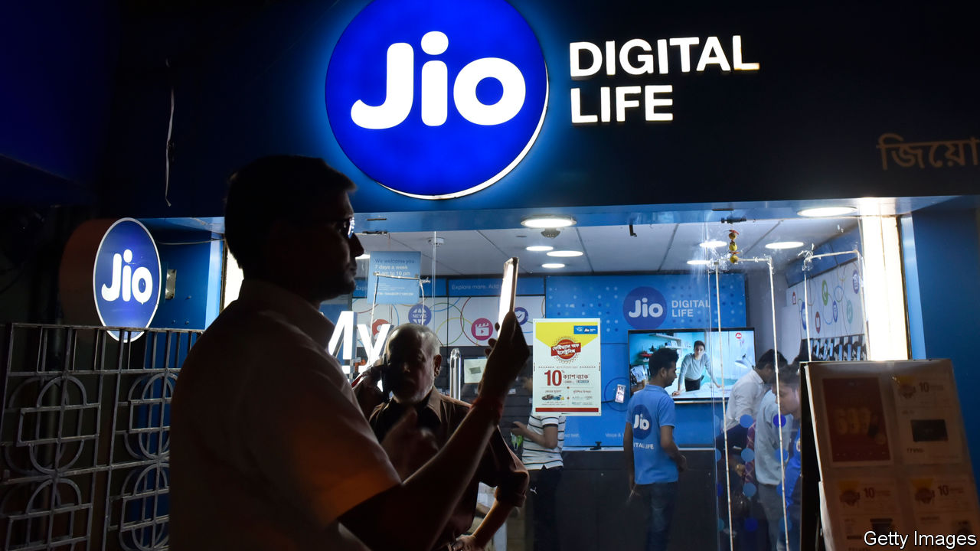

IF YOU LOOK at the headline figures, foreign companies still appear to be piling into India even as its economy reels from the pandemic. Since the country went into lockdown in March some $20bn of cross-border deals have been announced, with the likes of Facebook and KKR, a private-equity giant, sticking cash into digital firms, solar parks and more. Optimists argue that India could soon become a place to build factories, as firms seek to diversify their supply chains away from China.

Yet look closely, and a different picture emerges (see [article](https://www.economist.com/node/21788931)). Foreign firms are often on the wrong end of regulatory changes. Investors increasingly prefer to take minority stakes alongside local tycoons, rather than set out on their own. And Narendra Modi, the prime minister, is veering towards a policy of capricious self-reliance. This week India banned 59 Chinese-made apps, including TikTok. Unless things change, India and the firms that invest there will not reach their potential.

India was largely closed to foreign firms between independence in 1947 and liberalisation in 1991—it even kicked out Coca-Cola. Since then it has opened up, tentatively at first, and after 2000 more confidently. Cumulatively, multinational firms have invested over $500bn and some have won control of critically important assets. Vodafone took a majority stake in a big mobile network in 2007. The biggest carmaker is run by Suzuki, a Japanese firm. When Mr Modi was elected in 2014, he pledged to make India even more hospitable and to attract more factories. On paper the Sino-American trade war should make it easier to turn India into a global production hub.

How has Mr Modi done? Officials boast that India has moved swiftly up the “ease of doing business” rankings, from 142nd place in 2014 to 63rd place last year. But the reality is less impressive. India’s share of global foreign direct investment (FDI) flows has nudged up only slightly, from 2.5% in 2014 to 3.3% last year. Meanwhile, some troubling problems fester.

Foreign firms don’t always get fair treatment. True, some that have been active in India for many decades, such as Unilever, are treated like locals. But more recent arrivals can get beaten up. Vodafone poured over $20bn into India but found itself subject to a big retroactive tax claim, unfavourable regulation and, most recently, spectrum levies (some local firms got clobbered, too). Amazon and Walmart, which together have also invested over $20bn, faced a sharp change in the e-commerce rules in 2019 that made it harder for them to own or control inventory.

Because the playing field is not level, foreign firms seem to be shifting from owning their own subsidiaries to taking passive stakes in well-connected local firms instead. Ford has folded its business into a joint-venture. Aéroports de Paris has taken a non-controlling stake in an infrastructure firm. A who’s who of world business has bought small stakes in Jio, a mobile-phone and e-commerce firm run by Mukesh Ambani, India’s richest man, which competes with Amazon, Walmart and Vodafone. Of all the $57bn of cross-border deals announced in the past 12 months, 66% involved passive stakes and half involved partnerships with a tiny number of Indian tycoons. The economy is becoming dominated by a few local winners. According to Marcellus, an investment firm, 70% of corporate profits are made by the top 20 firms, only one of them foreign, up from 14% 30 years ago.

With the economy forecast to shrink by 4.5% this year and firms prowling for alternatives to China, you may think that Mr Modi would open the door. But his policies have turned inward, mirroring the lurch to protectionism in the West. On May 12th he made a speech which said that India should take part in global supply chains but also mentioned “self-reliance” 17 times. As military tensions with China rise (see [article](https://www.economist.com/node/21788907)), a new crackdown has begun. As well as banning the Chinese apps, the government is prodding e-commerce firms to have “country of origin” labelling on goods they sell. Foreign firms bring cash, know-how and competition. Once the pandemic passes, India must show that it is still open for business.■

This article was downloaded by calibre from <https://www.economist.com/leaders/2020/07/04/multinationals-love-india-more-than-it-loves-them>

|  |  |  |  |
| --- | --- | --- | --- |
| Previous | Articles | Sections | Next |

|  |  |  |  |
| --- | --- | --- | --- |
| Previous | Articles | Sections | Next |

#### Dam bluster

# Egypt, Ethiopia and Sudan must learn how to share the Nile river

Or a squabble over water could turn nastier

Jul 4th 2020 |

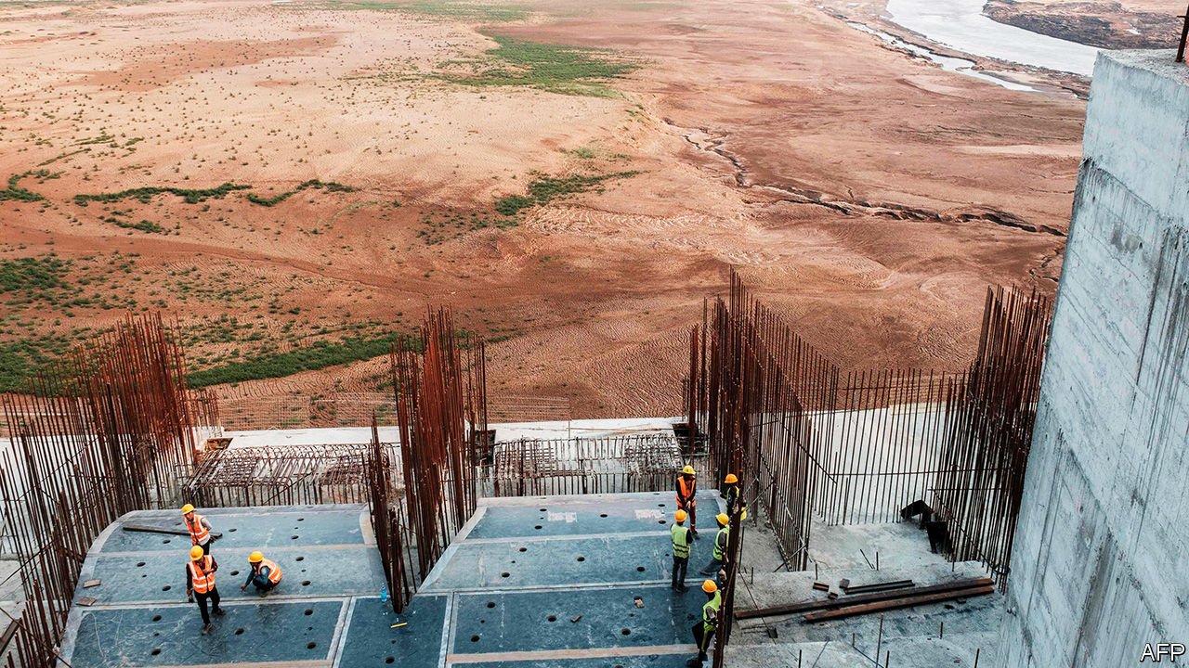

ONCE COMPLETED, the Grand Ethiopian Renaissance Dam will be nearly twice as tall as the Statue of Liberty and as wide as the Brooklyn Bridge is long. The reservoir behind it is roughly the size of London. Sitting on the Blue Nile, the main tributary of the Nile river, the dam is the largest hydro-electric project in Africa. Soon it will produce 6,000 megawatts of electricity, more than double Ethiopia’s output today. With a little co-operation between Ethiopia and its downstream neighbours, Egypt and Sudan, the dam could be a boon for the whole region.

Yet so far it has produced only acrimony. Egypt, which depends on the Nile for 90% of its fresh water, sees the dam as an existential threat. Shortly after construction began in 2011, officials in Cairo considered sabotage; a former president even considered bombing it. Last month Ethiopia accused Egypt of sponsoring cyber-attacks to disrupt the project.

In between all the sabre-rattling the three countries have held talks over how fast to fill the reservoir, how much water will be released and how to resolve any future disagreements. So far no deal has been reached. But the latest round comes with a deadline of sorts: Ethiopia says it will begin filling the reservoir behind the dam later this month. Egypt has vowed to use “all means available” to protect its interests (see [article](https://www.economist.com/node/21788885)). All sides will have to make concessions if conflict is to be avoided.

The biggest lack is trust. Start in Egypt, whose people view the Nile as their birthright. As its population has risen, the water supply per person has fallen. Egypt therefore wants Ethiopia to fill its reservoir slowly and to release enough water so that the river’s flow is not disrupted, especially during droughts. Egypt thinks Ethiopia has dragged out the talks to gain bargaining power as construction advances. The dam is now over 70% complete.

Belligerence in Cairo has led to stubbornness in Addis Ababa, where officials are seeking a quick return on their $5bn investment. They think Egypt is stuck in the past, attached to defunct treaties that allowed it to dominate the Nile. Meanwhile, around half of Ethiopians do not have access to electricity. The government hopes the dam will raise Ethiopia out of poverty. So it says it will begin filling the reservoir with or without an agreement. Up for re-election next year and facing serious unrest, Abiy Ahmed, the prime minister, is under pressure to take a hard line.

Sudan, for its part, backs the project, which lies about 20km from its border. It will receive some of the dam’s cheap electricity. More predictable water flows could help it grow more food. But it remains concerned that poorly co-ordinated releases of water could overwhelm its own Roseires Dam.

The three sides are said to have reached 90% of a deal. They can agree on what to do when there is enough rain. The dispute is over how to manage the dam when there isn’t. Ethiopia feels it is being forced to run its reservoir down too much during periods of drought. It would rather take things year by year and settle any disagreements through negotiations. Egypt and Sudan want commitments now, and prefer binding international arbitration to settle disputes.

In the long term, wiser policies would help. Subsidies have long encouraged Egyptians to waste water on a massive scale. These are being cut, but they should be eliminated. The sides should generate more solar power to meet growing demand and take pressure off the dam. All are sunny, and solar panels cost a fraction of what they did when the dam was conceived.

But right now all three need to strike a deal. Ethiopia should pledge to let more water through during long dry spells. An international arbiter should be brought in to handle future disputes. Egypt could compromise by letting the African Union (AU) play that role. Officials in Cairo believe the AU favours Ethiopia, where the AU has its headquarters, but the group is leading the effort to find a deal that works for everyone. If an agreement can be reached, it will make a welcome change. The world abounds with conflicts over water. The stuff is hard to share. But projects like the Grand Ethiopian Renaissance Dam promise a flood of benefits to countries that manage. ■

This article was downloaded by calibre from <https://www.economist.com/leaders/2020/07/04/egypt-ethiopia-and-sudan-must-learn-how-to-share-the-nile-river>

|  |  |  |  |
| --- | --- | --- | --- |
| Previous | Articles | Sections | Next |

|  |  |  |
| --- | --- | --- |
| Leaders | Sections | Briefing |

Letters

Letters to the editor: On artificial intelligence, green investing, GDP, gardens, working from home

.

|  |  |  |
| --- | --- | --- |
| Leaders | Sections | Briefing |

|  |  |  |  |
| --- | --- | --- | --- |
|  | Articles | Sections | Next |

#### On artificial intelligence, green investing, GDP, gardens, working from home

# Letters to the editor

A selection of correspondence

Jul 4th 2020 |

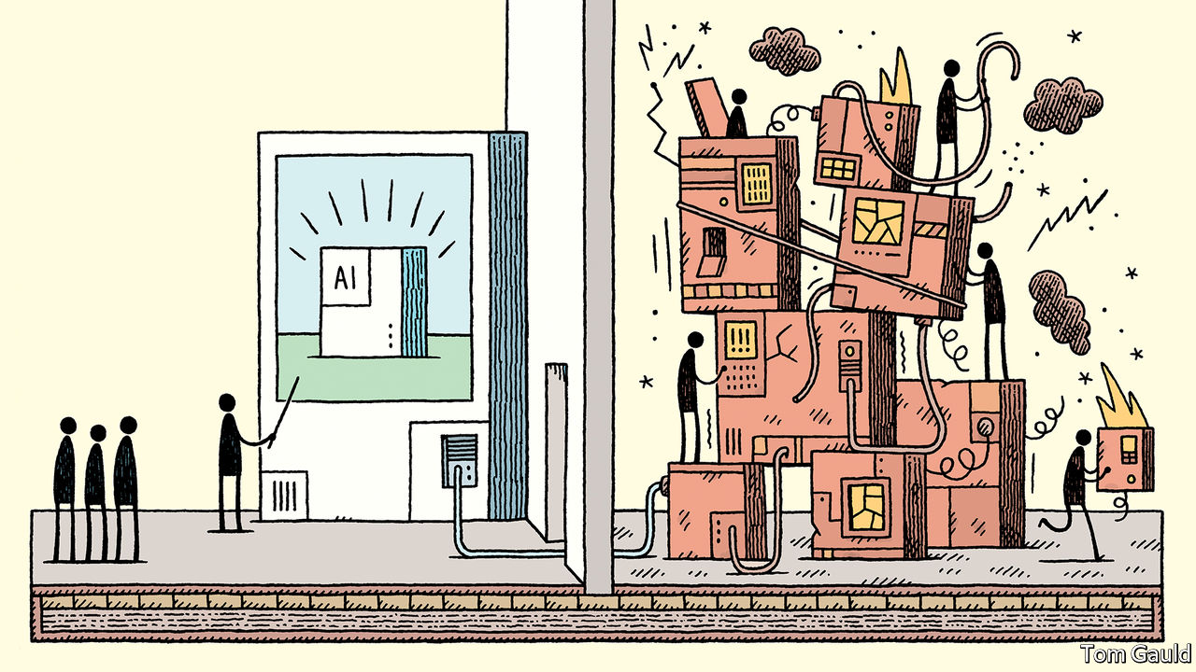

## Of limited intelligence

Artificial intelligence is an oxymoron ([Technology quarterly](https://www.economist.com/technology-quarterly/2020/06/11/an-understanding-of-ais-limitations-is-starting-to-sink-in), June 13th). Intelligence is an attribute of living things, and can best be defined as the use of information to further survival and reproduction. When a computer resists being switched off, or a robot worries about the future for its children, then, and only then, may intelligence flow.

I acknowledge Richard Sutton’s “bitter lesson”, that attempts to build human understanding into computers rarely work, although there is nothing new here. I was aware of the folly of anthropomorphism as an AI researcher in the mid-1980s. We learned to fly when we stopped emulating birds and studied lift. Meaning and knowledge don’t result from symbolic representation; they relate directly to the visceral motives of survival and reproduction.

Great strides have been made in widening the applicability of algorithms, but as Mr Sutton says, this progress has been fuelled by Moore’s law. What we call AI is simply pattern discovery. Brilliant, transformative, and powerful, but just pattern discovery. Further progress is dependent on recognising this simple fact, and abandoning the fancy that intelligence can be disembodied from a living host.

ROB MACDONALDRichmond, North Yorkshire

I agree that machine learning is overhyped. Indeed, your claim that such techniques are loosely based on the structure of neurons in the brain is true of neural networks, but these are just one type among a wide array of different machine- learning methods. In fact, machine learning in some cases is no more than a rebranding of existing processes. If by machine learning we simply mean building a model using large amounts of data, then good old ordinary least squares (line of best fit) is a form of machine learning.

TOM ARMSTRONGToronto

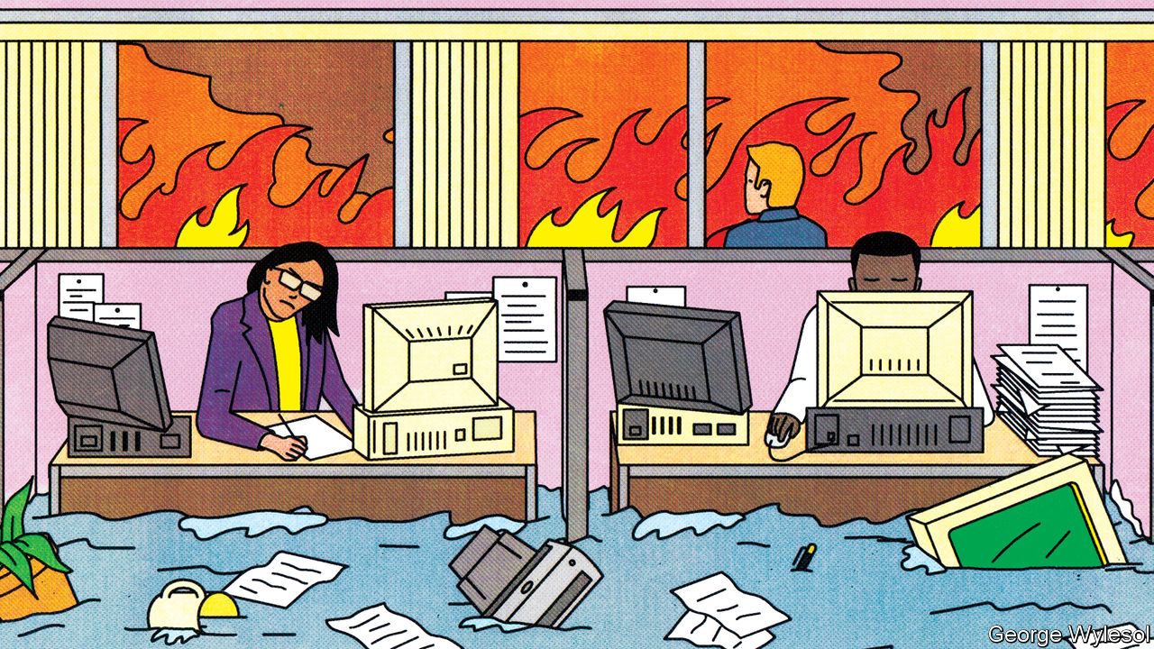

## Investors make a difference

The scope of your research into green investing was too narrow to condemn all financial services for their woolly thinking (“[Hotting up](https://www.economist.com/briefing/2020/06/20/how-much-can-financiers-do-about-climate-change)”, June 20th). You restricted your analysis to microeconomic factors and to the ability of investors to engage with companies. It overlooked the bigger picture: investors can also shape the macro environment by structured engagement with the system itself.

For example, the data you used largely originated from the investor-led Carbon Disclosure Project (for which we hosted the first ever meeting, nearly two decades ago). In addition, investors have also helped shape sustainable-finance plans in Britain, the EU and UN. Investors also sit on the industry-led Taskforce on Climate-related Financial Disclosure, convened by the Financial Stability Board, which has proved effective.

It is critical that governments apply a meaningful carbon price. But if we are to move money at the pace and scale required to deal with climate risk, governments need to reconsider the entire architecture of markets. This means focusing a wide-angled climate lens on prudential regulation, listing rules, accounting standards, investor disclosure standards, valuation conventions and stewardship codes, as well as building on new interpretations of legal fiduciary duty. This work is done most effectively in partnership with market participants. Green-thinking investors can help.

STEVE WAYGOODChief responsible investment officer  
Aviva Investors  
London

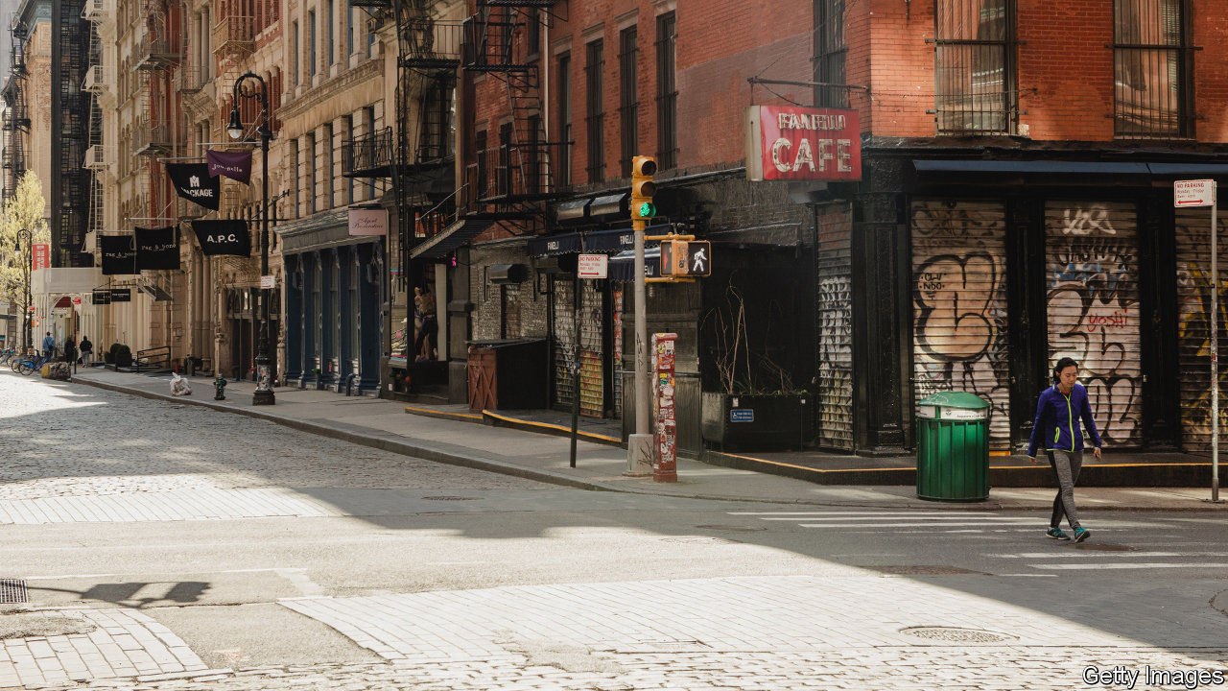

## Measuring economic output

Estimating indirectly observable GDP in real time is indeed a hard job for macro-econometricians, or “wonks”, as you call us (“[Crisis measures](https://www.economist.com/finance-and-economics/2020/05/30/the-pandemic-could-lead-statisticians-to-change-how-they-estimate-gdp)”, May 30th). Most of the components are either highly lagged, as your article mentioned, or altogether unobservable. But the textbook definition of GDP and its components won’t be changing any time soon, as the reader is led to believe. Instead what has always and will continue to change are the proxy indicators used to estimate the estimate of GDP.

MICHAEL BOERMANWashington, DC

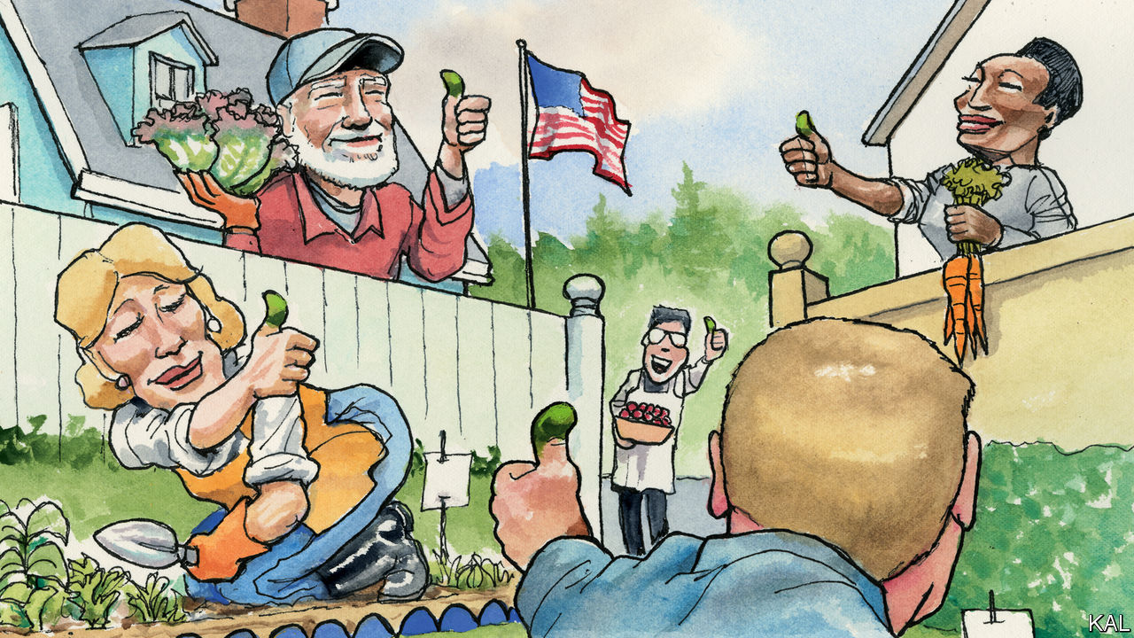

## Back to the garden

Reading Lexington’s account of his garden adventures ([June 20th](https://www.economist.com/united-states/2020/06/20/america-rediscovers-the-joys-of-vegetable-growing)) brought back memories of my own experience with neighbours in Twinsburg, Ohio, in the late 1970s. They also objected to vegetables growing in our front yard (the only available space). We were doing it for the same reasons as Lexington: pleasure, fresh food to eat, and a learning experience for our young children. The neighbours, recently arrived into the suburban middle class, saw it as an affront. They no longer had to grow food for their table. They could buy it at the store and keep it in the deep freeze. Our garden, in their face every day, reminded them of their roots in Appalachian poverty. They called us “hillbillies”.

Arthur C. Clarke once wrote: “Any sufficiently advanced technology is indistinguishable from magic.” Our version read, “Any sufficiently advanced lifestyle is indistinguishable from hillbillies.”

PHILIP RAKITAPhiladelphia

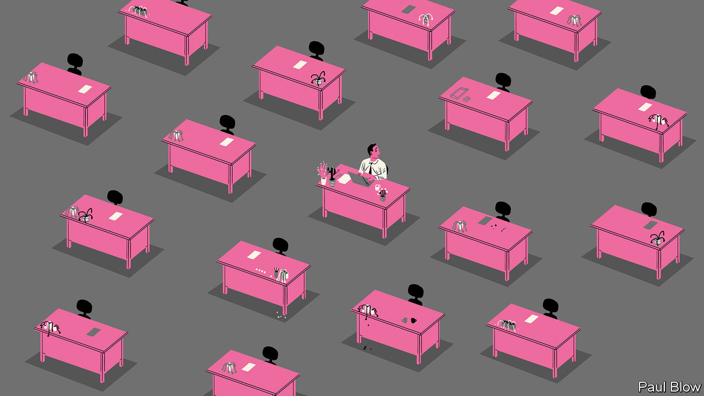

## I don’t like home work

Bartleby ([May 30th](https://www.economist.com/business/2020/05/30/working-life-has-entered-a-new-era)) thinks the benefits of working from home will mean that employees will not want to return to the office. I am not sure that is the case for many people. My husband is lucky. He works for a company that already expected its staff to work remotely, so had the systems and habits in place. He has a spacious room to work in, with an adjustable chair, large monitor and a nice view. I do not work so he is not responsible for child care or “home schooling”.

Many people are working at makeshift workspaces which would make an occupational therapist cringe. Few will have a dedicated room for their home office, so their work invades their mental and physical space.

My husband has noticed that meetings are being set up both earlier and later in the day because there is an assumption that, as people are not commuting, it is fine to extend their work day. Colleagues book a half-hour meeting instead of dropping by someone’s desk to ask a quick question. Any benefit of not commuting is lost. My husband still struggles to finish in time to have dinner with our children. People with especially long commutes now have more time, but even that was a change of scenery and offered some incidental exercise.

JENNIFER ALLENLondon

As Bartleby pointed out, the impact of pandemic working conditions won’t be limited to the current generation. By exacerbating these divides, will covid-19 completely guarantee a future dominated by the baby-Zoomers?

MALCOLM BEGGTokyo

The transition away from the physical office engenders a lackadaisical approach to the work day for many workers. It brings to mind Ignatius Reilly’s reasoning for his late start at the office from “A Confederacy of Dunces”:

I avoid that bleak first hour of the working day during which my still sluggish senses and body make every chore a penance. I find that in arriving later, the work which I do perform is of a much higher quality.

ROBERT MOGIELNICKIArlington, Virginia

This article was downloaded by calibre from <https://www.economist.com/letters/2020/07/04/letters-to-the-editor>

|  |  |  |  |
| --- | --- | --- | --- |
|  | Articles | Sections | Next |

|  |  |  |
| --- | --- | --- |
| Letters | Sections | United States |

Briefing

Joe Biden: He persisted

.

|  |  |  |
| --- | --- | --- |
| Letters | Sections | United States |

|  |  |  |  |
| --- | --- | --- | --- |
|  | Articles | Sections | Next |

#### America’s extraordinary election

# Joe Biden has a good chance of becoming a surprisingly activist president

He is reassuring and popular and has come to boast an ambitious policy platform

Jul 4th 2020 | WASHINGTON, DC

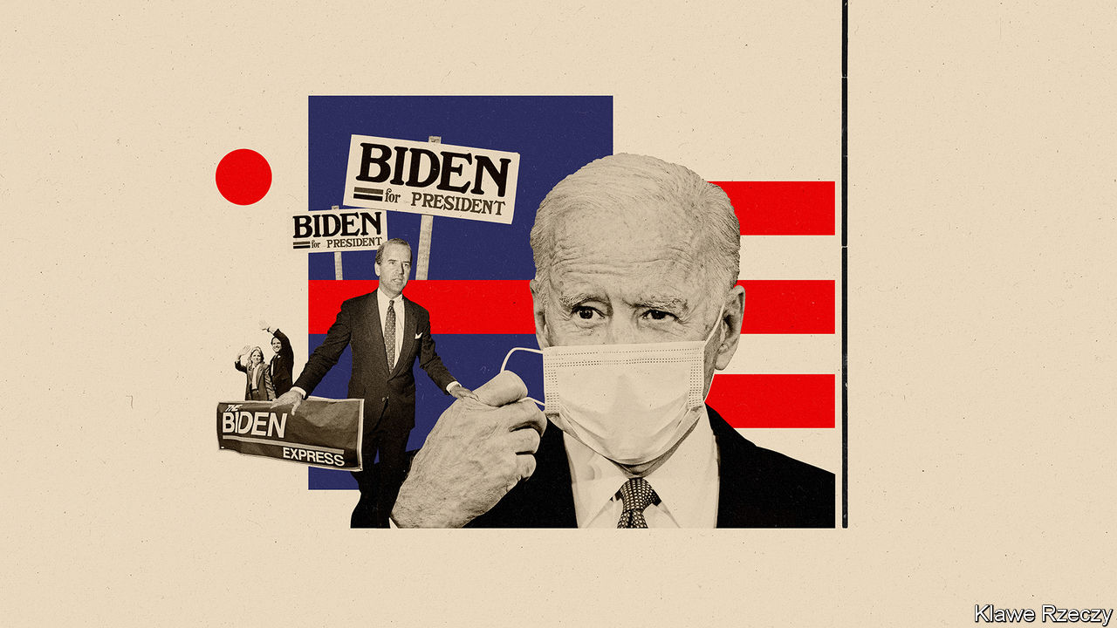

ON NOVEMBER 7TH 1972 the people of Delaware voted to send Joe Biden, a brash, garrulous county councilman, to the United States Senate—even though he would not turn 30, the Senate’s age minimum, for another two weeks. During the campaign he had sought both to use and downplay his youth. His ads touted “new thinking” and “new solutions”; the compliments he paid his 63-year-old opponent on the success of his fights against Stalin and polio were delivered with a faultless backhand. But he remained vague about precisely what all that novelty meant. In his slogan, “He understands what’s happening today”, the word “understands” was well chosen: it suggested to young voters that he got the counterculture and discontent over Vietnam, while reassuringly signalling to older ones that he did not fully condone them. As he told the Wilmington News Journal, “I’m not as liberal as people think.”

America’s youngest senator then is now its oldest ever presumptive nominee as a presidential candidate, running in a campaign as far removed from his debut in 1972 as 1972 was from Calvin Coolidge’s campaign of 1924. His age, at times, has been painfully apparent on the campaign trail: his loquacity is less bounded, his stories meander without necessarily reaching their conclusion. His primary campaign was, for the most part, poor. Yet as things stand he has a good chance of winning November’s election. If so he may, more through circumstance than design, bring real change to a country long gridlocked and polarised.

President Donald Trump is a highly divisive figure. He is the only president in modern history to never have seen more than 49% of the population approve of his performance in the role (see chart); his current rating is around 40%. At 74 he is the oldest president ever to stand for re-election, which goes some way to neutralising concerns about Mr Biden’s age. He is also the first ever to seek re-election after being impeached. Stories that might have destroyed another presidency—tear-gassing peaceful protesters for a photo opportunity, asking the president of China for help in re-election—seem to break around his ears every few weeks.

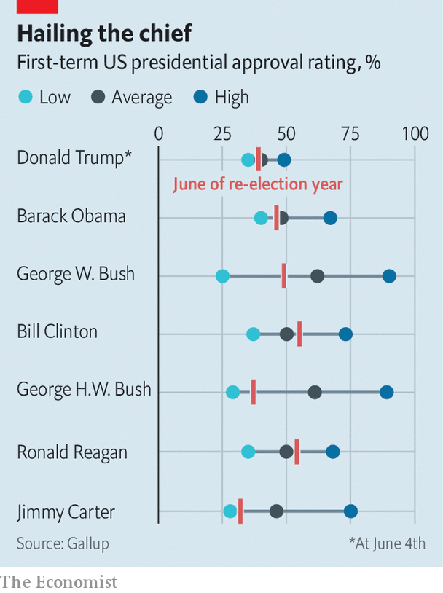

On top of an extraordinary incumbent, extraordinary times. America’s covid-19 epidemic has, so far, cost the country over 120,000 lives. Not yet controlled, it could claim almost that many again by election day. Mr Trump had hoped to run on a booming economy, and had he been able to he might well have won, despite his lack of broad support. Instead, he will run in a country ravaged by a misfortune he has done too little to deal with and blighted by unemployment and bankruptcy. Social distancing’s constraints have created a campaign unlike any other. An unprecedented number of Americans will vote by mail, a development that has already seen Mr Trump whipping up false fears of fraud.

All re-election bids are to a large extent referendums on the incumbent; this one is little else. Looking like a plausible president, the support of the party and not being Mr Trump seem to be more or less all that is required of Mr Biden, and the polls show that his familiar, unchallenging avuncularity is meeting the challenge well: a comforting figure for an uncomfortable time. On average he enjoys a polling advantage of about 9%, comfortably above that seen by Hillary Clinton in 2016. He holds solid leads in the “Blue Wall” states—Michigan, Pennsylvania, Wisconsin—that Mrs Clinton lost and stands a fighting chance in solidly Republican states such as Arizona, Georgia and Texas. The Economist’s election forecast, which combines polling data with economic and other fundamentals, currently puts Mr Trump’s chance of holding on to the White House at just one in ten.

## This house has got the best of us

Mr Trump will try to fight his way out of this with personal smears against Mr Biden. It was for extorting favours aimed at helping him paint Mr Biden as a nepotist corrupting foreign policy for the benefit of his son, Hunter, that Mr Trump was impeached. But Mr Biden looks likely to prove a tougher target for such tactics than Mrs Clinton was in 2016, largely because people like him.

It is not just that Americans by and large see him as approachable and good-hearted. They also know his life’s sorrows. Mr Biden’s first wife, Neilia, died in a car crash with their one-year-old daughter, Naomi, shortly after that first victory in 1972. His son Beau, who gave a moving speech about that loss when Mr Biden was nominated to be Barack Obama’s running mate in 2008, died of cancer in 2015. The tempering of grief has given Mr Biden deep reserves of empathy.

He will also be attacked on policy. Mr Biden has always sat close to his party’s ideological centre. At points in his career he has been lukewarm on abortion rights and federally enforced school integration, an advocate of harsh criminal penalties and a proponent of financial deregulation. But as the party’s centre has moved to the left, so has he. Perhaps Mr Biden has shifted with the political winds; perhaps he has a commendable willingness to rethink outdated positions. Either way, he has become something a bit akin to a radical, a seemingly centrist grand-dad running on as bold a Democratic policy platform as has been seen in generations. It looks set to include a public option on health care and an ambitious effort to fight climate change which will include a carbon tax.

Many on the party’s progressive wing give him little credit for this. In the primaries, they wanted to abolish private health insurance; today, many want to defund police departments. Some warn, or threaten, that if he fails to take a turn to the left on such causes he risks losing the election. Aimee Allison, who heads She the People, an organising and advocacy group for women of colour, urges Mr Biden to “meet the moment [and] turn protesters into voters. If he doesn’t...he’s not going to be able to close this fatal enthusiasm gap he has now.”

There are two problems with this. One is that the Democrats’ greatest recent success, winning back the House in 2018, was brought about not by progressives who retained safely Democratic seats but by centrists taking seats previously held by Republicans. The voters they won over then are the sort of people Mr Biden needs now. The second is that it would be inauthentic. Mr Biden’s persona is that of a moderate: a decent, reassuring figure running, as he often says, to “restore America’s soul”, and offering, as a surrogate put it, “a return to civility.” That is the Joe Biden for whom a majority of Americans twice voted when he was on the same ticket as Mr Obama.

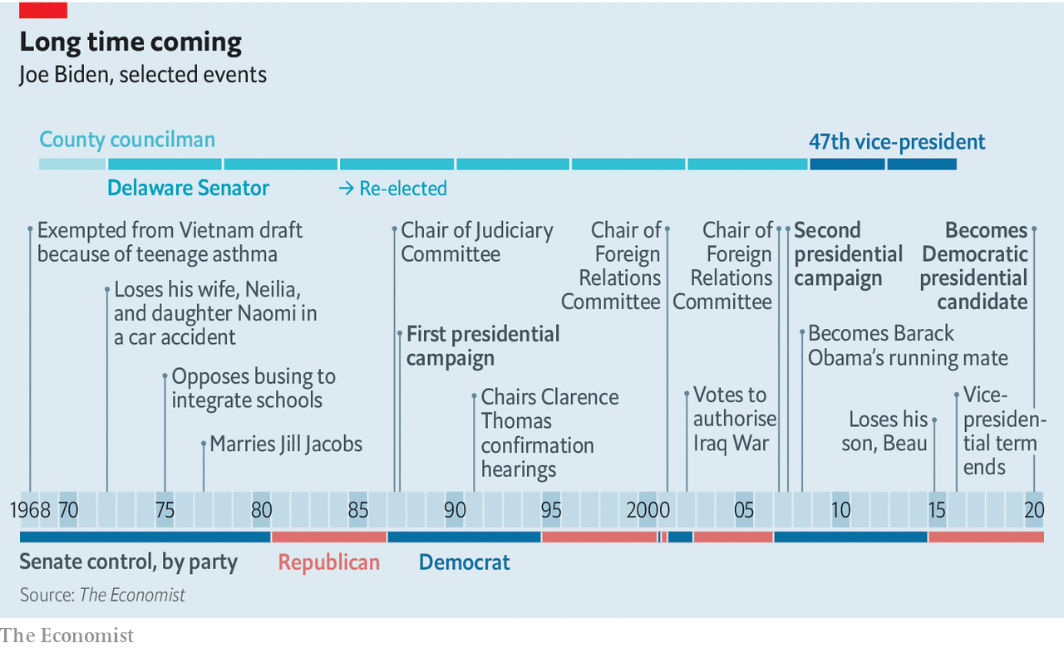

Vice-presidents have every chance of getting their party’s nomination if they want it. But in 2015, wracked by grief over Beau’s death, Mr Biden decided that he didn’t. He left public office, seemingly for good. Family and close advisers say it was Mr Trump’s coddling of white supremacists who marched on Charlottesville, Virginia, in 2017 which prompted him to rejoin the political fray. He campaigned for dozens of Democrats in the midterms; in March last year he announced his candidacy (accidentally, at a dinner in Delaware: distilled essence of Joe Biden).

It was his third such campaign. In his first, in 1987, he quit early after the media piled on to questions of plagiarism. Two decades later he dropped out after coming fifth in the Iowa caucuses. This time, with the vice-presidency on his resume, he led in the polls more or less throughout. He won none of the campaign’s first three contests. But no one else in the race managed to convince the party that they, rather than Mr Biden, were the candidate best placed to defeat Senator Bernie Sanders, widely seen as unelectably far to the left.

After Mr Biden won the South Carolina primary handsomely, two other centrist candidates, Amy Klobuchar, a senator from Minnesota, and Pete Buttigieg, then mayor of South Bend, Indiana, quickly dropped out of the race and endorsed him. That allowed Mr Biden to establish an overwhelming lead over Mr Sanders on Super Tuesday.

## A lot of people leaving town now

When Mr Sanders dropped out a month later Mr Biden had another chance to display his disposition towards bringing people together. The two senators created six task-forces to advise Mr Biden on policy all of which include supporters of both men—a way of avoiding a recurrence of the rancour that defined the 2016 primary, when Mr Sanders’s supporters felt the establishment had played dirty pool on Mrs Clinton’s behalf.

The policies that these groups come up with will not necessarily be those that Mr Biden runs on; he already has a substantial policy agenda, and it is coming to the fore. When the election’s sole defining issue was Mr Trump, it was plausible for Mr Biden to focus his run on normalcy in high office. Now the country is suffering through covid-19 and has seen a remarkable spate of protest his campaign has dialled back on talk of restoration, emphasising instead Mr Biden’s policies for meeting the moment.

Much of it is routine stuff for Democrats in 2020: a higher minimum wage, protection for unions, reform of bankruptcy and campaign-finance laws and so on. Two things stand out for their ambition. The first is health care. Republicans are once again pushing to end Mr Obama’s Affordable Care Act (ACA) without offering a replacement. The Democratic left wants it replaced with Medicare for All. Mr Biden plans instead to build on the ACA by letting people buy into a government-run plan—the “public option” deemed too radical just a decade ago. He also wants to lower the Medicare eligibility age from 65 to 60. The two steps could transform American health care: the public option could become big enough and therefore cheap enough that employers and employees prefer it to private insurance.

Similarly, Mr Biden has proposed climate-change plans that go well beyond Mr Obama’s achievements, calling for a net-zero-emissions economy by 2050 and an entirely electric car fleet. But he has not quite embraced the Green New Deal beloved of the left and has kept some centrist options open. He has not renounced the use of either nuclear energy or fracking (which could imperil his chances in otherwise-winnable-looking fracking states such as Pennsylvania and Ohio and just-about-in-play Texas). He is willing to explore technologies that capture carbon from fossil-fuel plants before it gets to the atmosphere, which makes many greens uncomfortable. Though the campaign calls the means by which he will seek to make polluters pay an “enforcement mechanism”, it seems clearly to be a carbon tax, and a more broadly based one than the cap-and-trade scheme which failed to get through the Senate under Mr Obama.

To make such changes the Democrats will need the Senate as well as the presidency and the House. That requires them to win three or more of the 23 Republican-held Senate seats being contested. A few months ago that looked like a long shot. Today’s polls make it look more plausible: but if the odds are better than 50:50, they are not so by much. This is another reason not to expect Mr Biden to make the big rhetorical or policy moves that the progressive wing says would excite the base. Flipping states with Republican senators is an inherently centrist undertaking.

Simply winning the Senate, though, is not enough. It might allow Mr Biden to fulfil his promise to restore the top marginal income-tax rate to 39.6% on those making over $400,000 and partially to reverse Mr Trump’s corporate-tax cuts, raising the rate from 21% to 28%: such measures can be passed as part of a “reconciliation bill” which requires only a simple majority. But almost all other business in the Senate is hostage to filibustering, which can only be overcome with 60 votes. Even were Mr Biden to achieve a landslide—and he has as good a chance of doing so as Mr Trump has of scraping a narrow win, according to our model—his coat-tails will be nowhere near long enough to bring 13 new Democratic senators with him.

Mr Biden, with the sort of respect for Senate procedure that comes from spending almost half your life within its precincts, says that he does not want to end the filibuster. He has also said he expects a Republican “epiphany” when Mr Trump leaves office, one that might make possible new bipartisan approaches to the nation’s problems. But Chuck Schumer, who would become majority leader were the Democrats to take the Senate, does not rule out getting rid of the filibuster. Some suggest that the mere threat of doing so might be enough to bring some Republicans round to the climate and health-care aspects of Mr Biden’s legislative agenda, epiphany or no epiphany.

Not all change needs legislation. Mr Biden could roll back the Trump administration’s own rollbacks of regulations on environmental protection and other things, putting back in force the rules that have been dropped, enforcing those that have been ignored. He could reverse the Trump administration’s immigration policies through executive action. He could also change the tone and manner of the presidency—though not necessarily that of the national conversation. Barracking from a defeated Mr Trump and his supporters would surely be raucous.

Foreign policy, where presidents have the greatest room for manoeuvre, would provide Mr Biden with his comfort zone. Decades as a member of the Senate’s foreign-relations committee and then as vice-president mean that he knows the game and many of the players. Neither the tactics of the opposing teams nor the state of the pitch, though, are as he left them. China is a far more assertive power; Russia has been able to interfere in American elections with minimal retribution. And the pandemic spreads on.

## Won’t you just say goodbye?

Mr Biden believes the world’s democracies want America to reassert itself in the role, abandoned by Mr Trump, of their leader and protector. He is unlikely to prove it so through force of arms, any more than Mr Obama chose to. But simply playing the part should prove a first step.

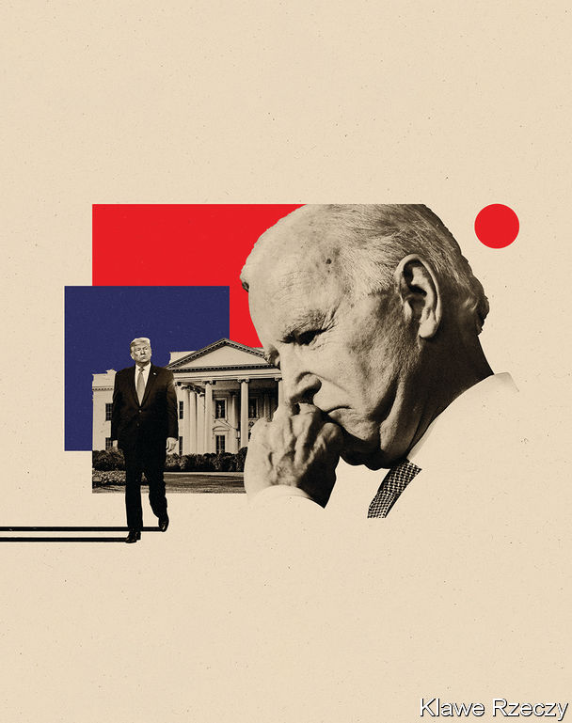

Mr Biden’s commitment to arms control is one of the through notes of his career. As president he would seek to pursue that interest in talks with Russia and Iran. He would rejoin the Paris agreement on climate change and hope thereby, and through the ambition of his domestic plans, to reinvigorate it. He has also promised to host “a global Summit for Democracy”, centred on fighting corruption and authoritarianism, and advancing human rights. Summitry is easy to mock; but as an opportunity for the relationship-building at which Mr Biden excels, it could bring benefits. Plenty of Asian countries which have resigned themselves to Chinese pressure would be glad to have an American thumb on the other side of the scale again.

Mr Biden has described himself as a “bridge” to the next generation of Democrats. He has been coy as to whether he sees that bridge as four years long or eight. Given that, should he win in November, he would be in his 80s when campaigning for a second term, this coyness cannot be taken as a simple refusal to look overconfident. His vice-presidential choice, due in early August, will thus be an important one—as Mr Obama’s has turned out to be.

Mr Obama, who represented profound change simply by virtue of his race and background, chose in Mr Biden an old-white-guy complement who represented experience and stability. He went on to govern cautiously and to be succeeded by his old-white-guy antithesis, a cruel man bereft of experience and deeply chaotic. Now Mr Biden, who still represents stability, seems by that very fact to represent the change people want. If they act on that desire, he may find himself in a position to govern more ambitiously than his one-time boss. ■

Dig deeper:

* Sign up and listen to Checks and Balance, our [weekly newsletter](https://www.economist.com/checksandbalance/) and [podcast](https://www.economist.com/podcasts/2020/06/26/checks-and-balance-our-weekly-podcast-on-american-politics) on American politics
* Explore our [presidential election forecast](https://projects.economist.com/us-2020-forecast/president)
* The Economist’s [guide to the US 2020 elections](https://www.economist.com/united-states/2020/04/22/the-economists-guide-to-the-us-2020-elections)

This article was downloaded by calibre from <https://www.economist.com/briefing/2020/07/04/joe-biden-has-a-good-chance-of-becoming-a-surprisingly-activist-president>

|  |  |  |  |
| --- | --- | --- | --- |
|  | Articles | Sections | Next |

|  |  |  |
| --- | --- | --- |
| Briefing | Sections | The Americas |

United States

The presidential election: Donald Trump’s uphill battle

.

State flags: Mississippi changes its colours

.

John Roberts: Hail to the chief

.

Capital punishment: Cruel, unusual and costly

.

The Democratic left: Gathering steam

.

Intelligence and the president: Pandering to the bear

.

Lexington: It’s messing with Texas

.

|  |  |  |
| --- | --- | --- |
| Briefing | Sections | The Americas |

|  |  |  |  |
| --- | --- | --- | --- |
|  | Articles | Sections | Next |

#### America’s 2020 election

# Donald Trump faces a much bigger task than he did in 2016

The polls, political fundamentals and key voters have all turned against the president

Jul 2nd 2020 |

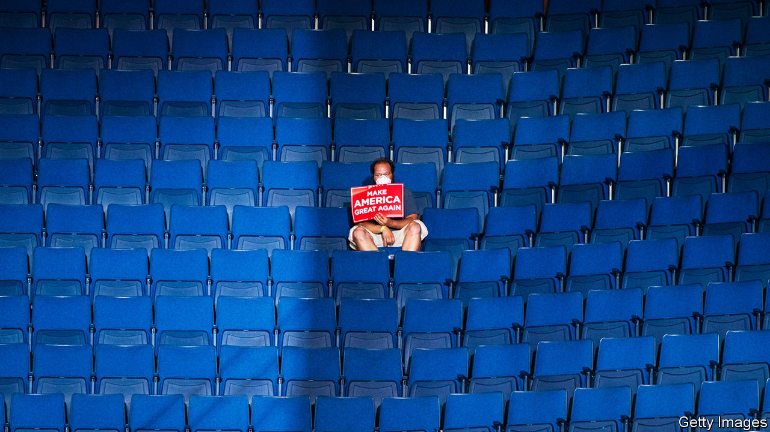

DONALD TRUMP’S path to re-election has never looked more difficult. In early June his deficit in the polls against Joe Biden was “just” six percentage points. That may seem large, but it is close enough for the president to conceivably gain the ground required to win an electoral-college victory, even with a minority of the popular vote. He needs to hold Mr Biden to a two- to three-point margin to do so. But nationwide protests, the growing reality of the country’s economic turmoil and a rapidly spreading rebound of covid-19 cases have pushed him even farther behind.

Today he faces a nine-point uphill climb nationally and is behind by between four and eight points in the bellwether states. The president even acknowledged his dire situation in an interview with Fox News last week, saying “Joe Biden is gonna be your president because some people don’t love me, maybe.” According to The Economist’s election-forecasting model, Mr Trump has a one-in-nine chance of winning a second term—down from a one-in-five shot last month.

The president is struggling for at least three reasons. First, he has always relied on defacing his opponents. In 2016 he succeeded in making Hillary Clinton unacceptable to a slightly bigger share of the electorate than the minority that actually liked him. His job was made easier by her low favourability ratings. According to a poll conducted by YouGov on the eve of the election, Mr Trump was rated favourably by 39% of American adults, compared with Mrs Clinton’s 41%; the shares who viewed them unfavourably were 60% and 57%, respectively. Of course, Mr Trump did not have to convince a majority of all American voters that he was preferable to the former secretary of state: his victory depended on persuading a majority of mostly white voters in the Midwest to opt for him.

Mr Trump’s strategy worked (if losing the popular vote by 3m ballots can be counted as working) last time round, when his opponent was already extremely unpopular. But from the start it looked a dicey bet against Mr Biden, who is far more popular than Mrs Clinton was. According to YouGov’s interviews of 1,500 Americans between June 21st and June 23rd, 43% of adults view the former vice-president favourably and only slightly more (47%) dislike him. Mr Trump’s ratings are much harsher: 42% like him and 53% do not. The president’s handling of the pandemic, in particular, makes it hard to imagine he has much room for improvement here.

Second, Mr Trump is being dragged down by the dramatic movement of older voters, horrified by the now-exploding spread of covid-19, away from him. Overall, Mr Biden’s vote margin has increased by about five points over Mrs Clinton’s final performance in 2016 among people who voted last time round, according to an analysis of YouGov’s data. Voters over 65 have led the charge; their vote margin for Mr Biden is six points better than Mrs Clinton’s was, whereas that of voters under 30 has not budged at all. White voters have also fled Mr Trump’s ranks in much larger numbers than voters of colour. Mr Biden is seven points ahead of Mrs Clinton’s position among whites, while Hispanics have moved six points towards Trump (though they still overwhelmingly oppose him).

Third and most important, the president has lost ground with non-college white voters. This group was Mr Trump’s seawall in 2016; it prevented a tide of national ballots from breaching his electoral-college victory. But this time these voters have moved eight points towards his opponent. In swing states their shift is a more modest six percentage points; but in those close contests, such a change, if it sticks, would imperil Mr Trump. He has also lost ground among Christians—both of the evangelical and mainline varieties.

It is unclear why white voters without a college degree have been the most likely to leave Mr Trump’s camp. Some clues may be found in this year’s Democratic presidential primary elections, in which non-college whites were also the most likely to leave Bernie Sanders’s wing of the party. It is likely that Mr Biden represents a more appealing candidacy to these voters than Mrs Clinton did. Social scientists have found that these voters tend to be more racially conservative and harbour more hostile views about feminism than others do. Mr Biden’s candidacy has focused less on the politics of diversity and empowerment than Mrs Clinton’s before him.

Whatever the reason, Mr Trump has lost most support among his stalwart backers from 2016. That may mean, when it comes down to it, that they are likelier than many now imagine to swing back to him on voting day. Perhaps they will. But according to YouGov’s data, the president’s defectors are more likely than others to have voted in the Democratic primaries this year—a sign that many may have been Democrats who did not like Mrs Clinton. They are also 14 percentage points more likely than other voters to believe that race relations have grown worse during Mr Trump’s tenure, and a whopping 22 points likelier to disapprove of how he has handled the coronavirus. Even worse for Mr Trump, they are 30% more likely than other voters to say their personal finances have deteriorated over the past year.

So on all the issues most important to voters at the moment, these voters rate Mr Trump poorly. Though they could move back to him, at present their defection has pushed Mr Trump to clear underdog status. It has also raised a distinct possibility that he could lose by a landslide.

Mr Trump’s allies have raised the possibility that he could win round enough undecided voters to muster an electoral-college victory again. Such voters are a natural crutch for the campaign: wishy-washy voters who last time held their breath until the “October surprise” from James Comey, the FBI director who announced a resumption of the investigation into Mrs Clinton’s emails, perhaps came to Mr Trump’s rescue. But the president’s campaign faces even more bad news on this front.

## Never tell me the odds

According to YouGov’s polling, this year’s undecided voters are more likely to be young, non-white and college-educated (all factors that correlate with voting for Democrats). Few are conservatives; 64% voted in this year’s Democratic primary elections. Of those with an opinion about the president, 63% disapprove of his time in office, and they are more likely to oppose him on race relations, covid-19 and the economy than they are to support him.

This puts Mr Trump in a serious bind. For each undecided voter he could win to his cause, he would probably cause two others to vote against him. The same is true for non-voters. According to YouGov’s data, voting-eligible Americans who did not cast ballots in 2016 oppose the president by 20 percentage points.

Many political pundits were stunned by Mr Trump’s upset victory in 2016. Mr Comey himself confessed to being so sure of the outcome of the contest that he took unprecedented steps against one candidate (which may have ended up costing her the election). But the statistical model The Economist built to predict presidential elections would not have been so shocked. Run retroactively on the last cycle, it would have given Mr Trump a 27% chance of winning the contest on election day. In July of 2016 it would have given him a 30% shot.

This time our model points with much greater confidence to a defeat for Mr Trump. Today, it gives him just an 11% chance of winning re-election in November. It is not impossible that he could pull it off. Fans of poker will know that closing an inside straight (which happens in 9% of hands) happens frequently enough to take seriously. It should be taken especially seriously when the leadership of the free world is at stake.

But is Mr Trump capable of doing what is needed to win? He would have to take the country’s ever-worsening outbreak of covid-19 seriously, change his tone and actions on racial justice and pursue economic policies that reverse the coronavirus-induced depression (renewed growth would certainly be a boon to his prospects). And then he would have to perform the nearly impossible task of making himself appear more moderate and likeable than his opponent. Mr Biden is routinely achieving 50% support in opinion polls, far higher than Mrs Clinton or Barack Obama managed in 2016 or 2012.

All this puts Mr Trump on a path to a resounding rebuke of his presidency in November. Every day that passes without a course-correction increases the likelihood of his defeat. ■

Dig deeper:

* Sign up and listen to Checks and Balance, our weekly [newsletter](https://www.economist.com/checksandbalance/) and [podcast](https://www.economist.com/podcasts/2020/06/26/checks-and-balance-our-weekly-podcast-on-american-politics) on American politics
* Explore our [presidential election forecast](https://projects.economist.com/us-2020-forecast/president)
* The Economist’s [guide](https://www.economist.com/united-states/2020/04/22/the-economists-guide-to-the-us-2020-elections) to the US 2020 elections

This article was downloaded by calibre from <https://www.economist.com/united-states/2020/07/02/donald-trump-faces-a-much-bigger-task-than-he-did-in-2016>

|  |  |  |  |
| --- | --- | --- | --- |
|  | Articles | Sections | Next |

|  |  |  |  |
| --- | --- | --- | --- |
| Previous | Articles | Sections | Next |

#### Racist symbols

# Mississippi changes its state flag

And removes a Confederate symbol

Jul 4th 2020 |



THE MAGNOLIA STATE this week became the last southern state to change its state flag, removing the Confederate battle flag which had formed part of the design. It will adopt a new flag, incorporating the words “In God We Trust” but excluding the so-called “stainless banner”. The 87-year-old widow of Medgar Evers, a murdered civil-rights icon, called the vote “all but unbelievable to me”.

This article was downloaded by calibre from <https://www.economist.com/united-states/2020/07/04/mississippi-changes-its-state-flag>

|  |  |  |  |
| --- | --- | --- | --- |
| Previous | Articles | Sections | Next |

|  |  |  |  |
| --- | --- | --- | --- |
| Previous | Articles | Sections | Next |

#### Hail to the chief

# Justice John Roberts joins the Supreme Court’s liberal wing in some key rulings

But he is not tilting left

Jul 4th 2020 | NEW YORK

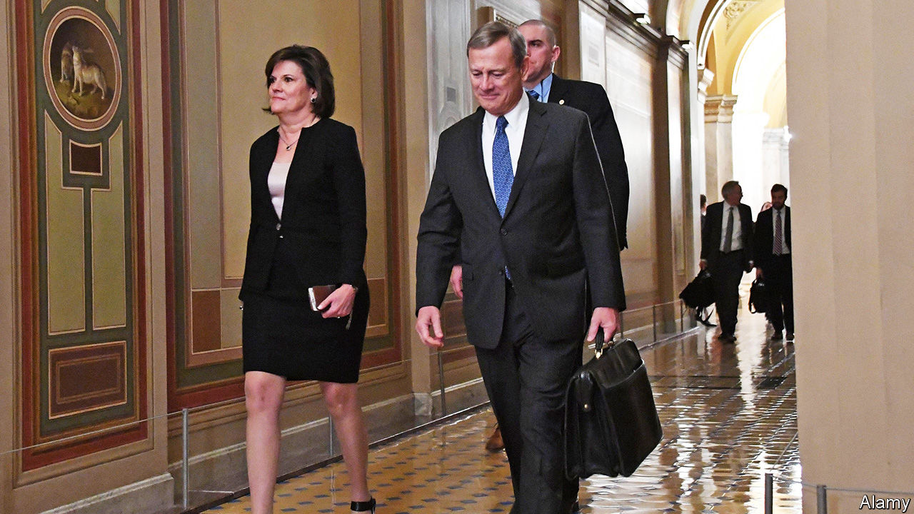

FOR A THIRD time in as many weeks John Roberts, America’s conservative chief justice, has sided with his liberal colleagues in a big case. After his votes on LGBT rights and immigrant protections, on June 29th he was the linchpin in a 5-4 decision striking down a law that would have limited abortion access in Louisiana. This brought cheers from liberals and howls from conservatives. Josh Hawley, a senator from Missouri and Chief Justice Roberts’s former clerk, called June Medical Services v Russo, the abortion decision, a “disaster” and accused his old boss (without naming him) of “perpetuat[ing] bad precedent while barely bothering to explain why.”

The precedent Mr Hawley deplores is Whole Woman’s Health v Hellerstedt, a decision in 2016 rejecting a Texas law that purported to protect women’s health while regulating about half of the state’s abortion clinics out of existence. Chief Justice Roberts is no fan of Whole Woman’s Health, either: he was among the dissenting trio of justices in the 5-3 ruling. This week in June Medical he repeated his disdain for the earlier decision, but explained that stare decisis—Latin for “let the decision stand”—required the court “to treat like cases alike”. Since the Louisiana requirement that abortion providers must secure admitting privileges at a hospital within 30 miles was “nearly identical” to the doomed Texas rule, and imposed a similarly “substantial obstacle” to abortion access, the outcome should be the same. The court must not upend its own judgment a mere four years on.

Yet, with an eye on future cases, the chief justice proceeded to undercut the very precedent he had relied upon to reject Louisiana’s law. Whole Woman’s Health said judges should consider both the benefits and burdens of a regulation. But weighing the two against each other, Chief Justice Roberts wrote, is a job for the legislature, not the courts. If a regulation does not make it exceedingly hard for women to procure abortions it would probably pass constitutional muster, no matter how slight or illusory the benefit. This may be read as an invitation to Republican-run states to cook up restrictive abortion laws as long as they can be pitched as not too burdensome—and are not replicas of a law the court has already rejected.

A more radical opportunity to turn the tide on abortion lurks in the chief justice’s opinion. He emphasises that June Medical is not about Roe v Wade, the ruling in 1973 that protects a woman’s right to abortion. Though Justice Clarence Thomas, in dissent, charged that the court’s abortion jurisprudence “remains in a state of utter entropy” and ought to be thrown out in its entirety, Chief Justice Roberts demurred. “Neither party has asked us to reassess the constitutional validity” of the abortion right itself, he wrote. If plaintiffs come asking—as they are in Georgia and Alabama, where near-blanket abortion bans are working their way through the courts—he might be willing to reconsider Roe.

There are loopholes in the other liberal victories, too. Though Chief Justice Roberts joined the left side of the bench (and Justice Neil Gorsuch) to bar workplace bias against gay and trans people, the majority opinion leaves open whether employers with religious objections to hiring LGBT workers might, in some circumstances, have a licence to discriminate. And in the case halting President Donald Trump’s cancellation of DACA (Deferred Action for Childhood Arrivals), the chief justice noted that the merits of ending Barack Obama’s programme were not the question. Mr Trump could still kill DACA if he would only follow basic standards of administrative law. The chief justice sent the president the same message a year ago when he refused to bless the administration’s flubbed quest to add a citizenship question to the 2020 census, but hinted it could try again.

Two other decisions penned by Chief Justice Roberts this week also came out 5-4—but with the liberals in their more familiar position as dissenters. The first of these was Seila Law v Consumer Financial Protection Bureau (CFPB), a challenge to the design of a federal agency set up after the recession of 2007-09. The majority did not break up the CFPB but, dampening its independence, gave the president the power to fire its director whenever he pleases. Then, on June 30th, the chief justice anchored Espinoza v Montana Department of Revenue, requiring any state that funds secular private schools to fund religious schools, too. Both rulings, cloaked as inevitable outgrowths of earlier cases, were in fact profound shifts in the law.

Acting boldly through superficially small steps—and getting credit for aisle-crossing while giving liberals at best temporary solace—seems to be panning out well for Chief Justice Roberts. He is cultivating a reputation for non-partisanship at the Supreme Court while advancing primarily conservative goals. And he’s winning: of the 53 cases decided so far this term, he has been in the majority in 52. ■

This article was downloaded by calibre from <https://www.economist.com/united-states/2020/07/04/justice-john-roberts-joins-the-supreme-courts-liberal-wing-in-some-key-rulings>

|  |  |  |  |
| --- | --- | --- | --- |
| Previous | Articles | Sections | Next |

|  |  |  |  |
| --- | --- | --- | --- |
| Previous | Articles | Sections | Next |

#### Cruel, unusual, and costly

# American conservatives are pushing for the repeal of the death penalty

The federal government’s enthusiasm for executions is at odds with many Republican-led states

Jul 4th 2020 | CHICAGO

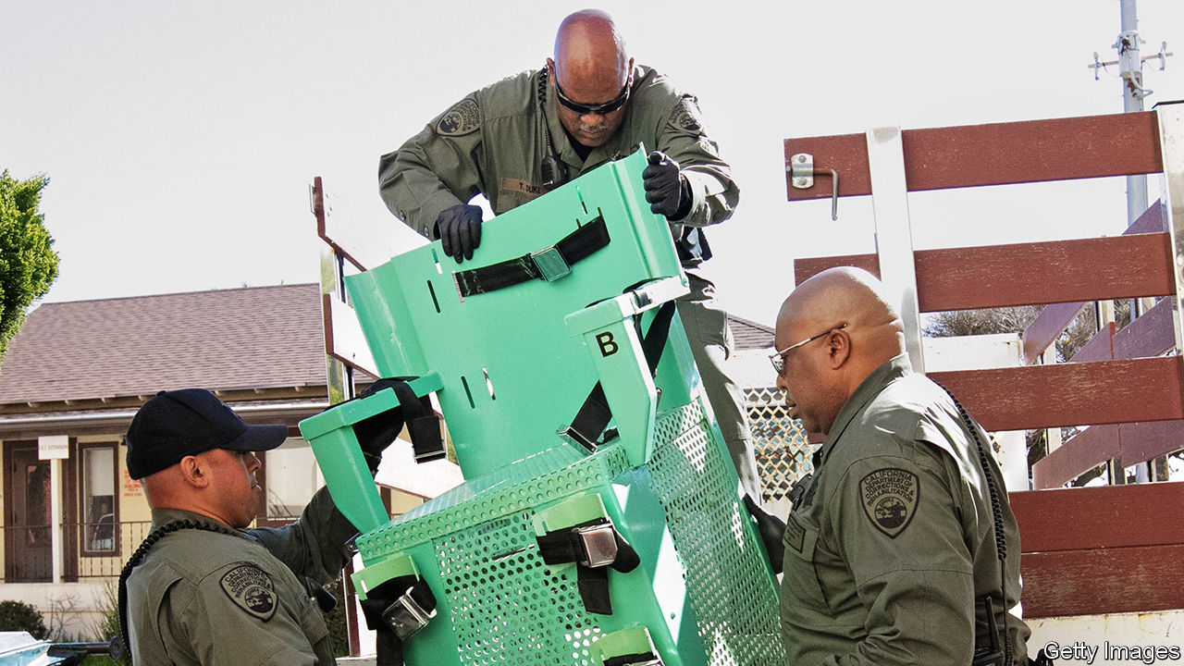

PENTOBARBITAL IS due to be injected into Daniel Lee, a white supremacist convicted of a triple murder, on the morning of July 13th. The drug, administered at a federal prison in Indiana, is supposed first to make him unconscious, then stop his heart or prevent breathing. This week the Supreme Court declined to take up a case that might have stopped his death. Instead, barring late legal challenges, his will be the first execution carried out under federal authority in 17 years. It comes a year after William Barr, the attorney-general, ordered them to resume. Three more, all of murderers, are set for the summer.

What will the federal executions achieve? Donald Trump has long yearned for more use of capital punishment. Late in June the president told an interviewer he is “totally in favour of the death penalty”. On Twitter he calls himself a “law and order” leader. His base of supporters should cheer. Among older Republicans a big majority long shared his views: a Pew survey from two years ago found that 81% of 50-64 year-olds supported its use, as did 78% who were 65 or older.

Look more widely, though, and attitudes are turning against the idea of the state killing its prisoners. Younger respondents and independents are less keen on it. Few believe it is an effective deterrent. A poll by Gallup, in late June, found that only 54% of all Americans see its use as moral, the lowest level in two decades since Gallup started asking, and down from 60% last year. Pollsters say a majority of Americans oppose its use once they are reminded of other punishments, such as life in prison without any chance of parole.

Could conservatives, who remain its staunchest supporters, even turn against the death penalty? Hannah Cox, of a national movement founded in 2013 to achieve that, calls Mr Trump’s administration “really remiss” and “out of step with grassroots” on the topic. Her outfit seeks repeal by states and has set up 15 chapters nationally. No longer is it taboo for conservatives to suggest the death penalty should be scrapped: “There’s been a significant shift in culture, attitude,” she says. Whereas a decade ago it was nearly impossible to get state Republicans to back repeal, in the past two years Ms Cox counts ten such bills sponsored by them.

Partly as a result, states increasingly shun its use. Last year only seven of them, mostly in the South, killed a total of 22 prisoners. Just 33 new death sentences were handed down, one of the lowest tallies ever. Last year Republican and Democratic legislators combined in New Hampshire to override their governor’s veto, abolishing the death penalty there. In March Colorado’s governor signed legislation making it the 22nd state to end it. Utah, Nebraska, Wyoming and others have come close. California last year called a moratorium. Many others keep the option, but have not applied it for a decade or more.

Jack Tate, a state senator in Colorado, says his fellow Republicans came to see “a common-sense case, this policy ain’t working”. One strand in the party, he says, are pro-lifers, especially Catholics (their church now opposes its use), who find it inconsistent to favour the death penalty but oppose abortion. Others, especially younger colleagues, warm to a libertarian view, doubting “whether the state should have the power of life and death”, especially when executions don’t provide any “healing” for victims’ families and when, too often, legal mistakes are made.

In overwhelmingly Republican Wyoming a representative, Jared Olsen, last year got a repeal bill passed by the House; it failed only narrowly in the Senate. He argued that capital punishment has become too costly and unequal. Hordes of Republicans lined up to sponsor a new version of his bill, suggesting it will fare well when reintroduced next year. Only wealthy counties pursue capital cases, he points out, because they typically require $1m or more to prosecute. (Just 2% of American counties have been responsible for more than half of all executions since 1976.)

Even in the past couple of months, believes Mr Olsen, opposition to the death penalty has grown. Awareness has spread of its unacceptable “racial application”, because African-Americans nationally are the likeliest to be sentenced and put to death. Recent Black Lives Matter protests have prompted understanding of “huge flaws in the justice system”, he says. As a result, he doubts the summer resumption of federal executions will be popular.

Views on the death penalty may thus be shifting, just as public attitudes swung towards gay marriage and legalisation of marijuana. In Ohio, for example, Republicans look likely to get round to supporting repeal—significant in a state with 141 prisoners on death row. The state’s governor, Mike De Wine, who is Catholic, has already made clear he will not approve any executions. He has hinted that he wants the state house to bring a repeal bill. Mike Hartley, a Republican strategist, calls the moment ripe for change.

Mr Hartley predicts that a test repeal bill will get to Ohio’s state legislature late this year, with the goal of building momentum for a big push next year. A recent convert to the cause himself, he points to growing conservative “distrust in institutions” to explain the shift, along with a better general grasp of racial inequities and, especially, of the gruesome details of how prisoners are killed: “People just realise it’s inhumane as shit.”■

This article was downloaded by calibre from <https://www.economist.com/united-states/2020/07/04/american-conservatives-are-pushing-for-the-repeal-of-the-death-penalty>

|  |  |  |  |
| --- | --- | --- | --- |
| Previous | Articles | Sections | Next |

|  |  |  |  |
| --- | --- | --- | --- |
| Previous | Articles | Sections | Next |

#### Left ahead

# The progressive left celebrates some notable Democratic primary victories

This will not change the make-up of Congress. But it could make Nancy Pelosi’s job a lot harder

Jul 4th 2020 | NEW YORK

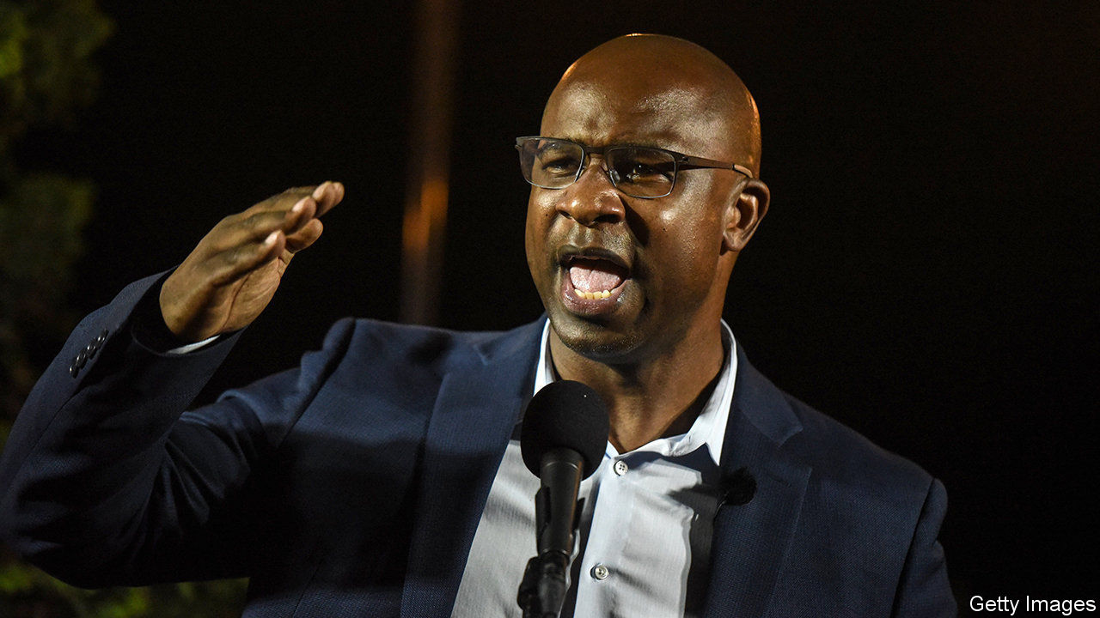

“I AM A BLACK MAN in America,” said Jamaal Bowman, a former headmaster, during his victory speech on June 23rd. “At a very young age as a black man in America, you get to learn about death and homicide.” He had just claimed a primary victory over Eliot Engel, who has represented New York’s 16th congressional district for three decades and, as chair of the House Foreign Affairs Committee, is one of the most senior figures in the Democratic Party. Mr Bowman called his upstart success a defeat for a system that “is literally killing us”.

It is also part of a wider shift. In the wake of the coronavirus epidemic and racial-justice protests, self-proclaimed progressives (many of them African-American) are ousting moderate incumbents all over America. “A new generation of leaders is transforming the Democratic Party,” claims Waleed Shahid of Justice Democrats, one of several leftist groups pushing policies such as Medicare for all, a green New Deal and free public universities. The result may not affect the balance of the next Congress, but it could bedevil the job of managing a likely Democratic majority.

Mr Bowman’s message resonated in one of New York’s poorer districts, which is 60% black or Hispanic. A similar message resonated in the nearby 17th district, where Mondaire Jones, a former prosecutor, is leading a crowded primary race. Assuming Mr Jones wins the general election in November, he would become the first gay black congressman. In the 15th district a third left-winger, Ritchie Torres, could become the first gay black Latino in Congress.

Surprisingly, such campaigns are succeeding beyond traditionally liberal New York. Leftists have unseated figures backed by the official Democratic Congressional Campaign Committee in Illinois’s third district, Virginia’s fifth and New Mexico’s third, where a celebrated former CIA agent, Valerie Plame, went down to defeat. Concerns about criminal justice have resulted in a slew of radicals running for posts such as district attorney or sheriff. All these, says Yvette Simpson of Democracy for America, another campaigning group, “are new sorts of candidate, people who never thought they had the right to anything.”

Progressives did not win everywhere, of course. But they showed how far they have come even where they lost. In the contest to become the Democrats’ Senate candidate in Kentucky, a 34-year-old state congressman, Charles Booker, came within a whisker of defeating Amy McGrath, even though she had official party backing, a vast financial advantage and seemed, as a white Marine pilot and fiscal conservative, a better fit for a deeply Republican state than an African-American progressive who supports reparations for slavery. “There’s no question in my mind that Democratic primary voters want to vote for black candidates more than they did several months ago,” says David Wasserman of the non-partisan Cook Political Report.

Upstart organisations matter as much as upstart candidates. Two groups connected with Vermont politicians provide campaign advice and endorsements: Democracy for America, set up by Howard Dean in 2004, and Justice Democrats, founded by staffers from Bernie Sanders’s campaign in 2016. A group called Real Justice focuses on “down-ballot” races, such as for district attorneys. And Colour of Change and Black Lives Matter Global Network provide issue advocacy, grassroots organisation and voter mobilisation.

These organisations, many only a few years old, are rolling in cash and volunteers. Membership in Colour of Change rose from 1.4m to 7m in a few months. “Unprecedented,” says its head, Rashad Robinson. ActBlue, an online platform enabling donors to give money to Democratic causes, raised $40m in 24 hours in early June. Mr Shahid argues that new fundraising and campaigning technology is doing what new tech always does: enables upstart organisations to compete with established groups such as the Democratic Party.

The splurge of cash and volunteers could be a fleeting product of the George Floyd protests. But left-wing groups are benefiting from longer-term trends, too. “Millennials are historically liberal,” says Sean McElwee of Data for Progress, a think-tank; 54% identify with or lean towards Democrats, only 38% do the same for Republicans—compared with 50% and 42% for all registered voters. Public opinion seems to be changing, too. In a recent poll by Monmouth University, 57% of voters said the police are more likely to use excessive force against African-Americans than whites; in 2014, the share was only 33%.

Most of the seats being contested are solidly Democratic, so the make-up of the House may not be affected by progressives’ success. But, as Karlyn Bowman, of the American Enterprise Institute, a think-tank, says, “it may have a big impact on Nancy Pelosi [the speaker] and the management of House Democrats.” “The Squad”—four left-wing Democrats elected in 2018—have proved a small thorn in her side. If more join them, then a strengthened left-wing caucus might be able to force its ideas—defunding the police, say—onto a reluctant leadership. ■

Dig deeper:

* Sign up and listen to Checks and Balance, our [weekly newsletter](https://www.economist.com/checksandbalance/) and [podcast](https://www.economist.com/podcasts/2020/06/26/checks-and-balance-our-weekly-podcast-on-american-politics) on American politics
* Explore our [presidential election forecast](https://projects.economist.com/us-2020-forecast/president)
* The Economist’s [guide to the US 2020 elections](https://www.economist.com/united-states/2020/04/22/the-economists-guide-to-the-us-2020-elections)

This article was downloaded by calibre from <https://www.economist.com/united-states/2020/07/04/the-progressive-left-celebrates-some-notable-democratic-primary-victories>

|  |  |  |  |
| --- | --- | --- | --- |
| Previous | Articles | Sections | Next |

|  |  |  |  |
| --- | --- | --- | --- |
| Previous | Articles | Sections | Next |

#### Pandering to the bear

# Russia allegedly offered bounties for killing American soldiers

The president doesn’t believe it

Jul 4th 2020 |

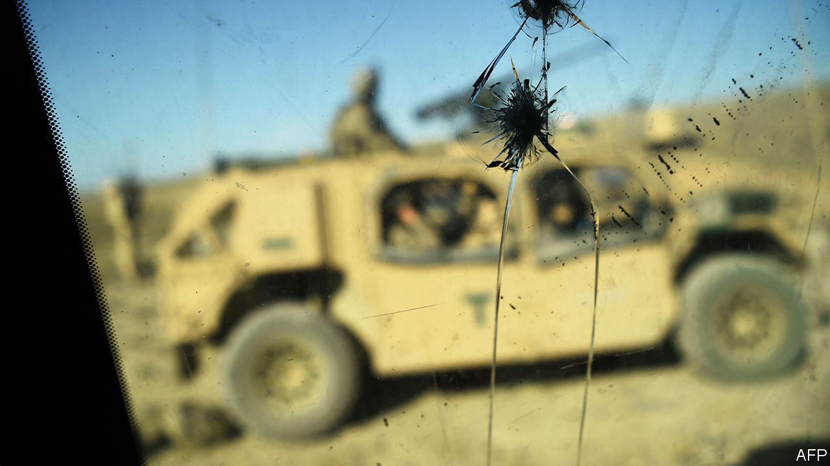

DONALD TRUMP’S blind spot for Russian aggression might seem like a stale fact of American political life by now—were it not that the aggression keeps getting worse. The latest example, according to an intelligence leak to the New York Times, which has since been widely corroborated, was a Russian scheme to pay bounties to Islamic militants in Afghanistan in return for killing American soldiers. A possible attempt to derail the peace deal signed between America and the Taliban in January, the scheme may have been behind the killing of three US marines last year.

Evidence of it is reported to include testimonies from captured militants and half a million dollars retrieved by Afghan agents. There are reported to have been initial doubts about the intelligence’s reliability. But it was nonetheless thought solid enough to be included in Mr Trump’s daily intelligence briefing dossier in late February. It was discussed in an inter-agency meeting at the National Security Council in March. Possible American reprisals for the alleged plot are said to have been drawn up—ranging from raising the issue with Russia to slapping sanctions on it. Yet the matter appears to have ended there.

Mr Trump claims to have known nothing about any of this, his gatekeepers having ruled the intelligence too flaky to be worth his time. His spokeswoman, Kayleigh McEnany, did not deny that it had been included in his daily brief. (Having thus implied the well-established fact that Mr Trump does not read his intelligence briefings, she uttered the memorable defence: “The president does read.”) Mr Trump subsequently upped the ante, calling the alleged bounty plot “just another HOAX”. However by then members of Congress from both parties had been briefed on the evidence and ruled it worrying enough to warrant further investigation. As The Economist went to press, the Gang of Eight—which includes the congressional leaders of both parties and their foremost representatives on the House and Senate intelligence committees—were awaiting an additional briefing from Gina Haspel, the CIA director.

What explains Mr Trump’s softness on Russia? According to his former national security, John Bolton, the president “repeatedly objected to criticising Russia and pressed us not to be critical of Russia publicly.” Even if Mr Trump had not known about the alleged bounty scheme, the alacrity with which he sought to rubbish it this week is in itself remarkable. There is no good explanation for this weakness. Yet at least two things can be said of it with certainty.

First, it has already made a nonsense of the administration’s decision to place Russia alongside China as a “revisionist power” in its 2017 National Security Strategy. Sceptics warned from the start that elevating the threat of a country with an economy smaller than Canada’s to this degree made no sense. And to be thus aggrandised could only delight, and probably embolden, Russia—as seems to have happened. It has celebrated its “revisionist” status in all manner of needling and worse ways: including assassinations in NATO allies, stepped-up cyber operations, sabre-rattling jet flights off the coast of Alaska. And instead of pushing back hard on this misbehaviour—which his administration unwittingly encouraged—Mr Trump has downplayed and denied it, while meanwhile lobbying for Russia to be readmitted to the G7.

Second, the damage this is doing to US democracy is significant. Half of Americans think their president is a shill for the Kremlin. The other half think Russia isn’t so bad after all. This is an even bigger win for Mr Putin than whatever his killers were up to in Afghanistan.

This article was downloaded by calibre from <https://www.economist.com/united-states/2020/07/04/russia-allegedly-offered-bounties-for-killing-american-soldiers>

|  |  |  |  |
| --- | --- | --- | --- |
| Previous | Articles | Sections | Next |

|  |  |  |  |
| --- | --- | --- | --- |
| Previous | Articles | Sections | Next |

#### Lexington

# It’s messing with Texas

Greg Abbott is battling the coronavirus with one hand and his party’s lunatic fringe with the other

Jul 4th 2020 |

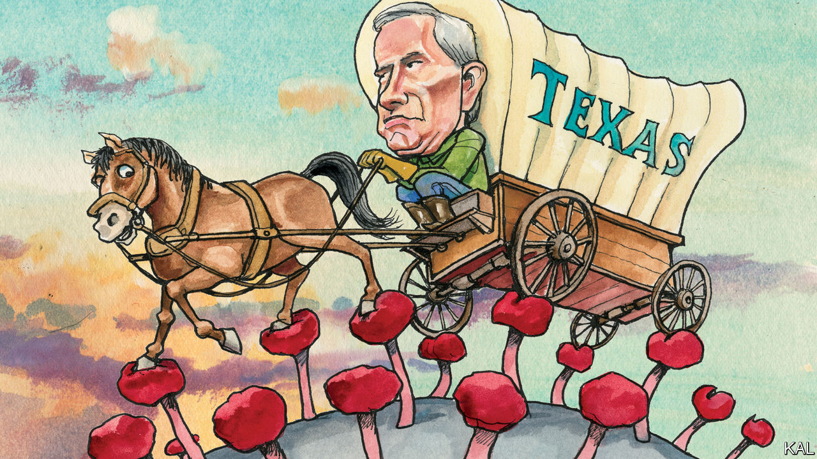

IN THE FIRST months of the coronavirus pandemic, Greg Abbott seemed happy to let Texas’s 254 county and 1,214 city authorities take the lead. The state’s vastness—with its widening contrast between rural reaches and exploding metropolises—argued for local decision-making. And the conservative governor had little to gain by organising an economic lockdown that a minority of Republicans considered tantamount to treason. By late March, however, with Texas still relatively unscathed by the virus, Mr Abbott’s calculation changed. He struck down an effort to make mask-wearing legally enforceable in Houston. He also issued orders—ahead of almost any other governor—to reopen the bars and restaurants that local officials had shuttered. It must have seemed like good politics as well as economics at the time.

Texas is now a centre of the viral wave sweeping the South and West. The state is seeing well over 6,000 new infections a day, five times the number of a month ago. And most are in Houston, where scenes reminiscent of New York in April are unfolding. Last week the biggest hospital network in America’s fourth-biggest city said its intensive-care wards were almost full. Mr Abbott meanwhile ordered bars and other non-essential businesses to close again, forced restaurants to cut their capacity by half and urged Texans to wear masks, as he mostly does. The would-be pioneer of reopening has become the first governor to order a reclosing.

His policy twists have been heavily criticised from both sides of the aisle, with some justification. A cautious politician, whose preference for handing down edicts after slow deliberation reflects his background as a judge, Mr Abbott has shown more calculation than leadership during the crisis. He did not endorse the local officials he deferred to early on, but hid behind them. His move to countermand them reflected a decade-long Republican campaign to centralise power in Austin in order to peg back the Democratic cities. Even so, Mr Abbott deserves to be cut a little slack.

Managing pandemic politics is easiest in states with stable majorities, as Andrew Cuomo of New York and Mike DeWine of Ohio have shown. It is much harder in more divided ones, especially for Republican governors, who cannot get too far out of step with the source of much of the divisiveness, President Donald Trump. And Texas is one of the most politically torn states of all. Its Republican rulers, grown decadent by decades in power, are bitterly feuding even as a tsunami of politico-demographic change rushes towards them. Mr Abbott’s highly politicised management of the pandemic may be about as solid as such pressures allow.

His political balancing act reflects his enigmatic figure. He is much less charismatic than his immediate predecessors, Rick Perry and George W. Bush, and—deep into his second gubernatorial term—less well-known. Having ascended to the governorship via the state Supreme Court bench and attorney-general’s office, he has never faced a tough election. Many Texans have no idea even that he is wheelchair-bound, owing to a freak tree-fall accident he suffered as a teenager—though his courage in battling back from that tragedy is his most admirable quality. Politically, too, Mr Abbott has managed to remain usefully indeterminate.

He took office as a conservative hardliner—boasting of the 31 times he had sued the Obama administration and soon enough echoing Mr Trump’s anti-immigration rhetoric. This earned him credit with a state party that had veered hard to the right. Dan Patrick, leader of the Texan senate and an advocate of American grandparents risking covid-19 infection for the sake of the economy—even unto death—is its most recognisable face. Yet Mr Abbott knows Mr Patrick’s politics is another sort of suicide mission in a state that last had a white majority over a decade ago. The 2018 mid-terms, in which the Democrats flipped 14 seats in the state legislature (and Mr Patrick survived a surprisingly fierce challenge) underlined that reality. Having won his own re-election with ease, Mr Abbott used his increased heft in the party to help launch one of the most quietly impressive Republican rethinks of the Trump era. The state’s next biennial legislative session, held last year, was devoted to property tax and bipartisan education funding, not—as previously—to bathroom bills.

Mr Abbott’s pandemic management has followed a similar pattern. Having covered his right flank, he has ended up in a pretty reasonable place—as indicated by the fact that he is now being criticised most harshly by the crazy right. By permitting local authorities to force companies to use masks, the governor showed “who he is, a traitor to liberty and our constitution,” tweeted a Republican state representative named Jonathan Stickland last week. Someone should tell Mr Stickland how that sort of nonsense is working out for Mr Trump: the president is currently in a tie for Texas with Joe Biden, which raises a possibility of Texas’s state house going Democratic for the first time since 2001.

Mr Abbott’s judiciously disguised pragmatism looks like his party’s best hope of avoiding that fate. It has made him popular in a divided state. His approval rating is 63%, 12 points higher than the president’s. It has also won him the confidence of the conservative donors who may need to spend unprecedented sums in November to shore up the Republican ballot in Texas.

## Headbanging in moderation

His qualified success also offers his party pointers for the post-Trump future that may be looming over it. In a rapidly diversifying society—nationally as well as in Texas—the Republicans will have to expand their appeal to keep winning elections. Yet it may well take a fire-breathing conservative (or ostensibly one, at least) to effect the shift. Who knows? Perhaps Mr Abbott could even be that fire-breather: defeat for Mr Trump would arguably make him the Republicans’ foremost leader. But that feels like a remote possibility at most. For now the governor has a real-life catastrophe to worry about.■

This article was downloaded by calibre from <https://www.economist.com/united-states/2020/07/04/its-messing-with-texas>

|  |  |  |  |
| --- | --- | --- | --- |
| Previous | Articles | Sections | Next |

|  |  |  |
| --- | --- | --- |
| United States | Sections | Asia |

The Americas

Mexican-American relations: The two amigos

.

Colombia: Post-party town

.

Cuba: Neither mulas nor moolah

.

Bello: Ecuador’s anguish

.

|  |  |  |
| --- | --- | --- |
| United States | Sections | Asia |

|  |  |  |  |
| --- | --- | --- | --- |
|  | Articles | Sections | Next |

#### The two amigos

# AMLO and Trump plan a frenemies’ get-together

The American president has gained more than the Mexican leader from their relationship

Jul 4th 2020 | MEXICO CITY

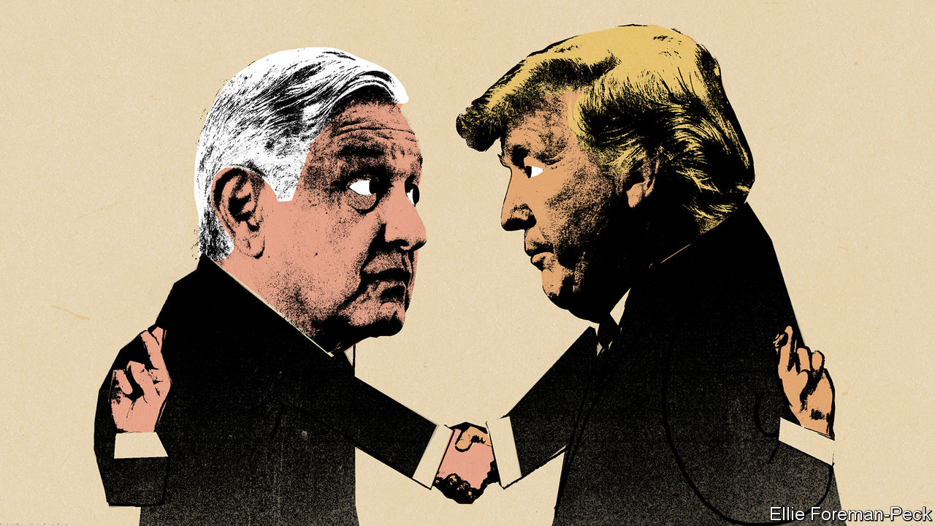

HISTORY WILL record the Mexican-American summit to take place on July 8th-9th as one of the odder ones. It will be a rare face-to-face meeting in the covid-19 era, bringing together leaders who are notably reluctant to promote social distancing. (Their countries have bigger caseloads as a result.) President Donald Trump has often bullied Mexico since he announced his candidacy in 2015. Nonetheless, Andrés Manuel López Obrador, who is often called AMLO, has chosen to make the White House his first foreign destination since taking office 19 months ago. The pretext is to celebrate the entry into force on July 1st of the United States-Mexico-Canada Agreement (USMCA), a slightly altered version of a free-trade pact that Mr Trump said he hated. Yet it is not clear that Justin Trudeau, Canada’s prime minister, will join the festivities.

A meeting of Mexican and American presidents normally boosts a relationship that is vital for both countries, especially in the areas of trade, immigration and crime. The Trump-AMLO encounter is unlikely to achieve that. It is not clear what AMLO will gain from the summit except frequent-flyer miles (he flies commercial, and will have to change planes en route to Washington).

Mr Trump’s main goal will probably be to distract attention from the pandemic and the recession that have clobbered his chances of re-election in November. The meeting will provide an occasion to boast that he has got much of what he wanted from his Mexican guest. Even though the pandemic caused bilateral trade to drop by half between May 2019 and the same month this year, he will no doubt call the USMCA a huge win (as will AMLO). The United States International Trade Commission forecast that the USMCA would raise American GDP by a scant 0.35%.

AMLO has gratified Mr Trump by deploying troops on Mexico’s southern border to block migrants from Central America and by co-operating with his “remain-in-Mexico” policy, which obliges asylum-seekers to wait for hearings on the southern side of the United States’ border. In May the United States apprehended 23,000 migrants on the border, a sixth of the level the year before. (The pandemic no doubt played a part in the decline.) At the Trump administration’s bidding, AMLO reopened foreign-owned factories that had been shut down during the pandemic.

The administration helped arrange the sale of 211 ventilators to Mexico. Otherwise, there has been little reciprocity. The USMCA is better than no trade deal from Mexico’s point of view, but it is unlikely to provide the certainty needed to buoy up its sinking economy. The United States is threatening to reimpose tariffs on Canadian aluminium to stop a surge in imports. There will be tension between the Trump and AMLO administrations over enforcement of labour standards set out in the new treaty. Democrats, though at odds with the Trump administration on almost everything, generally sympathise with its tough line on trade. An agreement in October between the two presidents to curb the flow into Mexico of illegal weapons from the United States has so far had little effect.

Though AMLO is a fervent nationalist, his foreign-policy priority has been to shield Mexico from Mr Trump’s animus. The summit will showcase his success. The two leaders are ideological foes but in some ways kindred spirits: populists whose strengths are in the realm of symbols rather than the substance of government.

But AMLO’s friendship with Mr Trump may come at the expense of his relations with Joe Biden, who now looks likely to win the presidency in November. Democrats are thought to be dismayed by AMLO’s subservience to Mr Trump. When Mr Biden visited Mexico as vice-president in 2012 he met all three candidates in Mexico’s presidential election, including AMLO. The Mexican president does not plan to return the favour on his trip. His advisers say that would risk politicising the summit. Some members of Mr Biden’s team think AMLO is trying to help Mr Trump get re-elected. If Mr Biden wins, Mexico’s president may have some fence-mending to do. ■

This article was downloaded by calibre from <https://www.economist.com/the-americas/2020/07/04/amlo-and-trump-plan-a-frenemies-get-together>

|  |  |  |  |
| --- | --- | --- | --- |
|  | Articles | Sections | Next |

|  |  |  |  |
| --- | --- | --- | --- |
| Previous | Articles | Sections | Next |

#### Post-party town

# Covid-19 gives Cartagena a chance to restrain tourism

A jewel on Colombia’s Caribbean coast wants a better class of visitor

Jul 4th 2020 | BOGOTÁ

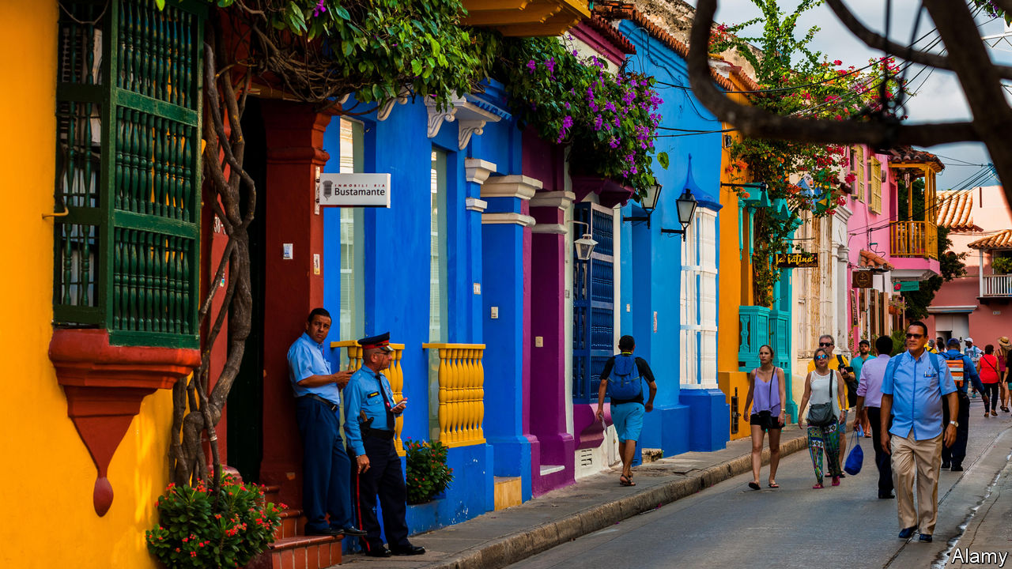

Editor’s note: Some of our covid-19 coverage is free for readers of The Economist Today, our daily [newsletter](https://my.economist.com/user#newsletter). For more stories and our pandemic tracker, see our [hub](https://www.economist.com/news/2020/03/11/the-economists-coverage-of-the-coronavirus)

FOR DECADES Colombia had trouble attracting tourists. Few wanted to visit a country where drug lords bombed passenger jets and guerrillas kidnapped ordinary citizens. The country became safer after the government began peace talks with the FARC, the largest guerrilla group, in 2012 (the war formally ended in 2016). When the shooting stopped, the first destination for many tourists was Cartagena.

Once the Spanish empire’s most important port in northern South America, Cartagena has kept its colonial centre and the limestone walls and forts that shielded the city from pirates. Recently the city has marketed itself too well. In 2019 more than 500,000 foreign tourists came, triple the number in 2012. Domestic visitors outnumber them. A study commissioned by UNESCO, which added Cartagena’s centre to its list of world heritage sites in 1984, warns that “the intensive use of tourism” threatens its preservation. In the covid-19 pandemic, Cartagena’s government sees a chance to ward off the danger.

Too much tourism strains the sewage system, which overflows during rains. Restaurant tables and chairs have conquered the plazas and bars and occupy some of the bastions that jut out from seaside walls. Rooftop bars and home-grown cocaine attract party animals from Europe and the United States. Pimps operating from nightclubs offer them under-age prostitutes. Music blasts until dawn. Martín González, who lives between two nightclubs, says his 76-year-old mother rarely gets a good night’s sleep. He often wakes up to find his terrace strewn with rubbish, including little bags of cocaine, tossed out of the nightclubs’ windows.

Much of the tourism industry operates illegally. The Foundation for The Historic Centre of Cartagena, a pressure group, has reported that more than half of nightclubs have no fire-safety certificate and a third did not pay property taxes in 2019. Some serve alcohol without licences. Some claim to be non-profit organisations. All of Cartagena’s elected mayors from 2013 to 2018 were investigated for corruption.

Just 4,200 people now live in the city centre, a third the number of residents in colonial times. “Cartagena has become this machine that excludes those who cannot afford to pay for a mediocre overpriced drink,” says Eduardo Rojas, a lecturer on heritage preservation at the University of Pennsylvania. But it is also a machine for employment. Tourism makes up a third of the city’s economy. More than half of cartageneros depend on the income it brings.

Covid-19 restrictions have wiped out those earnings. Tables have disappeared from public spaces. Owners of nightclubs and bars, once a powerful lobby, are going bust. Hostels are shutting down.

William Dau, who was elected mayor in October on an anti-corruption platform and took office in January, wants to turn the calamity to advantage. Before the pandemic struck, he commissioned the first study of the centre’s capacity to host tourists. “We want to reactivate, but we want a sustainable kind of tourism, not a predatory one,” says Maria Claudia Peñas, who advises Mr Dau on the economy. She wonders whether the city could thrive by attracting fewer but richer visitors. Perhaps, rather than thronging the city’s centre, visitors could be induced to watch birds and take part in water sports. A Panamanian firm is building a water park near the city.

The central government is supportive. Julián Guerrero, the deputy minister of tourism, suggests making timings of holidays less rigid to spread the influx of domestic tourists across the year. Cartagena joined the “living heritage programme” of the Inter-American Development Bank, which advises cities on how to make historic centres places to live rather than merely visit. Cities that preserve their culture and history attract such agreeable institutions as galleries, street markets and start-up firms, says Jesus Navarrete, the programme’s co-ordinator. After the pandemic ebbs, says Ms Peñas, the walls that once repelled pirates will keep tourist hordes away. ■

Editor’s note: Some of our covid-19 coverage is free for readers of The Economist Today, our daily [newsletter](https://my.economist.com/user#newsletter). For more stories and our pandemic tracker, see our [hub](https://www.economist.com/news/2020/03/11/the-economists-coverage-of-the-coronavirus)

This article was downloaded by calibre from <https://www.economist.com/the-americas/2020/07/04/covid-19-gives-cartagena-a-chance-to-restrain-tourism>

|  |  |  |  |
| --- | --- | --- | --- |
| Previous | Articles | Sections | Next |

|  |  |  |  |
| --- | --- | --- | --- |
| Previous | Articles | Sections | Next |

#### Neither mulas nor moolah

# The pandemic shuts down a lifeline for Cuba

“Mules” have stopped bringing in goods and cash

Jul 4th 2020 |

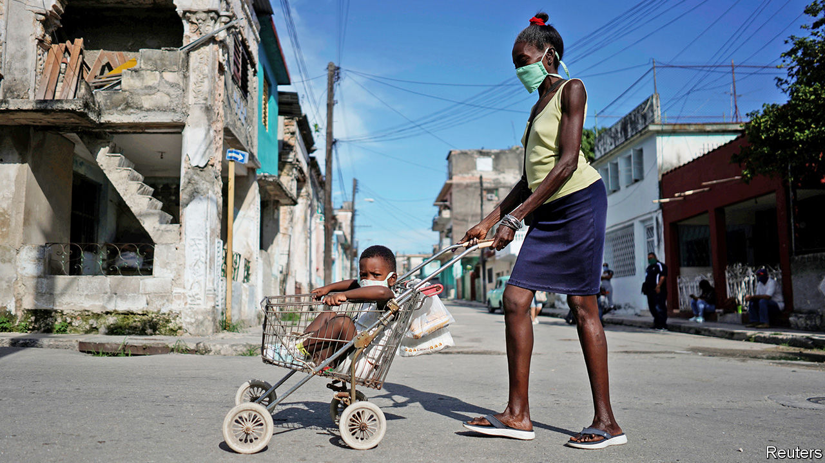

Editor’s note: Some of our covid-19 coverage is free for readers of The Economist Today, our daily [newsletter](https://my.economist.com/user#newsletter). For more stories and our pandemic tracker, see our [hub](https://www.economist.com/news/2020/03/11/the-economists-coverage-of-the-coronavirus)

ALTHOUGH THE United States has embargoed Cuba’s economy since the 1960s, the flow of goods, money and people between them has never stopped. Often the interchange is carried out by mulas, or mules (a term for drug couriers in other parts of Latin America). The first mulas were Cubans who left in the early 1980s and sent money and supplies to families who remained. Cuba’s government encouraged them as a way to support its economy, says Emilio Morales, president of the Havana Consulting Group, based in Miami.

Today’s mulas include 50,000 Cuban residents who travel to the United States, Panama and other places (even Russia) and bring back goods that are otherwise scarce or, when available in state-owned shops, overpriced. They range from kitchen appliances to cosmetics. Mulas also bring nearly half of cash remittances, perhaps $1.8bn a year. The government profits directly, too, by levying tariffs and charging $450 to renew passports that expire every two years.

With the outbreak of covid-19, Cuba’s borders closed and the mule-train stopped running. Prices of soap, appliances, nappies and powdered milk soared. Even the few products that Cuba makes are hard to find. Toothpaste disappeared. Cuban-made dentifrice will not be back before July, said the interior minister, Betsy Velázquez, because the government has no money to buy the raw materials. Cubans are still waiting for it. A shortage of fuel has eased, partly because the pandemic keeps Cubans at home (when they are not searching for necessities).

To replace mulas, Cubans with internet access use Telegram, a messaging app, to form chat groups that help locate products. These are moderated by volunteers and their spirit is altruistic. When members visit a shop, they note which products are available and how long the queue is. Now that mulas no longer bring cash, Telegram users tell each other when they spot an open branch of Western Union, one of the main ways to get money from abroad.

The government, which has controlled the covid-19 outbreak, has done less well in keeping shelves stocked. At a meeting with ministers in May, broadcast on television, President Miguel Díaz-Canel lamented that Cuba didn’t produce more guarapo (sugar-cane juice) and lemons, which he called, weirdly to Cubans, “the basis of everything”. He also emphasised the need for pre-made pizza dough, forgetting that most Cubans can’t lay their hands on cheese and tomato sauce.

Pre-pandemic, mulas brought in goods and cash worth $8bn a year, 8% of Cuba’s (inaccurately reported) GDP, says Mr Morales. Remittances in the first five months of 2020 are $518m lower than during the same period last year, he estimates. The economy is expected to contract by around 8% this year. Cubans hope for a respite in August, when international travel is due to resume. Even then, airline passengers will be allowed to check in just one suitcase, which will restrict what mulas can bring in. Foreign tourists will not be allowed to stray beyond five cays reserved for them. Cubans need mulas and tourists more than lemons and ready-made pizza dough.■

Editor’s note: Some of our covid-19 coverage is free for readers of The Economist Today, our daily [newsletter](https://my.economist.com/user#newsletter). For more stories and our pandemic tracker, see our [hub](https://www.economist.com/news/2020/03/11/the-economists-coverage-of-the-coronavirus)

This article was downloaded by calibre from <https://www.economist.com/the-americas/2020/07/04/the-pandemic-shuts-down-a-lifeline-for-cuba>

|  |  |  |  |
| --- | --- | --- | --- |
| Previous | Articles | Sections | Next |

|  |  |  |  |
| --- | --- | --- | --- |
| Previous | Articles | Sections | Next |

#### Bello

# Ecuador is in intensive care, and a straitjacket

The difficulties of a dollarised economy

Jul 4th 2020 |



Editor’s note: Some of our covid-19 coverage is free for readers of The Economist Today, our daily [newsletter](https://my.economist.com/user#newsletter). For more stories and our pandemic tracker, see our [hub](https://www.economist.com/news/2020/03/11/the-economists-coverage-of-the-coronavirus)

AT THE START of the covid-19 pandemic in Latin America in March and April, Ecuador offered the world Dantesque images of dead bodies dumped in the streets of Guayaquil, a tropical port that is the country’s largest city. The outbreak has eased, but it is not over. After the government relaxed its lockdown last month cases picked up, especially in Quito, the capital. That is happening elsewhere in the region, too. But Ecuador faces additional difficulties.

One is that the centrist government of Lenín Moreno, the president since 2017, was economically and politically weak even before the virus struck. Another is that since 2000 Ecuador has lacked its own currency, using the American dollar instead. That switch was the consequence of hyperinflation and a previous economic crisis. It has brought a degree of stability. But it means that when recession strikes, Ecuador cannot print money. Nor can it easily borrow because Mr Moreno’s populist predecessor, Rafael Correa, piled up debt during his decade in power, which the government has struggled to repay. So while governments elsewhere are loosening the purse-strings, Ecuador has to cut public spending just when it is most painful to do so.

Mr Correa ruled during a commodity boom. He used windfall oil revenue to double the size of the state. Although some of the money was invested in infrastructure, much went on expanding public employment and much was simply wasted or stolen. Despite the spending splurge, in proportion to the population Ecuador scores barely above the Latin American average in number of doctors and below it for hospital beds.

When the commodity boom ended, Ecuador was left with a big fiscal deficit and mounting public debt. Mr Moreno, an ally-turned-foe of Mr Correa, has been left to pay the bill. In March of last year his government signed a $4.2bn, three-year agreement with the IMF aimed at softening the effects of deficit-cutting and at boosting non-oil exports by making the economy more competitive. This reform programme soon went off the rails. In October, without preparing the political ground or compensating those worst hit, the government tried to eliminate indiscriminate subsidies on fuel (the IMF had urged it to raise value-added tax instead). After a fortnight of protests and rioting left ten dead, Mr Moreno backed down.

With the deficit heading back up to at least 6% of GDP, the government is scrambling for cash. Since March it has saved 2.5% of GDP by agreeing with bondholders to postpone interest payments, and another 1% by trimming the working hours of public employees. The public’s anger at scandals over medical procurement has reinforced its resistance to tax increases. The IMF approved an additional $643m emergency loan in May. The government has obtained a loan from China, and further relief from bondholders. It has used money from the Inter-American Development Bank to increase the payments to the poor and the number who get them. To try to boost recovery, it has introduced modest reforms of the labour law and the bankruptcy code.

Unpopular reforms are all the harder because a general election is due in February. But they are vital. Augusto de la Torre, a former Central Bank president, notes that “dollarisation is the most popular institution in my country—more popular than the church or the army.” But, he adds, “the country is learning the hard way that dollarisation means that we can’t print money.”

It is not a substitute for fiscal discipline and a more competitive economy. The problem is “there’s no coalition to pass the necessary reforms,” says Andrés Mejía, an Ecuadorean political scientist at King’s College in London. Instead there are what he calls “ghost coalitions” operating in the shadows, with parties refusing to support austerity publicly but quietly facilitating it. “They do enough to get the country past emergencies but not enough for long-term development.”

Muddle-through may be running out of road. With an approval rating of 19%, Mr Moreno has said he will not stand again. Perhaps sensing the difficulties ahead, Jaime Nebot, a powerful former mayor of Guayaquil, ruled himself out as a candidate on June 25th. Having received a jail sentence in absentia for corruption, Mr Correa, who lives in Belgium, is looking for a proxy candidate. With voters likely to be in an angry mood, unless a credible reformist candidate emerges the stage may be set for a return of populism—but a penniless version this time.

Editor’s note: Some of our covid-19 coverage is free for readers of The Economist Today, our daily [newsletter](https://my.economist.com/user#newsletter). For more stories and our pandemic tracker, see our [hub](https://www.economist.com/news/2020/03/11/the-economists-coverage-of-the-coronavirus)

This article was downloaded by calibre from <https://www.economist.com/the-americas/2020/07/04/ecuador-is-in-intensive-care-and-a-straitjacket>

|  |  |  |  |
| --- | --- | --- | --- |
| Previous | Articles | Sections | Next |

|  |  |  |
| --- | --- | --- |
| The Americas | Sections | China |

Asia

The war in Afghanistan: Withdraw first, ask questions later

.

India and China: Hit them where it hurts us

.

India’s obsession with TikTok: Fifteen seconds of fame

.

Feeding Singapore: The rise of the rooftop farmer

.

Vietnam: Your loss, my grain

.

Banyan: A charged relationship

.

|  |  |  |
| --- | --- | --- |
| The Americas | Sections | China |

|  |  |  |  |
| --- | --- | --- | --- |
|  | Articles | Sections | Next |

#### Withdraw first, ask questions later

# America is rapidly pulling troops from Afghanistan

The future of the country they are leaving behind is more uncertain than ever

Jul 4th 2020 | ISLAMABAD

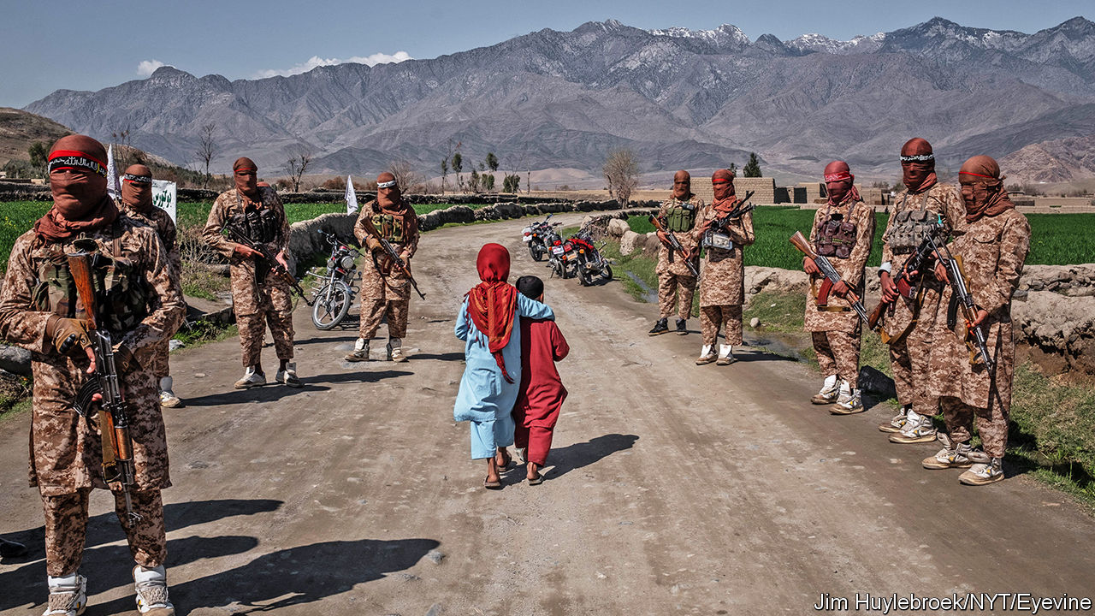

FAIZA IBRAHIMI is too young to remember when the Taliban ruled Afghanistan as a theocracy. She can scarcely believe her parents’ stories about it. She is a radio presenter in the western city of Herat. The idea that gun-toting zealots from the countryside used to forbid women to leave home unless fully veiled and accompanied by a male relative seems almost inconceivable: “My mother was unable to work and find bread. I couldn’t imagine that time again.”

It was only in 2001 that American forces toppled the Taliban regime, when the mullahs who led the movement refused to hand over Osama bin Laden after the 9/11 attacks. But nearly two-thirds of the population is less than 25 years old, and so has little or no memory of the Taliban’s rule. They are having to brush up on their history, however, as they contemplate the prospect of the Taliban returning to power in some form. The American troops that have propped up the Afghan government and held the Taliban at bay for the past 19 years are on their way out. Over the past four months the number of American soldiers in the country has fallen by a third, from around 13,000 to 8,600. The administration of President Donald Trump has pledged to reduce their strength still further, as part of a deal it signed with the Taliban on February 29th. In exchange the Taliban are supposed to cease providing shelter to foreign militants and—an element of the peace plan that is proceeding much less smoothly—enter into talks with the Afghan government.

“Intra-Afghan talks”, in which the government, the Taliban, opposition politicians and representatives of civil society were to discuss the country’s future, had been due to start within days of the signing of the accord. But the process immediately bogged down. First, the government and the Taliban bickered over a prisoner exchange outlined in the deal. America had promised that the Afghan government, which was not party to the agreement, would release “up to” 5,000 Taliban prisoners as a gesture of goodwill. The Taliban, in return, were to free 1,000 policemen and soldiers it held captive. Ashraf Ghani, the president, said 5,000 was too many, but the Taliban were adamant. Months passed.

Another sticking point has been the Taliban’s continuing attacks on soldiers and civilians. Although the insurgents observed something close to a ceasefire in late February, to pave the way for the signing of the deal, they reverted to their old ways soon afterwards. The government says they carried out 422 attacks in a single week in June. This breaks a promise to reduce violence, the American and Afghan authorities say. But if the Taliban made such a pledge, it was only in private: the text of the deal did not spell out any truce.

The Taliban did at least cut back on attacks during the Eid holiday in late May. That seems to have spurred Mr Ghani to release most of the required prisoners, even though violence subsequently increased again. There is lingering disagreement, too, over 200-odd people the Taliban want freed, some of whom are accused of terrible atrocities. Nonetheless, diplomats believe the way may at last be clear for talks to begin within weeks, probably back in Qatar, where the original accord was signed.

These discussions, should they go ahead, will give Afghans a glimpse of how much the Taliban have changed their spots since the 1990s. Perhaps unsurprisingly, they have not been clear what they want for the country, beyond the departure of American troops. Their statements speak vaguely of Islamic government. When asked whether their attitudes to women have changed, they say only that women’s rights will be protected in accordance with Islamic teachings. Although they claim no longer to oppose girls going to school, for instance, girls do not seem to be allowed to remain in education past puberty in the rural areas controlled by the Taliban, according to a report published this week by Human Rights Watch, a pressure group.

Some Afghans believe that the Taliban’s refusal to elaborate on their stances is a sign that they are not serious about negotiations, and plan to attempt to seize power by force once the Americans are gone. Others assume that divisions within the organisation make it hard to stake out clear positions. Although the talks with America suggested an element of pragmatism, the Taliban still insisted on referring to themselves as leading an “Islamic emirate”, just as they did when they ruled the country in the 1990s. “If this thing moves forward, the day’s going to come where they can’t just say, ‘We will settle that later’,” says Andrew Watkins of International Crisis Group.

The government, for its part, has said it wants to preserve “a sovereign, democratic and united republic”. It will definitely resist the re-creation of a doctrinaire Islamist regime. In a speech by video-link to an American think-tank on June 24th Abdullah Abdullah, in effect the government’s chief negotiator, said, “We cannot achieve peace with sacrificing the basic and fundamental rights of our people.” He has said he will include women in his negotiating team. But he also concedes that the government will have to compromise to win the Taliban over—without specifying how.

Yet more uncertainty surrounds America’s part in Afghanistan’s future. The only element of the peace plan going according to schedule is the withdrawal of American forces. “It is not the duty of US troops to solve ancient conflicts in far away lands that many people have never heard of,” Mr Trump told cadets at the US Military Academy at West Point on June 13th. Claims that Russia paid a bounty to the Taliban for every American soldier they killed are causing him embarrassment (see [article](https://www.economist.com/node/21788912)). Joe Biden, his rival in November’s election, has long been sceptical about state-building in Afghanistan. How forcefully either man would push to preserve Afghan democracy is unclear. Many doubt that either would send troops back in should the Taliban come close to toppling the elected government.

Covid-19 has made all these questions more fraught. The disease is said to be barrelling through the Afghan security services. The American troops who remain in Afghanistan are providing less training to the Afghan army in part to avoid catching it from their Afghan comrades. Attempts to contain the spread of the virus have also hit the already sputtering Afghan economy. Nation-building, under any government, is looking harder than ever.

Afghans like Miss Ibrahimi anxiously await the start of talks. She wants to remain working in Afghanistan to justify her parents’ sacrifices. But she doubts that the gun-toting zealots her mother told her about have changed much. “If the Taliban come with that ideology that they had before 2001, then it won’t be a change for peace, or better security or a better country,” she says grimly. ■

This article was downloaded by calibre from <https://www.economist.com/asia/2020/07/04/america-is-rapidly-pulling-troops-from-afghanistan>

|  |  |  |  |
| --- | --- | --- | --- |
|  | Articles | Sections | Next |

|  |  |  |  |
| --- | --- | --- | --- |
| Previous | Articles | Sections | Next |

#### Hit them where it hurts us

# India has few good ways to punish China for its Himalayan land-grab

Most economic sanctions would harm India, too

Jul 4th 2020 | DELHI

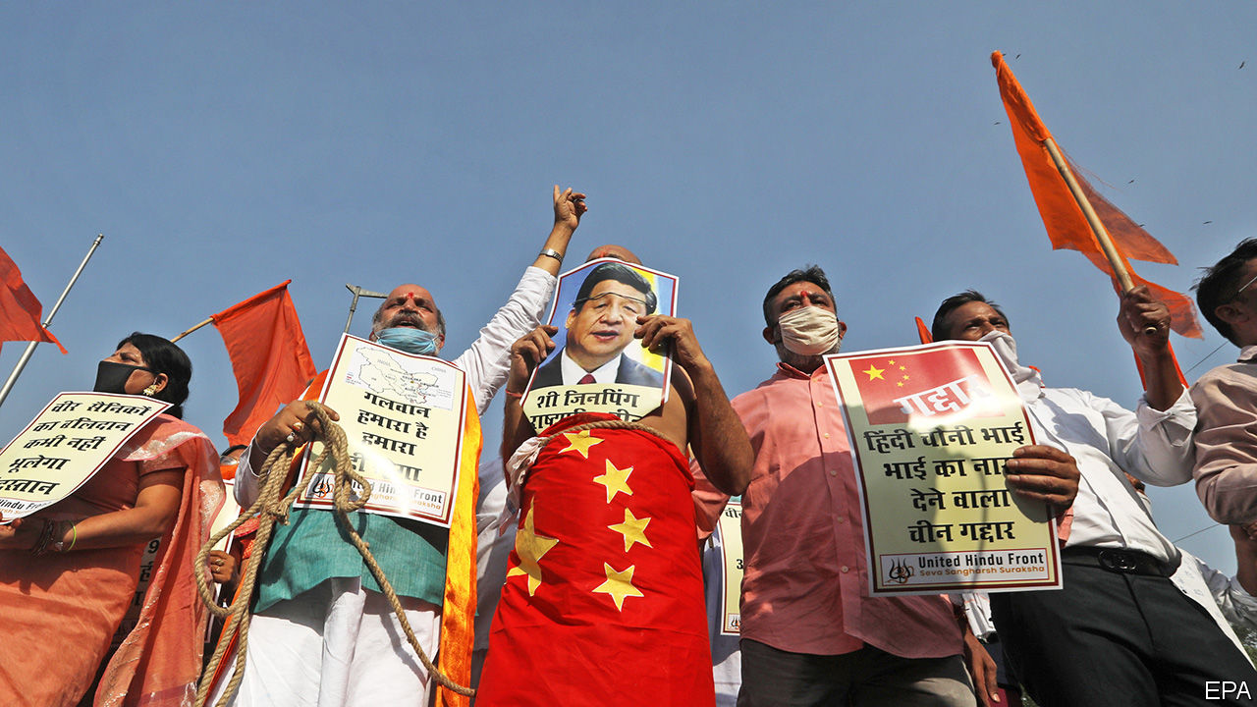

“NOW THE Chinese will know that, when we want to act, we shall act as we wish, without warning,” thundered Arnab Goswami, jabbing a finger towards the camera. “We shall move in stealth, and attack when necessary!” Judging from the triumphalism of this host on Republic TV, a jingoistic private channel, one might have guessed that the Indian army was at the gates of the Forbidden City. But the daring blow he trumpeted was in fact a limp ministerial decree, announcing a ban on TikTok, a popular video-sharing platform, and 58 other smartphone apps deemed to have links with China.

India’s ban was officially billed as a defensive measure, meant to protect citizens from possible data-mining by “elements hostile to national security”. Few Indians doubt that its real intent is retaliatory. Since June 15th, when some 20 Indian soldiers died during an unarmed clash with Chinese troops at a remote spot on the countries’ ill-defined border, Narendra Modi, India’s prime minister, has faced political pressure to hit back at China. Considering that Indians have downloaded TikTok more than 600m times, and that several other targeted Chinese apps also had huge followings, few can have missed the government’s action. Mr Modi has “done something” for all to see to avenge the slain soldiers—although he has also snuffed out an astonishingly popular pastime overnight (see [article](https://www.economist.com/node/21788905)).

The feebleness of India’s response underlines the difficulty of its position on the cusp of what Jabin Jacob of Shiv Nadar University in Delhi describes as an emerging cold war between the Asian giants. Since the spring China has massively reinforced its troops in its Himalayan border regions. In these barren, high-altitude areas, the “Line of Actual Control” between India and China has never been formally defined, much less agreed upon, with only seasonal patrols probing claimed territorial limits. China has abruptly changed that by creating reinforced, permanent-looking positions at as many as seven strategic spots, all situated just inside what India considers its territory. Last month’s bloodshed, which caused an unknown number of Chinese casualties, occurred when Indian troops tried to dismantle one of these.

Militarily, India faces a fait accompli. China’s new positions give its forces a strategic advantage, making it difficult for Indian troops to hit back. Taunting Chinese soldiers have even inscribed a giant map of China on one patch of newly grabbed terrain. India could imitate China’s tactics and create its own new forward positions, but such tit-for-tat moves could simply go on at mounting cost over many years, with China’s bigger budgets and superior infrastructure putting it in a better position to dig in.

Hence the temptation for India to try to hurt China in other ways. The ban on popular apps represents a pinprick for an economy that is nearly five times the size of India’s. True, India is TikTok’s biggest foreign market by far, but the app’s earnings in India are relatively paltry.

Mr Jacob says the app ban is better understood as part of a more strategically considered pushback against China’s growing influence. The irritants to India include a persistent trade deficit of around $50bn and the inroads Chinese diplomacy has made in small, neighbouring states that India considers its own satellites.

Even before the recent border tensions, India had begun quietly raising barriers to Chinese capital. New rules imposed in April require central government vetting of all direct investments by Chinese firms. In May the authorities began mulling stricter oversight of trades linked to China in the stock- and bond markets. Since the troubles in June, Indian customs officers have been scrutinising shipments from China much more closely. On July 1st two big air-freight firms, FedEx and DHL, both announced they would cease carrying goods from China to India because of delays in customs clearance. Some of those delays may become permanent: the government is consulting with Indian businesses over a list of more than 1,000 Chinese-made items on which it intends to raise tariffs.

Such economic nationalism goes down well in some quarters. Prafulla Ketkar, the editor of a journal considered a mouthpiece for India’s biggest Hindu-nationalist group, sees the beginning of a “holy war” against an “expansionist monster”. But much of India’s shopping list from China consists of vital inputs for its own factories, including more than two-thirds of the active ingredients for India’s booming drugs industry, nearly all the compressors used by its air-conditioner manufacturers and most of the cheap solar panels that have allowed India to make impressive strides in clean energy. Chinese venture-capital firms have injected some $8bn into Indian start-ups. That flow will now dry up. Even worse, by showing such readiness to wield economic cudgels, Mr Modi sends a signal not only to China but also to other investors looking for a steady, reliable place to do business. ■

This article was downloaded by calibre from <https://www.economist.com/asia/2020/07/04/india-has-few-good-ways-to-punish-china-for-its-himalayan-land-grab>

|  |  |  |  |
| --- | --- | --- | --- |
| Previous | Articles | Sections | Next |

|  |  |  |  |
| --- | --- | --- | --- |
| Previous | Articles | Sections | Next |

#### Fifteen seconds of fame

# India’s ban on TikTok deprives the country of a favourite pastime

The app provided a window on the heartland

Jul 4th 2020 | DELHI

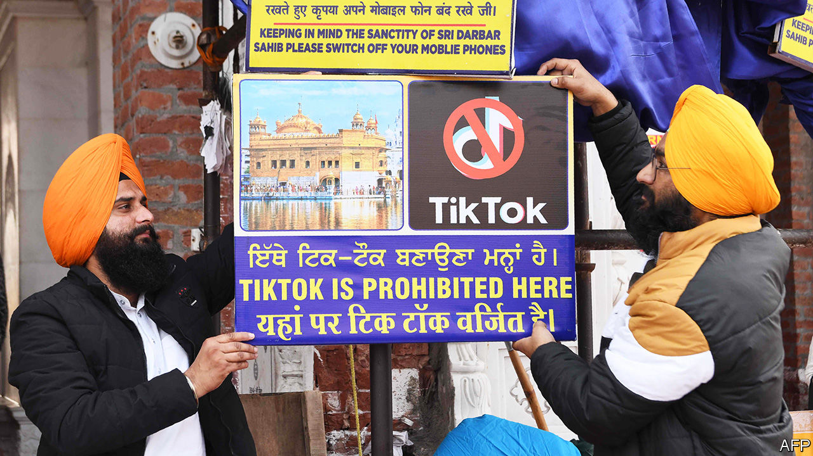

IN INDIA, AS elsewhere, TikTok looks like a cornucopia of bright and busy nonsense: an endless, blooming, buzzing confusion of shaky videos and cheap special effects, dispensed free of charge in 15-second doses. But time spent on the app—or on its Chinese-owned peers, all of them abruptly blocked by the government on June 29th—had a way of leading curious users far from the big cities and celebrities that typically define Indian pop culture. Not just TikTok, but also Helo, Likee and Bigo Live, were virtual highways to places no actual highways serve, in small-town and rural India. They revealed a part of the country that is changing rapidly.

Thousands of people around India appear to have made a living recording and broadcasting short videos, mostly of shimmying, lip-synching and prat-falling, for millions of other Indians to whom they would otherwise have remained utterly obscure. TikTok had about 1.2m content creators and 120m monthly viewers. A striking proportion of the creators hailed from marginalised groups. A scrawny cloth-seller from a small city could start an overnight dance sensation; swaggering young Muslim comics found audiences as big as those of mainstream Hindi films; transsexual performers shared make-up tips with fans and gawkers; rural grannies taught cooking and a girl built a fanbase while lip-synching to a rap in Hmar, a language spoken in a few small patches of the sparsely populated north-east. A cottage industry of disdainful urbanites had sprung up on YouTube to mock the TikTok army, in classist and sometimes casteist terms. Yet an aspiring dietician from the state of Haryana could build a following of 11m on the strength of his resemblance to Virat Kohli, captain of India’s cricket team. Eventually Mr Kohli himself became his collaborator.

Amit Varma, a podcaster from Mumbai who ran an online course about TikTok, puts the app’s success down to timing. It arrived in 2017, just after Reliance Industries, a huge conglomerate, had launched Jio, a 4G telecoms operation which radically reduced the cost of mobile data. Instead of a gigabyte a month, smartphone users suddenly had a gigabyte a day to play with. Cheaper Chinese handsets, meanwhile, made owning a smartphone more affordable.

“This is not content made by clueless elites,” Mr Varma says. “In Bollywood a few big shots run the whole thing. But they have outdated ideas about what people want.” What they really want, if TikTok’s algorithms had it right, is weirder, homelier and more varied material than they could find on television, YouTube, Instagram or any of the English-first apps favoured by wealthy urbanites. Bidding fans farewell on the evening of June 30th, one TikTok star after another urged them to regroup on one or another of those apps, or on one of the close to 100 Indian copycats that have sprung up.

This article was downloaded by calibre from <https://www.economist.com/asia/2020/07/04/indias-ban-on-tiktok-deprives-the-country-of-a-favourite-pastime>

|  |  |  |  |
| --- | --- | --- | --- |
| Previous | Articles | Sections | Next |

|  |  |  |  |
| --- | --- | --- | --- |
| Previous | Articles | Sections | Next |

#### The rise of the rooftop farmer

# Singapore looks to the skies—for fields

Government subsidies make excellent fertiliser

Jul 4th 2020 | SINGAPORE

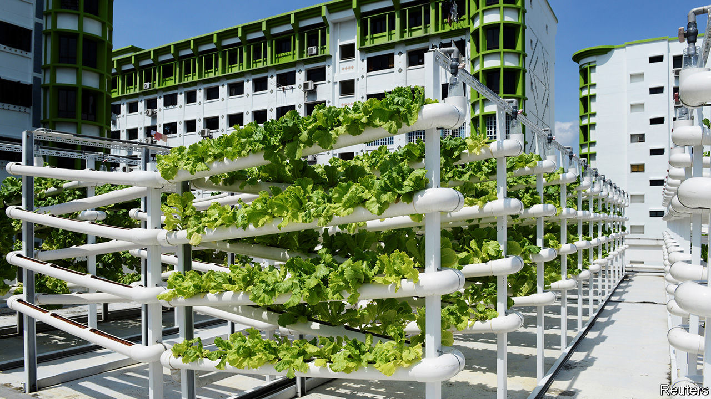

BENJAMIN SWAN’S farm is on the fourth floor of an office building in an industrial part of Singapore. To see his crops, visitors are escorted past a door unlocked with a thumbprint and through an airlock. (“Our air is certified,” says an assistant.) Room after room is filled with plumes of kale and lettuce, evenly spaced on long trays stacked in floor-to-ceiling racks. Cables snake across the racks and ceilings, like an electrical root system. LED lights, designed to emit only the part of the electromagnetic spectrum that plants can absorb, cast a purple glow. The greens are planted in a substrate—not a speck of soil is in sight.

Singapore is a hymn to concrete and metal. But look closely and you can see farms mushrooming across the city-state: on the roofs of malls and car parks, in schools, warehouses and even the site of a former prison. This is new. Commercial farming in the land-scarce city was phased out in the 1970s and 1980s. “Unlike virtually any other country on earth, Singapore has lost a generation of farmers,” says Bradley Busetto of the Global Centre for Technology, Innovation and Sustainable Agriculture, a UN outfit based in Singapore. Today just 720 square kilometres of land, less than 1% of Singapore, is set aside for farms. But a new crop of entrepreneurs are betting on rewards from finding idle spaces where lettuces may be coaxed to life. Since 2014, 31 commercial urban farms have sprouted.

The government is delighted. Singapore imports more than 90% of its food. It is “extremely vulnerable to fluctuations in our food availability that may be brought about by climate change, disease outbreaks and global food situations,” says Low Li Ping of the Singapore Food Agency. In 2019 the government said the country should produce 30% of its food by 2030.

It has put its money where its mouth is. Before the pandemic the government had pledged S$207m ($149m) to help farmers boost productivity and to spur research. In April the government, spooked by the pandemic’s (small) disruptions to global markets for food, promised an extra S$30m to help farmers grow more in the next six to 24 months, and invited urban farmers to apply to rent the roofs of nine government-owned car parks. Mr Swan, the indoor kale farmer, credits the government with helping to fund his company’s R&D and introducing him to investors.

Such help is gratefully received. Farming in the city can be expensive. Property and labour are costly. To maximise space, farmers stack plants. Some go inside, which means losing a free and plentiful input—the sun—but allows greater control of the environment. “Every room is its own climate,” says Sven Yeo of Archisen, an indoor farm that tinkers with temperature, humidity, carbon dioxide, light, water and nutrients to produce tastier lettuce, sorrel and chard. The technology does not come cheap, but it does allow for more frequent and bountiful harvests. Mr Swan says his farm yields 178 times more lettuce per square metre than a traditional one. It started production in 2015 and broke even for the first time in 2018. His labours are bearing fruit. ■

This article was downloaded by calibre from <https://www.economist.com/asia/2020/07/04/singapore-looks-to-the-skies-for-fields>

|  |  |  |  |
| --- | --- | --- | --- |
| Previous | Articles | Sections | Next |

|  |  |  |  |
| --- | --- | --- | --- |
| Previous | Articles | Sections | Next |

#### Your loss, my grain

# As covid-19 saps Vietnam’s economy, private charity is blossoming

That is unusual for a workers’ paradise

Jul 4th 2020 | HANOI

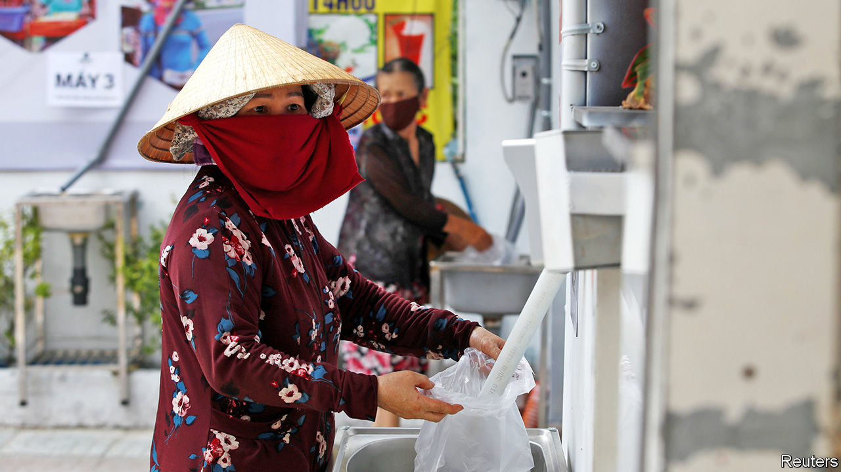

Editor’s note: Some of our covid-19 coverage is free for readers of The Economist Today, our daily [newsletter](https://my.economist.com/user#newsletter). For more stories and our pandemic tracker, see our [hub](https://www.economist.com/news/2020/03/11/the-economists-coverage-of-the-coronavirus)

DESPITE THE mid-morning heat, residents of the Vietnamese capital, Hanoi, swarm around the dispenser filling their brown paper bags. Having taken her share, Vu Thi Hoan straps the 2kg package to her bicycle and prepares for the journey home. Ms Hoan, who collects and sells trash for a living, has seen her income diminish in recent months, “probably because now there are more trash collectors”. Before covid-19 struck she sold cardboard for 3,000 dong ($0.12) a kilo. Now she is lucky to get a third of that. Like many others, Ms Hoan, a migrant from rural Thai Binh province, only gets by thanks to a free weekly visit to the “rice ATM”.

A property company called Cen Group set up the dispenser in late May to support Hanoi’s poorest through the epidemic. The firm only provided the first five tonnes of rice, however; since that ran out the scheme has continued with donations from the public, says Pham Thanh Hung, Cen Group’s vice chairman. The local authorities have helped, too, says Mr Hung, by expediting the necessary permits, referring people in need and providing police for security. Indeed, generous coverage in the state-controlled media suggests that the top ranks of the Communist Party have blessed the initiative.

Cen Group’s was not the first rice ATM. Hoang Tuan Anh, an entrepreneur, came up with the idea and built the first prototype after hearing about a factory worker who committed suicide after losing her job. Now a handful of companies make them, supplying tens of locations in cities across the country. Each ATM distributes 1.5-2kg of rice per person, enough to feed a small family for three days. Some machines get through three tonnes of rice a day, serving up to 2,000 people.

Vietnam, impressively, fended off covid-19 without a single confirmed fatality. But the pandemic nonetheless caused the economy to sicken. The IMF has slashed its growth forecast this year from 7% to 2.7%. The decline in global consumption has battered manufacturing, which accounts for a sixth of GDP. The sealing of borders has been catastrophic for tourism, another big industry. According to the government, 5m people either lost their jobs or saw their incomes shrink during the first four months of the year. Things are unlikely to have improved much since, although Vietnam did start lifting its lockdown in late April.

At the same time the government approved a 62trn dong ($2.6bn) scheme to help those who have lost their jobs because of covid-19. But would-be recipients complain it has been slow to get off the ground. It is still not clear, for instance, whether migrant workers in informal jobs, the bulk of those using rice ATMs, are covered.

All this may help explain the government’s surprising embrace of private charity, not something people are supposed to need in a proletarian paradise. Large-scale philanthropy is rare in Vietnam, says Danielle Labbé of the University of Montreal, but it is a country where “good ideas replicate quickly.” The theatre of the machines, abetted by favourable press coverage, seems to be an effective way to drum up donations. But one beneficiary waiting to make a withdrawal has an idea of her own. “This is really time-consuming. Why don’t they just put the rice in bags and give it to us straight away?” ■

Editor’s note: Some of our covid-19 coverage is free for readers of The Economist Today, our daily [newsletter](https://my.economist.com/user#newsletter). For more stories and our pandemic tracker, see our [hub](https://www.economist.com/news/2020/03/11/the-economists-coverage-of-the-coronavirus)

This article was downloaded by calibre from <https://www.economist.com/asia/2020/07/04/as-covid-19-saps-vietnams-economy-private-charity-is-blossoming>

|  |  |  |  |
| --- | --- | --- | --- |
| Previous | Articles | Sections | Next |

|  |  |  |  |
| --- | --- | --- | --- |
| Previous | Articles | Sections | Next |

#### Banyan

# Chinese investment in Pakistan was supposed to be a showcase

Instead, it illustrates the limits of China’s new development diplomacy

Jul 4th 2020 |

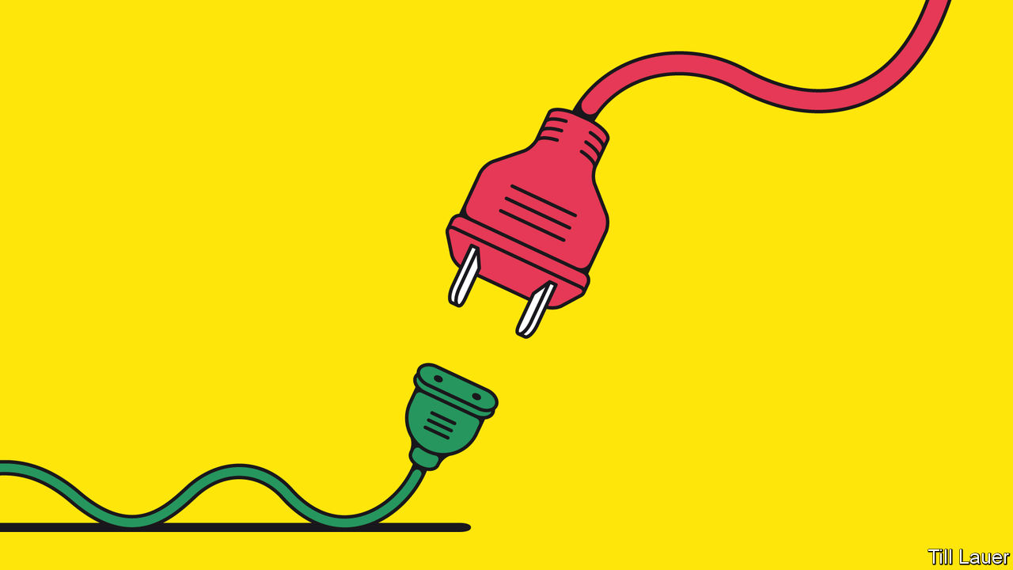

WHEN XI JINPING launched his Belt and Road scheme of global development aid with Chinese characteristics, he needed a country to showcase it. Pakistan seemed the obvious choice. It was China’s only real ally, a security partner on a vulnerable flank. Meanwhile a new prime minister, Nawaz Sharif, and his business-friendly Pakistan Muslim League had just come to power pledging big infrastructure projects and an end to the country’s notorious brownouts. In 2015 the China-Pakistan Economic Corridor (CPEC) was announced, involving promised sums that soon topped $60bn. This was a “game- and fate-changer” for the country, Mr Sharif crowed. What could possibly go wrong?

Quite a lot, as it happens. The latest evidence is a fresh report by a committee convened by Mr Sharif’s successor, Imran Khan, to look at problems in power generation. It accuses Chinese companies of “malpractices”, including inflating costs. The contractors of two coal-fired plants, at Port Qasim in Sindh province and Sahiwal in Punjab, are allegedly overcharging by $3bn. Construction costs alone were padded by over $200m, it claims.

Pakistan’s indebted power industry is notorious for sleaze, and the findings of the committee, which also faulted local contractors, should come as no surprise. Mr Khan himself campaigned for office by attacking corruption on CPEC projects. After he won the election in 2018, with a little help from Pakistan’s powerful generals, he thought to berate China into renegotiating terms and offering other financial help—he had, after all, inherited a full-blown balance-of-payments crisis. Yet Mr Khan’s first trip to Beijing was mortifying. He got nothing like the money he demanded. And China’s leaders scolded him for airing dirty laundry in public—a Belt and Road no-no.

By late last year things were looking better. Mr Khan had secured an IMF bail-out. The China relationship was back on track, albeit with a greatly pared-down CPEC. Gone were the proposals for industrial co-operation and most of a welter of special economic zones. But work had restarted on other projects. They included a port at Gwadar on the Arabian Sea and a railway from Peshawar to Karachi: that cost a ruinously expensive $8bn, but was too conspicuous a project to abandon. Reassuring both China and Pakistan’s top brass, a retired general was put in charge of a new CPEC authority. It was to serve as a one-stop shop and cut through Pakistan’s enterprise-choking red tape.

Even before the authority had a chance to fail, along came covid-19. Specialist Chinese workers were stuck in their hometowns celebrating the Chinese new year. The government hardly wants to see 75,000 Pakistani employees on CPEC projects laid off, but it cannot afford to keep them at work either. The economy faces its first recession in decades, and yet another balance-of-payments crisis. And since the government eased lockdown regulations in May, coronavirus infections are rising. Mr Khan is desperately pushing for debt relief from all Pakistan’s creditors.

The committee’s report, which the generals presumably approved, is part of the campaign. It raises the stakes with China, which must be appalled at the display of laundry just as America is loudly contending that Belt and Road is all about entrapping poor countries through debt. Yet the evidence of malpractice Mr Khan has revealed may give him leverage to seek better terms; a similar gambit worked for Malaysia last year. To save China’s face, Mr Khan’s government has postponed a corruption investigation. Instead, according to the Financial Times, it is asking to delay repayments for up to a decade.

More concessions are coming. In other words the CPEC game, as a prominent economic commentator, Khurram Husain, puts it, is still on. Yet it will be a much reduced one, with some projects stalled or slowed, and others abandoned. There will be some real benefits: brownouts in much of the country are a memory. But, says Andrew Small, author of a book on China and Pakistan, CPEC “will be defined by the things that might have happened but won’t”.

Pakistan, for instance, will not stop lurching from one economic crisis to the next. Nor will it have the economic confidence to transform its paranoid relations with India. Above all, it will not serve as a model to the world of a new form of relations with a magnanimous China, in which mutual advances in security and economic development are forever blissfully intertwined.

This article was downloaded by calibre from <https://www.economist.com/asia/2020/07/04/chinese-investment-in-pakistan-was-supposed-to-be-a-showcase>

|  |  |  |  |
| --- | --- | --- | --- |
| Previous | Articles | Sections | Next |

|  |  |  |
| --- | --- | --- |
| Asia | Sections | Middle East & Africa |

China

Hong Kong’s freedoms: The evening of its days

.

Popular culture: Star wars

.

Chaguan: The great unifier

.

|  |  |  |
| --- | --- | --- |
| Asia | Sections | Middle East & Africa |

|  |  |  |  |
| --- | --- | --- | --- |
|  | Articles | Sections | Next |

#### The evening of its days

# A new national-security bill to intimidate Hong Kong

It is harsher than the gloomiest predictions

Jul 2nd 2020 | HONG KONG

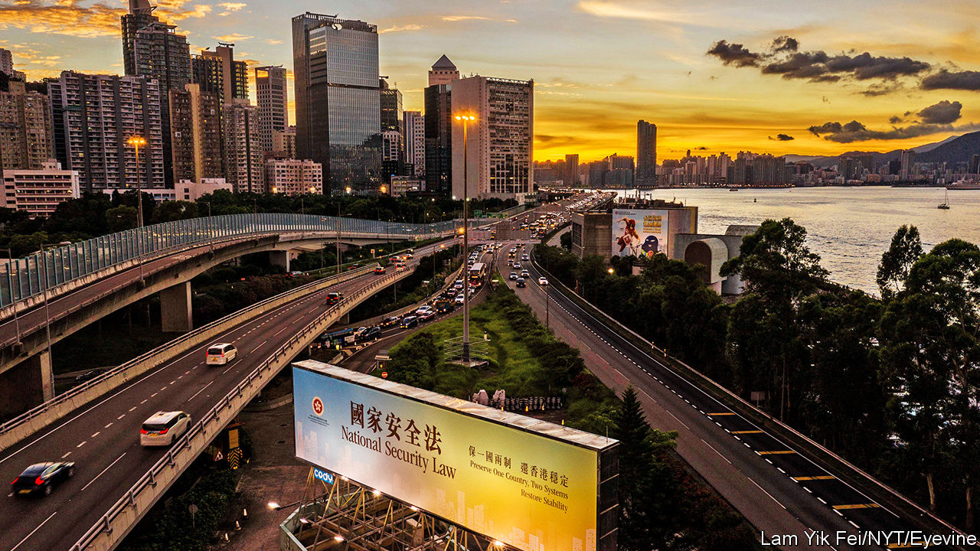

A SENIOR CHINESE official called it a “birthday gift” for Hong Kong. It was a chilling choice of words for the biggest blow to the territory’s freedoms since Britain handed it back to China in 1997. Close to midnight on June 30th, on the eve of official celebrations of the handover’s anniversary, China imposed a draconian national-security bill on Hong Kong. It gives the government in Beijing sweeping power to crush dissent in the territory using its own secret police and even its own courts.

The new law relates to crimes involving secession, subversion, terrorism and collusion with foreign forces. Hong Kong’s post-handover constitution, the Basic Law, had required the territory to pass its own legislation concerning such offences. But local opposition had stymied the government’s efforts to do so. Unrest during the past year, which Chinese officials call an attempted “colour revolution”, caused the Communist Party to lose patience. In May it announced it would do the job itself.

The law was drafted in secret by legislators in Beijing—not even Hong Kong’s government was shown its contents until it was passed by China’s rubber-stamp parliament. Mercifully, it cannot be used to charge people for things they did before June 30th, or so officials say. But otherwise it is even more intimidating than most people in Hong Kong had expected.

The bill could result in far more serious charges being laid against protesters should they engage in activities that were common during the recent upheaval. Vandalising public transport could now be treated as terrorism. Breaking into the legislature or throwing eggs at the central government’s liaison office, as demonstrators did last year, could be considered subversive. Calling for Hong Kong’s independence, as some protesters have, could invoke a charge of secession. Encouraging foreign countries to impose sanctions on China could result in prosecution for collusion. The maximum sentence for all four of these categories of crime is life in prison.

To oversee the clampdown, the central government will open a new “Office for Safeguarding National Security”. It will be the first open operation in Hong Kong involving the mainland’s civilian security forces. A separate policymaking “Committee for Safeguarding National Security” will also be set up, led by the territory’s chief executive, Carrie Lam. It will include an “adviser” appointed by the central government. Trials involving the new law will be presided over by judges hand-picked by the government. The justice secretary may allow them to dispense with juries and hear cases in secret.

Ms Lam said the new law would target only “an extremely small minority of people”. To many Hong Kongers, that is no comfort. In “complex” or “serious” cases the bill allows the mainland’s security agencies to take charge. They will not be subject to Hong Kong law. They may even take suspects to the mainland for trial. There they could face execution.

It is not only the large numbers of young black-clad protesters at the forefront of the recent unrest who need worry. The law could be applied to a wide range of peaceful activity. For example, taking part in anything “unlawful” aimed at undermining China’s communist system could be considered subversive. That could be construed to mean any anti-government rally that goes ahead without police permission. A person who “conspires” with anyone abroad to provoke “hatred” in Hong Kong towards the local or central government could be accused of collusion. The power to interpret these terms will rest with China’s legislature. The law may affect a wide range of other freedoms. It calls for stronger “regulation” of schools, universities, social organisations, the media and the internet.

It will also apply to people abroad. That may mean that if considered suspects in any of these crimes they could face arrest, should they visit Hong Kong. The bill implies that foreign firms in Hong Kong could be punished should they help a country apply sanctions against China. America is mulling some. On July 1st its House of Representatives passed a bill calling for sanctions against banks that do business with Chinese officials deemed responsible for human-rights abuses in Hong Kong. The legislation is likely to be submitted to the Senate in a few days.

Hong Kong is already feeling the chill. Just before the law was passed, Joshua Wong disbanded his party, Demosisto, which had supported self-determination for Hong Kong. “Yellow” cafés favoured by protesters began removing pro-democracy messages from their windows. Some activists closed their Twitter accounts.

Despite a police ban on protests on July 1st, and the risk of breaking the new law, thousands of people still gathered to protest. Elderly women handed out posters saying “Heaven will destroy” the Communist Party. But the number of demonstrators was far smaller than at many of last year’s protests. The police arrested 370 participants. At least ten were accused of violating the security bill, including a man caught with a pro-independence flag.

China will try to make sure that Hong Kong continues to prosper, not least by pumping up its stockmarket. Shut out of American stockmarkets amid Sino-American tensions, Chinese firms are increasingly turning to Hong Kong’s exchange to list. The share index rose by more than 2.8% on July 2nd, the first day of trading after the law was published. But the territory’s political future is bleak. The local government says it has spent $6.29m to retain a public-relations company to help a “Relaunch Hong Kong” campaign. Its choice was Consulum, a firm that has tried to help Saudi Arabia improve its authoritarian image. It will have its work cut out in Hong Kong. ■

This article was downloaded by calibre from <https://www.economist.com/china/2020/07/02/a-new-national-security-bill-to-intimidate-hong-kong>

|  |  |  |  |
| --- | --- | --- | --- |
|  | Articles | Sections | Next |

|  |  |  |  |
| --- | --- | --- | --- |
| Previous | Articles | Sections | Next |

#### Star wars

# China’s devoted, combative celebrity fan clubs

A true fan downloads multiple copies of the same song and insults rival stars

Jul 4th 2020 |



“THE UNTAMED”, a costume martial-arts drama, is one of the most-watched television series in China. Since its online release last year it has been viewed 8bn times. Its heart-throb star, Xiao Zhan (pictured), has gained a legion of fans. In October so many of them crowded an airport in Beijing to see him that they delayed a flight.

In February Mr Xiao’s devotees flooded the internet with complaints about a website hosting raunchy fiction about him. The government shut it down. In May a video went viral of a classroom full of primary-school students chanting: “Brother Xiao Zhan, you are very good!” The teacher who filmed them was suspended.

Mr Xiao’s millions of admirers belong to what are known in Chinese as fanquan, or “meal circles” (because the word for meal sounds like the English word “fan”). These are passionate and sometimes combative online groups devoted to particular celebrities. The Chinese government has long demanded patriotism and good behaviour from stars, but it has placed few limits on fans. On the internet, where debate and organising are usually tightly controlled, fanquan enjoy rare freedom to do both.

But as fanquan have grown, so too has official scrutiny of them. State media have criticised their “irrational” behaviour. Aviation authorities have pleaded with them not to stalk stars at airports. (Some fans buy information about their idol’s movements.) In May a member of China’s rubber-stamp parliament called on the government to “strictly rectify” fanquan because of the threat they posed to the “inheritance of red culture”. Mr Xiao, who is 28, has asked his fans to calm down. “I hope everyone puts their studies, work and life before chasing stars,” he said.

Members of fanquan are mainly women in their 20s. Some teenagers join the fun, too. A government report shows that 12.8m internet users under 18 frequently engaged in “fan-support” activities. These include posting praise, attacking critics and insulting devotees of other stars. After Mr Xiao’s fans turned their guns on the sexually provocative fiction website, the site’s supporters boycotted brands he represented and filled their social-media pages with furious abuse. Among defamation cases that were heard by the Beijing Internet Court between January and November last year, nearly 12% were filed by celebrities, often against fans of rival stars.

Fandom also entails spending. Nearly 15% of fans born since 2000 lavish at least 5,000 yuan ($707) on their favourite stars each month—about 40% more than the average urban disposable income. Sometimes they crowdfund shows of affection, such as adulatory billboards in New York’s Times Square. More often they help celebrities ascend online charts. Take Mr Xiao’s latest single—he is also a singer— “Spot of Light”. In the first 48 hours after its release, it notched more than 25m downloads, a record. His fans reportedly helped by buying an average of nearly 66 copies each.

Despite the unruliness of fanquan, the government may see occasional benefit in their ability to organise. After Wuhan, the city where covid-19 cases first soared, went into lockdown on January 23rd, fanquan raised and helped to distribute more than 7.4m yuan in relief money within about ten days. Last year, during pro-democracy unrest in Hong Kong, the mainland’s state media urged fanquan to praise “brother China” against critics abroad. They duly complied, and launched tirades against the protesters. The Communist Youth League called it #thefangirlscrusade.

But the fanquan are not always biddable. This year the League tried in vain to encourage their members to praise animated idols named after Mao Zedong’s writings. The idea was scrapped within hours. ■

This article was downloaded by calibre from <https://www.economist.com/china/2020/07/04/chinas-devoted-combative-celebrity-fan-clubs>

|  |  |  |  |
| --- | --- | --- | --- |
| Previous | Articles | Sections | Next |

|  |  |  |  |
| --- | --- | --- | --- |
| Previous | Articles | Sections | Next |

#### Chaguan

# The West cannot force China to read its interests differently

But democracies can work together to build defences against China’s predatory behaviour

Jul 2nd 2020 |

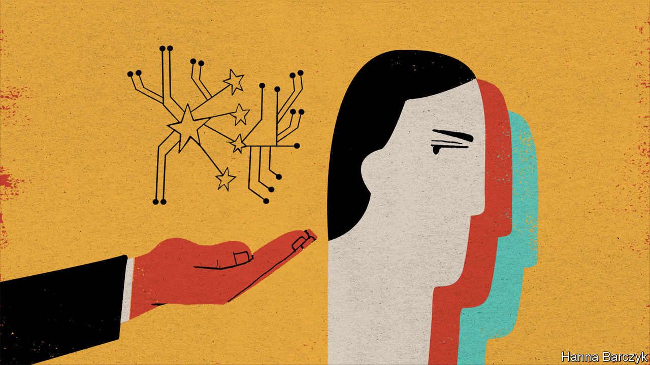

IN RECENT DAYS, as China prepared to turn Hong Kong into a cowed simulacrum of a world city—a shiny stage-set of modernity, run from the shadows by the mainland’s hard men—Chaguan asked Western envoys in Beijing how their countries might respond. Several chose to hear and answer a different question, namely, how might their government make China change course?

Be realistic, such diplomats sighed. China will impose this national-security law on Hong Kong. What would you have us do? Other well-placed foreigners in China are still more fatalistic about the West’s ability to influence China. That is true whether they are being asked about repression in Hong Kong or about Xinjiang, the far-western region that China has turned into a police state. It is shocking enough that over 1m members of Xinjiang’s mostly Muslim Uighur minority have been locked in re-education camps in recent years, suspected of extremism for praying or even wearing beards. On June 30th the Associated Press reported on an official campaign to force abortions and sterilisations on Uighur women, causing birth rates to plunge 24% in Xinjiang last year. Ask Westerners in Beijing about such painful subjects, and they cite forecasts that in coming years China will account for 30% of global economic growth. In a pandemic-induced recession, when millions of workers are losing their jobs, they reason, what government will sacrifice livelihoods on the altar of Hong Kong’s freedoms or Chinese human rights?

That maximalist framing of the China debate—pretending that any criticism of Chinese actions amounts to a futile call for changing China’s worldview, or even its political system—is in reality a cop-out, a convenient way to rationalise impotence. Chinese officials try a similar trick. They have spent decades accusing the West of plotting regime change, whenever democratic leaders object to any Chinese action. Actually, far from trying to contain China, for 40 years Americans and Europeans ignored endless provocations and broken promises in the hope that as the country grew richer it would open, and be more willing to co-operate on tackling climate change, nuclear non-proliferation or other global public goods.

Now America has a president, Donald Trump, who shows no interest in Chinese repression and scorns global goods, but whose administration does include true China hawks who regard Communist Party rule as inherently immoral. That has led to policies of unprecedented toughness, delivered with never-seen-before incoherence. Mr Trump mostly wants China to buy more American stuff, notably farm goods grown by Trump voters. To prise open Chinese wallets, Mr Trump has imposed punitive tariffs on Chinese goods and allowed hawkish underlings to enact offensive policies aimed at constraining China’s rise. America has banned exports of semiconductors and other sensitive goods to China, and formally declared such technology giants as Huawei to be a threat to national security. Visas for Chinese students and journalists have been limited and sanctions promised on Chinese officials responsible for abuses in Hong Kong and Xinjiang.

Bluster from Trump administration hawks, undercut by a president who cares little for principles, did nothing to slow China’s rush to impose authoritarian rule by law on Hong Kong. Fatalistic Westerners may feel vindicated, muttering that nothing can be done to change China’s ways. But changing China is not the only marker of success. A new paper by François Godemont of the Institut Montaigne in Paris describes Europe and America’s poor record of agreeing on, let alone imposing, policies that force China to do things. Mr Godemont is pitilessly clear-eyed about how China has fobbed Europe off with unkept promises and empty dialogues.

Yet if Europe is bad at offensive moves, it is doing better at defence. No player matters more than Germany. It accounts for almost 43% of the European Union’s exports to China, and is duly wary of confrontation (German officials shun EU language calling China a “systemic rival”). Still, Germany has joined EU institutions, France and others in tightening investment rules to shield covid-battered tech firms from being snapped up. New EU rules on procurement and scientific co-operation stress transparency and the protection of intellectual property. The European Commission is to ask EU countries to approve curbs on foreign subsidies. Such defences against Chinese predations give the EU leverage.

## Calling China out for its abuses is a good first step

A second reason to eschew fatalism is that next year America may have a new president, Joe Biden, committed to repairing transatlantic relations. Though Mr Biden spent years engaging with China, as a senator and vice-president, America has changed. Both parties see China as a strategic competitor. Highlighting their differences with Mr Trump, Democrats are keen to challenge autocrats and speak up for political freedoms.

Shared concerns about China could be a catalyst for renewed transatlantic co-operation, argues a new paper, “Dealing with the Dragon, China as a Transatlantic Challenge”, produced by the Asia Society Centre on US-China relations, the Bertelsmann Foundation in Germany and George Washington University. Differences remain. Broadly, Europeans see China’s rise as an economic threat, while Americans see a national-security challenge. Europeans are wary of offensive policies like export controls on high-tech goods. The Trump era has left a legacy of deep distrust. Still, the paper notes, America and Europe would gain by co-ordinating defences. A joint agenda could include sharing intelligence about cyber-security, Chinese investments and technological standard-setting, as well as about tireless Chinese attempts to co-opt or control international organisations, from the UN to the Arctic Council.

China is convinced that its interests are served by iron-fisted repression at home and bullying abroad. The West will not browbeat China into reading its interests differently. But democracies can build joint defences. That is already a worthy goal.■

This article was downloaded by calibre from <https://www.economist.com/china/2020/07/02/the-west-cannot-force-china-to-read-its-interests-differently>

|  |  |  |  |
| --- | --- | --- | --- |
| Previous | Articles | Sections | Next |

|  |  |  |
| --- | --- | --- |
| China | Sections | Europe |

Middle East & Africa

The Grand Ethiopian Renaissance Dam: Showdown on the Nile

.

Malawi’s new president: A lesson in democracy

.

Another sort of plague: Locusts at the gate

.

Sierra Leone: Guild of thieves

.

Facebook and autocrats: With friends like these

.

Music in the Arab world: Rap the casbah

.

|  |  |  |
| --- | --- | --- |
| China | Sections | Europe |

|  |  |  |  |
| --- | --- | --- | --- |
|  | Articles | Sections | Next |

#### Showdown on the Nile

# The bitter dispute over Africa’s largest dam

Egypt, Ethiopia and Sudan are struggling to share water

Jul 4th 2020 | BEIRUT AND ADDIS ABABA

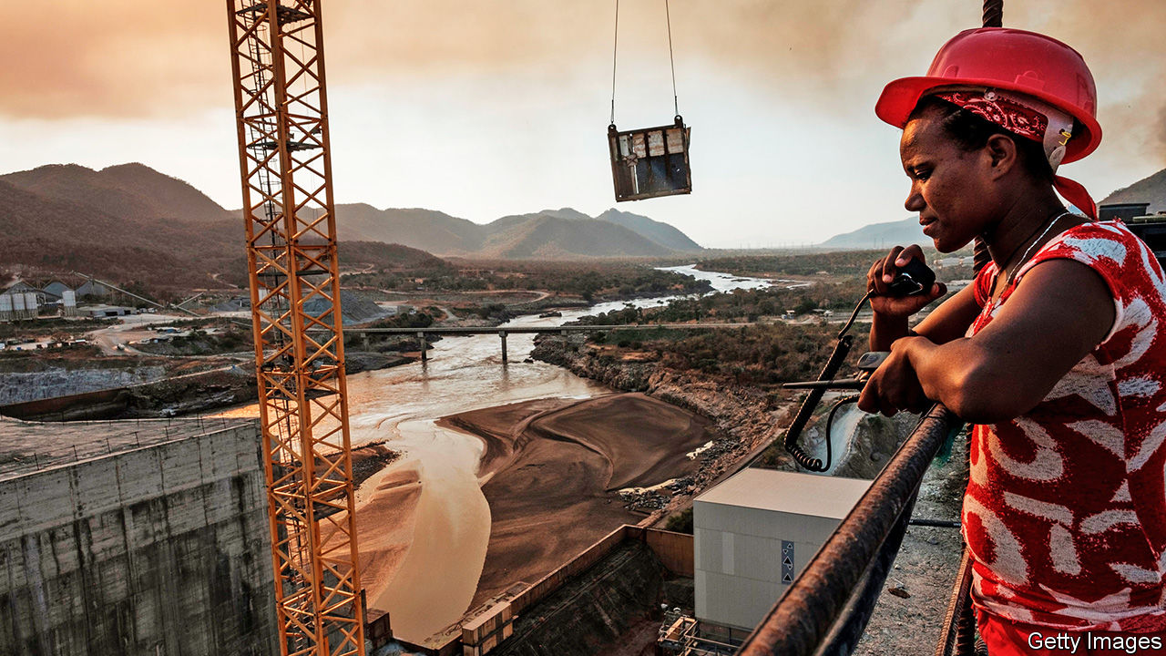

FOR BIRUK NEGAFH, as for millions of Ethiopians, the summer rains may bring the climax of a decade’s work. As a high-school student in 2011 he bought 100-birr bonds (then worth $6 each) to help finance the Grand Ethiopian Renaissance Dam, a giant edifice that would span the Blue Nile, the main tributary of the Nile river (see map). At university he donated to fundraisers for the project. Now, like almost all Ethiopians, he eagerly awaits the day—perhaps weeks away—when Ethiopia begins to fill the reservoir. “It’s a national victory,” he says.

Half a century in the making, the hydro-electric dam is Africa’s largest, with a reservoir able to hold 74bn cubic metres of water, more than the volume of the entire Blue Nile. Once filled it should produce 6,000 megawatts of electricity, double Ethiopia’s current power supply. Millions of people could be connected to the grid for the first time. More than an engineering project, it is a source of national pride.

For Egypt, however, it seems a source of national danger. Over 90% of the country’s 100m people live along the Nile or in its vast delta. The river, long seen as an Egyptian birthright, supplies most of their water. They fear the dam will choke it off. Pro-regime pundits, not known for their subtlety, have urged the army to blow it up.

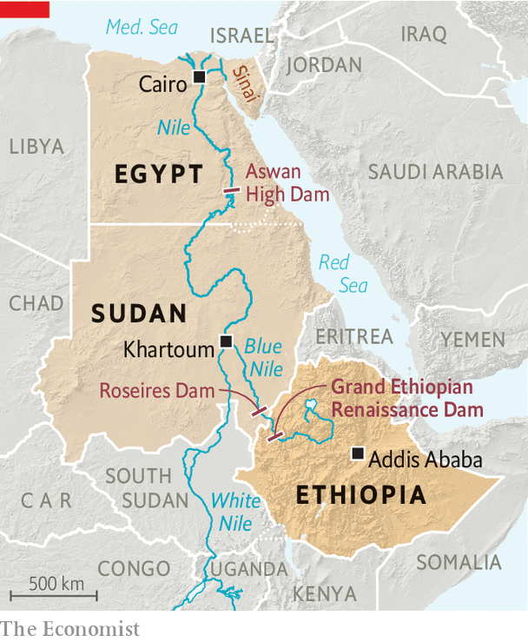

Both sides have tried diplomacy, but years of talks failed to produce a deal on how Ethiopia would fill and operate the dam. The African Union tried to mediate, as did America earlier this year. Now a deadline looms: Ethiopia wants to start filling the reservoir during this summer’s rainy season. On June 26th, after another round of talks, Egypt, Ethiopia and Sudan pledged to reach a deal within two weeks. Ethiopia agreed not to start filling the dam during that period.

Diplomats say most of the issues are resolved. But the outstanding one is big: how to handle a drought. Egypt wants Ethiopia to promise to release certain amounts of water to top up the Nile. But Ethiopia is loth to “owe” water to downstream countries or to drain the reservoir so much that electric output suffers. It wants a broader deal between all riparian states, including those on the White Nile, which flows out of Lake Victoria down through Uganda and Sudan.

Even if talks fail and Ethiopia starts filling without a deal, Egyptians will not find their taps dry. There is enough water in the reservoir behind Egypt’s Aswan High Dam to make up for any shortfall this year. But the mood in both countries is toxic. Egyptians have cast Ethiopia as a thief bent on drying up their country. In Ethiopia, meanwhile, Egypt is portrayed as a neocolonial power trampling on national sovereignty. The outcome of the talks will have political consequences in both countries, and perhaps push them to the brink of conflict—at a time when Egypt is already contemplating involvement in a war in Libya.

Mooted first by Emperor Haile Selassie in the 1960s, Ethiopia’s grand dam became a reality and a national obsession under Meles Zenawi, the longtime prime minister who ruled until 2012. His political masterstroke was asking Ethiopians to finance it through donations and the purchase of low-denomination bonds. (The World Bank and private investors were unwilling to put up the cash.) Almost every Ethiopian became a stakeholder. Most contributed voluntarily, but there was always an element of coercion. Civil servants had to donate a month’s salary at the start. Local banks and other businesses were expected to buy bonds worth millions of birr.

When he took office in 2018, Abiy Ahmed, Ethiopia’s current prime minister, criticised the dam as a project “used for political expediency” and warned it could take another decade to finish, statements seen as an attack on his predecessors. Some questioned his commitment. The cloud grew heavier after the death in 2018, officially by suicide, of the project’s chief engineer. At a meeting with Abdel-Fattah al-Sisi in Cairo, Abiy reportedly shocked advisers by discarding a planned speech and telling the Egyptian president: “I swear to God, we will never harm you.”

Two years on, Egyptians complain that Abiy has reverted to type. He is “inflexible”, says an Egyptian diplomat. Ethiopia is gripped by jingoism over perhaps the only issue that unites citizens of all ethnicities. On state TV broadcasters compare the dam to the battle of Adwa in 1896, when Ethiopians came together to defeat the Italians. Teddy Afro, perhaps the country’s most famous pop singer, released a song about the Nile on June 29th. Delaying filling would be politically risky for Abiy.

Nor does Mr Sisi have much room to compromise. Egypt is already short of water. The UN sets the threshold for scarcity at an annual 1,000 cubic metres per person. In 2018 Egyptians had just 570 cubic metres; even without the dam, that could drop to 500 cubic metres within five years. Ethiopia has blocked proper studies of how the dam will affect downstream countries.

The shortage is partly Egypt’s own fault. It uses almost 80% of its water, which it subsidises, for agriculture. (In Jordan and Israel, two nearby countries with limited freshwater resources, the figure is closer to 50%.) Irrigation canals, most of them decades old, are notoriously ill maintained and leaky. Farmers grow thirsty crops like bananas, rice and sugar cane, despite government plans meant to deter the practice. All this for a limited pay-off: Egypt still imports half its food. Supplies are further pinched by farm projects in Sudan, where Gulf states have bought large tracts of arable land to help feed their own people.

For years Egyptian officials failed to take the dam seriously. Now they face a deadline—and a pile of other problems. Egypt’s covid-19 outbreak started slowly, but the daily death toll peaked on June 15th and remains at a high plateau. Economic damage is mounting, too. On June 26th the IMF approved a loan of $5.2bn to Egypt.

Mr Sisi is also nervous about developments on his western border. Khalifa Haftar, the Egyptian-backed Libyan warlord who last year vowed to capture Tripoli, beat an ignominious retreat this spring. He was pushed back after Turkey sent armed drones and Syrian militiamen to support the UN-recognised government in Tripoli.

Egypt sees a Turkish presence next door as a threat. Relations have grown steadily worse since 2013, when Mr Sisi overthrew Muhammad Morsi, an Islamist, like Turkey’s president, Recep Tayyip Erdogan. Last month Mr Sisi said his country had a right to intervene in Libya. He warned the Turkish-backed forces not to advance past Sirte, a strategic coastal city that sits near Libya’s main oil-export terminals.

Egypt’s army is wary of foreign wars, a caution that dates back to its ill-fated intervention in Yemen in the 1960s, which cost tens of thousands of lives (and left it unprepared to fend off Israel in 1967). Since then it has largely avoided overseas adventures, save for an unimpressive cameo in the Gulf war in 1991. Instead it has fought jihadists on the Sinai peninsula, overthrown a president and built an economic empire that stretches from luxury hotels to cement. Now Mr Sisi finds himself uncomfortably surveying crises on two fronts.

Abiy’s position in Ethiopia is hardly more comfortable. Rivals at home have seized on his perceived weakness. One opposition leader accuses him of offering the dam as a “sacrificial lamb” to foreign powers. “If he fails to start filling in July, he is in trouble,” says Jawar Mohammed, an influential activist, who was arrested last month. On June 30th protests erupted after a popular musician from the Oromo ethnic group was killed, a reminder of how thin the veneer of national unity is. The technical details of a deal can be worked out, but neither leader has a deep reservoir of political capital to make it a reality. ■

This article was downloaded by calibre from <https://www.economist.com/middle-east-and-africa/2020/07/04/the-bitter-dispute-over-africas-largest-dam>

|  |  |  |  |
| --- | --- | --- | --- |
|  | Articles | Sections | Next |

|  |  |  |  |
| --- | --- | --- | --- |
| Previous | Articles | Sections | Next |

#### Second time lucky

# Malawi’s re-run election is a victory for democracy

Brave judges, a feisty press and plucky civil society boost a hopeful trend in Africa

Jul 4th 2020 | JOHANNESBURG

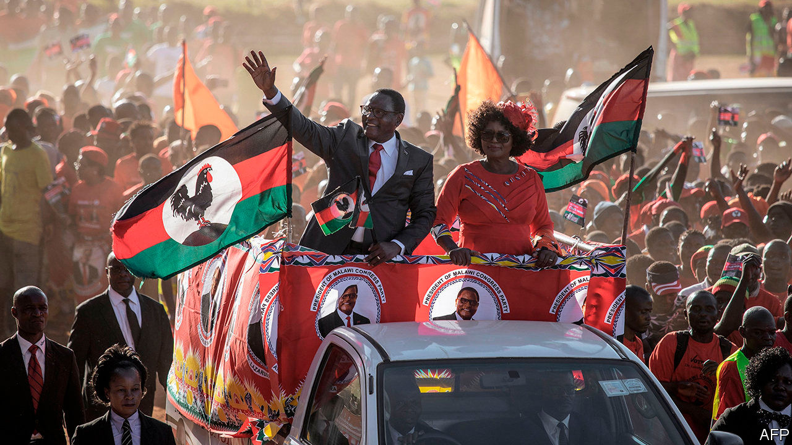

THERE IS A blueprint for presidents keen to rig elections. First, use state resources to bribe, fool and bully people before the poll. Once voting starts, stuff the ballot boxes or fiddle the tallies. Afterwards, make sure the army and judges are on your side in case opponents take their case to the streets or to the courts.

When Peter Mutharika, the incumbent, was declared the winner of Malawi’s presidential election in May 2019, it seemed a textbook case of rigging. Voting sheets had been altered with Tipp-Ex, a correction fluid. International observers complained only half-heartedly. But Malawians fought back. Activists organised peaceful protests. Opposition parties went to the Constitutional Court. In February its judges, apparently after turning down bribes, granted a re-run, which was held on June 23rd.

The result, announced on June 27th, was a victory for Lazarus Chakwera of the Malawi Congress Party (MCP) and his opposition alliance. He won 59% of the 4.4m votes cast; Mr Mutharika took just 40%. The margin of defeat was such that the now former president had no grounds to question the outcome.

Lazarus is a deliciously appropriate name for a politician whose career seemed to have died a year ago. It also marks his religiosity, since his father, a subsistence farmer who had already seen two sons perish in infancy, named the future president after a man whom Jesus is said to have raised from the dead. Mr Chakwera became a theologian, leading the Malawian branch of the Assemblies of God church, part of a global Pentecostal network. In 2013 he swapped the cloth for the campaign trail. He became head of the MCP, which had struggled to shake off its legacy as the political vehicle of Hastings Banda, the dictator who ruled Malawi from 1964 to 1994.

Malawi is one of the most devout countries in Africa. Fully 81% of Malawians say they trust religious leaders, compared with an average of 69% in the 34 countries recently surveyed by Afrobarometer, a pan-African pollster. That made it easier for Mr Chakwera to present himself as a clean alternative to Mr Mutharika, whose regime was widely seen as filthy.

It will, however, take more than preaching to improve Malawians’ lot. Mr Chakwera has promised 1m new jobs and a universal subsidy for fertiliser—a tempting pledge in a mostly agrarian economy. But it will be hard to pay for these promises. The country is one of the poorest in the world: 70% of its people live on less than $1.90 a day (at purchasing-power parity). Many public services depend on foreign aid. GDP per person is forecast to fall this year and next, thanks to covid-19.

In any event, Malawi deserves to savour its victory. It has shown the importance of strong institutions in fragile democracies. Independent judges, a vibrant civil society, a feisty press, a strong parliament—they all make it harder for a dodgy incumbent to cling to power. Their steady if uneven rise across the continent is one reason why there have been 32 peaceful changes of power in Africa since 2015—and why 19 of these have involved an incumbent having to stand aside. Malawi is a sign that African politics is becoming more competitive. And politicians and parties that have to compete have more of an incentive to deliver improvements to voters’ lives, in Africa as anywhere else. ■

This article was downloaded by calibre from <https://www.economist.com/middle-east-and-africa/2020/07/04/malawis-re-run-election-is-a-victory-for-democracy>

|  |  |  |  |
| --- | --- | --- | --- |
| Previous | Articles | Sections | Next |

|  |  |  |  |
| --- | --- | --- | --- |
| Previous | Articles | Sections | Next |

#### Another sort of plague

# Locusts have hit east Africa hard

Farmers, NGOs and investors are all worried. West Africa could be next

Jul 4th 2020 |

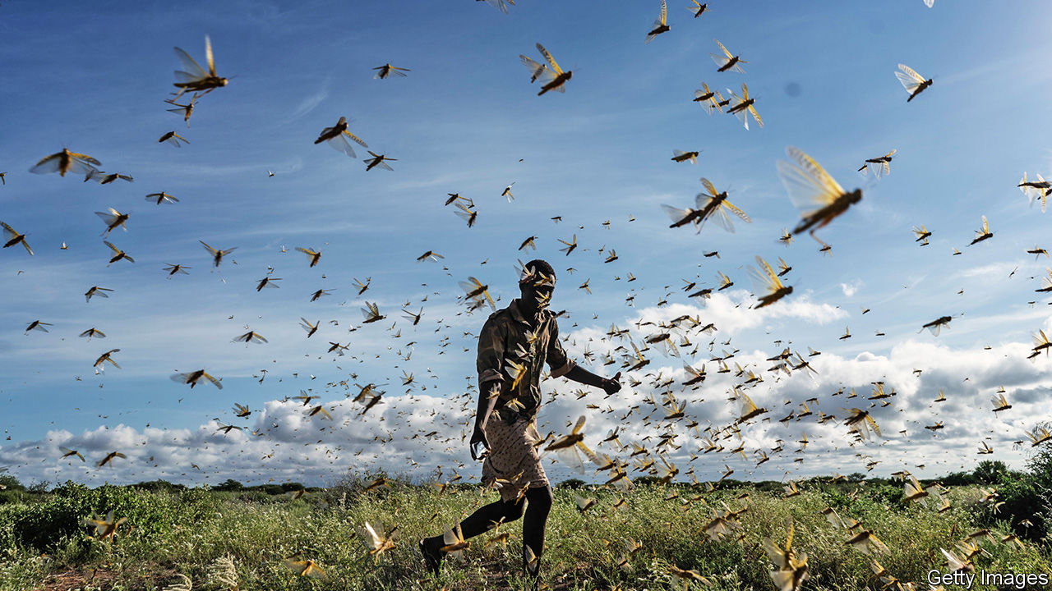

VAST SWARMS of locusts have swept through Kenya and Ethiopia since January, devastating fields, pastures and livelihoods. Governments have struggled to suppress them. They have continued to breed in their billions, threatening whole economies, which are also being battered by the covid-19 pandemic.

Last month Fitch, a credit-rating agency, issued its first-ever warning that locusts could shake east Africa’s macroeconomic stability. In Ethiopia the voracious insects may drive up food prices, accelerating consumer inflation that is already running at about 20% a year. They may also cause Ethiopia’s fiscal deficit to widen.

Moody’s, another ratings agency, is just as gloomy. It said the locusts are “credit negative” for governments in the region. The “twin shocks” of covid-19 and locusts have led it to cut by more than half its economic growth forecasts for several countries, including Ethiopia and Kenya. East Africa is particularly vulnerable to locusts because farming and herding generate about a third of its GDP and provide two-thirds of jobs. The only exception to this rule of thumb is Kenya, which has a more diverse economy.

Like humans, locusts eat maize, sorghum and millet. They also chomp the grass that sustains livestock. Swarms like one that ravaged Kenya earlier this year can contain 200bn locusts and eat as much in a day as the entire population of Germany. And more may be on their way. “We are not seeing the end of the tunnel yet,” says Fatouma Seid of the UN’s Food and Agriculture Organisation (FAO).

The bugs’ breeding puts rabbits to shame; each generation can be 20 times larger than the one before. This latest one is now feeding voraciously as the pests grow from immature hoppers into adults that eventually swarm and migrate.

The invasion, which grew dramatically in January, is the biggest in decades for Ethiopia, Kenya and Somalia. Data are patchy on the harm the locusts are causing, because covid-19 makes it hard for bug-watchers to get around. But in April it was reckoned that locusts had already damaged 200,000 hectares of Ethiopia’s arable land and 1.3m hectares of its pasture, despite a spraying campaign. As a result an extra 1m Ethiopians need emergency food. The International Rescue Committee, an NGO, says locusts have damaged more than half of Somalia’s pasture, too. Some 20m people already face hunger in the wider region. Covid-19 and locusts may double that figure, says the World Food Programme.

The World Bank fears that the infestation could cause economic damage in the greater Horn of Africa and Yemen to the tune of $8.5bn if remedial steps are not taken. Even if the outside world piles in with immediate help, losses could exceed $2.5bn, it reckons. Agricultural exports, which dominate the region’s sales abroad, are at risk, too.

Even more worrying is that the zone of devastation is expanding. Swarms could soon swirl over from Somalia to India and Pakistan, which are already suffering infestations. And maturing locusts in northern Kenya are preparing to take flight and ride the winds blowing north. These could carry them as far as 150km in a day.

The FAO’s Keith Cressman hopes they will stop in Sudan, which is generally fairly good at spraying and suppressing them; it has even sent locust-surveillance teams to its embattled western region of Darfur for the first time in 17 years. But unless it rains more in Sudan’s deserts, the locusts will not stay there for long. In search of food, billions may head to west Africa via the Sahel (see map), where they would be harder to control.

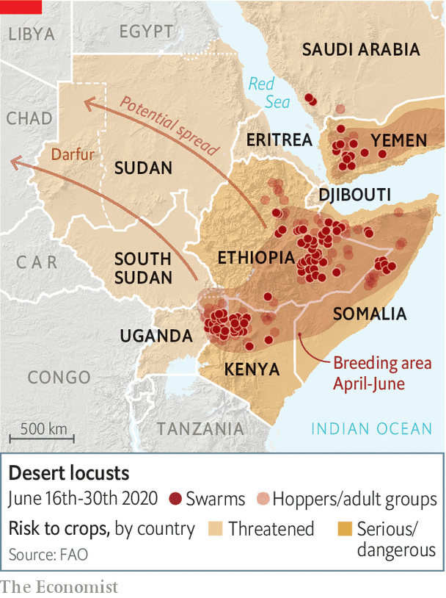

After a slow start, governments are reacting. More than half a million hectares in east Africa have been sprayed with pesticides, despite delays in the arrival of experts from abroad and shipments of chemicals because of covid-19. Many of the region’s most valuable crops have been protected. But pastoralists reliant on grasslands have not been so lucky. Foreign donors have pitched in. The World Bank will lend $500m to countries in east Africa and the Middle East, but it is not nearly enough. Ethiopia has received less than two-thirds of the $77m it asked donors for.

The best way to beat the bugs is to track them constantly, then spray them before they can breed again. Prevention is also much more cost-effective than controlling an outbreak once it has taken hold. For example, in 2003 it cost $570m to eliminate swarms of locusts in the Sahel, a sum that could have paid for 170 years of prevention, says the FAO. And that is before taking into account the damage to crops and pastures that the locusts caused. But early action is not happening. Last year the FAO repeatedly and unsuccessfully asked for pre-emptive help for Yemen and Ethiopia. The FAO has since appealed for $23m for surveillance and prevention in west Africa. So far nothing has been pledged. ■

This article was downloaded by calibre from <https://www.economist.com/middle-east-and-africa/2020/07/04/locusts-have-hit-east-africa-hard>

|  |  |  |  |
| --- | --- | --- | --- |
| Previous | Articles | Sections | Next |

|  |  |  |  |
| --- | --- | --- | --- |
| Previous | Articles | Sections | Next |

#### Club of cutpurses

# Inside the thieves’ guild in Freetown

Beggars have a union in Sierra Leone; so do sex workers

Jul 4th 2020 | FREETOWN

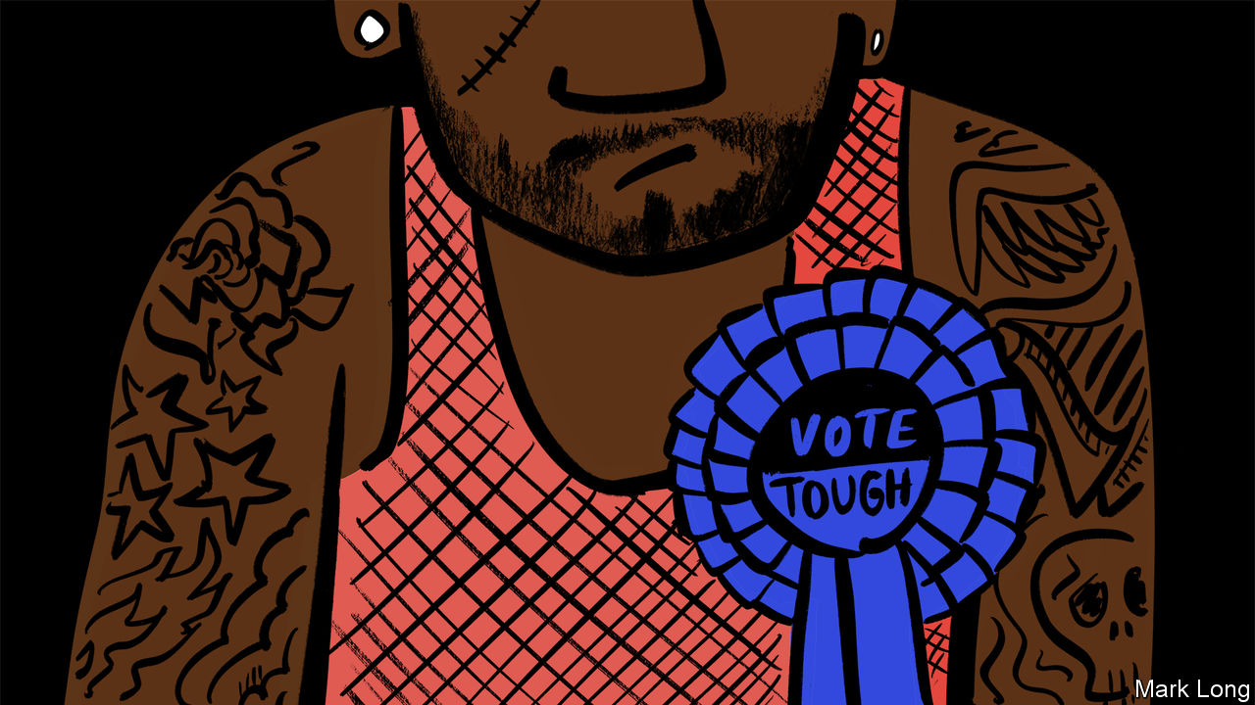

LIKE MANY clubs, it is selective. Only the right sort of person may join. It has a spokesman, a financial secretary and an interim chairman. But in other ways the Black Street Boys is rather different from, say, a club in Pall Mall or Augusta, Georgia. Members sport matching tattoos of the harp symbol used on bottles of Guinness. And instead of spending their days playing bridge or golf, the Black Street Boys talk about breaking into cars, picking pockets or robbing people at knifepoint.

Before admission, “we’ll interview you, ask where you come from, what your motivation is and why you decided to come here and learn the ways of the streets,” says its interim chairman. He claims to be reforming the gang and that its members now make an honest living patching up car tyres or stitching clothes. But everyone in town says many are still crooks. The chairman took over after the untimely death of his predecessor. He is filling in until an election can be held. His duties include intervening when members scuffle with other gangs, such as Friends of the Dead, whose members loiter at a nearby cemetery.

It is not only thieves who have guilds in Sierra Leone. Every Saturday at 5pm a gaggle of women meet on a beach in Freetown, the capital. Each presents a membership card with her name and photo. A chairwoman leads the discussion while a harried secretary takes minutes. The women then fumble in their handbags for their dues of $2 to the sex-workers’ association.

“Nobody else was going to help us, so we decided to support ourselves,” explains Isha Turay, the chairwoman. The money she collects each week goes into a communal pot. Members can dip into it in an emergency, such as needing to pay a hospital bill or bury a relative. Anyone who abuses the system is immediately thrown out. When, all too often, a client refuses to pay up, the group rallies. A handful of members will turn up on his doorstep, accompanied by a burly male.

There are hundreds of informal associations like these across the country. The youngsters who sell pirated CDs in downtown Freetown answer to a chairman and vice-chairman, as do the beggars who loiter outside a hilltop supermarket in the west of the city. Neighbours band together and form committees to look out for one another. The chairmen mediate squabbles, punish thieves and drum up cash when members are sick. Some are corrupted by power and end up squeezing extra, undue payments from members.

Such groups exist because the state is a shambles. According to a report last year by Transparency International, a Berlin-based watchdog, more than half of Sierra Leoneans paid bribes for public services. When officials are predatory, people turn to their communities for protection.

There are some historical reasons for these structures, too. They mirror the decentralised system of governance that existed when the British colonised Sierra Leone. Without a national leader, each region was controlled by a chief and his underlings. There are still chiefs today who wield a lot of power outside the cities.

“It’s not that much different from any UK village choir or soccer club,” says Paul Richards, an anthropologist. “Someone has to do the work, and they reward themselves with grand titles.” The main difference, perhaps, is that in a country with almost no state, those with the titles have a lot of work to do. ■

This article was downloaded by calibre from <https://www.economist.com/middle-east-and-africa/2020/07/04/inside-the-thieves-guild-in-freetown>

|  |  |  |  |
| --- | --- | --- | --- |
| Previous | Articles | Sections | Next |

|  |  |  |  |
| --- | --- | --- | --- |
| Previous | Articles | Sections | Next |

#### With friends like these

# Facebook has been bending to the will of Arab despots

Activists are finding it hard to stay on the right side of the company’s rules

Jul 4th 2020 |

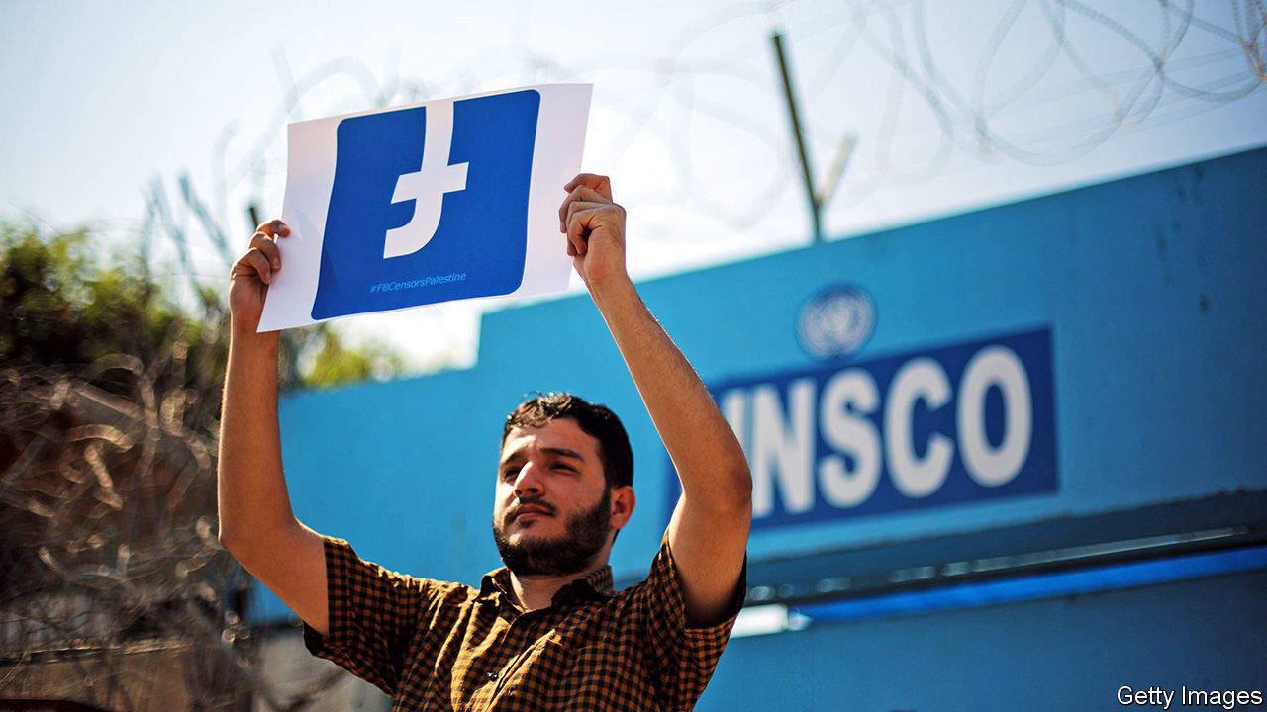

FOR SARIYA AL-BITAR, an architect in Syria’s war-torn city of Idlib, the message was devastating. “Your account has been permanently disabled for not following our Facebook Community Standards,” read the note from the social-media giant. “Unfortunately, we won’t be able to reactivate it for any reason.” Fourteen years of family photos, reminiscences and his diary of Syria’s civil war—along with his list of 30,000 followers—were erased. Mr Bitar had tried to be careful. He had not called dead rebels shahids (martyrs) or posted gore. He suspects Facebook silenced him for commemorating a Syrian football star who, after months of protesting, picked up arms and was killed by the regime of Bashar al-Assad.

In a region ruled by despots, Facebook claims to give “free expression maximum possible range”. That has won it a vast following. The platform has more users in the Gulf states than anywhere else in the world, relative to the population. It is the main source of news for many Arabs. Some even credit it for the Arab spring protests of 2011. But since going public in 2012, Facebook has grown more mindful of the authoritarians who provide it with access, say critics, and less hospitable to activists. In recent months it has culled hundreds of users from Tunisia to Iran and deleted hundreds of thousands of posts. “Many people feel that Facebook is no longer a platform they can use to hold the powerful to account,” says Marwa Fatafta of Access Now, a pressure group. Add to that Facebook’s challenges in America, where it has lost a slew of advertisers over its failure to police hateful content (see article).

Size is part of the problem. Facebook has 2.7bn users, many of whom write in foreign languages. Their posts are vetted for hate speech and incitement. But the firm’s 15,000 content moderators struggle to cope. Most do not know Arabic and its dialects. So the firm relies on automated filters, which make mistakes. They screen flagged words, but cannot detect cultural nuance or satire. Facebook rarely explains why it deletes content. “Despite a huge number of users in the global south, they are largely excluded from the conversation,” says Wafa Ben-Hassine, a Tunisian-American human-rights lawyer.

Facebook is bound by American law, which counts some key players in the Middle East as terrorists. Iran’s Islamic Revolutionary Guard Corps, Hizbullah, Hamas and a raft of other armed Islamist groups are banned. Occasionally American media outlets give members of these groups airtime, but Facebook has a rigid interpretation of the law against aiding and abetting terrorists. More troubling is how it bans people sympathetic to these groups—or removes content that simply refers to them. Even Hizbullah’s opponents spell the militia’s name with a space between each letter to prevent Facebook deleting their posts.

Arab governments have passed laws against cybercrime and online terrorism to cow social-media firms and their users. Facebook “tries to comply” with local codes. It has opened an office in Dubai to liaise with officials in the region. “Digital platforms try as much as they can to collaborate with regulators to avoid the consequences of violating local regulations,” says a Gulf official. Dissidents concur.

Governments use more subtle forms of pressure, too. They have threatened to tax Facebook’s in-country earnings and lean on advertisers. Many also operate electronic armies to bombard Facebook with content, often complaining about opposition groups. A watchdog backed by Israel called Act.IL claims to have 15,000 “online volunteers” from 73 countries keeping an eye on the platform. As a result, say critics, Facebook screens content by Palestinians far more vigorously than posts by Israelis.

In an effort to restore user confidence, the firm recently deleted hundreds of fake accounts promoted by Saudi Arabia, Iran and Egypt. In May it unveiled a new oversight board which will act as its “supreme court”. It will hear appeals and monitor government websites for incitement. “Official terrorist designations will not necessarily be binding on us, especially when they come from authoritarian governments that misuse terrorism to abuse opponents,” says Tawakkol Karman, a Yemeni journalist and Nobel laureate who is one of two board members from the Middle East. More such thinking is needed. ■

This article was downloaded by calibre from <https://www.economist.com/middle-east-and-africa/2020/07/04/facebook-has-been-bending-to-the-will-of-arab-despots>

|  |  |  |  |
| --- | --- | --- | --- |
| Previous | Articles | Sections | Next |

|  |  |  |  |
| --- | --- | --- | --- |
| Previous | Articles | Sections | Next |

#### Rap the casbah

# As Arab rappers challenge the old ways, despots hit back

Middle Eastern rulers prefer songs without pesky lyrics

Jul 4th 2020 |

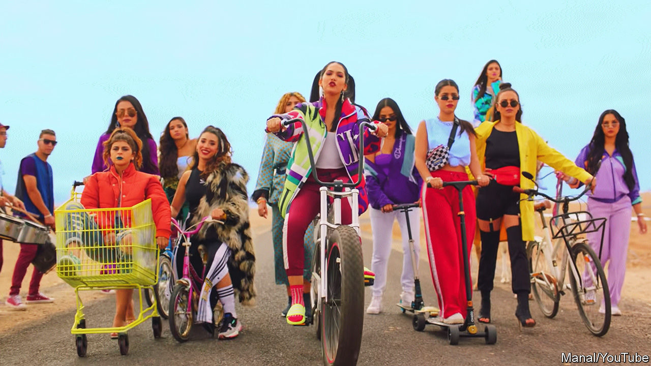

“I’M A WOMAN in a land of dicks,” raps Khtek, a Moroccan student, whose first single, “KickOff”, went viral in February. Her lyrics criticise the country’s gaping inequality and stifling political, social and sexual hierarchies. Her tattoos and blue hair defy the kingdom’s traditions. “My rap is a voice for those who don’t have one,” says Khtek, a stage-name which in darija, Morocco’s vernacular, means “your sister”.

Rap music came to the Middle East a generation ago, when Moroccans studying in the West returned with it. King Muhammad VI has promoted hip-hop as a cultural antidote to Islamism. But it has been embraced most enthusiastically by the urban poor, who create their own tracks in local slang. Nowadays Arab rappers challenge conservative mores and articulate the fury of disenfranchised, jobless youths. Last year their protest songs became anthems in the mass demonstrations that toppled leaders in Algeria, Sudan and Iraq.

Morocco’s rap scene is probably the most lit in the Arab world. Manal Benchlikha, simply known as Manal (pictured, on bike), is a symbol of girl power. One of her songs notched up 43m views on YouTube. Female rappers often challenge the taboos of a patriarchal society. “I rap for queers and the discriminated,” says Khtek. Others challenge officials and the police. A song called “Aacha el Chaab” (long live the people) lampoons the king. It went viral last year.

Some Arabs dislike what rappers are saying. As in America, lyrics sometimes promote gangsterism, violence and qarqoubi, north Africa’s version of crack cocaine. Despite the rise of female stars, men still dominate the line-up and often produce misogynistic tunes. Several rappers joined Islamic State, a jihadist group, and tried to lure others with songs like “Dirty Kuffar”(unbelievers). Black Tiger, a Libyan rapper dressed in army fatigues and flanked by a chorus of gunmen, encourages young fighters for Khalifa Haftar, a rebel warlord.

Despots have responded predictably. Morocco jailed one of the rappers behind “Aacha el Chaab”. Saudi Arabia detained a rapper for her track “Girls of Mecca”. Syria has chased most of its rappers abroad, including Bu Kolthoum, who now cheers on rebels from his home in Europe. Egypt is mulling a ban on rap songs that include profanities—in other words, almost all of them. Such is the repression that “political messages have disappeared, even underground,” says Gemyhood, an Egyptian music critic.

A few leaders are following the example of King Muhammad VI and trying to co-opt rap for their own ends. Last year Muhammad bin Salman, the de facto ruler of Saudi Arabia, hosted 50 Cent, an American star, as part of his push to promote more liberal social mores. Some Shia seminarians in Iraq rap their sermons using traditional rhythmic chest-beating as their backing track.

And even autocrats don’t seem to mind Trap, a throbbing rap genre, where the music drowns out the lyrics. The most popular rap song to emerge from the United Arab Emirates is called “Wala Kilma”, meaning “Not a Word”.

This article was downloaded by calibre from <https://www.economist.com/middle-east-and-africa/2020/07/04/as-arab-rappers-challenge-the-old-ways-despots-hit-back>

|  |  |  |  |
| --- | --- | --- | --- |
| Previous | Articles | Sections | Next |

|  |  |  |
| --- | --- | --- |
| Middle East & Africa | Sections | Britain |

Europe

Russia: Parade’s end

.

Turkey: Osman and the snails

.

France: The president’s dilemmas

.

Ireland: A new world

.

Covid-19 and the Nordics: Borderline personalities

.

Charlemagne: Let expats vote

.

|  |  |  |
| --- | --- | --- |
| Middle East & Africa | Sections | Britain |

|  |  |  |  |
| --- | --- | --- | --- |
|  | Articles | Sections | Next |

#### Parade’s end

# A phoney referendum shows Putin’s legitimacy is fading

A proposal to extend his rule passes, buried in a huge package of feel-good measures

Jul 4th 2020 |

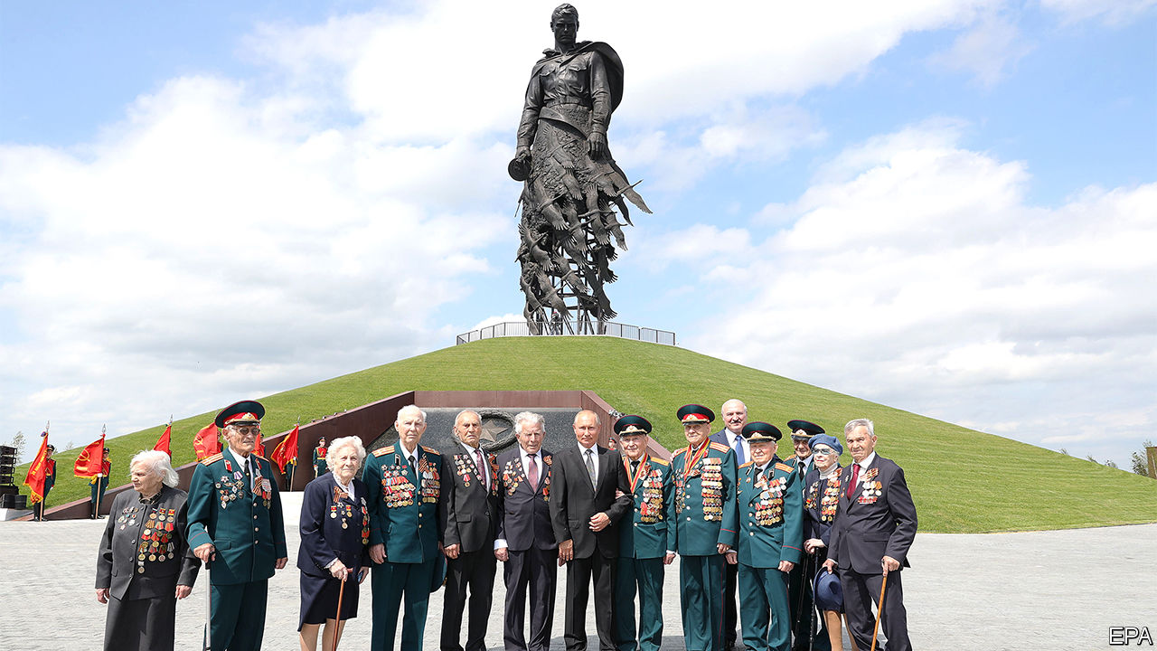

ON JUNE 30TH Vladimir Putin posed in front of a 25-metre bronze statue to the Soviet soldier which he had just unveiled. Filmed from below, to give him extra height, President Putin appealed to his people to vote on a package of constitutional changes, for the sake of the motherland that millions of Russians died to defend against Hitler.

He did not mention the real reason for the vote: to let him stay in power beyond 2024, when he is obliged by the current constitution to stand down. The next day Mr Putin declared victory, after a whopping 78% of Russians were declared to have voted to approve the 200-odd changes which together mark a new phase in his reign. He hopes to move from being merely the second president of post-Soviet Russia to being its life-long supreme leader.

Mr Putin’s moment before the statue was the culmination of a week-long circus, full of parades, trickery, games and prizes. Muscovites received text messages telling them that if they turned out to vote, they could win one of 2m vouchers together worth 10bn roubles ($140m). In Siberia voters were lured with prizes ranging from a smartphone to an apartment. One flat was won by the head of a local polling station. Employers ordered staff to vote.

Mobile polling stations were set up in playgrounds and courtyards, and on lorries parked by the sides of the road, where ballots could be cast into cardboard boxes. The voting was stretched over a week and was partly conducted electronically, creating ample opportunity for rigging.

It was not a proper referendum. It had no precedent or legal basis. It did not require a minimum threshold, was not independently monitored and did not follow any clear rules. The changes had already been passed by Russia’s servile parliament, approved by its constitutional court and signed into law by the president.

The 206 proposals in the referendum were designed to confuse. Voters were asked to approve a long list of crowd-pleasing ideas: inflation-proof pensions, protected status for the Russian language and the banning of gay marriage. Adding to the flim-flam were proclamations of faith in God and ancestors. Voters were not allowed to pick and choose which elements to support: it was either yes or no to the whole lot.

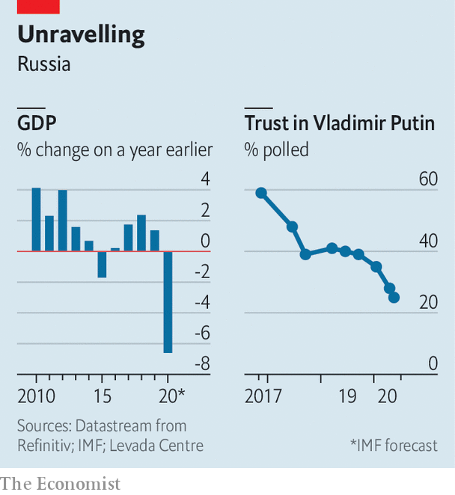

Buried in the middle of this haystack of populist pledges was the real point of the exercise. The number of terms Mr Putin has served as president is to be set back to zero. More power is to be concentrated in his hands. He will be able to fire judges of the supreme and constitutional courts.

It was less brazen than rolling tanks into Red Square and declaring a coup, but only just. The referendum flagrantly violates the post-Soviet constitution of 1993, which Mr Putin swore to uphold. Constitutional amendments are meant to be voted on separately by parliament, so that Russians are not forced to choose between their own moderately comfortable retirement and Mr Putin’s.

## How to win a referendum

Instead, MPs passed a law allowing them to vote on the entire package of changes. Mr Putin’s liberation from the two-term limit was kept out of official advertising material because, so an independent opinion poll showed, three-quarters of Russians opposed it. Kirill Rogov, a political analyst, likens Mr Putin’s win to Russia’s victories in the 2014 Sochi Winter Olympics, achieved by doping athletes and swapping their urine samples through a secret hatch in a laboratory. “It shows Putin can win because nobody can stop him. But it also shows he can only win by breaking the rules,” he says.

Big electoral victories have been at the core of Mr Putin’s claims to legitimacy. He also relies on a mix of personal charisma and appeals to nationalism—hence his constant evocations of the spirit of the second world war. But after 20 years in power, his legitimacy appears to be melting away, and his attempts to restore it through fakery and coercion risk eroding it further.

Appointed as acting president of Russia by Boris Yeltsin at the end of 1999, Mr Putin long ago did away with free and fair elections. Genuine opponents are harassed, imprisoned or barred from standing. State media are thoroughly one-sided. Nonetheless, there has been a degree of popular consent to his rule. It has rested on the concept of “Putin’s supermajority”—an idea first introduced by one of his spin-doctors, Gleb Pavlovsky, months before Mr Putin’s first election victory in 2000. It drew on the antique notion of a special bond between ruler and people. It embraces the populist claim that Mr Putin speaks for the majority of former Soviet citizens who lost out during the country’s transformation in the 1990s, at the hands of a minority who benefited from liberal reforms. In time, the new Russian elite became reliant on Mr Putin to protect their status and (often ill-gotten) wealth.

This broad consent started to crack in 2011, when Mr Putin announced that he would return to the presidency after getting round term limits (for the first time) by spending a spell as prime minister. Protests broke out in large Russian cities. In 2014 Mr Putin arrested that discontent and boosted his faltering popularity by annexing Crimea, a peninsula on the Black Sea belonging to Ukraine. This act of war drew global condemnation but sparked a wave of nationalist euphoria within Russia.

However, by 2018 the Crimean bounce had largely dissipated. International sanctions and the cronyism of the new elite made Russians poorer. With less money to go around, regional bigwigs started to grumble and fight. Mr Putin was too preoccupied with his military adventures in Syria and elsewhere to arbitrate over domestic power struggles. Local mayors and governors were ousted by rivals backed by the security services. Those who tried to resist by appealing to the electorate, like Alexander Shestun, the head of a district near Moscow, ended up in prison.

Still, in presidential elections in March 2018 the Kremlin managed to spend, coerce and finagle its way for Mr Putin to win 77% of the votes cast. Ekaterina Schulmann, a political scientist, characterises this as an election won on credit—and the Kremlin has struggled to pay it off. The government has felt obliged to raise the official retirement age. This has provoked an uproar among Mr Putin’s traditional supporters.

In late 2018 the Kremlin suffered upsets in several regional elections, and in the summer of 2019 mass protests broke out in Moscow after the Kremlin disqualified all the independent candidates in (relatively unimportant) municipal elections. The police brutally put the protests down, but the sympathies of perhaps half the population were with the protesters.

Mr Putin acknowledged the shift in public opinion. On January 15th he told the nation: “Our society is clearly calling for change. People want development, and they strive to move forward.” The package of constitutional tweaks he proposed was supposed to give the impression of real reform, while in fact it cements his power. In initial discussions, Mr Putin did not say anything about his role after 2024. His plan may have been to keep people guessing. This would have been a risky tactic, however. Though no one really expected him to retire at the end of his current term, uncertainty within the Russian elite over what would happen at that point risked turning Mr Putin into a lame duck.

So on March 10th a codicil to the reforms was added. After they were passed, Mr Putin’s term-limit clock would be reset to zero. The deal was to be sealed in an “all people’s vote” on April 22nd—Lenin’s birthday—and followed by a military parade on May 9th, the 75th anniversary of the Soviet victory in the second world war, to be attended by many foreign leaders including the presidents of America, China and France.

Covid-19 disrupted this plan. Mr Putin reluctantly postponed both the parade and the vote, and all but disappeared from view. Sergei Sobyanin, the mayor of Moscow, imposed a strict lockdown on March 29th which he said should last until daily new cases were in only double figures.

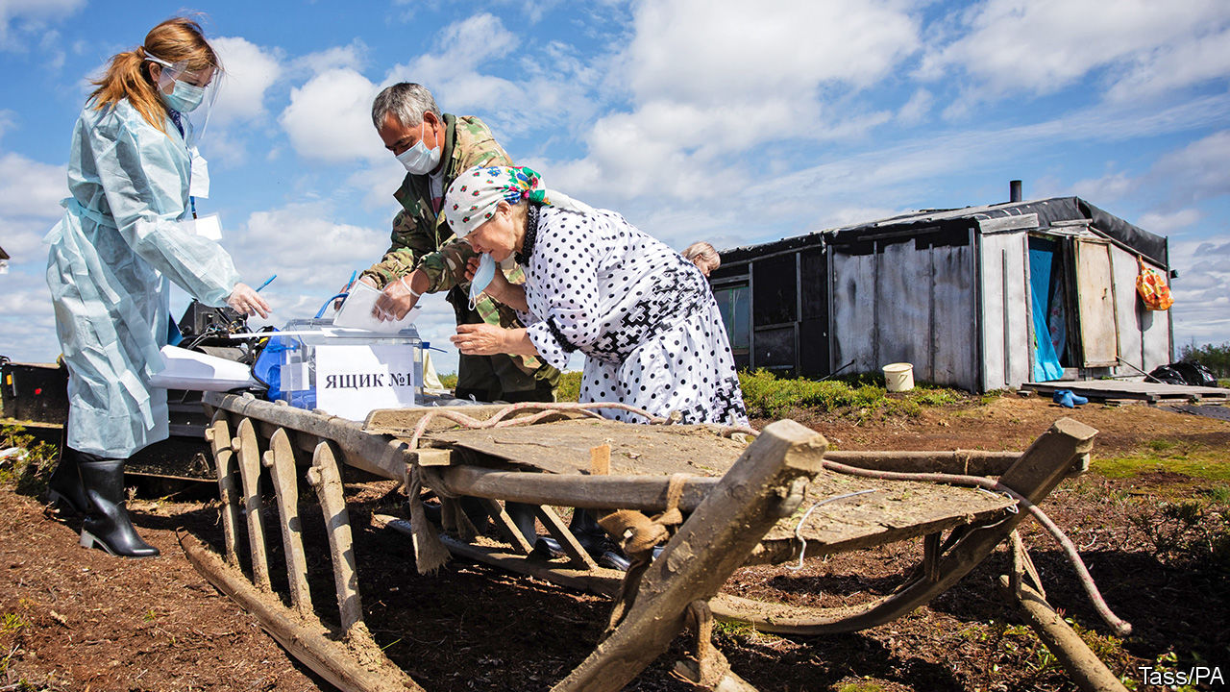

According to the Levada Centre, an independent pollster, Mr Putin’s already shaky position has deteriorated further during the covid-19 crisis. Russia has been hit badly by the pandemic—much worse, it appears, than official statistics reveal. A focus group conducted by sociologists and psychologists led by Sergei Belanovsky, who accurately predicted the mass protests of 2011-2012, shows that dissatisfaction is directed personally against Mr Putin. “This is not irritation. This is anger. Anger is boiling over because of their stupid decisions. We should tell them to go to hell,” one respondent said.

Postponing the vote until the autumn seemed too risky. So on May 26th, despite new covid cases running at nearly 9,000 a day, Mr Putin announced that the Victory Day parade would be held on June 24th, the day on which Stalin held his own parade in 1945. The Soviet dictator had stood on the Lenin Mausoleum, watching Red Army soldiers drag captured Nazi banners over the wet cobblestones and toss them in the gutter in front of the podium. Seventy-five years later Mr Putin stood in front of the same mausoleum, surrounded by decorated veterans who had been quarantined for two weeks so as not to infect the commander-in-chief and the few post-Soviet autocrats who attended. Moving the commemoration from May 9th to June 24th had been a setback for Mr Putin. But it ended up being held on the date of the event in 1945 it most closely resembled: the parade of Stalin’s power, not the people’s earlier joyful celebration of victory back on May 9th.

The voting started the day after Mr Putin’s parade. Its result was never in doubt, but whether the exercise succeeds in buttressing Mr Putin’s legitimacy certainly is. A barrage of caricatures and rude comments on social media suggests that the ruse is not working. “Putin has lost his majority,” says Mr Belanovsky. His focus groups show that it is not just democracy-minded Russians who have turned away from him. So have nationalists and communists. Once delighted by Mr Putin’s annexation of Crimea, they now see him as corrupt and deceitful. Most important, Mr Belanovsky writes, is that Mr Putin has lost the backing of the apolitical middle that used to be his main base.

The weaker its support, the more Mr Putin’s regime is likely to rely on repression. Yet using force without even a veneer of legitimacy can quickly bring the parade to an end. In March 1991 the Soviet people were asked whether the Soviet Union should be preserved. Almost 78% of them answered yes. Five months later the KGB mounted a coup to oust Mikhail Gorbachev, a reforming leader, and to stop the disintegration of the state. In two days the coup was crushed, and by the end of the year the Soviet Union was gone. ■

This article was downloaded by calibre from <https://www.economist.com/europe/2020/07/04/a-phoney-referendum-shows-putins-legitimacy-is-fading>

|  |  |  |  |
| --- | --- | --- | --- |
|  | Articles | Sections | Next |

|  |  |  |  |
| --- | --- | --- | --- |
| Previous | Articles | Sections | Next |

#### Snails in a cell

# A lockdown opera pays tribute to a political prisoner in Turkey

Osman Kavala has spent nearly three years locked up on spurious charges

Jul 4th 2020 |



IN A PRISON outside Istanbul, Osman, an inmate held in solitary confinement, finds two snails nestled in his lunch. Longing for company, he decides to look after the gastropods, feeding them lettuce and rice. The snails reward him—with a song. “In some kitchens, we’d end up in a pot with garlic butter and seasoning,” they chant. “Our luck to be here with Osman, a man of such honour and reason.” But even a snail is bound to find prison life dreary. “It’s all very slow,” one sings, “even for me.”

So begins a ten-minute video opera, “Osman Bey and the Snails”, produced by Opera Circus, a performing-arts company based in Britain. It is a tribute, based on a true story, to Osman Kavala, a businessman, philanthropist and one of Turkey’s best-known political prisoners. Mr Kavala has spent nearly three years behind bars on outlandish coup and terrorism charges.

The project began as an exchange between Thomas de Waal, a writer and journalist, and Nigel Osborne, a composer, who have known Mr Kavala for years. Mr de Waal heard about the cellmates his friend had adopted and joked that Mr Osborne should turn the story into an opera. The composer took up the challenge. Mr Osborne infused his work with elements of Arabic, Kurdish, Turkish and Balkan music, a nod to the bridges Mr Kavala has tried to build between artists and communities divided by the bloody collapse of the Ottoman empire. A group of Mr Kavala’s friends and human-rights campaigners wrote the libretto. Opera singers from across the globe recorded the songs from their lockdowns. No money changed hands.

Mr Kavala was originally arrested in connection with the protests that convulsed Turkey in 2013. This year a court cleared him of all charges. But as he prepared to leave prison he was arrested on new, even more preposterous charges, related to an attempted coup in 2016. The snails are now free, and living with his lawyer. But Mr Kavala remains behind bars.

This article was downloaded by calibre from <https://www.economist.com/europe/2020/07/04/a-lockdown-opera-pays-tribute-to-a-political-prisoner-in-turkey>

|  |  |  |  |
| --- | --- | --- | --- |
| Previous | Articles | Sections | Next |

|  |  |  |  |
| --- | --- | --- | --- |
| Previous | Articles | Sections | Next |

#### A slap for Macron

# After hearing birdsong during lockdown, French cities vote Green

The ruling party performs dismally in local elections

Jul 4th 2020 | PARIS

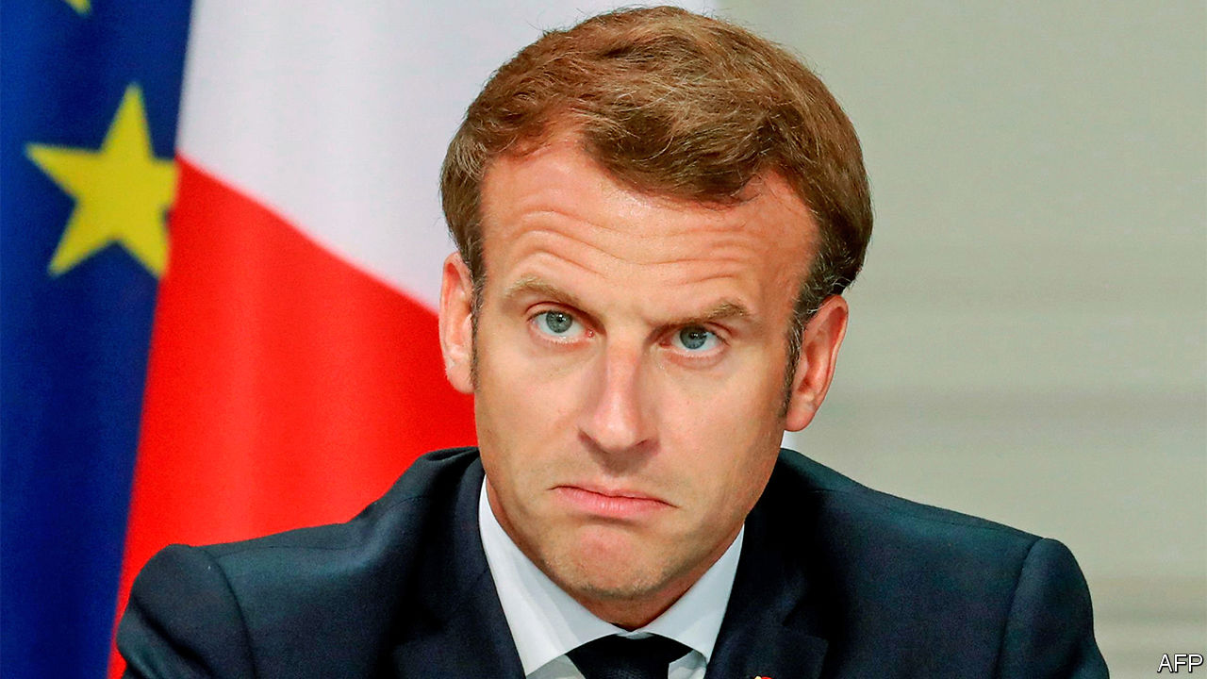

WHEN HE WON the French presidency in 2017 at the age of 39, Emmanuel Macron triumphed in France’s big cities. In Paris, Lyon, Bordeaux and Strasbourg he topped first-round voting, and grabbed over 81% of the run-off vote against the nationalist Marine Le Pen. The former economy minister, who enthused about tech startups and modernising France, was a natural candidate for bike-riding metropolitans. Yet in the second round of municipal elections on June 28th, his party, La République en Marche (LREM), failed to secure a single big French city. Many of them fell instead to the Greens.

In some ways, a setback was to be expected. Mr Macron is unpopular. This was an opportunity for a mid-term protest vote. And the country has suffered over 29,000 deaths linked to covid-19. Partly because of worries about the virus, the abstention rate, at 58%, was a record high. Yet at last year’s European elections the president’s party nonetheless came in a respectable second place. This time, even in Paris, where polls a year ago suggested victory for LREM, its candidate, Agnès Buzyn, trailed in just third place, with 13% of the vote, behind the Republicans’ Rachida Dati. Anne Hidalgo, the sitting Socialist mayor, kept her job, with a solid 49%. Ms Le Pen’s ex-partner, Louis Aliot, meanwhile triumphed in the city of Perpignan.

This dismal result leaves Mr Macron with two dilemmas. One is how to respond to the surge of the Greens in his electoral base. Often backed by the Socialists, they scored striking victories in big cities, including Lyon, Bordeaux and Strasbourg. Lockdown, which let people hear silence interspersed with birdsong in car-free cities for the first time in decades, may have played a part. In Paris, where the Greens backed the re-elected mayor, Ms Hidalgo has been a longtime anti-car crusader. With just 2.2m people, compared with around 9m in London, Paris is cut off from its suburbs and disproportionately peopled by the car-less.

Mindful of this flourishing greenery, Mr Macron on June 29th promised a “profound change of philosophy”. In a speech to mark the close of France’s 150-member citizens’ assembly, an experiment in direct democracy designed to devise measures to combat climate change, he vowed to take up 146 of its 149 ideas. In the run-up to the presidential election in 2022 it will not be easy for the Greens to match their success in car-averse cities with countrywide appeal. Urban hipsters on bicycles may have voted for the Greens. Rural folk, who depend on cars, tend not to. Indeed, it was from remote and bucolic areas that the gilets jaunes protesters emerged in response to Mr Macron’s attempt to increase the carbon tax on motor fuel. Yet however much the president embraces greener policies, he may find it hard to match the appeal of their single-issue politics.

The second question is what to do about his insolently popular prime minister, Edouard Philippe, who comes from the centre-right. Presidents have traditionally used their prime ministers as a shield, disposing of them when they outlive their usefulness. Yet Mr Philippe is more popular than his boss, and was elected mayor of Le Havre with a resounding 59% of the vote. This would supply him with an exit point—and potentially a base for his own ambitions—should Mr Macron wish to reshuffle the top job in favour of a greener or left-leaning figure. But his eviction, should it happen, will be hard to justify. ■

This article was downloaded by calibre from <https://www.economist.com/europe/2020/07/04/after-hearing-birdsong-during-lockdown-french-cities-vote-green>

|  |  |  |  |
| --- | --- | --- | --- |
| Previous | Articles | Sections | Next |

|  |  |  |  |
| --- | --- | --- | --- |
| Previous | Articles | Sections | Next |

#### A tale of two taoiseachs

# Ireland’s two oldest rival parties get together

But the one closest to the Irish Republican Army is waiting in the wings

Jul 4th 2020 | DUBLIN

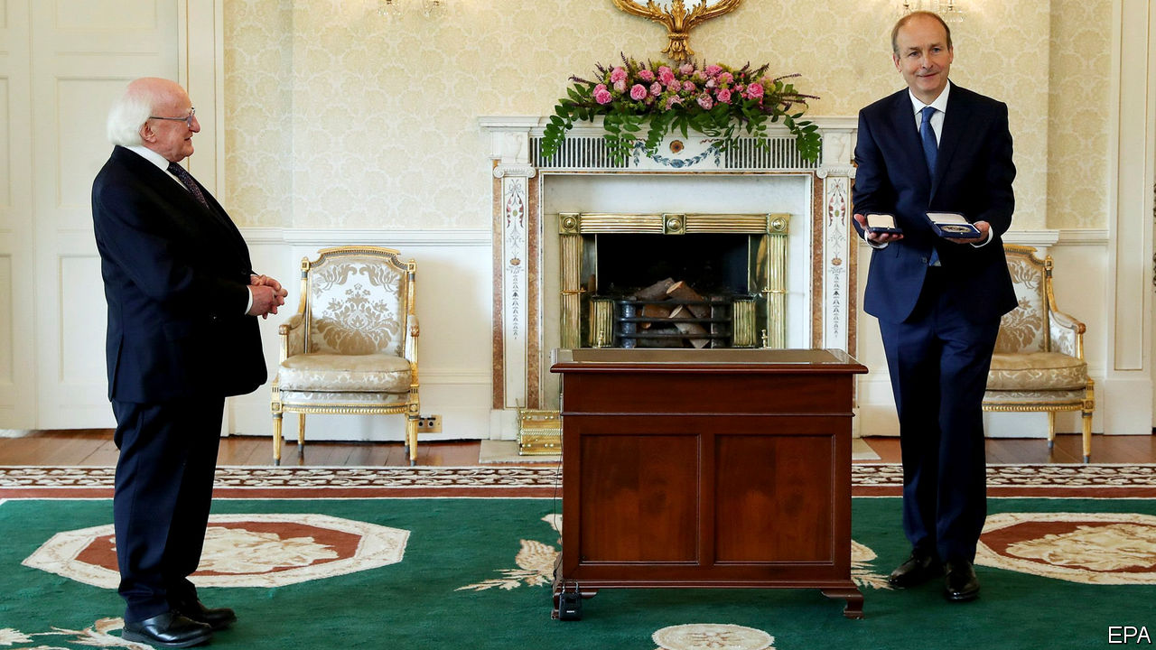

YOU CAN tell a lot about the slow-changing culture of Irish politics from the names of its three largest parties. Micheal Martin, who took over as prime minister this week after months of deadlock, has led Fianna Fail, or the “Warriors of Destiny”, for nine years. His predecessor as taoiseach (prime minister), Leo Varadkar, drops to deputy prime minister, but could swap jobs with Mr Martin again if their new coalition lasts more than two years. Mr Varadkar’s party is Fine Gael, the “Tribe of the Gaels”. Meanwhile the parliamentary opposition will be led by the leftists of Sinn Fein, or “We Ourselves”, formerly the political wing of the Irish Republican Army (IRA).

In the rest of Europe, blood-and-soil nationalism mostly went out of fashion after 1945. But Ireland avoided both fascism and the second world war, so its party names still echo the fervour of early-20th-century separatism. Armed uprisings won independence from Britain for most of Ireland in 1922, and Fianna Fail and Fine Gael emerged out of rival Sinn Fein factions in the subsequent short but bitter civil war. Apart from that, there has been little to choose between the two: both are centre-right, pro-business, small-government parties, and—at least until recently—friendly with the once mighty Catholic church. The narcissism of small differences has let them alternate in power since the state was founded, each blaming the other for all the country’s ills.

Yet probably not for much longer. For most of its history Fianna Fail, which has always had a more populist streak, could aspire to winning outright majorities in the Dail, Ireland’s parliament. Fine Gael, a little more posh and a little less loud, had to make coalition deals. Now the two parties cannot even muster a majority between them: with 38 and 35 seats respectively, they needed the Green Party’s 12 MPs to have a majority.

This mainly conservative cabinet will now have to devise uncharacteristically bold responses to crises on several fronts. Like the rest of the world, Ireland will wrestle with the social and economic costs of the covid-19 pandemic. With its intimate links to Britain, it has more to lose than any other EU member state if Brexit proves chaotic. And then pre-existing problems persist in housing and health care, which many voters blame on the inaction of both Fianna Fail and Fine Gael. This was largely why the pair were both punished in elections in February which, for the first time, saw Sinn Fein win more votes than either of the two establishment parties.

Sinn Fein’s leader, Mary Lou McDonald, complains that the new coalition is a “conspiracy” to foil the people’s will, but with the Dail now aligned for the first time on a left-right axis, she will relish the chance to score points against a government with a difficult job that is likely to be unpopular. Her party may be trying to distance itself from its armed republican roots, but the old IRA slogan, “Tiocfaidh Ar La”, is ageing well. It means “Our day will come.” ■

This article was downloaded by calibre from <https://www.economist.com/europe/2020/07/04/irelands-two-oldest-rival-parties-get-together>

|  |  |  |  |
| --- | --- | --- | --- |
| Previous | Articles | Sections | Next |

|  |  |  |  |
| --- | --- | --- | --- |
| Previous | Articles | Sections | Next |

#### Borderline personalities

# Covid-19 is scrambling Scandinavian stereotypes

Danes used to think of Swedes as meticulous and reliable. No longer

Jul 4th 2020 |

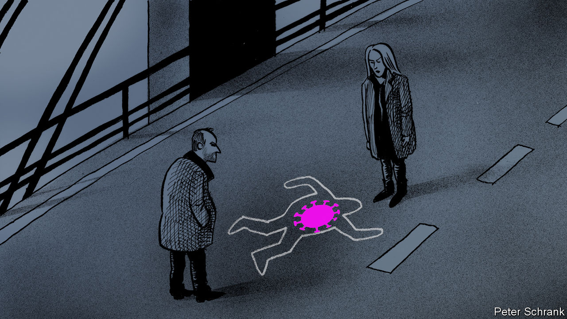

Editor’s note: Some of our covid-19 coverage is free for readers of The Economist Today, our daily [newsletter](https://my.economist.com/user#newsletter). For more stories and our pandemic tracker, see our [hub](https://www.economist.com/news/2020/03/11/the-economists-coverage-of-the-coronavirus)

IN THE TELEVISION series “The Bridge”, a Danish and a Swedish detective must collaborate when a body is found on the Oresund bridge between the two countries. The series was an international hit, but few foreign viewers recognised that the cops embody Danish and Swedish stereotypes of each other. The wisecracking, chain-smoking Copenhagen detective hews to the Swedish view of Danes as jolly, messy and unreliable. His counterpart in Malmo seems to have Asperger’s syndrome; the joke is that to Danes, her obsessive literalism and emotion-free sex life simply look like an acute case of Swedishness.

Covid-19 has scrambled these stereotypes. Denmark implemented a meticulous lockdown. Sweden has taken a uniquely laid-back approach, keeping schools and restaurants open. Its infection and death rates are now far above its neighbours’. As a result, when Denmark, Norway and Finland opened their borders to each others’ tourists on June 15th, they kept them closed to Swedes. Sweden’s foreign minister, Ann Linde, begged them not to discriminate against her countryfolk, and warned of permanent harm to Nordic co-operation. But the neighbours say they are simply protecting their own public health.

Swedes tend to consider themselves impeccable in matters moral and sanitary. Being treated as irresponsible carriers of disease has been a bewildering blow. Stefan Lofven, Sweden’s prime minister, insists that his country’s high infection rate is a matter of chance rather than failed policy.

Much of the conflict has played out on the bridge where the TV series was set. Since the 8km-long link across the Oresund Strait opened in 2000, the economies of Copenhagen and Malmo have in effect merged. After the border closed in March, only Swedes with steady jobs were allowed to cross, not tourists or day-trippers. The economic damage was considerable. Swedes were especially galled that Danes continued to visit their country to enjoy its open bars. On June 27th, Denmark began letting in Swedes from provinces where infection rates are low, but not from regions where they are high, such as Stockholm.

Stereotypes shift. The Gotlandsvisan, a 14th-century Swedish ballad, portrays Danes as unreliable, which matches the modern image, and cruel, which does not. Danes once ridiculed Swedes’ cowardice; now they make fun of their formality. Covid-19 is just the latest crisis to give old roles a new twist.

Editor’s note: Some of our covid-19 coverage is free for readers of The Economist Today, our daily [newsletter](https://my.economist.com/user#newsletter). For more stories and our pandemic tracker, see our [hub](https://www.economist.com/news/2020/03/11/the-economists-coverage-of-the-coronavirus)

This article was downloaded by calibre from <https://www.economist.com/europe/2020/07/04/covid-19-is-scrambling-scandinavian-stereotypes>

|  |  |  |  |
| --- | --- | --- | --- |
| Previous | Articles | Sections | Next |

|  |  |  |  |
| --- | --- | --- | --- |
| Previous | Articles | Sections | Next |

#### Charlemagne

# Let expats vote in the countries where they live

Taxation without representation is unfair

Jul 4th 2020 |

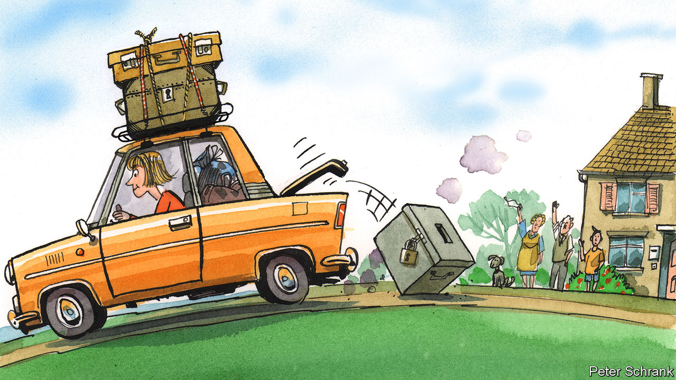

PAYING €7.50 to vote is annoying, but it beats a 10-hour round trip on a bus. Aleksandra Sojka, a Polish academic who works in Spain, had to post her ballot in the first round of the Polish presidential election on June 28th. This is an improvement on 2007, before postal voting was introduced, when Ms Sojka made the 500-mile round trip from Granada to the Polish embassy in Madrid to cast a vote. Voting on matters closer to home is not an option. In Spanish national elections, as in much of the EU, non-citizens who live in the country have no vote. Ms Sojka has no say on the government under which she has lived, worked and paid taxes for over a decade. Yet with her Polish ballot she will help decide on the president of Poland—a place she left for good in 2007.

A quirk lurks at the heart of the EU’s cherished freedom-of-movement rules. Poles who move to Spain can find work, send their children to a local school, claim benefits if they fall on hard times, or enjoy health care if they fall on a hard floor, just like any Spaniard. But they cannot vote in the elections that determine these services, even though they pay for them through their taxes. Free movement is fundamental for the EU, but it comes at a civic cost. Taxation without representation was famously a bugbear of American colonists in the 18th century. It is a fact of life for some EU citizens today.

About 13m people live in a different EU country from the one they were born in, and are thus barred from the main democratic process in the country in which they live. If this group were a country, it would be the EU’s eighth-largest (bigger than Belgium; smaller than the Netherlands). Although they can vote in local and European elections, this gives them a say only on things like bin collections and the transnational business regulations that are still the core of EU governance. Life in between is untouched. When the democratic urge strikes, they can vote only in their home country—setting policy for others, but not themselves.

Some end up disenfranchised altogether. After 18 months away, Irish citizens are kicked off the voting register. For others, voting is simply made difficult, sometimes cynically. In Hungary, citizens abroad with a residential address in Hungary must vote at a consulate, while those without one can vote by post. In practice, this means young Hungarians working abroad temporarily (who are less likely to vote for Viktor Orban’s Fidesz) have to make an often long and inconvenient trip to a consulate. Meanwhile, ethnic Hungarians who live in neighbouring Romania (and who are more likely to back Mr Orban) have a short trip to the post office.

Turnout, unsurprisingly, is much lower among citizens who live abroad. Given that those who emigrate tend to be young, this can do funny things to a nation’s politics. Rather than stay and push for a bad government to be swapped for a good one, fed-up young liberals can head to the door. To stay and fight is hard if you can flee and thrive instead. In this way, freedom of movement acts as a pressure valve for autocratic regimes, argues R. Daniel Kelemen, an academic at Rutgers University, helping them keep power. If it is difficult to vote at home and impossible to vote abroad, expats often become ex-voters.

When expats do vote, they can make all the difference. Ms Sojka is one of more than 500,000 expat Poles who are registered to vote in the next round of the Polish presidential contest, on July 12th. The run-off between Andrzej Duda, the incumbent from the nationalist Law and Justice party, and Rafał Trzaskowski, the liberal mayor of Warsaw, is tight. Polls show both on 50%. Over 100,000 extra expat voters registered the day before the deadline. Among this group in the first round, Mr Trzaskowski had a convincing lead of 27 points (though lagging by 13 points among all voters). Nearly one in 12 Poles of working age lives elsewhere in the EU. It is a large caucus of voters, which could swing a very narrow vote.

Allowing people to vote in a country they have left brings its own problems. In one sense, it is reasonable: EU expats rely on their home government for their right to live in another country (as any British expat in Europe will remind you, at length). It is only fair to ensure that expats have a say over their own legal status, this logic goes. But an objection gnaws away at this principle. What right do those who left many years ago have to decide the fate of a place in which they no longer live? Leaders who revel in blaming forces abroad for their country’s ills would happily cry foul if expats swung an election. Representation without taxation is not much better than its reverse.

Freedom of movement is a unique achievement. But the right to move without the right to vote is a feeble one. It gives those who use it a primarily economic relationship with their new country, rather than a civic one. European workers are reduced to a silent cog in a machine, pumping cash into a system over which they have no control. It pushes against what many EU politicos regard as the bloc’s crowning achievement. The EU is sometimes accused by its more fervent critics of wanting to erase national differences. In this case, it does the opposite, forcing those who move to cling onto their national politics.

## Brussels Tea Party

Efforts to fix these flaws have fallen flat. National elections are a prerogative of national governments. Handing out votes to new arrivals from abroad falls low down the pecking order. Freedom of movement may be cherished, but that does not mean it is common: barely 4% of EU citizens live in a different country. A European Citizens’ Initiative—a petition to which the European Commission must respond—demanding universal suffrage is circling. It will be a topic of discussion during the upcoming Conference on the Future of Europe, where EU bosses will ponder big ideas. A simple, but politically tricky, option faces them: allow EU citizens to vote based on residency, rather than nationality. No taxation without representation is an old mantra, but a good one. ■

This article was downloaded by calibre from <https://www.economist.com/europe/2020/07/04/let-expats-vote-in-the-countries-where-they-live>

|  |  |  |  |
| --- | --- | --- | --- |
| Previous | Articles | Sections | Next |

|  |  |  |
| --- | --- | --- |
| Europe | Sections | International |

Britain

Producing a vaccine: Moonshot

.

Relations with China: Getting off the fence

.

The economy: V-sign

.

Infrastructure: Boris digs for victory

.

Lockdown in Leicester: Not again

.

Teaching history: War of the poses

.

Toy soldiers: The lead belt booms

.

Bagehot: Giving the bureaucrats a rocket

.

|  |  |  |
| --- | --- | --- |
| Europe | Sections | International |

|  |  |  |  |
| --- | --- | --- | --- |
|  | Articles | Sections | Next |

#### Covid-19

# Oxford University is leading in the vaccine race

Governments are pouring money into a more urgent version of the space race

Jul 2nd 2020 |



Editor’s note: Some of our covid-19 coverage is free for readers of The Economist Today, our daily [newsletter](https://my.economist.com/user#newsletter). For more stories and our pandemic tracker, see our [hub](https://www.economist.com/news/2020/03/11/the-economists-coverage-of-the-coronavirus)

BY OXFORD’S EASTERN bypass road, some way from the famous spires, sits an unremarkable collection of glass office buildings that includes the Jenner Institute. Described by an industry observer as “a slightly dusty corner” of the university, until six months ago it mostly busied itself with useful but ill-funded research into diseases suffered by people in poor countries. Now it has become the likeliest candidate to produce the world’s first vaccine against covid-19.

With governments all over the world pouring money into it, the effort to get a vaccine has come to resemble a more urgent version of the space race. According to a tally maintained by the Milken Institute, an American think-tank, 180 vaccines are in development. In late June China waved through an emergency authorisation to allow its armed forces to use a vaccine that remains incompletely tested. A number of American vaccines are doing well, but have yet to progress to late-stage testing. Soumya Swaminathan, chief scientist for the World Health Organisation, says the Oxford vaccine is the leading candidate.

Oxford’s vaccine is already in three late-stage trials. Only one other vaccine, developed by Sinopharm, a Chinese firm, has started a late-stage trial, and it does not have the global support and finance that Oxford’s does. AstraZeneca, a British pharmaceutical company, is building an international supply chain to make sure that the vaccine is available “widely and rapidly”.

It might be clear by the end of August whether or not the vaccine is effective. A single successful trial showing efficacy would allow a regulator to approve the vaccine for emergency use—something that would probably pave the way for use in high-risk groups. That could happen in October. The firm thinks that full approval, which would require results from multiple trials, could come early in 2021. Vaccine development routinely takes 10-15 years, so this would be a remarkable result.

Oxford, which rivals Cambridge as Britain’s best life-sciences university, is rich not just in talent but also in research money. None of the 60 or so groups at the university working on the disease waited for government funding. “I think it’s one of the reasons Oxford has done so well in this,” says an insider. “We just got on and did it.” Other Oxford researchers have since identified the first drug proven to reduce mortality from covid-19. But the Jenner Institute may turn out to have made the biggest breakthrough of all.

The institute started work on January 11th, the day after covid-19’s genetic material was sequenced. It had previously developed a vaccine for a closely related virus that causes MERS, another coronavirus disease. Sarah Gilbert, head of the laboratory at the institute that had done the work, and her team have now engineered a chimpanzee virus to deliver a portion of the covid-19 genetic material into the body, thus generating an immune response.

Once the vaccine had been made, the medicines regulator, the MHRA, rushed through approval for clinical trials. In normal times it has 60 days to respond to a request; in this case, it gave its approval in a week. Later-stage trials were expedited by using interim data from earlier trials, rather than waiting for final data.

At the same time, factories had to be found to produce the vaccine. In March the UK Bioindustry Association carried out a survey, which found that “there was limited capability to scale to significant volumes,” says Steve Bates, the association’s chief executive. That changed quickly as Oxford worked with domestic manufacturers. In April it signed a deal with AstraZeneca which soon had hundreds of staff working on scaling up the vaccine.

The vaccine is grown inside cells that are cultured in vats called bioreactors. Production starts small, at 200 litres. When AstraZeneca is happy with what it produces in the smallest bioreactor it will scale up production. Four bioreactors of 2,000 litres can produce a billion doses in two months. Although AstraZeneca is not a vaccine company, the processes for producing a vaccine are similar to those it uses for its biotechnology products.

According to AstraZeneca, making each dose of the vaccine costs about as much as a cup of coffee. Two billion doses have already been ordered. The company has agreed to supply over a billion doses to Europe, Britain, America, and GAVI, a vaccine finance group. The Serum Institute of India is also producing an additional one billion doses of the Oxford vaccine, mainly for low- and middle-income countries, of which 400m will be made before the end of 2020. In Britain, 30m doses will be available by September.

But the big question—whether the immune response that the vaccine generates is enough to protect against the disease—is as yet unanswered. In an ongoing British trial designed to find this out, 7,000 patients have been injected with it; further trials have just started in Brazil and South Africa. These should also determine whether the vaccine is safe, whether it produces a rare reaction in which it exacerbates rather than ameliorates the disease and whether one or two doses are required to provide protection.

If the vaccine works, governments will have to decide who should get it first. In Britain, the Joint Committee on Vaccination and Immunisation, which advises the government, has recommended that front-line health- and social-care workers, then those most vulnerable, should be first in the queue. But it has warned that its advice may change should more data become available on the transmission dynamics of the disease or the effects of a vaccine.

Boris Johnson has called the race for the vaccine “the most urgent shared endeavour of our lifetimes”. It is not, he insists, “a competition between countries”. But he would no doubt be delighted if the world’s first vaccine came from Oxford. Aside from extricating the world from a crisis, such a triumph would go some way to mitigating the blow to Britain’s international reputation dealt by the government’s poor management of the epidemic.■

Editor’s note: Some of our covid-19 coverage is free for readers of The Economist Today, our daily [newsletter](https://my.economist.com/user#newsletter). For more stories and our pandemic tracker, see our [hub](https://www.economist.com/news/2020/03/11/the-economists-coverage-of-the-coronavirus)

This article was downloaded by calibre from <https://www.economist.com/britain/2020/07/02/oxford-university-is-leading-in-the-vaccine-race>

|  |  |  |  |
| --- | --- | --- | --- |
|  | Articles | Sections | Next |

|  |  |  |  |
| --- | --- | --- | --- |
| Previous | Articles | Sections | Next |

#### Getting off the fence

# Britain gives 3m Hong Kongers the right to live and work

The offer will annoy China

Jul 2nd 2020 |

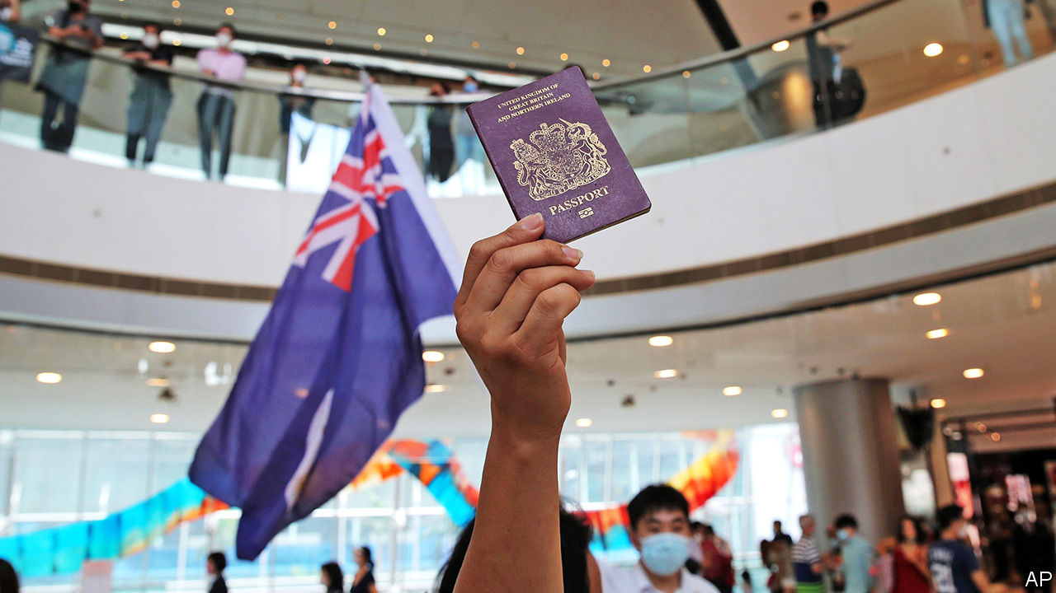

AT MIDNIGHT ON July 1st 1997 Hong Kong passed from British to Chinese hands, starting a new era under the “one country, two systems” policy. It allowed the territory to retain a high degree of autonomy from Beijing. The arrangement was meant to stay in place for 50 years.

On June 30th 2020, after less than half the agreed amount of time had passed, that era looked closer than ever to a premature end. China’s rubber-stamp parliament passed a sweeping new security law designed to chill dissent and stifle protests (see article).

The law had been widely anticipated. So had Britain’s response, announced on July 1st. The 3m-odd British Nationals (Overseas) (BNO)—Hong Kongers born in the territory before 1997—as well as their dependents will gain the right to live and work in Britain for five years, after which they can apply for citizenship. The government indicates that those who take up the offer will not need a job before arriving, and will not be subject to a salary threshold. It is the most generous opening of British borders to foreign workers since new EU citizens were welcomed in 2004.

Dominic Raab, the foreign secretary, characterised the decision as a response to China’s failure to live up to its promises. “But we,” he said, “will not look the other way on Hong Kong, and we will not duck our historic responsibilities to its people.” Some of that may even be true. An official involved with cabinet meetings on the topic said he was struck by the vehemence with which ministers argued that this was a point of principle on which Britain had a moral obligation to act. Priti Patel, the home secretary, is no friend of migrants but she understands Britain’s responsibility to holders of its passports. Her family was among those who migrated to Britain from Uganda in the 1960s and 1970s.

Unlike the Ugandan Asians, who arrived in large numbers after a hard-fought battle, only a small number of eligible Hong Kongers are likely to turn up. Even if they leave Hong Kong, they may have other berths: Australia’s prime minister, Scott Morrison, said on July 2nd that his country was “very actively” considering welcoming them. Nonetheless, the offer itself will have an impact both at home and abroad.

Domestically, it allows the Conservatives to argue that they are not the migrant-bashing party they are made out to be, and that Brexit truly is about a “global Britain”. At the grassroots of the party, Hong Kongers are seen—for better or worse—as the “good” kind of migrant: honest, hard-working and entrepreneurial. Most Brits who have heard of the plans approve of them, and Hong Kongers are unlikely to compete for fish-packing jobs in Grimsby.

But the bigger impact will be on Britain’s foreign relations. China had warned Britain against offering Hong Kongers any additional rights. This week, before the details of the offer were out, a Chinese official said that any such move was surely a “slap in the face” for his country. China is Britain’s third-biggest trading partner, after the EU and America. Its students flock to British universities. Huawei, a telecoms giant, recently announced plans for a £1bn ($1.2bn) research centre in Cambridge.

Yet the government is increasingly wary of Chinese investment and under pressure from America to kick out Huawei from its telecoms infrastructure. Hours after Mr Raab’s announcement it emerged that Britain had granted asylum to Simon Cheng, a BNO who worked for the British consulate in Hong Kong. He said he had been tortured in China last year. The China Research Group, a caucus of Tories whose name is meant to echo the European Research Group that led the Eurosceptic movement in Parliament, is gaining adherents.

Downing Street still talks of “a strong and constructive relationship with China in many areas” but with the caveat that “this relationship does not come at any price”. Boris Johnson insists that “I’m not going to get drawn into Sinophobia because I’m not a Sinophobe.” That may well be so. But there is a dawning realisation in government that it can no longer sit on the fence in its approach to China.■

This article was downloaded by calibre from <https://www.economist.com/britain/2020/07/02/britain-gives-3m-hong-kongers-the-right-to-live-and-work>

|  |  |  |  |
| --- | --- | --- | --- |
| Previous | Articles | Sections | Next |

|  |  |  |  |
| --- | --- | --- | --- |
| Previous | Articles | Sections | Next |

#### Recession

# How speedily will the British economy recover?

Fast, thinks the chief economist of the Bank of England. Many disagree

Jul 4th 2020 |

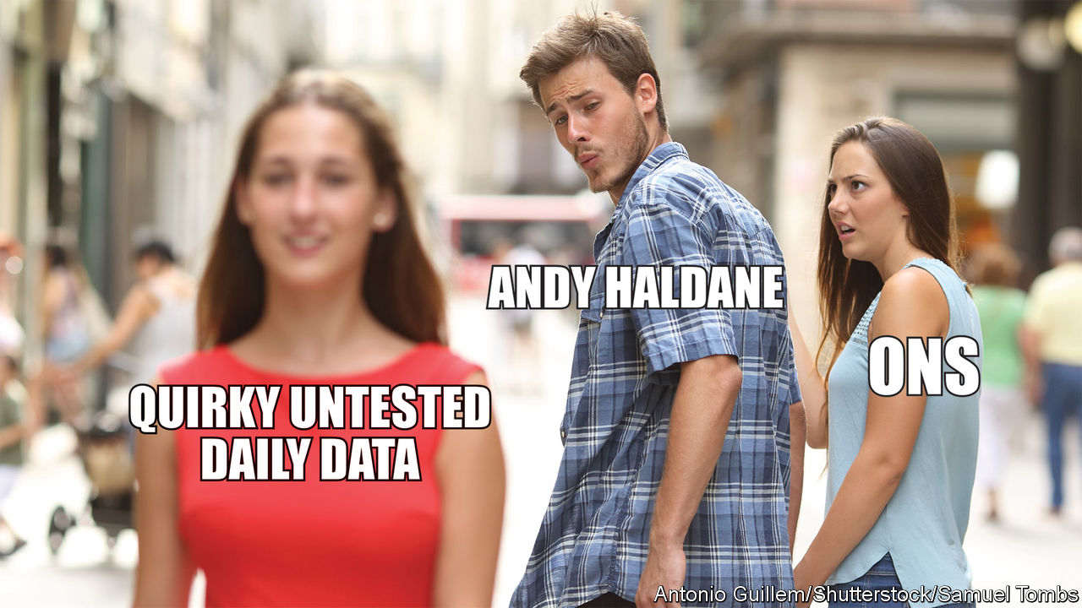

AT THE MID-JUNE meeting of the Bank of England’s rate-setting Monetary Policy Committee, eight of the committee’s nine members voted to expand quantitative easing by £100bn ($124bn) to provide more support for the economic recovery while one, the bank’s chief economist Andy Haldane, voted against. In a speech on June 30th Mr Haldane set out his reasoning. It makes for cheery reading at a time when most British economy-watchers are still stressing the downside risks to output and inflation. April marked the trough for the economy. The Office for National Statistics (ONS) reckons that GDP contracted by 20.4% in that month.

Few doubt that May and June’s figures will be better, but it will be weeks before they come out. In the meantime, opinion is divided on the question of the shape and speed of the recovery. The optimistic Mr Haldane declared that “It is early days, but my reading of the evidence is so far, so V.” He buttressed his argument by drawing on experimental, real time indicators. Especially striking was his use of the bank’s payment-system data to provide an up-to-date measure of consumer spending based on debit- and credit-card transactions at around 90 British firms (see chart). By this measure, household spending appears to have recovered rapidly from the April drop.

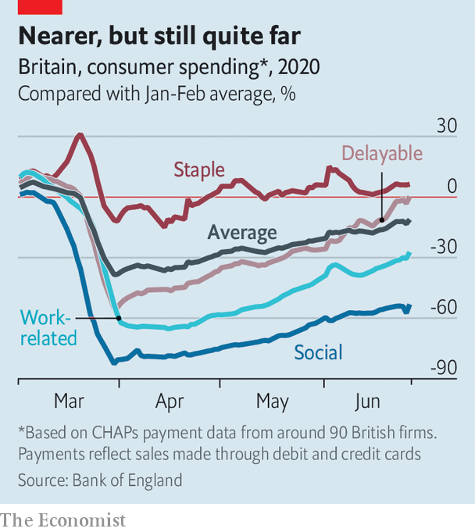

Many analysts are unconvinced. Unemployment looks likely to rise and precautionary savings may remain high. Data on card payments may well be flattered by a shift away from cash and, even if the picture is broadly correct, making up the final lost 10% of GDP will prove tricky if people continue to travel less and do not pack into restaurants and pubs. Samuel Tombs, of Pantheon Macroeconomics, spoke for many who prefer to rely on proven data sources when he tweeted his response (above).

This article was downloaded by calibre from <https://www.economist.com/britain/2020/07/04/how-speedily-will-the-british-economy-recover>

|  |  |  |  |
| --- | --- | --- | --- |
| Previous | Articles | Sections | Next |

|  |  |  |  |
| --- | --- | --- | --- |
| Previous | Articles | Sections | Next |

#### Build, build, build

# Boris’s infrastructure plans

The government wants to dig for victory

Jul 2nd 2020 |

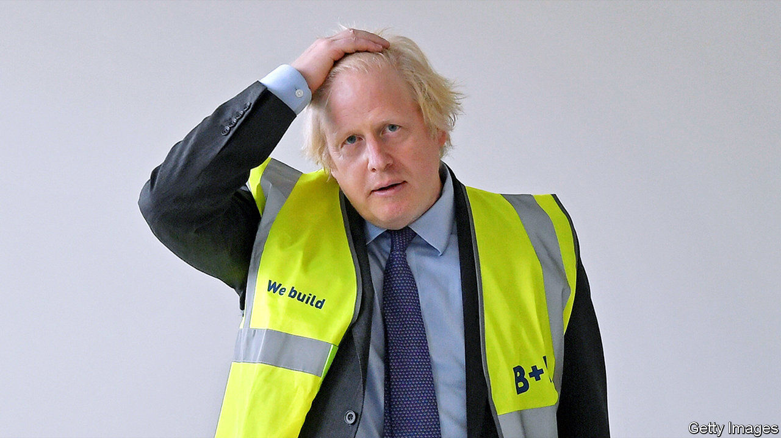

BORIS JOHNSON loves the smell of wet concrete in the morning. Like a children’s encyclopedia from the 1960s, his speeches imagine a Britain forged in steel and glass, humming with nuclear fusion, spaceports and high-speed trains. His career has been punctuated with plans for daring monuments. A cable car over the Thames got built. A vast island airport, and bridges to France and Ulster, did not.

Mr Johnson’s plans for a spree of infrastructure spending to “level up” poorer places were blown off course by the covid-19 pandemic, but he returned to his theme in a much-trailed speech intended to relaunch his premiership on June 30th, with the catch-phrase “build, build, build”. The pandemic has given it a new purpose: to dig Britain out of recession.

Given the hype, the speech was underwhelming. The government will stick to its original plan to increase capital spending to 3% of GDP, the highest consistent level since the 1970s (see chart), and will speed up £5bn of repairs to roads, schools and hospitals. An announcement that the government was revising up its borrowing plans by an additional £50bn ($62bn), or 2.5% of pre-crisis GDP, this year made barely a ripple in the bond markets.

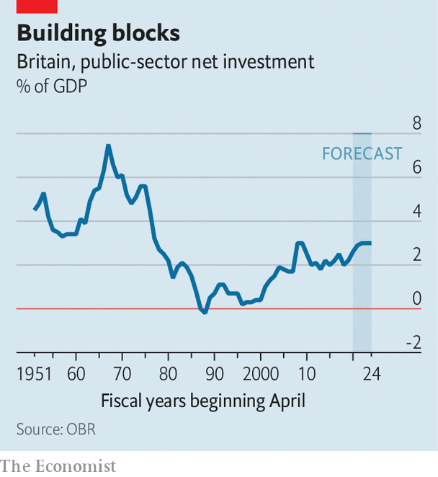

Since the economy will have no difficulty absorbing the extra demand and worries earlier this year that the construction sector would have difficulty delivering on the government’s grand plans have dissipated, bringing spending forward seems sensible. But Mr Johnson’s comparison of his scheme to Franklin D. Roosevelt’s New Deal, which dragged America out of the Depression, doesn’t bear much scrutiny. FDR increased central government spending from under 4% of GDP in 1930 to over 10% by 1939. In Britain it stood at about 40% just before the crisis and is forecast to be at similar level in 2024. Today’s construction projects are capital-intensive and require skilled labour; unemployed baristas are not going to find work digging sewers.

But there is one big similarity. FDR, according to his biographer Robert Dallek, had no grand plan for rescuing America, only an “uncanny inexplicable feel for what might work and what would stimulate public approval”. Richard Hofstadter, a historian, describes an “era of fumbling and muddling through”. Mr Johnson’s plans, similarly, lack analytical rigour. His observations that Britain needs greener energy, more flexible planning laws and better skills were made in similar speeches by recent predecessors. He does not specify which areas will be targeted for “levelling up” or how success might be measured.

“They don’t have a map. They don’t have a theory of change,” laments a Tory MP. “To say we need more infrastructure hides a series of questions: why, and what for?” says Colin Talbot of the Centre for Business Research at the University of Cambridge. The answer depends in part on whether ailing towns such as Wigan and Keighley are best helped by becoming attractive commuter hubs for their neighbouring cities, which is the Treasury orthodoxy, or by trying to revive their industries, which is more popular with local politicians but harder to do. Henry Overman of the London School of Economics argues that what ultimately makes places prosperous is a high density of skilled workers, which means thinking hard about education, welfare and public health. If infrastructure alone did the job then well-connected Folkestone and Barking would be better off, he notes.

More significant shifts in fiscal policy are likely at what the Treasury is calling a “summer update” and Number 10 dubs “a mini-budget” on July 8th. The chancellor will give details on what, if anything, will replace the furlough scheme which is currently paying the wages of some 9m Britons and due to be wound down by October. There is talk of an extended wage subsidy, perhaps to the sectors such as retail and hospitality more directly impacted by social-distancing measures. A cut in VAT is likely, again perhaps targeted at retail, hospitality and tourism.

But “levelling up” is as much a political project as an economic one. Mr Johnson wants to show the voters who backed him in December that they’ve been heard. His new northern MPs have presented the Treasury with shopping lists of roads and railways. That points to quick, visible projects such as repaving high streets, and discourages serious reflection about their constituencies’ future role in Britain’s economy.

Mr Johnson’s claim that Britain outside London has been “neglected and unloved” is politically convenient, but nonsense. The issue of regional inequality has occupied successive governments over decades, from Harold Macmillan’s National Economic Development Council to Tony Blair’s Regional Development Agencies. Given the lack of progress so far, the question deserves revisiting. But any solution needs 25 years to show results, and a cross-party consensus. Mr Johnson wants something to show by the general election in 2024, and to crush the Labour Party. ■

This article was downloaded by calibre from <https://www.economist.com/britain/2020/07/02/boriss-infrastructure-plans>

|  |  |  |  |
| --- | --- | --- | --- |
| Previous | Articles | Sections | Next |

|  |  |  |  |
| --- | --- | --- | --- |
| Previous | Articles | Sections | Next |

#### Whacking moles

# Leicester shuts up shop

The introduction of a second lockdown has been little smoother than the first

Jul 4th 2020 | LEICESTER

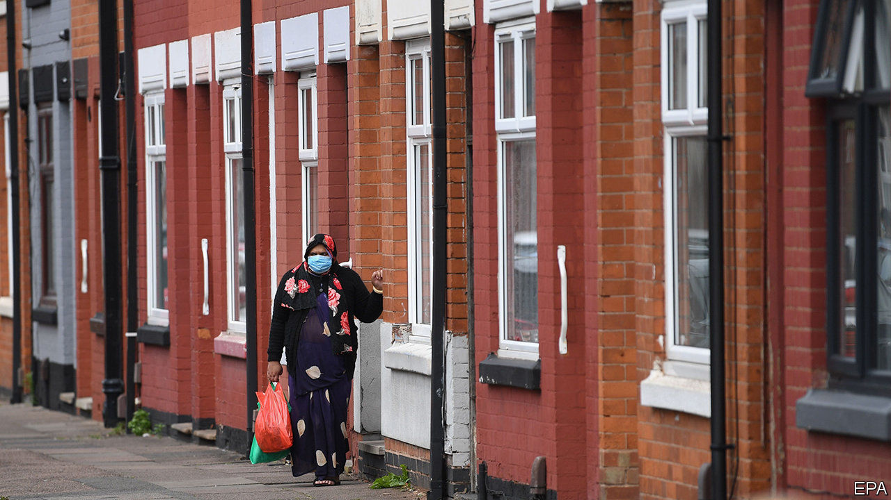

Editor’s note: Some of our covid-19 coverage is free for readers of The Economist Today, our daily [newsletter](https://my.economist.com/user#newsletter). For more stories and our pandemic tracker, see our [hub](https://www.economist.com/news/2020/03/11/the-economists-coverage-of-the-coronavirus)

OVER THE past few months, Boris Johnson has repeatedly said that the government is ready to play “whack a mole”, shutting down any area which sees an outbreak of covid-19. On June 30th Leicester got whacked. As the rest of the country reopened, the East Midlands city, home to 330,000 people, closed down. Schools and most shops have been shut, vulnerable people told to continue shielding. And the rest of the country has been ordered to avoid the city.

Despite Mr Johnson’s fighting talk, the government has tried to avoid such measures. Previous spikes have been stopped with narrower restrictions: closing a hospital in Somerset, two GP surgeries in London and a meat-processing factory in Yorkshire. Yet a surge in testing failed to halt the spread of the virus in Leicester, possibly because the government was unsure exactly where the outbreak sprang from. It has been worst in the east of the city, a place of cramped garment factories and multigenerational residences, home to a large south Asian population.

By the time Matt Hancock, the health secretary, announced the new measures, the seven-day infection rate in the city was 135 cases per 100,000 people, nearly three times the rate at which Germany automatically introduces restrictions. Leicester’s mayor has criticised the government for not giving the city council the granular data needed to suppress an outbreak. Although the quality of publicly available testing data is poor in Britain, other councils say they have begun to receive better information in recent weeks. It is not clear why Leicester did not.

Unlike in other European countries, the government had set out neither the criteria for introducing a local lockdown nor what one would look like. Crucial details, including the area affected and what was banned, only emerged in the days after Mr Hancock’s announcement. “They showed a map which said I was outside. Then on TV they said my area was inside,” says Gaynor, a retiree, walking her dog on Leicester’s western outskirts. “I’m confused.”

Across the city, in North Evington, one of the worst affected neighbourhoods, Aaqib Razzaque, who teaches chemistry at a local sixth-form college, worries about the lack of a public information campaign to support the new measures. “Not everyone watches the news, or understands it,” he says. Indeed, many of the city’s Indian community speak Gujarati as a first language, and have little English. “They should have adverts in different languages,” he adds—something Downing Street has since confirmed it will fund. Although they have become more common in the recent days, masks are still a relatively rare sight, as in the rest of Britain.

In a fortnight’s time the government will review the restrictions it has placed on Leicester. Until then, most residents say they intend to follow the rules, no matter the inconvenience. “It’s got to be done, hasn’t it?” sighs Yusuf, smoking on his doorstep. “It’s for individuals’ safety here.” Yet they are rather less sanguine about how the process has been handled. At the start of the original lockdown, Britons were mostly willing to give the government the benefit of the doubt. That goodwill has since evaporated. ■

Editor’s note: Some of our covid-19 coverage is free for readers of The Economist Today, our daily [newsletter](https://my.economist.com/user#newsletter). For more stories and our pandemic tracker, see our [hub](https://www.economist.com/news/2020/03/11/the-economists-coverage-of-the-coronavirus)

This article was downloaded by calibre from <https://www.economist.com/britain/2020/07/04/leicester-shuts-up-shop>

|  |  |  |  |
| --- | --- | --- | --- |
| Previous | Articles | Sections | Next |

|  |  |  |  |
| --- | --- | --- | --- |
| Previous | Articles | Sections | Next |

#### Schools

# Changing history teaching

Campaigners want history to be taught differently. It already is

Jul 4th 2020 |

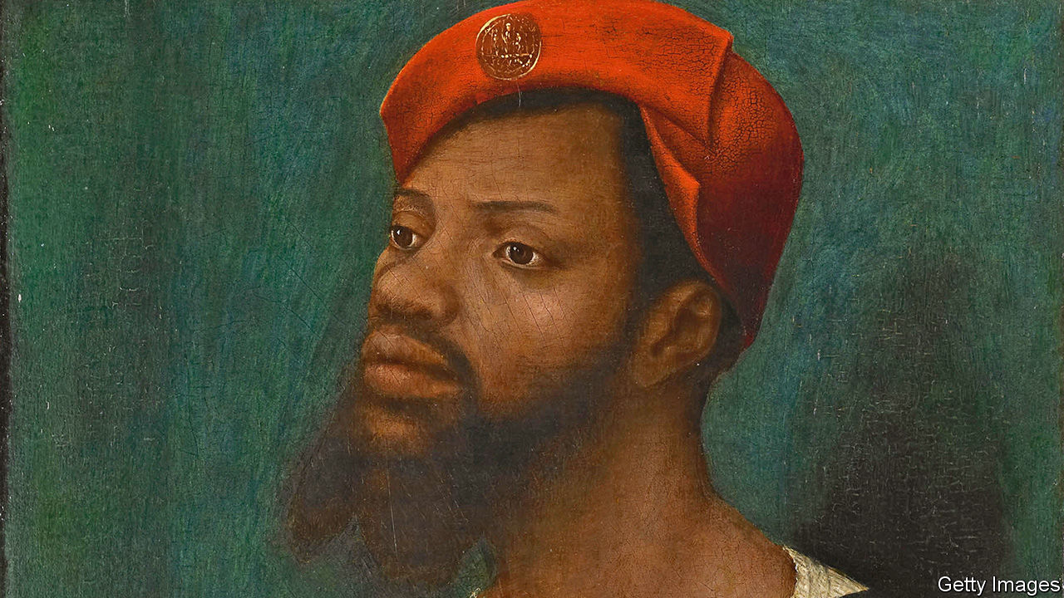

IN HIS FOUR years as education secretary, Michael Gove learned that no subject on the curriculum was as contentious as history. As he acknowledged in a speech in 2013, it can be an “ideological battleground” for “contending armies”. “There may, for all I know, be rival Whig and Marxist schools fighting a war of interpretation in chemistry or food technology, but their partisans don’t tend to command much column space in the broadsheets”.

In the past few months, the history wars have spilled onto the streets. Revisionism has required toppling statues rather than hosting seminars; the worth of classics of literature and television is being radically reappraised. Campaigners want the curriculum “decolonised” and the history of black Britons made compulsory in schools.

Partly in reaction to such demands, Policy Exchange, a think-tank close to the government, launched a “History Matters” project on June 29th, to “address the rewriting of history as it happens”. But right-wingers are equally keen on disseminating the right kind of history. Mr Gove’s first attempt to rewrite the history curriculum to give “a connected sense of the narrative of our islands” was widely criticised as narrow and triumphalist. Referring to a comic take on English history, Simon Schama, a historian, damned the proposals as “‘1066 and All That’, but without the jokes”.

Yet demands to add or remove pet topics from the national curriculum are largely pointless. Most children attend academy or free schools or private schools, none of which are bound by the curriculum. In any case, it only applies until children turn 14, when the subject becomes optional, and provides vague menus of suggested topics that leave teachers plenty of choice. “The power is really with history teachers and schools,” says Michael Riley of University College London. “They have the freedom to devise the curriculum they want.”

Many are beginning to do just that. According to a survey in 2019 by the Historical Association, an educational charity, about four in ten state schools have altered their lessons in the last two years to include a broader range of history. Contrary to the beliefs of some campaigners, Britain’s role in the transatlantic slave trade was already widely covered. “I’m not aware of any department that doesn’t teach slavery,” says Will Bailey-Watson, who trains history teachers. The more current debate among teachers, he says, is how to broaden their teaching of other topics so that children learn other aspects of black history.

Take Jaspreet Kaur, a history teacher who likes to ask “who am I ignoring?” when planning lessons. That has meant educating her pupils about Sophia Duleep Singh, an Indian suffragette, as well as Emmeline Pankhurst. She argues that teaching topics in a way that allows all her students to identify with the protagonists makes for “more passionate historians”. Hannah Cusworth, head of history at a school with a sizeable minority of black pupils, teaches children about Miranda Kaufmann’s book, “Black Tudors”, in part to demonstrate “there was a history before slavery”.

There are constraints on such innovation. Flora Wilson, another teacher, points out that many pupils only have two hours’ history teaching a week. Adding too many topics risks reducing history to a mere list of facts, “one fucking thing after another” in the words of a character in Alan Bennett’s “The History Boys”. “What do you leave out in order to make sense of the important things you’re leaving in?” And teachers do not always have the time or the confidence to research a topic they do not know well. One suggests campaigners emulate the model of the Holocaust Educational Trust, a charity that provides teaching resources and arranges for survivors to give talks in schools.

In the end, change is likely to come organically. Teachers are most comfortable talking about topics they themselves were taught. As university curriculums evolve, so will the classroom. And as academics like Ms Kaufmann unearth more neglected stories from the past, teachers like Ms Cusworth will be excited to pass them on. History may be a battlefield, but its terrain is always shifting.■

This article was downloaded by calibre from <https://www.economist.com/britain/2020/07/04/changing-history-teaching>

|  |  |  |  |
| --- | --- | --- | --- |
| Previous | Articles | Sections | Next |

|  |  |  |  |
| --- | --- | --- | --- |
| Previous | Articles | Sections | Next |

#### The lead belt

# Why Games Workshop is worth more than Marks & Spencer and Centrica

Disease and demographics have boosted the toy-soldier business

Jul 4th 2020 |

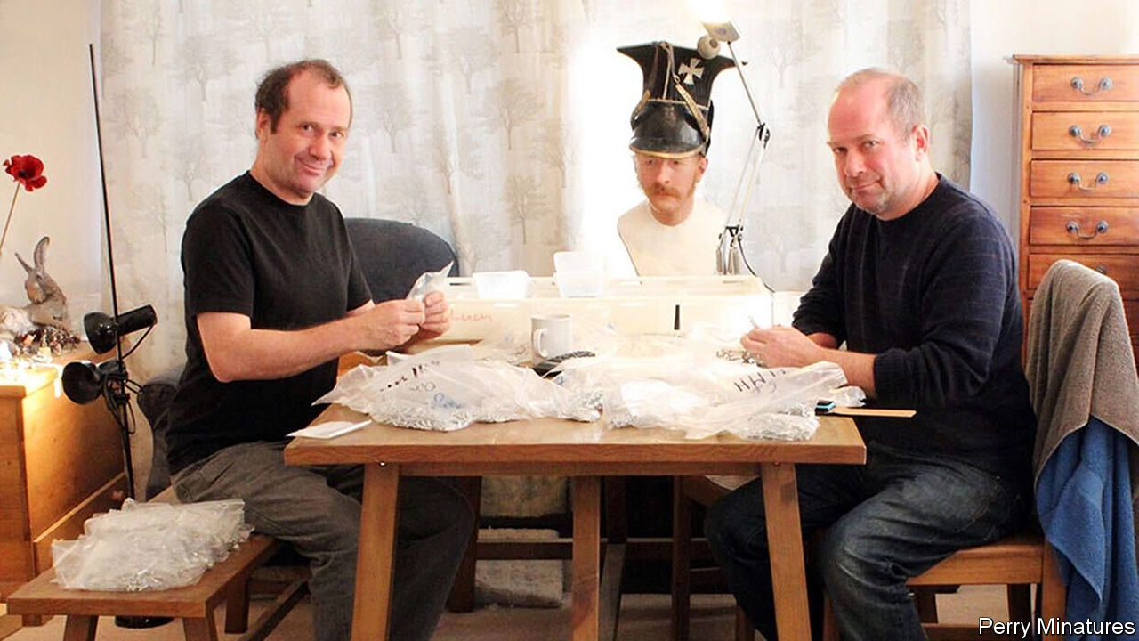

THE FIRMS that are doing well out of the pandemic are, by and large, high-tech ones, helping people to live virtually. But an industry about as unlike Zoom as possible is also flourishing. “It’s like two Christmases’ worth of demand,” according to Alan Perry of Perry miniatures.

Wargaming—collecting and painting toy soldiers before fighting battles using dice, tape measures and often complicated rules—is surprisingly big business in Britain. The share price of Games Workshop, the best-known and biggest player in the industry, has risen 1,500% over the past five years, making it the best-performing British listed share over the period. With a market capitalisation of around £2.7bn ($3.4bn), it has overtaken Centrica, owner of British Gas, and Marks & Spencer.

Games Workshop’s science-fiction and Tolkienesque figures are designed at its headquarters in Nottingham, centre of the “lead belt”—although the figures have not been made from lead since the 1990s. Miniatures are sculpted by hand, and moulds then created. The industry norm is to cast to order rather than carry large inventories, so figures are mostly produced in Britain to reduce delivery times.

Games Workshop’s presence in Nottingham has spawned a local cluster. Many of the city’s figure designers, manufacturers and rules-publishing firms are run by ex-Games Workshop staff. The wider industry is less focused on elves and space marines and more geared to historical gaming: the second world war and the Napoleonic and medieval periods are especially popular. Nottingham is a “mecca of sorts for gamers”, says Teras Cassidy of Canada’s Geek Nation Tours, who organises tours for North American fans.

Games Workshop, which boomed in the 1990s, is enjoying a surge of demand from what the industry calls “returners”—30- or 40-something men who last held a 28mm-high orc in their teens and, now that they no longer have to pretend to be cool, find themselves picking up their paintbrushes once more. “I’ve got a wife and a kid and I don’t feel the need to pretend to have other hobbies any more,” says Paul, a 36-year-old local-government worker. Historical gamers tend to be older: many mention Airfix kits of the 1960s and 1970s as their introduction to the hobby.

Social distancing mostly closed down the wargaming side of the hobby, but that’s not really what aficionados are in it for. Mr Perry, an ex-Games Workshop sculptor who runs Perry Miniatures with his twin brother Michael, says that “for every hour you actually game, you might have spent 25 painting”. Michael Perry lost part of his right arm after a cannon explosion during a medieval re-enactment in 1996, and now sculpts with his left hand.

It’s a good hobby for an anxious time. Gamers talk about the painting process as others might discuss yoga or meditation. “Spending evenings quietly assembling and painting the models is part of the charm,” says Richard, a finance worker. Many gamers added to their “lead piles” of unpainted soldiers during lockdown, and prepare them for the fray right down to the tiny buttons of their Napoleonic uniforms. Let battle commence!■

This article was downloaded by calibre from <https://www.economist.com/britain/2020/07/04/why-games-workshop-is-worth-more-than-marks-and-spencer-and-centrica>

|  |  |  |  |
| --- | --- | --- | --- |
| Previous | Articles | Sections | Next |

|  |  |  |  |
| --- | --- | --- | --- |
| Previous | Articles | Sections | Next |

#### Bagehot

# The government takes on the civil service

Boris v the bureaucrats

Jul 4th 2020 |

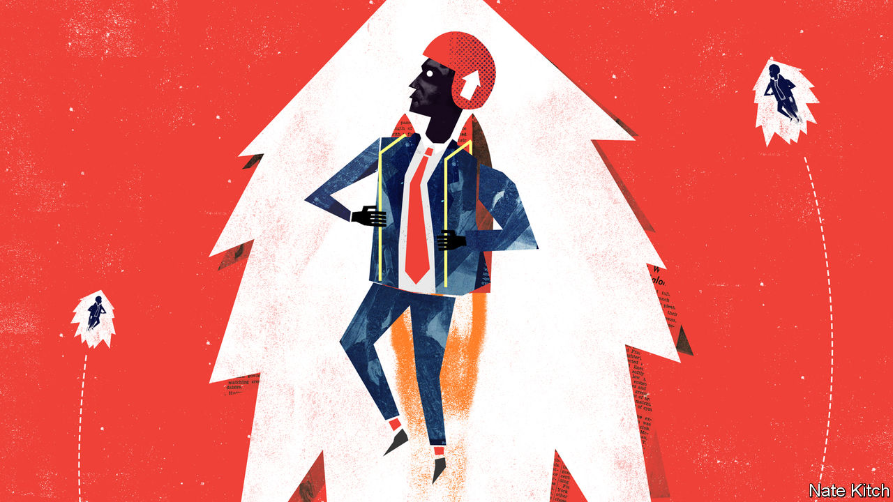

THE CEASEFIRE is over. A couple of months ago the government suspended its war on the establishment “blob” to focus on covid-19 but, although the epidemic continues to rage, it has taken up arms again. Dominic Cummings, Boris Johnson’s chief adviser, has declared that “a hard rain” is going to fall on the civil service and Mr Johnson has blasted his biggest target to date. In effect he sacked Sir Mark Sedwill, who combined the job of the head of the civil service with that of national security adviser, the day after Michael Gove, the minister for the Cabinet Office, laid out a blueprint for reforming Whitehall in a lecture to the great and the good.

The government’s critics complain that this is a cynical ploy to shift the blame for Britain’s dismal handling of the epidemic from politicians to civil servants. The government argues that rebuilding post-covid Britain requires a better bureaucracy. Whichever of these clashing positions is closer to the truth—and there is probably something in both—the fight to refashion the civil service will be at the heart of politics for the rest of Mr Johnson’s premiership.

The lecture contained lots of typically Govian fireworks—a quotation from Gramsci (“The inherited is dying—and the new cannot be born”), W.H. Auden’s description of the 1930s (“a low dishonest decade”). But it also contained a blueprint for reform. Mr Gove wants to reconnect the civil service with the country that it serves. That means moving “decision-making centres” out of London and broadening recruitment. He also wants to bring it into line with the modern economy. The traditional “Rolls-Royce” civil service was built on the idea of recruiting people with fine minds who moved between departments as they ascended towards knighthoods and gold-plated pensions. But Rolls-Royces are costly and inefficient. Mr Gove wants more specialists who can develop deep expertise, more mathematicians who understand “the Monte Carlo method or Bayesian statistics”, and more evidence-based policy rather than shots in the dark.

Mr Gove is right that the state’s administrative brain should not be trapped in the capital city, stuck in the past, or short of expertise. The more distinct London becomes from the rest of Britain, the stronger the case for moving some departments to the regions. And the more the world is driven by tech the stronger the case for recruiting more people who understand the digital world.

Yet Mr Gove displays considerable chutzpah in casting himself as the champion of expertise. He is an English-literature graduate who made his career as a newspaper columnist—an instant expert on everything, in other words—and the problems he described are far more prevalent in Mr Johnson’s government than in the civil service. Deep expertise? Whatever the merits of having the same man running both the civil service and the National Security Council, Sir Mark brought to the latter job decades of experience in the national-security world. His replacement, David Frost, is a political appointee whose CV includes a degree in medieval history and a spell as head of the Scotch Whisky Association.

And for all the Cummings-inspired rhetoric, these complaints are very familiar. Mr Gove echoed a century’s worth of civil-service reformers who have railed against Whitehall’s faults. Lloyd George established Mr Gove’s department, the Cabinet Office, to bring in outsiders with “push and go”. In 1968 the Fulton Report argued for replacing generalists with specialists and time-serving with rapid promotion. Margaret Thatcher brought in Derek Rayner, the boss of Marks & Spencer, to make Whitehall more businesslike. Governments have been moving civil servants out of London for decades. Why should it be any different this time?

The answer lies in the combination of Brexit and covid-19. Leaving the European Union has thrown many of the pieces of government in the air, providing the opportunity to reconfigure them. Covid-19 has shown the British state in a dismal light. The epidemic took a bigger toll in Britain than in other European countries not just because politicians made bad decisions, but also because bits of the machinery of government failed. There is now a cross-party consensus that a rethink is needed. On May 19th Gus O’Donnell, head of the civil service from 2005 to 2011, a trustee of The Economist and in many ways the embodiment of the blob that Mr Cummings demonises, told the Institute for Government that Britain needs to improve “state capacity” and “state resilience” to deal with unexpected threats.

Not all attempts to bring about change have been stillborn. When Paul Samuelson, a great American economist, visited the Treasury in 1961, he was shocked to find how few economists it employed. Today you can’t throw a stone there without hitting one: Lord O’Donnell, who ran the Treasury before moving to the Cabinet Office, was a specialist in econometrics who taught at Glasgow University. The Government Economic Service, founded in 1964, now has 1,400 economists—more than in any other institution in the country. The state’s performance on covid-19 has been patchy rather than uniformly dismal: the Treasury produced a world-class rescue package in as little as a week.

The biggest obstacle to reforming the state is not the establishment’s resistance to reform but the government itself. Mr Johnson instinctively values loyalty, to both himself and Brexit, above competence, particularly if the loyalty comes from Brexiteers. His predecessor, Theresa May, voiced many people’s worries when she asked, regarding Mr Frost’s appointment, “Why…is the new national security adviser a political appointee with no proven expertise in national security?” Mr Johnson is also surrounded by people—particularly Mr Cummings—who think that the only way to achieve change is to wage war. This is as counterproductive as it is thuggish. It turns potential allies into enemies and green shoots into scorched earth.

This government has a better chance of building a more effective British state than any government in decades. If it fails, it will have only itself to blame.■

This article was downloaded by calibre from <https://www.economist.com/britain/2020/07/04/the-government-takes-on-the-civil-service>

|  |  |  |  |
| --- | --- | --- | --- |
| Previous | Articles | Sections | Next |

|  |  |  |
| --- | --- | --- |
| Britain | Sections | The World If |

International

The pandemic’s next stage: The new normal

.

|  |  |  |
| --- | --- | --- |
| Britain | Sections | The World If |

|  |  |  |  |
| --- | --- | --- | --- |
|  | Articles | Sections | Next |

#### The new normal

# Covid-19 is here to stay. The world is working out how to live with it

People will have to change their behaviour to prevent second waves of the virus

Jul 4th 2020 | JOHANNESBURG, MADRID, PARIS AND ROME

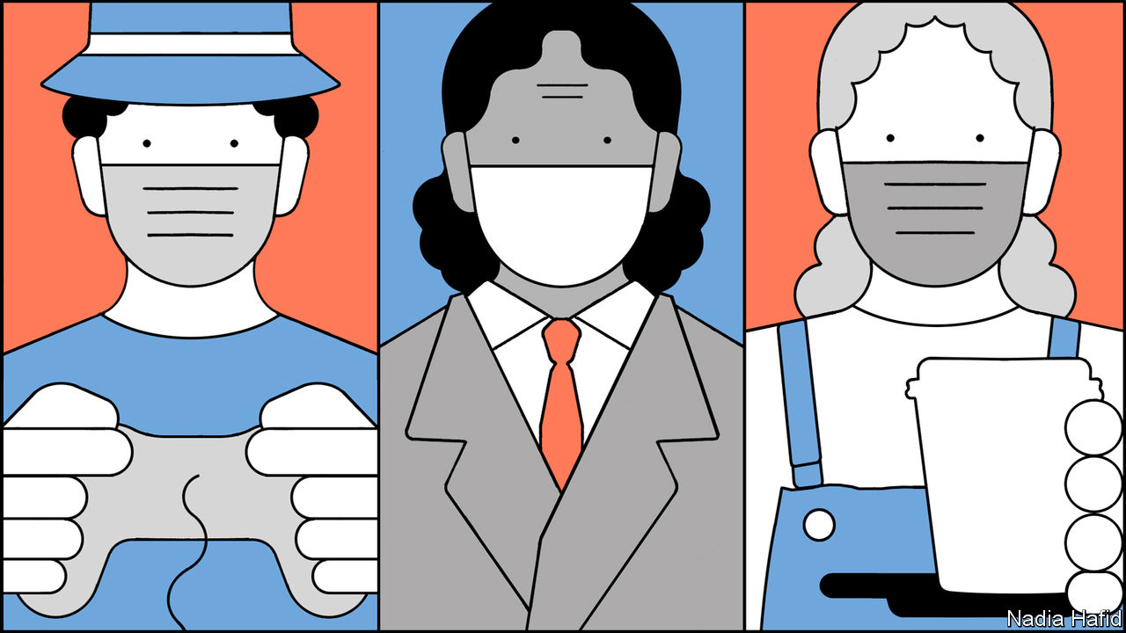

Editor’s note: Some of our covid-19 coverage is free for readers of The Economist Today, our daily [newsletter](https://my.economist.com/user#newsletter). For more stories and our pandemic tracker, see our [hub](https://www.economist.com/news/2020/03/11/the-economists-coverage-of-the-coronavirus)

YOU MAY BE exhausted but the covid-19 pandemic is barely getting started. Six months after Chinese scientists notified the World Health Organisation (WHO) of a new virus that caused deadly pneumonia, covid-19—as the disease was later dubbed—has spread to almost every country around the world and killed more than 500,000 people. In London, Madrid and New York deaths this year have been more than twice what they usually are in the same months. It took more than three months for global cases to reach a million; the last million came in less than a week.

Yet even in the countries with the worst outbreaks, just 5-15% of people have been infected. They may be immune to future infections, at least for a while, but with most of the population still susceptible, getting back to life as usual is impossible. The disease would again grow rapidly. Hospitals would soon be overwhelmed. A recent study published in the Lancet, a medical journal, estimates that about 4.5% of people infected by covid-19 globally are likely to become so ill they require hospitalisation. By comparison, less than 8% of Americans have to stay overnight in hospital in any normal year.

A vaccine is the best way out of this. But even the most determined optimists reckon it will be at least January 2021 until one becomes widely available. In the meantime, the world is preparing to cope with covid-19 in the long term. As countries loosen restrictions and open borders, cases are starting to rise again. If left unchecked, they will swell into new waves of infection. All-encompassing national lockdowns would wreck economies. So countries are looking for middle-ground measures that will prevent the disease from overwhelming hospitals while loosening some of the heaviest restrictions. Used together, these measures will probably ward off new waves of infections. Whether governments will choose to implement them—or have the means to do so—and whether people will follow new rules is less certain.

The priority is to shield from infection those who are most likely to become gravely ill. That becomes difficult if large numbers of people are becoming infected. To prevent the virus from spreading uncontrollably, governments are relying on a combination of three key measures: testing and quarantine; changes in behaviour that reduce transmission (which include social distancing, the wearing of masks and handwashing); and targeted lockdowns of outbreak hotspots—a practice known as a “circuit-breaker” that has been popular in East Asian countries thus far and is now being embraced elsewhere.

Whether countries that have got a grip on covid-19 experience new waves of the disease will depend on how people behave and how quickly authorities can detect an increase in cases, says Andrea Ammon of the European Centre for Disease Prevention and Control (ECDC). If authorities can quickly identify new outbreaks, they will be better able to prevent them from spreading. That means any restrictions imposed in response can be more limited. “What we’ve learned about this virus is that we shouldn’t underestimate even a small outbreak. It can easily be the core of bigger transmission,” says Dr Ammon.

Countries facing their first waves of covid-19 were caught off guard. One of the biggest tragedies was the failure to protect the residents of care homes. They have accounted for about 40% of covid-19 deaths in America and in several other Western countries. Governments are determined to avoid a repeat of this debacle. Infection-prevention measures at care homes are being ramped up, including more testing and greater use of masks by staff and visitors.

Besides the elderly, it is now apparent that people with certain health conditions—including obesity, diabetes and heart disease—are particularly vulnerable. Estimates suggest that 22% of people globally have at least one underlying condition that puts them at high risk if they are infected. In America 38% of adults fall into this category because of their age or health problems; nearly half are of working age.

## What are the odds?

Ensuring people understand how to assess their own risk—especially in the event of an outbreak in their area—is crucial. In March Britain’s National Health Service sent letters to some 2.2m people deemed to be at particularly high risk, telling them to avoid going out when the outbreak was at its worst. In future doctors and patient organisations will be more closely involved, advising vulnerable people and their families on how to balance reducing their risk of contracting covid-19 with their need for some degree of social life.

In the early days of the pandemic, almost all countries tried to “test, trace and isolate” those infected in an effort to quarantine them and break chains of transmission. But many governments, such as Britain’s, abandoned this approach when case numbers grew rapidly and they did not have enough testing capacity and staff to do the job. Panicked countries in Europe and elsewhere imposed national lockdowns in an effort to prevent hospitals from becoming overwhelmed.

But the places that did best in the first months of the pandemic are those that never stopped contact-tracing, says David Heymann of the London School of Hygiene and Tropical Medicine. They include countries as varied as South Korea, Denmark, Germany, Vietnam, Uruguay and Rwanda. Many European countries and some American states used their initial lockdowns to expand their testing and contact-tracing systems and build apps that could make it possible to carry out the task more efficiently if there is a second wave.

These improved systems have responded with varying degrees of success. In Spain the health ministry believes it is still only detecting around a third of all cases (which does, however, mark an improvement on its rates of about 10% at the start of the country’s epidemic). Of these, 40% have no known link to other infected people. Public-health professionals say the system needs more staff if it is to function effectively. Contact-tracers in some states in America are reaching fewer than half of those testing positive for covid-19. Apps that notify users about a close contact with an infected person have often proved disappointing. The one in France was downloaded by fewer than 2m people and notified only 14 of them that they had come into close contact with someone infected with covid-19 in the first three weeks.

Some of the governments that scaled up their contact-tracing systems significantly during the outbreak, such as Britain, chose to run them centrally. That proved to be a mistake. Success rates in obtaining details of contacts and getting in touch with people have turned out to be higher when the task is done by local health departments or community organisations. Persuading someone who has just tested positive for covid-19 to hand over the phone numbers of friends, family and co-workers is hard. They are more likely to co-operate if the call requesting such information comes from someone with the dulcet tones of a local.

“Every epidemic is local,” says Madhukar Pai, an epidemiologist at McGill University in Canada, “so a combination of local leadership, local data to track what is happening, and a local army of community health workers and volunteers is absolutely critical to get it under control.” In countries as large as India, he says, the success of different places in keeping covid-19 at bay will vary. Cases of covid-19 in India and deaths from the disease are rising precipitously. But Dharavi, a slum in Mumbai where 850,000 people are packed into 2.5 sq km and as many as 80 people share each toilet, has tamed an outbreak that began in April. Authorities there set up clinics to check people’s temperatures. Health-care workers went door-to-door to screen people for symptoms and moved those who were infected to nearby schools and sports grounds which had been converted to quarantine centres. In the first half of June the slum had only six deaths from the disease, compared with 71 in April and May.

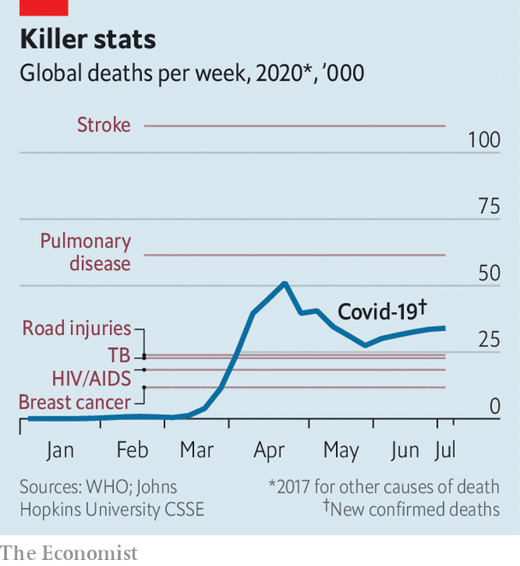

The process of tracing the contacts of those infected with covid-19 has been less smooth in Europe and America. As a result, other measures to curb transmission are even more vital. These include encouraging people to wear face-masks and keep their distance from others (social distancing). Turning these things into social norms, however, has been tricky for a variety of reasons. For one, the official advice on masks in America and Britain, among other countries, changed over time. People were initially discouraged from wearing them, partly for fear that they would run down the scarce supplies for health workers. In America masks are now officially recommended but have become a political statement, with some supporters of President Donald Trump, who refuses to wear a mask, following his lead.

Thanks to studies of outbreaks around the world, it is becoming clearer where social distancing matters most. Covid-19 thrives on close contact. Four things are now known to exacerbate its spread: being at close quarters for a prolonged period of time, in a large crowd, and taking part in activities that lead people to breathe out forcefully (for example singing, shouting and heavy exercise). In combination these create “super-spreading” conditions. Early in the pandemic, at a choir practice near Seattle, one person infected with covid-19 passed it on to more than half of the 61 people in the room, two of whom died.

Such discoveries are helping officials come up with more targeted rules. Conferences and big events are already banned in many places for the foreseeable future. As Britain emerges from its lockdown, weddings are allowed again–but without singing and with no more than 30 people present. Sweden’s drinking holes are allowing table service only, to prevent punters jamming together at the bar. The future of indoor exercise classes looks wobbly.

The extent to which people will comply with rules about wearing masks and on everyday social distancing will depend on how and from whom they get the message. Dr Ammon of the ECDC says that explaining the risks of covid-19 is a challenge for all public-health authorities because they have never had to do it on such a scale. “But we’ve learned from other settings that you need to win over the influencers in certain groups to convey the message in a credible way.” Precisely who those influencers are will vary. The exhortations of online celebrities will carry more weight with young people. Those of imams and priests may convince religious types. But the messaging must start at the top. “Politicians have to convey the message to people that it’s really up to them to decide what’s happening with this pandemic,” continues Dr Ammon. “And in a way empowering them by saying: ‘What you do actually matters’.”

But in many countries, including America, Brazil, Russia and Iran, politicians have lost the trust of their people by contradicting their experts on basic facts about the pandemic, publishing implausible numbers on covid deaths or propagating conspiracy theories.

Pushing people to change their behaviour swiftly is increasingly important in poorer countries with fast-growing epidemics. In India and South Africa shortages of tests—because of crimped global supply—are already rendering contact-tracing less useful. In South Africa, which has largely abandoned tracing, the buzz-phrase among political leaders now is “from anxiety to agency”. Officials are trying to boost adherence to the most basic things to prevent the spread of covid-19, including wearing masks, now compulsory on public transport and in all shops. President Cyril Ramaphosa made a point of (clumsily) putting one on at the end of a televised speech. “We now need to change the mindset of people,” says Salim Abdool Karim, who chairs South Africa’s medical advisory committee on covid-19. “We need each person to see that they have the ability to change, to influence their own risk. That for me is the biggest challenge.”

The worry in poor countries, says Dr Pai, is that such messages may fail to sink in if people see the disease spreading. Already, he says, there are people who think there is no point in wearing a mask because they will get the virus anyway.

It is hard to predict how behaviour will shift in any particular country. Past experience shapes attitudes. Many experts think that levels of compliance with guidelines about masks, quarantine and social distancing in Asian countries are high because people there have painful memories of the SARS epidemics in 2003-04.

But there are signs that in parts of Europe and America that have come through their first big wave of covid-19 people may comply with new rules that will be in place even as restrictions ease. In France President Emmanuel Macron said that even he was surprised by the extent to which his fellow citizens obeyed new rules. During the first few weeks of their lockdown, the French watched as pale-faced doctors emerged, night after night, from emergency wards into television studios to tell the nation that France was at the base of a ghastly wave. Fear, backed up by hefty fines and strict policing, probably contributed to this collective discipline. Although French cafés, museums, beaches and schools have reopened, the country’s earlier experience may explain why rules such as wearing masks on all public transport, in offices and other shared indoor space, are for the most part still being obeyed.

The mood is similar in Spain, which had one of the worst early outbreaks. During its first wave, the country saw at least 28,000 deaths, according to the health ministry. The number of excess deaths was roughly 50,000 compared with previous years. “We can’t lower our guard,” said Pedro Sánchez, the prime minister, on June 20th, as he lifted a 98-day state of emergency. As they contemplate taking longed-for summer holidays, Spaniards are torn between a desire to return to normal and fear of renewed outbreaks. Most now wear face-masks outside. Madrid’s and several other regional governments have provided some masks free of charge through pharmacies; they are easily obtainable in shops.

But even as people take these precautions, they are desperate for life to return to something like normality. Spaniards generally respect social-distancing norms. But on Thursday and Friday evenings the outside terraces of bars throng with mainly mask-less young people. Beaches are open again, though police move in to break up crowds. In Britain partygoers have already been caught at illegal raves. The police and hospitals are bracing themselves as British pubs prepare to open on July 4th. In Berlin, where masks are mandatory in shops and on public transport, the local government imposed fines for non-compliance when numbers wearing them fell.

## Cluster headaches

In many European countries new covid-19 cases have crept up as restrictions have eased. So far cases have appeared in clusters, often linked to parties or other celebrations where people have gathered in large numbers. But the biggest clusters have often been among migrant workers. In Britain, Germany, Spain and Italy migrant workers from Africa and eastern Europe often live in cramped accommodation. A lot of them work in food-packing factories—loud places where workers stand close to one another, often yelling to make themselves heard over the clatter of machinery, creating ideal conditions for the virus to spread. Many are not fluent in the local language and so struggle to understand messages about preventing the spread of covid-19 or to get in touch with doctors if they become ill. Public-health authorities are now more aware of the problem and making greater use of translators.

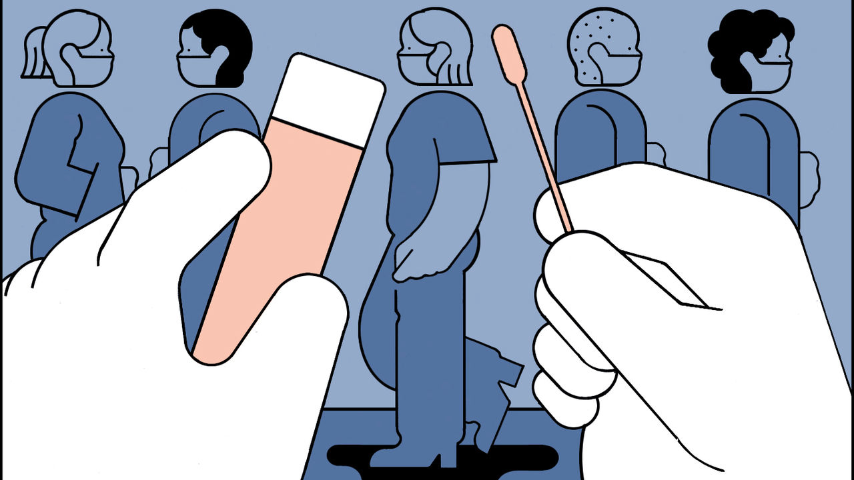

But such outbreaks are being exploited by politicians. On June 29th the leader of Italy’s hard-right Northern League, Matteo Salvini, was forced to abandon a rally at Mondragone near Naples after being drowned out by chanting demonstrators. They were protesting at what they saw as his attempt to capitalise on clashes the previous week between Bulgarian seasonal workers and native Italian residents. Most of the Bulgarians, who gather local harvests, live in a complex of apartment blocks that on June 22nd was returned to lockdown after becoming a hotspot of the virus. Almost 50 residents tested positive and were put into isolation in a nearby hospital. Refusing to accept this renewed confinement, some of the Bulgarians marched through the town, defiantly unmasked, prompting criticism and even attacks by locals. On June 12th, a less visible revolt took place inside a former barracks housing asylum-seekers outside the northern town of Treviso. In both cases, the reason was the same: the immigrants’ fear that they would lose their jobs if they failed to turn up for work.

Such patterns have laid bare one of the gnarliest problems facing all governments. Convincing people to change their behaviour in the ways needed to prevent new waves of covid-19 will rely on people worrying about others as well as themselves. In most places the disease has become one that threatens the elderly, the poor and marginalised minorities. But beating back a virus that has spread around the world with such ferocity will be impossible unless most people play by the rules of the new normal. ■

Editor’s note: Some of our covid-19 coverage is free for readers of The Economist Today, our daily [newsletter](https://my.economist.com/user#newsletter). For more stories and our pandemic tracker, see our [hub](https://www.economist.com/news/2020/03/11/the-economists-coverage-of-the-coronavirus)

This article was downloaded by calibre from <https://www.economist.com/international/2020/07/04/covid-19-is-here-to-stay-the-world-is-working-out-how-to-live-with-it>

|  |  |  |  |
| --- | --- | --- | --- |
|  | Articles | Sections | Next |

|  |  |  |
| --- | --- | --- |
| International | Sections | Business |

The World If

If the Republicans pivoted on climate: The elephant’s U-turn

.

If water shortages destabilised China: Trickle-down policies

.

If climate activists turned to terrorism: Green blood

.

If carbon removal became the new Big Oil: Big Suck

.

If covid-19 devastated aviation: Peak plane

.

If technology tracked all carbon emissions: The rise of carbon surveillance

.

If mammoths were recreated: Doing the tundra quick-steppe

.

If nuclear power had taken off: The road not taken

.

|  |  |  |
| --- | --- | --- |
| International | Sections | Business |

|  |  |  |  |
| --- | --- | --- | --- |
|  | Articles | Sections | Next |

#### If the Republicans pivoted on climate

# What if the Republicans pivoted on climate?

How an ambitious, conservative environmentalism came into being. An imagined scenario from 2024

Jul 4th 2020 |

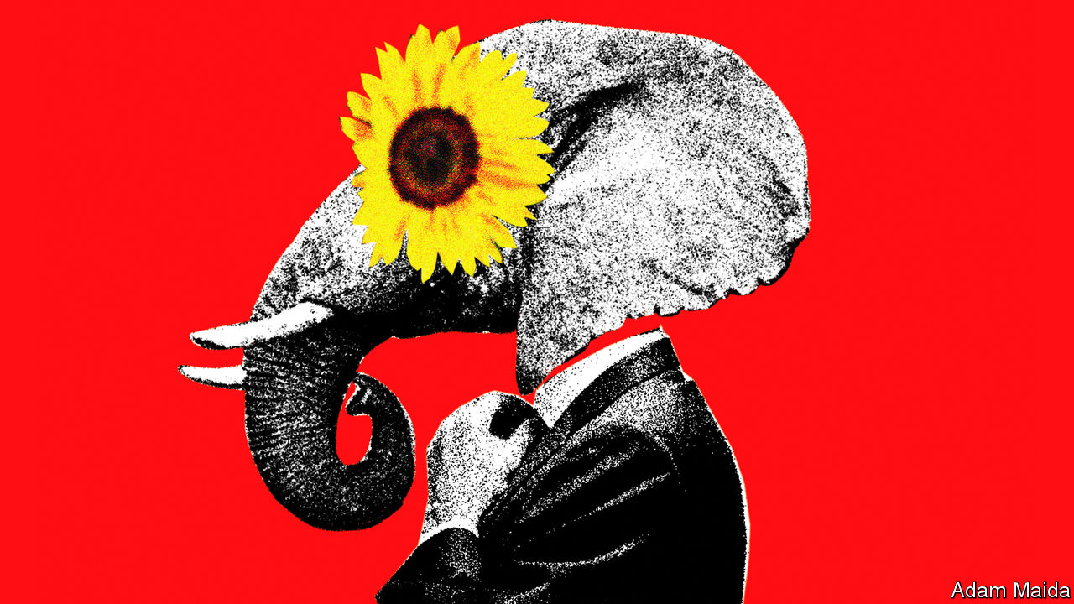

Editor’s note: Each of these climate-change articles is fiction, but grounded in historical fact and real science. The year, concentration of carbon dioxide and average temperature rise (above pre-industrial average) are shown for each one. The scenarios do not present a unified narrative but are set in different worlds, with a range of climate sensitivities, on different emissions pathways

IN THE DETRITUS littering Phoenix’s cavernous arena, the morning after the 2024 Republican convention, were the usual greasy corn-dog wrappers, coffee cups, shrivelled balloons and campaign flyers—but also evidence of the remarkable change Larry Hogan had brought to the party. The wrappers and cups were all recyclable, the balloons not red, white and blue but green—and mixed in with the bumf were copies of the Republican presidential nominee’s stirring “pledge to the Earth”: “We, the party of Lincoln, mindful of the damage humanity is doing to God’s creation, commit to combating climate change, conserving species and environmental consciousness.” Introducing the former governor of Maryland to the stage to deliver his address, Bill Gates called it “perhaps the most hopeful statement ever made in American politics”.

What a change this was from Donald Trump’s pollution-boosting tenure—which was of course largely the point. Mr Hogan, who had emerged from America’s coronavirus crisis as the country’s most popular governor, had been a somewhat reluctant environmentalist during his time in Annapolis. He claimed to have been fully converted to the climate cause during a post-gubernatorial fishing trip to Alaska. But the Republicans’ green shift was more obviously a response to the 2020 election, in which the party lost the presidency, both congressional chambers, a clutch of governors’ mansions, hundreds of state legislators—and seemingly any prospect of returning to national power.

Trumpism had turned out to be a blind alley. Even in the party’s southern heartlands, suburbanites, millennials and a multitude of younger voters, repelled by its philistinism, antediluvian social policies and race-baiting, flocked to the Democrats. A staggering 70% of college-educated Americans rejected the Grand Old Party. High time, then, to slay a holy cow. And as Republican strategists looked around, sharpening their knives, the appeal of abandoning their former antipathy to environmental policy was obvious. It would not only be a hit with science-respecting educated voters. It would also be relatively easy. Immigration reform would be a non-starter with the Trumpist rump. Evangelicals were never going to compromise on abortion. Far fewer conservatives were fundamentally against environmentalism, however.

As Mr Hogan loved to remind them, conservation shared more than a lexical root with conservatism; it was an expression of it. Republicans had been responsible for most of America’s environmental progress. Yellowstone National Park, the national forest reserves, the Environmental Protection Agency (EPA), the emissions-trading scheme that fixed acid rain—all were creations of Republican presidents. To renew conservatism, Mr Hogan insisted, Republicans need only look to their own noble past.

He was right. As recently as the mid-1990s some had worried about climate change just as much as the Democrats. The embrace of climate-change scepticism by the party and its supporters was driven (as Mr Hogan did not say) by a well-funded misinformation campaign by wealthy polluters, waged through conservative think-tanks, lobbyists and direct contributions to Republican candidates. Yet the party’s donors had also shifted. Many traditional Republican backers, including oil companies, were now in favour of Mr Hogan’s greenery. And the party had, in addition, become increasingly dependent on the largesse of the renewable-energy companies that had burgeoned in many conservative states.

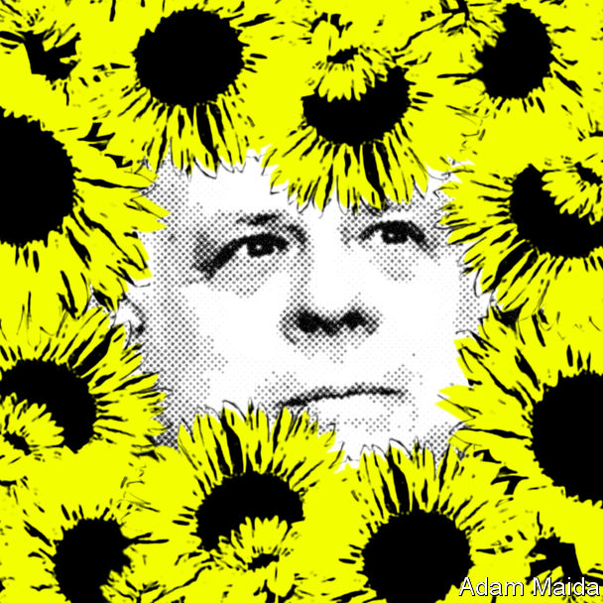

A boardroom terror of Democratic tax rises probably played a part in this corporate shift. But the main reason was realism. The combination of ever more alarming climate science and a solid electoral majority for addressing the issue had made ambitious climate action inescapable. Given this reality, the Republicans’ old and new donors alike reckoned that it would be better introduced by a pro-business Republican administration, rather than a hostile Democratic one.

President Joe Biden’s business-throttling environmental policies had hastened that conclusion—even if, ironically, his Republican opponents were largely to blame for them. Having been prevented by the obstructiveness of Senate Republicans from passing almost any legislation—including the carbon tax he had campaigned on—Mr Biden had instead been pushed down a regulatory path. This had in turn so delighted the rowdy Democratic left (which hated market-based solutions) that the president had doubled down.

The Biden EPA’s latest rules made it almost impossible to cut urban trees, build large structures with more than 50% concrete content or develop shale-gas sites. Alexandria Ocasio-Cortez, the climate secretary, even declared a “war on gas”. This leftward lurch opened up a space for a distinctively conservative approach. Mr Hogan could push his “green capitalism”—based on the carbon tax Mr Biden had wanted—as an alternative to the Democrats’ green socialism.

He was not the only Republican presidential hopeful to have made this calculation. The party’s primary contest had featured all sorts of climate talk. Mr Hogan’s main moderate rival, Nikki Haley, also proposed a carbon tax, but less compellingly. She called it a “sustainability levy”, a phrase that convinced no one it would be anything other than a tax. This encapsulated the South Carolinian’s much-hyped yet over-rehearsed and rather cloying candidacy. Mr Hogan called his proposed tax a “polluter fee”, a phrase that appealed to the party’s still-aggrieved working-class base.

Another contender, Senator Marco Rubio, pitched what he called a “pro-environment industrial policy”. It would consist of heavy public investment in low-carbon technology and industries, for two main reasons, neither of which involved the climate: a need to out-compete China and high-quality job creation. Mr Hogan, a flexible small-governmentalist, purloined the proposal after Mr Rubio’s early exit from the contest.

Even the Trumpist candidate, the disgraced former president’s eldest son Donald Trump junior, had an environmental policy of sorts. This was down to his chief policy adviser, Steve Hilton, who had succeeded in getting a British Conservative Party leader, David Cameron, elected prime minister by the same means. Yet expecting Don junior to explain complicated geoengineering schemes proved to be a bad misjudgment.

In a televised debate the younger Trump launched a bizarre sales pitch for “using capitalism to make these huge mirrors that are called aerosols for whitening the climate”. Rightly fearing he had lost his audience, he then ended with a bump: “But, whatever, it’s all green shit!” Mercilessly, Mr Hilton’s former employer, Fox News, cut away to show Mr Hogan, at the adjacent podium, disdainfully shaking his head. “I like you, Don,” he said. “But I’m green and you’re full of it.” It became his unofficial campaign catchphrase. ■

For our latest coverage of climate change, register for The Climate Issue, our fortnightly newsletter, or visit our climate change story hub

This article was downloaded by calibre from <https://www.economist.com/the-world-if/2020/07/04/what-if-the-republicans-pivoted-on-climate>

|  |  |  |  |
| --- | --- | --- | --- |
|  | Articles | Sections | Next |

|  |  |  |  |
| --- | --- | --- | --- |
| Previous | Articles | Sections | Next |

#### If water shortages destabilised China

# What if water shortages destabilise China?

The painfully unequal distribution of water in China reawakens intra-regional resentments not seen in decades. An imagined scenario from 2050

Jul 4th 2020 |

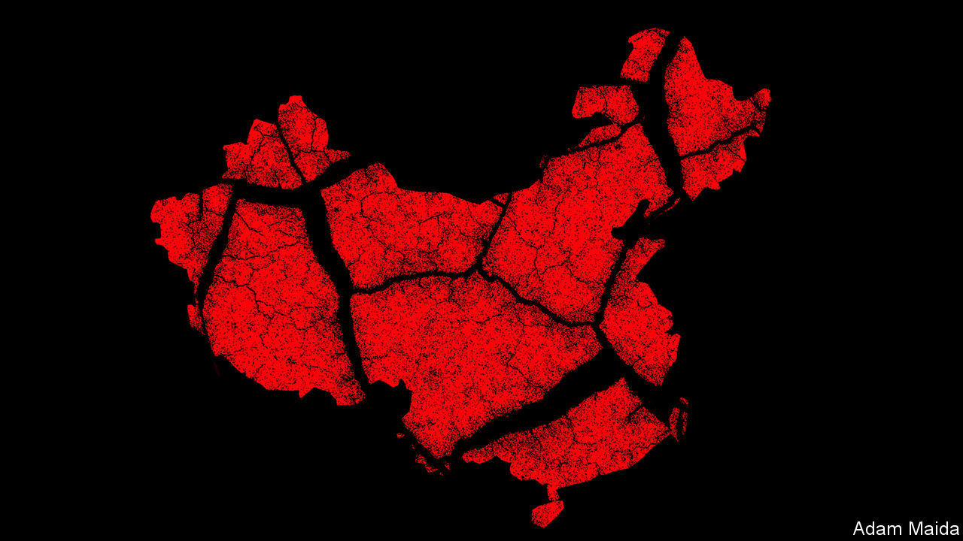

Editor’s note: Each of these climate-change articles is fiction, but grounded in historical fact and real science. The year, concentration of carbon dioxide and average temperature rise (above pre-industrial average) are shown for each one. The scenarios do not present a unified narrative but are set in different worlds, with a range of climate sensitivities, on different emissions pathways

THE DEADLY heatwave that has gripped Asia for five months has had many unexpected consequences. One of the more surprising has been Chinese political and business leaders feuding, semi-publicly, about the unequal way China’s water is shared out. This was supposed to be a quiet year for Communist Party rulers, who spent 2049 noisily celebrating their regime’s 100th anniversary. Instead they are on high alert.

The spark for the current political crisis was the success of “Yu the Great”, a two-hour documentary about a nobleman whose flood-fighting genius saw him named emperor 4,000 years ago. The film was watched more than 4bn times before censors cracked its cryptomorphic packaging. Its producer and narrator, one of China’s richest technology magnates, was detained last month in Shenzhen and has not been seen since.

The film was understood by many viewers as a coded complaint about chronic water shortages that have blighted China in recent years, despite ever-larger investments in dams, flood-defence barriers and desalination plants, and campaigns to move millions of people from one side of the country to the other.

In the documentary, Yu the Great is praised for realising that floods cannot be defeated with man-made barriers—the failed approach repeatedly tried by his own father, Lord Gun—but must be harnessed and guided, by building channels. Viewers could not fail to grasp that stubborn, purblind Gun is a proxy for China’s ageing rulers, who draw their authority from the military high command and from Xi Jinping, the country’s unseen and silent 97-year-old paramount leader.

Archeologists have found no physical traces of Yu the Great, but that is not the point. Worshipped for centuries as a deity, Yu is hailed in the documentary as a sort of philosopher king, who bound nine provinces into a single empire by carefully balancing the needs of each. That, too, is a complaint about regional inequalities that have left present-day China a rather resentful, unhappy place. Only a few regions, such as western Sichuan and northern Yunnan, have seen agricultural productivity gains. Climate change has turned much of northern China into an arid semi-desert. The Hai, Liao and Yellow rivers, which once watered great tracts of the North China Plain, the country’s breadbasket, run dry each summer. Farther south, even tributaries of the mighty Yangzi, such as the Han river, flow too slowly in the summer to flush away toxic algal blooms.

In contrast the most southerly provinces, including the high-tech powerhouse of Guangdong, seesaw between having either too much water or not enough. The south is lashed by frequent super-typhoons and flash floods, while storm surges and landslides have destroyed multi-billion-dollar industrial zones and housing developments around the Greater Bay Area, a sprawling, sweltering, permanently gridlocked megalopolis that is home to 120m people, made up of such formerly separate cities as Guangzhou, Shenzhen and Hong Kong. At other times, scorching temperatures have left the south gripped by extended droughts.

Scarcity of water even complicates China’s hold over the great territorial prize of the Xi era, the island of Taiwan. Seven years after being retaken in the short, brutal war of 2043, after an isolationist America said that it would no longer defend it, the island is a harshly policed shadow of its former self. A lack of water has thwarted plans to bring over more mainland settlers.

At emergency global summits to debate climate change, China has talked about playing a leading role as a responsible great power. It is true that it has invested massively in renewable energy. But powerful economic interests have made China cautious. When it comes to dismantling coal-fired power plants, or closing carbon-spewing factories built by Chinese firms in Asia and Africa, China has consistently kept an eye on what rival powers are doing. It has matched American efforts and commitments on greenhouse-gas emissions, but not gone further. In the words of a European diplomat: “China does not do altruism. The approach is to seek maximum credit for minimum effort.”

When it comes to regional diplomacy, China has taken a more conciliatory stance, at least where its largest neighbours are concerned. Swallowing traditional doubts about Chinese settlers overrunning its sparsely peopled east, Russia has worked with China to exploit Arctic sea lanes that are now ice-free for much of the summer. Protective Russian and Chinese icebreakers now lead convoys of oil tankers heading eastward to China, and of container ships steaming westward to European markets. Six states that border the Arctic—Canada, Denmark, Finland, Iceland, Norway and Sweden—have all seen Chinese cargo and cruise ships bring lucrative business to once-sleepy northern ports, tempering domestic political opposition to China’s presence in the high North.

China’s relations with India have been patched up and water-sharing treaties signed between the two nuclear powers, as glaciers high in the Himalaya melt at a dangerous rate. Smaller neighbours have been less fortunate. Brushing aside complaints from Myanmar, Laos and Vietnam, China has hoarded water behind its dams in the upper reaches of the Mekong and other vital rivers, then bought an uneasy peace by selling neighbours cheap electricity from those dams.

At home in China, government scientists do not dispute the dangers posed by man-made global warming. But the response of the Communist Party has been to pour more concrete and to put still more faith in state planning and social controls. Engineering works intended to tame nature and redistribute water, in a country where 80% of it is found in the south, have been a pillar of Communist rule since the days of Mao Zedong. Chinese officials cited Mao’s observation from 1953—“Water is abundant in the south and scarce in the north, so why not borrow a little from the south?”—in 2014 as a giant series of canals and pumping stations, the South to North Water Diversion Project (SNWDP), began carrying water from the Yangzi river system to Beijing and other parched northern cities.

## Counting every drop

In 2035, with water in ever-shorter supply, China conducted its first Water Census, estimating available water resources per resident of each city and county. Those places with plenty were colour-coded green. Areas suffering from water stress were given an orange code, while those with dangerously few resources were coloured red. The populations of arid, red-coded places may not grow, by law. In practice, many arid areas have emptied, as locals realised no new government funds would be forthcoming for roads, schools or hospitals or to support economic development.

At first, many Chinese did not pay close attention, because a first wave of forced relocations disproportionately affected ethnic minorities living in western regions. In all, perhaps 8m members of the Uighur, Kazakh, Hui and Mongol minorities have now moved from red-coded areas. Some ended up as workers in high-walled factories run with paramilitary discipline. Others, carrying identity cards branding them as migrants from “arid” areas, have suffered discrimination in their new homes. These environmental migrants—though China rejects that label—often struggle to register children in schools or access public services.

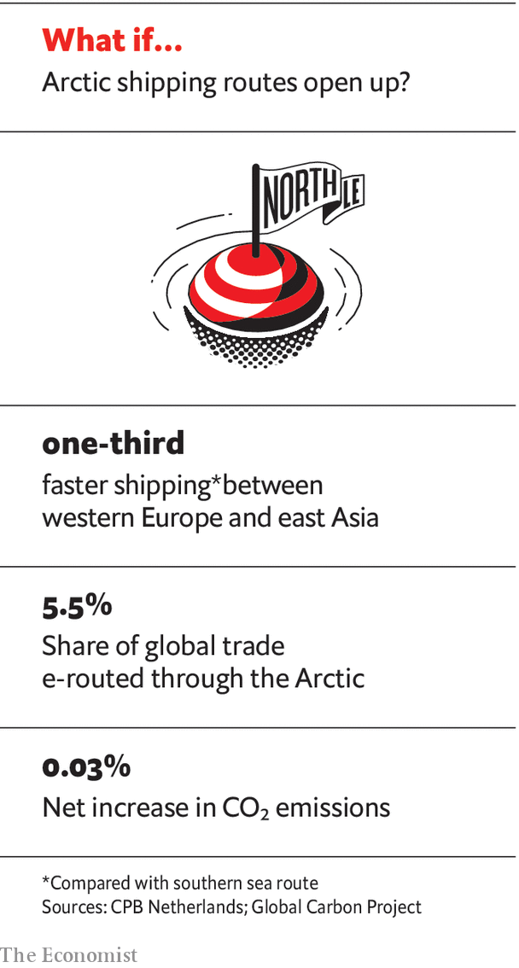

Wider public opinion began to sour on the Water Census when a second survey, completed in 2042, handed arid, red-coded identity cards to millions of Chinese from the majority Han ethnic group, triggering a fresh wave of coerced relocations. Farmers from northern and central provinces were obliged to sign family plots of land over to the government in exchange for subsidies to help them start new lives in green-coded regions where the population is allowed to grow. China’s rural areas are ageing rapidly, though, and many farmers said they were too old to move. Impatient with such talk, officials in some red-coded villages are accused of forcefully moving “retired” farmers to hastily built housing blocks.

Water has caused trouble in Hong Kong, the former British colony that has been under strict political supervision since anti-government demonstrations in 2019. Defying local police and mainland security agents, environmental activists staged a string of lightning protests in the late 2030s to block the construction of a nuclear-powered desalination plant, one of dozens being built along the coast. Not only was the plant built but, in a show of force, it was opened in 2047 to mark Hong Kong’s formal absorption into Guangdong province, 50 years after the handover.

The latest Water Census, made public this year, prompted rage on Chinese social media when it emerged that Beijing and its nearby administrative annexe of Xiong’an, a new “smart city” built at the behest of President Xi, both enjoy green codes on the basis of projected deliveries of water from the SNWDP. That is a convenient fiction. In reality the scheme has repeatedly missed its delivery targets as droughts have hit the Yangzi basin. According to government statistics leaked to a news outlet in Guangdong, Xiong’an is desperately short of water. Yet because Mr Xi’s prestige is at stake, its population is still being allowed to grow.

To the central government, it is a special provocation that the leaked Xiong’an water statistics emerged in Guangdong, a wealthy, self-confident province with a mutinous history. The furious response of leaders in Beijing to “Yu the Great” is in part explained by the filmmaker’s close connections to powerful southern politicians. Millions on social media posted images of Yu the Great and his mausoleum near the eastern city of Shaoxing. When those were banned they began sharing pictures of the Zhong Hai and Nan Hai, ornamental lakes inside the party leadership compound in Beijing, labelled “sweet waters”.

Such expressions of grievance may seem somewhat arcane. But in a closely watched surveillance state those voicing them are taking real risks, and their anger should not be ignored. The painfully unequal distribution of water in modern China is reawakening intra-regional resentments not seen for more than a century. Outsiders have spent years speculating what China might do about climate change. Now they are asking: what might climate change do to China? ■

This article was downloaded by calibre from <https://www.economist.com/the-world-if/2020/07/04/what-if-water-shortages-destabilise-china>

|  |  |  |  |
| --- | --- | --- | --- |
| Previous | Articles | Sections | Next |

|  |  |  |  |
| --- | --- | --- | --- |
| Previous | Articles | Sections | Next |

#### If climate activists turned to terrorism

# What if climate activists turn to terrorism?

Protesters against climate change have not resorted to terrorism to advance their cause. This scenario from 2031 imagines what would happen if they did

Jul 4th 2020 |

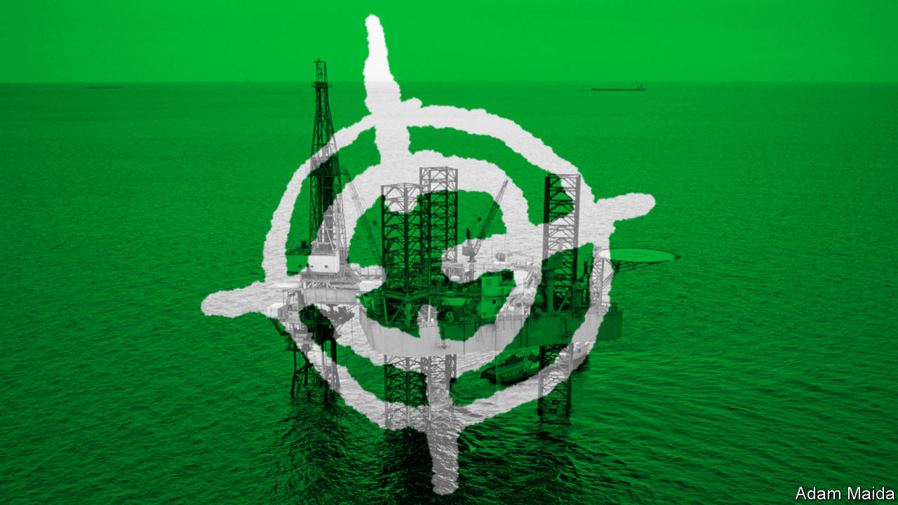

Editor’s note: Each of these climate-change articles is fiction, but grounded in historical fact and real science. The year, concentration of carbon dioxide and average temperature rise (above pre-industrial average) are shown for each one. The scenarios do not present a unified narrative but are set in different worlds, with a range of climate sensitivities, on different emissions pathways

THE FIRST the world heard of the self-styled Earth Defence Army (EDA) was in February 2028, when the Jamnagar oil refinery in Gujarat, the world’s largest, ground to a halt after a crippling cyber-attack. In a video manifesto the EDA claimed responsibility for the attack, providing detailed evidence of its involvement. The group’s masked leaders warned that oil companies around the world would face similar attacks—as would banks and investors associated with them. “The planet cannot fight back,” one EDA member declared, “so we have no choice but to fight back on its behalf.”

Next, the EDA released a trove of messages stolen from four large oil companies and their accountants. These, the group claimed, revealed a covert scheme to undermine emissions-reduction efforts by misreporting numbers. (The companies in question denied wrongdoing.) “Your sabotage will be met with sabotage,” the EDA’s leaders announced. It began a campaign of direct attacks on oil companies’ property, modelled on those conducted by the Earth Liberation Front (ELF), whose arson attacks in America, starting in the 1990s, had caused $100m-worth of damage.

The EDA praised the activities of the ELF and other earlier environmental groups, dating back to the 1970s, that had at the time been considered extremists or eco-terrorists. In March 1979, for example, the crew of a trawler called Sea Shepherd smashed through the ice of the Gulf of St Lawrence, before jumping out to spray baby seals with red paint, rendering their fur worthless. The Sea Shepherd Conservation Society went on to smash and scuttle whaling and sealing vessels around the world, using sledgehammers, paintball guns and even mines.

Similarly, Earth First!, a group established in 1980, had “spiked” trees with materials intended to damage loggers’ saws. It spawned the ELF, a more radical offshoot. After two decades, the number of so-called “eco-terrorism incidents” peaked in 2001 at 163, according to one study. Yet even as al-Qaeda’s attacks on New York and Washington that year focused attention on Islamist extremism, eco-terror remained a major concern. In 2004 a senior FBI official said animal-rights extremism and eco-terrorism were “our highest domestic terrorism investigative priority”. In practice, right-wing extremists proved a far bigger danger in the two decades that followed. It was not until the late 2020s, with the Paris agreement dissolving amid geopolitical acrimony, that a small fringe of radical climate activists coalesced into what became the EDA.

After its months-long arson campaign had little effect—companies insisted they would not be cowed by terrorists—the EDA turned to deadlier measures. In May 2029 an investment banker, who had been involved in arranging $75bn in financing for oil-and-gas projects a decade earlier, was gunned down outside his home in London. A local EDA cell claimed responsibility. A month later a drone carried a powerful improvised explosive onto an oil rig in the Gulf of Mexico, killing 15 workers and halting production for months.

In 2030 the FBI triumphantly announced that it had rolled up a New York-based eco-terror cell plotting an attack on the city’s stock exchange. But the trial descended into farce when it became clear that the investigation not only relied on a warrantless surveillance programme, later struck down by the courts, but also involved undercover FBI agents who had coaxed the group’s members towards violent action.

Mainstream environmental groups were aghast at the militant turn taken by some of their former colleagues. But the EDA’s leaders claimed that the ends justified the means. They pointed to oil companies’ falling share prices, the shuttering of a series of coal-fired power stations in South-East Asia and growth in the number of banks announcing moratoriums on fossil-fuel investments. Yet it was hard to be sure of the impact of the EDA’s campaign, given the growing influence of more moderate environmental groups willing to break the law—but not to shed blood. As disagreements within its ranks grew, the EDA splintered.

In the end, eco-terrorism remained a fringe ideology, never attracting more than a few thousand ideologues. As mainstream environmentalists realised that extremists were tarnishing the movement and undermining support for effective climate policies, they turned against their former colleagues, quietly helping the security services shut down many of the remaining cells. Although bomb threats remain common, explosions are now few and far between. The eco-terrorists seem likely to end up as footnotes in a larger and darker history of climate calamity. ■

For our latest coverage of climate change, register for The Climate Issue, our fortnightly newsletter, or visit our climate change story hub

This article was downloaded by calibre from <https://www.economist.com/the-world-if/2020/07/04/what-if-climate-activists-turn-to-terrorism>

|  |  |  |  |
| --- | --- | --- | --- |
| Previous | Articles | Sections | Next |

|  |  |  |  |
| --- | --- | --- | --- |
| Previous | Articles | Sections | Next |

#### If carbon removal became the new Big Oil

# What if carbon removal becomes the new Big Oil?

One giant industry emerges as another declines. An imagined scenario from 2050

Jul 4th 2020 |

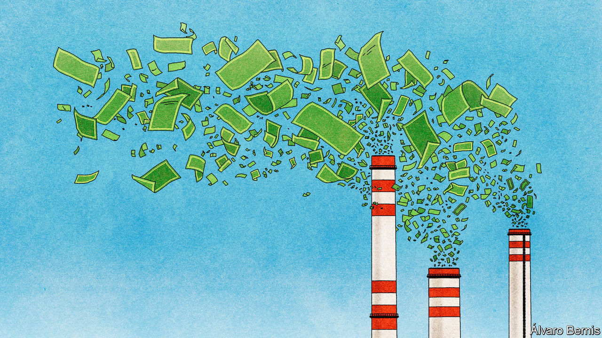

Editor’s note: Each of these climate-change articles is fiction, but grounded in historical fact and real science. The year, concentration of carbon dioxide and average temperature rise (above pre-industrial average) are shown for each one. The scenarios do not present a unified narrative but are set in different worlds, with a range of climate sensitivities, on different emissions pathways

IT IS HARD to envisage now, but the Permian basin in Texas and New Mexico used to be America’s biggest source of crude oil. At its peak it accounted for more than half of national production. Today the steel pumpjacks have been replaced by direct-air capture (DAC) units. Powered by the sun, the machines suck carbon dioxide from the atmosphere and pump it into the sedimentary rock formations below. There is an elegant symmetry in the way the carbon is being pumped back into the ground. Big Oil has given way to Big Suck.

The transformation of the Permian region illustrates an industrial shift that began in the early 2020s. The once-mighty oil industry, in its old form, has withered. From its husk a thriving new industry has emerged. Carbon-removal firms now number among the world’s biggest. Alongside big cuts in emissions, their technology has helped stabilise the climate and reduce emissions to net-zero. The atmospheric concentration of carbon dioxide is even beginning to drop as carbon-removal efforts are expanded. At the same time, the industry has reshaped geopolitics—and is creating its own set of environmental impacts.

The trouble for Big Oil started in 2014, when booming American production helped spur a plunge in prices. The covid-19 pandemic of 2020 triggered a short, sharp contraction in demand. Longer-term decline was unavoidable. Internal combustion engines in road vehicles, which made up more than two-fifths of oil use in 2020, were starting to give way to electric motors. Further pressure came from the rise in carbon taxes, as governments, cash-strapped after covid-19 bail-outs, sought new streams of revenue. The oil-price spike of the late 2020s simply reinforced the trend towards other forms of energy.

Firms that built the kit used in oil production, such as refineries and pipelines, were the first to go bust as investments in new assets ground to a halt. Next up were companies that struggled to divest themselves of pricey oilfields. As oil-producing firms fought for survival, one strategy was consolidation through mergers. In the end, some supermajors ran down their reserves, halted oil investment and were run for cash. By contrast, national oil companies with low production costs, such as Saudi Aramco, kept pumping. But the most innovative giants, sensing an existential threat, realised that if they were to continue supplying oil and gas, they would need to capture and store the carbon emissions they produced, too.

By the late 2020s, two methods had emerged as the most effective ways to do this. One was DAC, which involves trapping carbon dioxide from the atmosphere by sucking air through an absorbent material. The other was “bioenergy with carbon capture and storage” (BECCS), where the absorption is done by trees and crops as they grow. That biomass is then burned for energy and the resulting carbon dioxide is captured. Either way, it is stored underground, permanently removing it from the atmosphere.

Before it was brought into being, carbon-capture technology was assumed to be very expensive—one early study of DAC suggested costs of $600 a tonne or more. When entrepreneurial start-ups tried it out in the early 2020s, though, it came in at about a third of that. The costs of BECCS were never as high, because capturing carbon dioxide from a power-station chimney, where the concentration is about 10%, is inherently more efficient that capturing it from ambient air, where the concentration is just 0.045%. That said, cost estimates for BECCS were—and to some extent remain—vexed by the question of how to account for the opportunity cost of the vast plantations it requires.

Oil companies already had expertise in putting fluids back underground as well as taking them out: it is how fracking is done. They also had experience in mounting operations on truly large scales—which, when applied to carbon-capture, brought costs down yet further. Increasing the size of an industry by a factor of 50, as happened in the 2020s, gets you a lot of learning by doing. Most important, carbon removal allowed them to continue pumping oil. Their new business model was selling fuels in markets in which there was no feasible alternative, such as long-haul air travel, at “net-zero” prices which included the certified capture of an amount of carbon equivalent to that given off by the fuel’s combustion. It was called “carbon leasing”: the oil company lent the customer fresh new carbon and took old, used carbon back in return.

International politics helped. At the COP27 climate conference, in 2022, world leaders finally managed to agree on the creation of an international carbon market in which carbon-removal credits could be traded. This let companies sell removal capacity they did not need for carbon-leasing deals and buy spare capacity when their removal systems let them down. At the same time, the Organisation for Carbon Accounting (OCA), a global monitoring body, was spun out of the Intergovernmental Panel on Climate Change. Its real-time audits of carbon-removal facilities gave the industry credibility.

The astonishingly rapid scale-up in production—outpacing the construction of railways or power grids in previous eras—was due in part to smart industrial design. Equipment for DAC was tailored to existing industrial know-how: that used in car plants, gas-turbine factories, and mining and water-treatment. The BECCS industry, for its part, got a boost from genetic modification, in the form of new strains of trees and crops that absorb more carbon dioxide as they grow. The giant carbon-removal utilities which emerged now pull around ten gigatonnes of carbon dioxide out of the skies each year; along with their carbon-leasing businesses and the electricity generated by their BECCS plants, that gives carbon-removal companies a collective turnover of more than $1trn.

## Back into the ground

The emergence of this new industry has had far-reaching ramifications, as some locations are better suited to carbon removal than others. Three conditions are needed: storage, space and low-cost power. Storage was the easiest to crack. Many countries have locations suitable for burying carbon dioxide, such as sedimentary or basaltic rock formations. For DAC a more important factor was the continuous availability of cheap energy. In some cases this meant building DAC plants by geothermal power stations, such as in Iceland. But most large-scale DAC facilities depend on solar power, the cheapest energy source.

DAC plants also need a lot of space. An early estimate, made in 2019 by Howard J. Herzog of the Massachusetts Institute of Technology, was that removing 1m tonnes of carbon dioxide a year from the air would require a facility ten metres high, 3-5 metres wide and 5km long. The technology has become more compact since then, but it is still land-hungry. So today most DAC plants are in deserts, where sun and space are plentiful. North Africa is one hotspot, along with Australia and America’s southern states. Space is needed to grow fuel for BECCS too, as are weather conditions ripe for growing biomass. Countries in the tropics, notably Indonesia and Tanzania, emerged as big BECCS hubs.

All this has tilted the scales of geopolitics. Some oil-rich countries, such as Venezuela, have suffered, as oil that is costly and dirty to extract remains below ground. China established a national giant, Sinodac, and solidified its role as the world’s manufacturing hub for batteries and solar panels. Other countries, such as Brazil, Indonesia and Tanzania, gained political clout as their carbon-removal sectors boomed.

## Money from thin air

Carbon removal affected the corporate world, too. Even though the planet has now achieved net-zero emissions, individual companies still emit carbon dioxide and buy carbon credits, in the form of negative emissions, from carbon-removal firms. Unexpected price increases can hit profits in the still-carbonised sectors. That was the case in 2047 when a forest fire near a BECCS plant in Kalimantan, Indonesia’s slice of Borneo, destroyed a huge number of trees, which act like temporary storage units for carbon dioxide until it is captured at a BECCS plant. The resulting release of carbon dioxide made a big dent in the world’s carbonremoval capacity. Prices shot up and some companies were badly stung (at least those that had failed to hedge in the removals futures market). DeltaAmericanBlueCircle went bankrupt.

The removal industry also finds itself under close scrutiny from environmental groups. One concern is just how securely carbon dioxide is stored underground. The role of the industry in the Memphis earthquake of 2042 remains hotly contested. Carbonremoval bosses dismiss these criticisms as nitpicking. Now that the climate has stabilised, they grumble, some environmental NGOs are overstaffed, overfunded and have little else to do.

A larger headache for bosses is navigating the long-term future of their industry. Large-scale carbon removal will be needed for a few decades yet, after world leaders pledged at COP50 in 2045 to bring atmospheric carbon-dioxide levels down further. But no agreement has been made as to how far. If and when governments agree they are happy for the concentration of carbon-dioxide to remain stable, the growth of the carbonremovals industry will stall and may go into reverse.

One route for expansion is cannibalisation. Rivalry between the BECCS and DAC camps is growing. Both are spending more on marketing and lobbyists. They want to persuade consumers and politicians that their technology is superior, and that humanity’s aim should be to return the atmosphere to pre-industrial levels of carbon dioxide. Despite these efforts, analysts expect the sector to shrink and consolidate in the coming years. That may favour the largest carbon-removal outfits, several of which are also oil producers. The very firms that prospered by taking carbon out of the ground may profit the most from putting it back. ■

For our latest coverage of climate change, register for The Climate Issue, our fortnightly newsletter, or visit our climate change story hub

This article was downloaded by calibre from <https://www.economist.com/the-world-if/2020/07/04/what-if-carbon-removal-becomes-the-new-big-oil>

|  |  |  |  |
| --- | --- | --- | --- |
| Previous | Articles | Sections | Next |

|  |  |  |  |
| --- | --- | --- | --- |
| Previous | Articles | Sections | Next |

#### If covid-19 devastated aviation

# What if aviation doesn’t recover from covid-19?

How the pandemic transformed the travel industry. An imagined scenario from May 2022

Jul 4th 2020 |

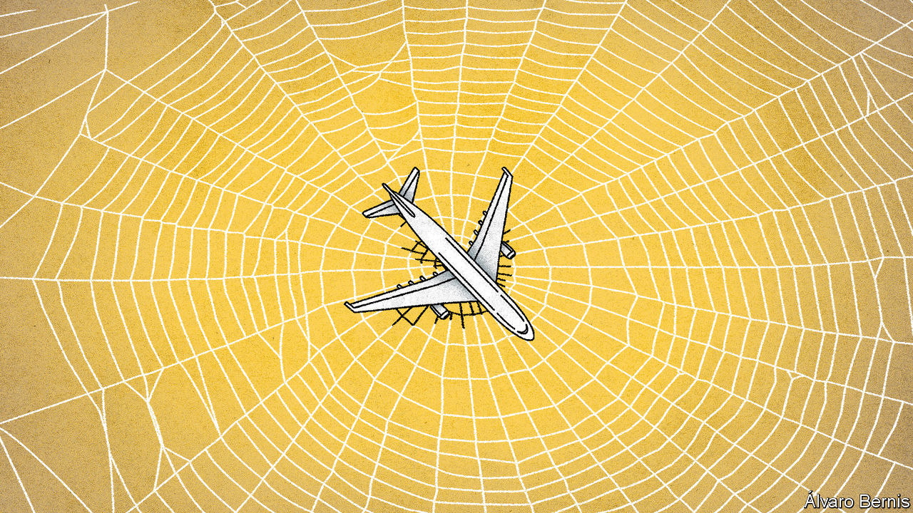

Editor’s note: Each of these climate-change articles is fiction, but grounded in historical fact and real science. The year, concentration of carbon dioxide and average temperature rise (above pre-industrial average) are shown for each one. The scenarios do not present a unified narrative but are set in different worlds, with a range of climate sensitivities, on different emissions pathways

IN SEPTEMBER 2019 a group of climate activists formulated a plan to shut down London Heathrow, Europe’s largest airport. Heathrow Pause, a splinter group of the Extinction Rebellion movement, had been inspired by an incident at Gatwick the previous year, when an unauthorised drone closed Britain’s second-largest hub for three days. They hoped to repeat the trick at Heathrow. But their drones failed to get off the ground, due to signal-jamming by the airport. In December 2019, Extinction Rebellion tried again to close Heathrow, this time by blocking its entrance road with a pink bulldozer. But police confined the protest to a single lane of traffic, meaning that incoming passengers could simply drive around the problem.

The activists lying in front of the bulldozer that cold December morning could not have known that a virus just 0.1 microns wide, more than 8,000km away in China, was inadvertently about to help their cause. Few industries were harder hit by the subsequent covid-19 pandemic than air travel. Government lockdowns, travel restrictions and cancellations by fearful passengers soon grounded most of the industry. By April 2020 Heathrow’s passenger numbers had fallen by 97% to the lowest monthly figure since the 1950s. Global passenger numbers did little better, falling that month by 94% year on year, to levels last seen in 1978. Half a year of lost revenue later—amounting to well over $250bn—the industry’s finances were in ruins.

Two years on, the forecast made in May 2020 by the International Air Transport Association (IATA) that passenger numbers would return to pre-pandemic levels by 2023 now looks wildly optimistic. But the trade body’s prediction that only 30 of the world’s 700 or so airlines would survive the crisis without government help was spot on. Carriers that failed to get bail-outs fell like dominoes, starting with Flybe, Europe’s largest regional airline, in March 2020, Virgin Australia in April and LATAM, Latin America’s largest carrier, in May. Sir Richard Branson, founder of the Virgin Group, became an illustration of his old quip: “The easiest way to become a millionaire is to start out as a billionaire and then go into the airline business.”

Even airlines that got government bail-outs did not find life easy. Austria and France led the way by imposing strict environmental conditions. Airlines were forced to cut their emissions to meet aggressive targets and to end competition against greener alternatives such as high-speed rail. That raised their costs and limited their potential revenue. And they were soon cash-strapped again. America’s airlines quickly chewed through $25bn in federal grants and loans; Air France-KLM and Lufthansa of Germany did the same with bail-outs worth nearly €10bn ($11bn) each. The result was a drastic slimming down of the world’s flag-carriers.

Airline executives had initially thought the pandemic would cause manageable, but not catastrophic, disruption. Looking at previous epidemics in Asia, such as SARS in 2002-03 and the South Korean outbreak of MERS in 2015, IATA expected a sharp dip in traffic, followed by a return to the original trend six or seven months later. In retrospect, that was overly hopeful. A short, stuttering recovery during the autumn of 2020 was choked off by the pandemic’s second wave of infections. “This time is very different,” says Leigh Bochicchio of the Association of Corporate Travel Executives, an American industry association. “It’s a very different beast to SARS or 9/11.” After those earlier shocks, there was no second wave of infections or terror attacks to remind people of the danger of flying.

And in retrospect, SARS was much easier for airlines to manage than covid-19. SARS showed symptoms immediately and could be detected with temperature checks at airports. It was not initially contagious; those infected could be isolated before they spread it to others. Covid-19, in contrast, shows no symptoms for up to two weeks after infection, a period in which it is contagious. No wonder experts soon found that airline travel was the primary means by which the disease spread around the world.

In the past, the airline industry has always fully recovered from crises. But this time has been different. “Peak plane”, once Extinction Rebellion’s fantasy, no longer looks so inconceivable. With the prospects for a vaccine still uncertain, business travel began to pick up again in 2021, though only as a trickle. The biggest global downturn since the Depression left corporate travel budgets an easy cost-code to squeeze.

Even firms that are solvent enough to let their employees fly have not been keen to do so. “People are more comfortable with online meetings, and that will never go away,” notes Ms Bochicchio. After the global financial crisis of 2007-09, international business travel fell by a third in many countries, and never recovered. Companies found new ways of doing business using video calls. That story repeated itself in spades after covid-19. Many corporate events and conferences have gone online permanently. Another chilling effect was that firms feared being sued by employees who caught covid-19 on business trips—a possibility their insurers increasingly refused to cover. As a result, the average age of business travellers is now falling: surveys show millennials are more likely to regard business travel as a status symbol than older workers, and consider themselves at less risk from covid-19.

Leisure travel has been much slower to recover. That was not due to any initial reluctance to get back in the sky. Surveys during the pandemic found that 69% of Americans said they missed travelling. Half of Chinese expected to travel more once the crisis was over. Perhaps most remarkably of all, 23% of Britons said they planned to be on the first flight deemed safe.

But many newly established “air bridges” and “travel bubbles”—pairs and groups of countries between which travellers could move without quarantine—collapsed in panic when the second wave of the pandemic hit in autumn 2020. “Staycations”—holidaying within one’s own country—became the norm in 2021, as crowded aeroplane cabins were shunned in favour of cars, trains and even cruise ships (which, despite their association with the early weeks of the outbreak, turn out to be well suited to social distancing).

The aviation industry did its best to win back customers with a marketing blitz, but cabin crew dressed in personal protective equipment, who treated all passengers as biohazards, failed to reassure. The requirement to leave middle seats empty, to maintain social distancing, was dropped by governments when airlines complained that it cut their capacity. But that prompted concerns that airlines were more concerned with profits than with passenger safety.

## The end of low-cost flights

Rising ticket prices have also deterred travellers from flying away on holiday. Although fares initially fell to put bums back on seats after the first and second waves—dropping by 35% in 2021, just as Dollar Flight Club, an American travel website, had predicted—the low prices didn’t last long. Ryanair, Wizz Air and Air Asia, the world’s biggest budget carriers after the pandemic, waged the “mother of all fare wars” in an effort to put all non-state-subsidised rivals out of business in Europe and Asia. The resulting consolidation has left little competition in the industry. As soon as they could, airlines began to pass on the extra cost of their new counter-coronavirus measures to passengers. Analysts think fares could soon be double what they were before the pandemic.

Perhaps the clearest sign of the long-term change in direction for aviation has been the collapse in demand for new aircraft. The world’s two biggest planemakers, Airbus and Boeing, predicted just before the pandemic that global air travel would grow by 4.3% each year over the next 20 years, requiring around 40,000 new airliners to be built. Now they are not so sure. Airlines permanently grounded over 5,000 planes during the pandemic. Boeing cut future production by 50% and cancelled plans to develop two new airliners in the coming decade. Even Airbus, which has enough orders to keep its assembly lines busy for a decade, decided to slow production by 30%.

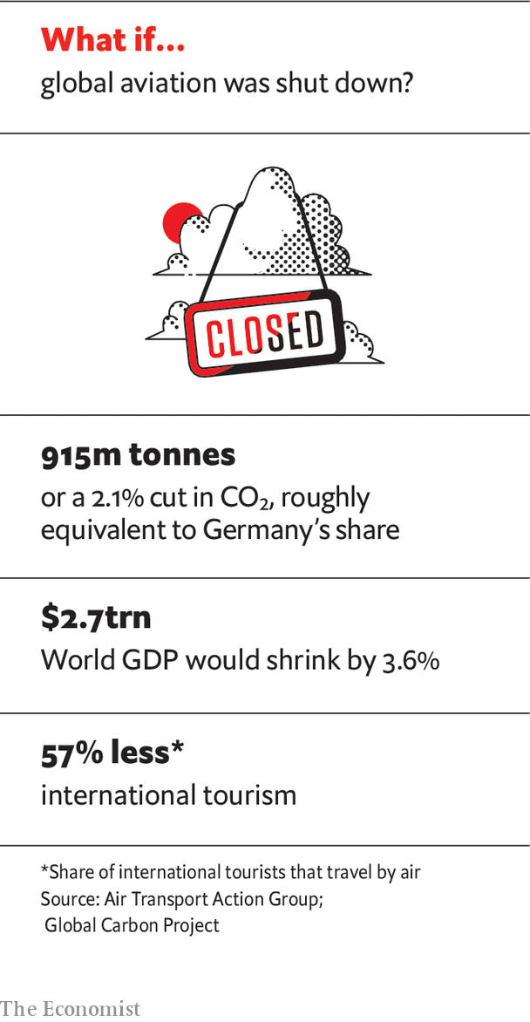

The biggest casualties were the biggest birds. Boeing 747 jumbos, once the “Queens of the Skies”, were nearly all grounded in 2020, never to fly again. The even-larger superjumbo fared almost as badly. “The A380 is over,” lamented Sir Tim Clark of Emirates during the pandemic. Having once owned 115 of the 242 in existence, Emirates retired 40% of them in 2020.

Planemakers and airlines alike are pinning hopes of a travel revival on the wanderlust of the young, and of the rising middle classes in the developing world. Their faith may be misplaced. The young are highly climate-conscious and have taken to “train-bragging”, encouraged by campaigners such as Greta Thunberg. Several European governments have stepped up investment in high-speed rail as part of their stimulus packages. Polls suggest people under 25 see climate change and pollution as the two most important issues facing the world. In the developing world, meanwhile, the pandemic shattered the illusion in Africa and India that travelling by plane was any safer or more hygienic than overcrowded diesel trains or by car.

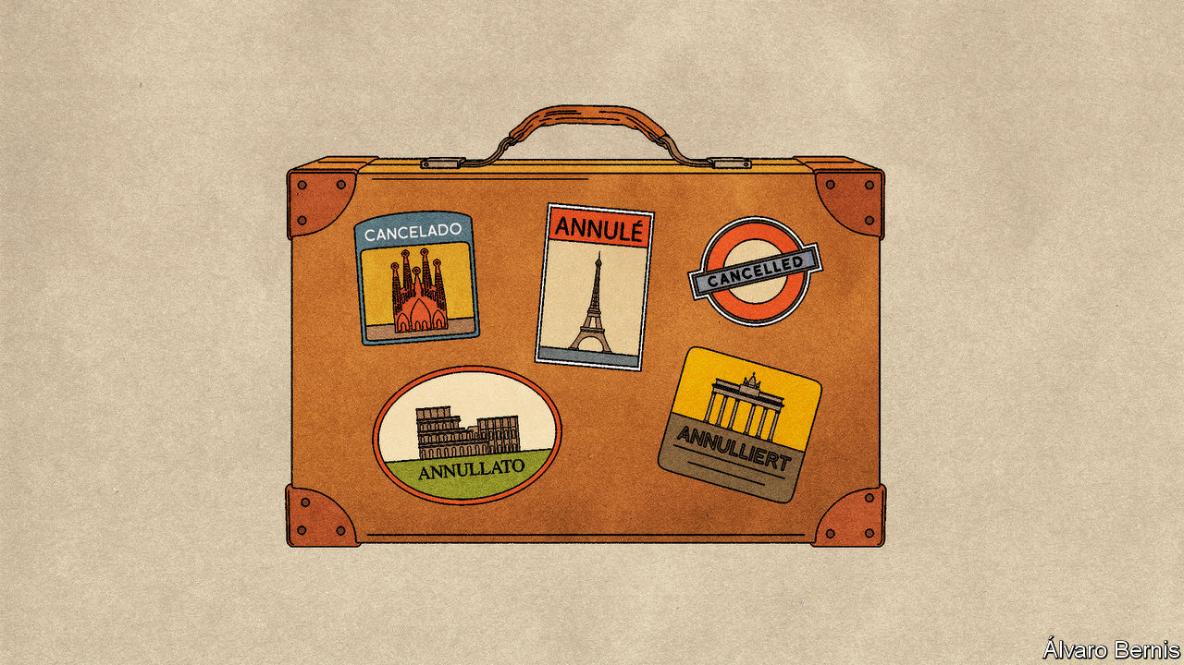

That covid-19 has exposed the fragility of globalisation is particularly apparent in the case of aviation. The industry can no longer rely on the steady growth of the past, or indeed any growth at all. Yet historians will write that it was not radical environmental movements such as Extinction Rebellion that killed the trend. Instead it was the combination of a microscopic virus and free-market capitalism.

The five-year period before the pandemic was the only one since Orville and Wilbur Wright made their first flight in 1903 in which the industry covered its cost of capital. Burned again by covid-19, many investors have now decided to stay away from anything that flies. Warren Buffett, a billionaire investor, once quipped that “if a farsighted capitalist had been present at Kitty Hawk, he would have done his successors a huge favour by shooting Orville down.” During the pandemic, Mr Buffett realised that this historical observation was no joke. Selling his shares in American airlines at a multi-billion dollar loss, he noted that they should be avoided by investors. His reason: “The world has changed after covid-19.” ■

This article was downloaded by calibre from <https://www.economist.com/the-world-if/2020/07/04/what-if-aviation-doesnt-recover-from-covid-19>

|  |  |  |  |
| --- | --- | --- | --- |
| Previous | Articles | Sections | Next |

|  |  |  |  |
| --- | --- | --- | --- |
| Previous | Articles | Sections | Next |

#### If technology tracked all carbon emissions

# What if technology tracked all carbon emissions?

Could governments use smartphones to monitor citizens’ carbon emissions? An imagined scenario from 2030

Jul 4th 2020 |

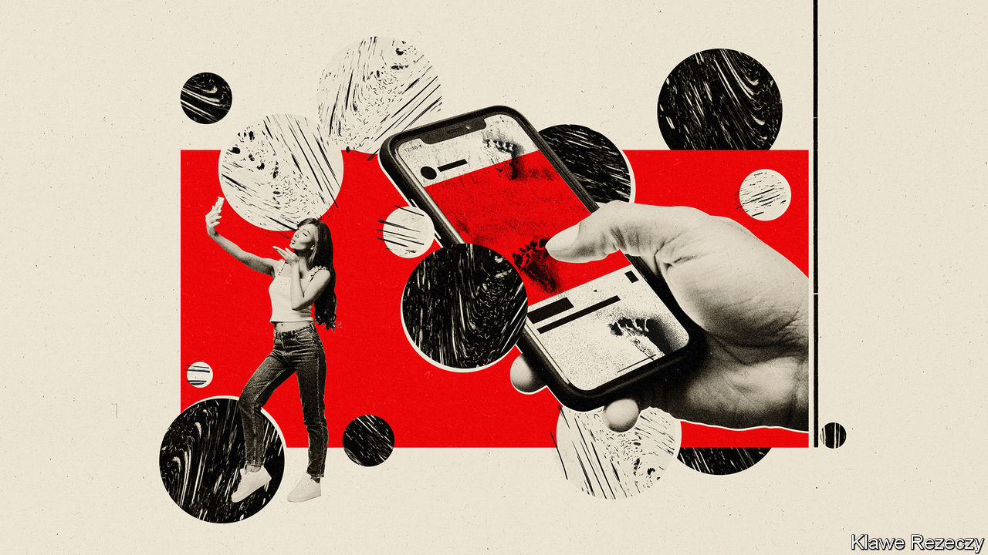

Editor’s note: Each of these climate-change articles is fiction, but grounded in historical fact and real science. The year, concentration of carbon dioxide and average temperature rise (above pre-industrial average) are shown for each one. The scenarios do not present a unified narrative but are set in different worlds, with a range of climate sensitivities, on different emissions pathways

IT STARTED WITH an app. “My Carbon Action” was released in late 2019 by a Finnish company that made banking software. It analysed people’s purchase data automatically to work out how much carbon underpinned their consumption. Its users were the sort of people who were already accounting for carbon emissions manually, typing guesstimates into carbon-footprint calculators and buying offsets for their meat consumption or their flights to alleviate their guilt over contributing to a warming world.

Barely anyone noticed the app at the time, but it was an early example of the automated carbon-accounting that has since transformed the global production system. It started a chain reaction that ran throughout the 2020s and led to today’s ubiquitous surveillance and measurement of emissions across supply chains, manufacturing facilities and consumer activity.

At first, My Carbon Action and its copycat apps were mostly remarkable for their inaccuracy. The details generated by transactions with bank cards or digital payments were too vague to offer a reliable proxy for carbon emissions: who could tell what “MAXIM’S CSD (2973) Food & drink $7.48” meant, let alone the carbon footprint of that transaction? The products people bought, where they had come from and how they had been produced were unknown, even to the companies that sold them. The Finnish system used transaction totals and vendor names to make a rough guess of what had been purchased, and its own internal models to estimate its carbon footprint. Spent eight dollars at Starbucks? You probably bought a coffee and a snack.

Slowly, the guesses became more accurate. Climate campaigners pressed companies to provide more and better emissions data about the products they sold. Neobanks had introduced digital receipts in the late 2010s, but they had been little more than a gimmick. Now they became a place to display the climate worthiness of your operation, and the main channel through which emissions data could be funnelled and collected. In 2021 Pret A Manger, a British sandwich chain, started totting up the carbon footprints of all its products, printing them on the labels in the shop and on its receipts. When customers paid with Pret’s app, a smartphone or a linked bank card, emissions data could be sent directly to their emissions-counting app.

Carbon accountancy improved, but some of the biggest firms held out. That changed in 2023 as the West Coast wildfires raged from California to Oregon and furious Amazon employees, their families choked with smoke, demanded change from their gigantic employer. The world’s largest e-commerce firm promised to start calculating and publishing the full life-cycle emissions of the products it sold. At first Amazon’s emissions values just applied to products it sold directly, calculated by its internal modelling team. Then they were expanded to third-party sellers. By that time the direction of travel was clear, and all e-commerce platforms started to include support for emissions calculations in their systems. Amazon opened up its own platform, turning it into a database that could be queried to determine the carbon footprint of millions of products. Walmart followed suit.

In China, Alibaba and JD.com, Asia’s two biggest retailers, pushed their own carbon-accounting systems, which they had started two years before Amazon’s. The Swiss-based International Organisation for Standardisation held its first meeting on standards for carbon accounting in transactions in November 2022. By 2023 the world’s retailers had the beginnings of a common standard for reporting the emissions that underpinned their products. Real-time data about the carbon implications of consumption started to flow in earnest. Clever hedge funds bought up this data and started trading against it, identifying the manufacturers with the dirtiest footprints and shorting them. Soon they had securitised future negative carbon flows.

## Following the carbon footprints

Using various “carbon bragging” apps, climate influencers began to publish live feeds of their carbon footprints, determined in real time from data flowing through their smartphones, which had by this time replaced travel passes for public transport, airline and train tickets. Facebook (as the company now known as Instagram used to be called) bought the Finnish company and integrated its code into the Instagram app, instantly making it the market leader among carbon-bragging apps. It launched the new feature on Thanksgiving 2024, when Selena Gomez became the first user to publish her footprint via Instagram.

Other celebrities fell in line, from Bollywood to Hollywood. Some celebrities who had touted their green credentials were shamed when they accidentally revealed their carbon-profligate habits, from gas-guzzling cars to private jets, due to confusion over the app’s privacy settings.

And sometimes the system got things very wrong. In one infamous case Antonia Magnini, an Italian woman, was told that her Pret A Manger lunch was responsible for emissions equivalent to the entire annual carbon output of Suriname. A bug in Pret’s supply-chain software had mistakenly totted up a sandwich’s worth of a new rocket leaf as the entire year’s projected supply for the whole chain worldwide, and rounded up. Ms Magnini was the unlucky first buyer of the first sandwich containing the new rocket. She sued Pret for reputational damage after the alert propagated onto her Instagram page. The company settled out of court.

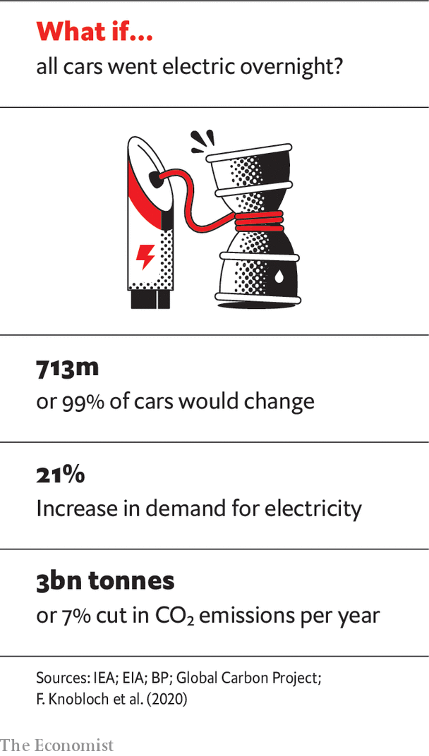

But things changed dramatically after the Great Hurricanes of 2025, and the upending of climate politics in America that ensued. The bipartisan climate bill passed in the wake of the disaster introduced steadily declining personal carbon allowances (PCAs), linked to the carbon-accounting systems already in widespread use. It also levied carbon surcharges on anyone who exceeded their PCA, and paid carbon rebates to anyone who did not use their whole allowance. To ensure the accuracy of the carbon-accounting infrastructure, the bill mandated regular audits of companies’ accounting systems by independent bodies, and heavy fines for undercounting carbon footprints. People and companies were required to provide “carbon returns” to the newly renamed Internal Revenue and Carbon Service (IRCS), which was given oversight of the entire carbon-accounting system.

This gave the IRCS real-time access to all transaction data. It also pitted privacy advocates, who objected to the extension of government surveillance to the entire economy, against environmentalists, who considered it a price worth paying to tackle climate change, particularly as global average temperatures surged towards 1.5ºC above the pre-industrial level. Consumers had long accepted what was, in effect, surveillance of their internet use by private companies in return for free, ad-supported services such as search, email and social media. Many of them were already using climate-bragging apps. This would promote and extend carbon transparency. And the carbon-rebate system had wide support. So what was the problem?

Other governments around the world followed suit with their own versions of carbon taxes and PCAs, linked to now-standardised carbon-accounting systems. China linked its version to its existing social-credit systems, through a series of compulsory app updates for all citizens.

Globally, carbon-intensive activities such as long-haul travel or private jets became far more expensive. At the same time, the new system encouraged investment in low-, zero- and negative-carbon technologies. Celebrities competed to make their palatial homes and estates carbon-neutral, then carbon-negative. Attempts to hide emissions from the accounting system were punished socially as much as legally. The boss of Goldman Sachs was fired in 2026 after he was found to have registered his private jet under the emergency-services exception for aviation-fuel carbon tax. Social movements to increase carbon taxes and surcharges, and reduce PCAs more quickly, gained traction.

Inevitably, people tried to find loopholes. The use of cash, already in steep decline, had been further discouraged by governments to bring more people into the system. But local alternatives and barter systems emerged, along with an illicit economy based on cryptocurrencies, dominated by ShhCoin, launched in 2026 by Zach De Royland, a 23-year-old libertarian from Arkansas. ShhCoin let users buy and sell services anonymously, outside the carbon-accounting system.

To close this loophole, the American government launched a swarm of satellites in 2028 that used spectroscopy, visual and radar images, analysed by artificial intelligence, to pinpoint undeclared sources of carbon-dioxide emissions. Where the original carbon-accounting system had focused on the consumption that drove emissions, the satellites provided a way to identify them at source. Other governments joined the American scheme. But China launched satellites of its own, claiming the American-led system, which had uncovered several sources of illicit emissions within China, was politically biased. Blanket surveillance of the physical world closed the last big loophole for laundering emissions through informal systems, and shut down the supply chains of the ShhCoin economy.

Today, with carbon-dioxide emissions falling steadily, the carbon-accounting system—or carbon-surveillance system, as it has now become—provides a powerful policy tool that allows governments to set the pace of decarbonisation of their economies. Global temperatures have risen alarmingly, but the target of net-zero emissions by 2050, a policy goal of many countries, seems within reach. The original carbon-tracking app of 2019, like many other inventions in the past, has gone from a diversion for a few rich people to a world-changing technology. Privacy activists object that the system is far more obtrusive than it needs to be. But as they campaign for the dismantling of the surveillance system that has helped saved the planet, they face an uphill struggle. ■

This article was downloaded by calibre from <https://www.economist.com/the-world-if/2020/07/04/what-if-technology-tracked-all-carbon-emissions>

|  |  |  |  |
| --- | --- | --- | --- |
| Previous | Articles | Sections | Next |

|  |  |  |  |
| --- | --- | --- | --- |
| Previous | Articles | Sections | Next |

#### If mammoths were recreated

# What if mammoths are brought back from extinction?

Could recreating mammoths help curb global warming?

Jul 4th 2020 |

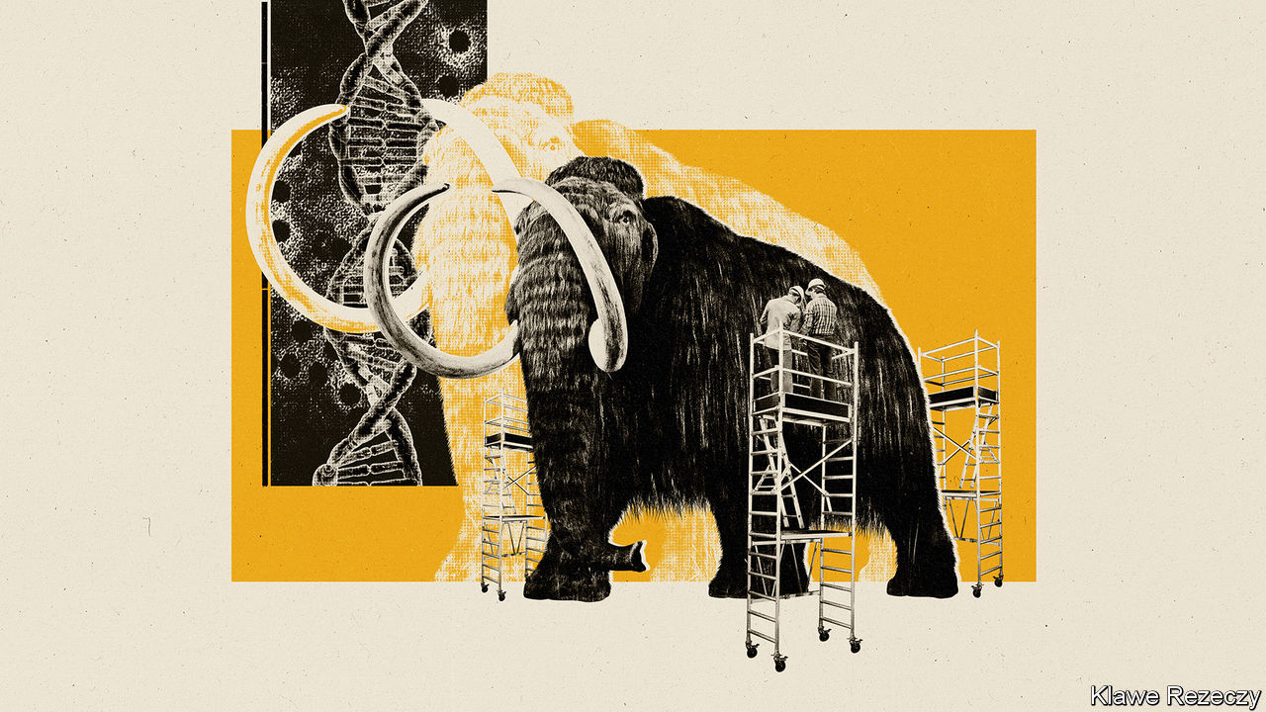

Editor’s note: Each of these climate-change articles is fiction, but grounded in historical fact and real science. The year, concentration of carbon dioxide and average temperature rise (above pre-industrial average) are shown for each one. The scenarios do not present a unified narrative but are set in different worlds, with a range of climate sensitivities, on different emissions pathways

IN THE LATE 1980s Michael Crichton, a novelist and filmmaker, had a lucrative idea. He picked up on the work of Allan Wilson, a geneticist at the University of California, Berkeley, and let his imagination run riot. Wilson had extracted DNA from an extinct type of zebra called a quagga. The DNA in question was fragmented, and the extinction of the quagga only a century in the past, but that did not matter. Crichton speculated about recovering far older DNA than the quagga’s by looking in the guts of bloodsucking insects preserved in amber that had formed millions of years ago, during the age of the dinosaurs. If the insects had been feasting on dinosaurs, he mused, they might have preserved those creatures’ DNA. And if you have something’s DNA you could, perhaps, recreate it. The result was “Jurassic Park”.

Sadly, there is no sign of any real DNA having been preserved from that far back in the past. But be a bit less ambitious in your time-travelling, and apply the three decades’ worth of biotechnological advances that have happened since “Jurassic Park” was published to the question of how you might go forward from here, and the aspiration of recreating at least some prehistoric creatures no longer seems completely fanciful. It may, moreover, be of practical importance, because one animal the de-extinctionists have in their sights is the woolly mammoth. And some people believe that reintroducing mammoths into the wild would make a change to the ecology of Earth’s northern reaches sufficiently large as to help curb global warming.

This, then, is the idea behind the Harvard Woolly Mammoth Revival Project, run by George Church. Unlike the long-dead dinosaurs in “Jurassic Park”, mammoths were present on Earth as recently as 4,000 years ago. That, and the fact that many of the parts of the world in which they lived are still pretty chilly, means quite a lot of mammoth DNA remains reasonably intact in frozen corpses recovered from the tundra—enough for palaeogeneticists to have reconstructed the animal’s genome. And with a genome, as Crichton mused, you can aspire to produce an animal.

Mammoths are a species of elephant. This helps because two (or, according to some taxonomists, three) other species of these animals remain alive today to provide assistance to the mammoth-revivers. Though African elephants (one species, or possibly two) are closer in size to mammoths than their Asian cousins are, genetics show that the Asian variety are mammoths’ closest living relatives, so it is they that are the focus of Dr Church’s research.

People once fantasised about cloning a mammoth directly, from cells or cell nuclei somehow revived from a fossil specimen. Dr Church’s approach is less ambitious and more realistic. It is to engineer the crucial elements of mammothness into Asian-elephant cells and then use these modified cells to create beasts which have the characteristics of mammoths, even if they are not strictly the real thing.

The technology that may make this possible is CRISPR-Cas9 gene editing, which permits precise changes to be made at particular places in an existing genome. In the case of mammoths the task does not, at first sight, seem too hard. An Asian elephant’s genome is 99.96% similar to a mammoth’s. Unfortunately, the 0.04% of difference amounts to about 1.4m places in the genome where the genetic “letters” of the DNA message differ between the species. Most of these differences are, admittedly, in places where they probably do not matter. But there are 2,020 exceptions which, collectively, change the nature of 1,642 genes—about 6.5% of the total. It is these differences that make mammoths and Asian elephants distinct.

Dr Church’s team are therefore concentrating on “mammothising” what they perceive to be the most pertinent of these genomic locations. They are tweaking the genes of laboratory-grown Asian-elephant skin cells one at a time, focusing on changes they hope will promote mammoths’ famed hairiness, their propensity to store layers of fat beneath their skin, their cold-adapted haemoglobin and even the protein molecules in their cell membranes that act as channels for the passage of sodium ions, and which are also adapted to the cold. Whether they also tinker with genes for size is, for now at least, undecided.

## First, make your mammoth

The team’s hope, once enough mammothness has been engendered into these cells, is that they can then be induced, by what is now a well-established laboratory procedure, to turn from being skin cells into stem cells. A stem cell is one that has the developmental plasticity needed to give rise to all sorts of other cells as it multiplies. In the short term, this approach will let Dr Church and his colleagues grow tissues such as blood, for further study. In the longer term, perhaps using an artificial womb, a stem cell of this sort might be grown into an embryo that can be brought to term. Not quite a true mammoth. But not a bad imitation.

That is all a huge technical challenge. But it is not completely fanciful. And success would usher in the second part of the plan: to liberate groups of newly created mammothoids into the wild, and let them multiply and change the Earth. This is the long-held dream of another group of researchers, led by Sergey Zimov, who runs the Russian Academy of Science’s Northeast Scientific Station, near Cherskii. Not only is it an attractive idea in its own right—for who could resist the idea of mammoths once again thundering over Siberia?—but it might also alter the climate for the better.

Dr Zimov’s plan is a grand project of biogeoengineering. Recreated mammoths are the boldest part of his aspiration to revive the grassland-steppe ecosystem that dominated Siberia until the arrival there of human beings, about 30,000 years ago. It had more or less disappeared by about 10,000 years ago, the end of the Pleistocene epoch, to be replaced by the modern tundra, which is dominated by moss and small trees.

This shift in vegetation was, Dr Zimov and his colleagues believe, a result of the extinction or near-extinction at that time of most of the area’s large herbivore species. This was almost certainly a consequence of hunting by human beings. Where once there were woolly rhinoceros, musk ox, bison, saiga, yaks, wild horses and mammoths, there now remain only reindeer and elk. The hooves of those vast herds of herbivores were, he believes, the crucial factor stopping the spread of moss at the expense of grass. And the crashing bulk and appetites of the largest species—mammoths in particular—would have dealt with young trees before they could grow up, as is still the case for elephants in what remains of Africa’s savannah. The loss of the grassland, climate modelling suggests, propelled an increase in temperature.

One factor driving this change was that forest and moss are darker than grassland. Their spread has therefore increased the amount of sunlight absorbed by the area they are growing in, causing warming.

A second factor was that large animals helped maintain the soil in the perpetually frozen state known as permafrost, by churning up the winter snowfall and thus bringing the soil into contact with the freezing winter air. But without them, the snow instead forms an insulating blanket that allows the soil beneath to warm up. And when permafrost melts, the organic matter in it breaks down, releasing methane and carbon dioxide—both greenhouse gases.

The third pertinent effect is that grass sequesters carbon in the soil in its roots. In Arctic habitats it would do this better than the small, sparse trees now present, and much better than moss, a type of plant that has no roots. Carbon stored this way is thus kept out of the atmosphere where, in the form of carbon dioxide, it would contribute to global warming. When the grass disappeared, the storage capacity did, too.

All these things point to the idea that restoring the Siberian grasslands at the expense of the tundra would be a good thing to do. And Dr Zimov has indeed made a start at doing so, in an area of tundra, covering 160 square kilometres (62 square miles), near his research station. In 1988 he enclosed part of this area and has gradually populated it with reindeer, Yakutian horses, elk, bison, musk ox, yaks, Kalmykian cows and sheep. These coexist with several species of predator, including lynx, wolverines and brown bears. He calls this rewilding project “Pleistocene Park”, and thinks it would benefit greatly from having a few mammoths, or even mammoth substitutes, in it as well.

Pleistocene Park is an experiment, but it seems to be working. Grasses now dominate large parts of it, carbon storage in the soil is going up and the rate of nutrient turnover is increasing, too. This last point is important because a faster turnover of nutrients means more animals can be supported by a given area—a prerequisite for re-establishing large herds.

Clearly, for Dr Zimov’s project to have any effect on the climate it would have to be carried out on a grand scale. The Northeast Siberian coastal tundra, to give the area of habitat in which Pleistocene Park is located its proper name, covers about 850,000 square kilometres, so the park is, at the moment, a mere pinprick. It would also take many decades, even without the complication of introducing as-yet-imaginary mammothoids into the mix.

Expansive though the tundra is, however, whether that effect will be large enough to weigh in the scales of a planet-sized problem is a matter of debate. The models suggest that the global temperature rise brought about by the shift from steppe to tundra was a bit over 0.1ºC. Reversing this shift would, presumably, push the temperature down by a similar amount. That, as Chris Field of Stanford University, in California, who was one of the modellers, points out, would help stabilise the climate, provided global temperature rises above preindustrial levels can be kept, by other means, below 1.5-2ºC, the objective agreed in Paris in 2015. But if the rise were much greater than this, he thinks the permafrost would melt anyway—mammoths or no. ■

This article was downloaded by calibre from <https://www.economist.com/the-world-if/2020/07/04/what-if-mammoths-are-brought-back-from-extinction>

|  |  |  |  |
| --- | --- | --- | --- |
| Previous | Articles | Sections | Next |

|  |  |  |  |
| --- | --- | --- | --- |
| Previous | Articles | Sections | Next |

#### If nuclear power had taken off

# What if nuclear power had taken off in the 1970s?

How would the world look today if more countries had adopted nuclear power after the 1973 oil crisis? A look back on an alternative history from a rather different 2020

Jul 4th 2020 |

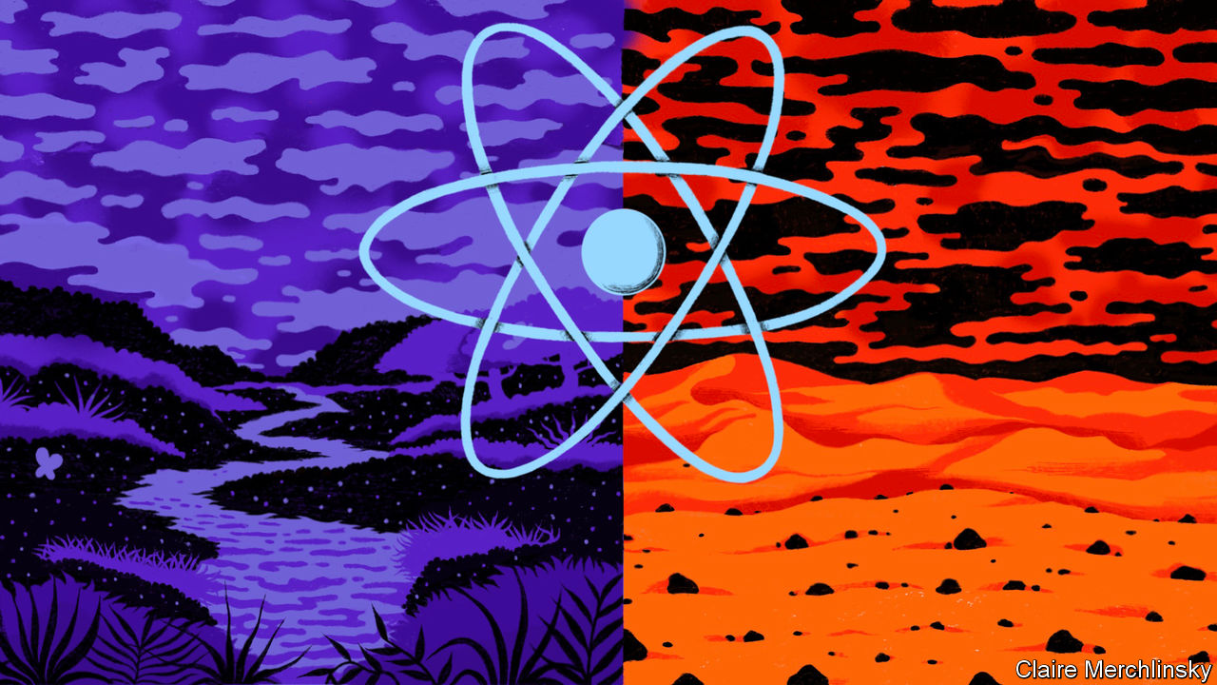

Editor’s note: This scenario is an set in a different 2020 from the one we now inhabit, on a timeline that diverged in 1974

IT IS NOT a date that means much to most people. But hindsight suggests that March 6th 1974 may have been a turning-point in human history. The decision announced on that day by Pierre Messmer, France’s prime minister, may have saved the world from a dangerous rise in temperatures—an obscure phenomenon known in scientific circles as “global warming”.

Messmer’s announcement was a plan to construct 80 nuclear-power plants over the following decade, and 170 by the turn of the century. It was a direct response to the oil shock of 1973, when concerted action by the Organisation of Arab Petroleum Exporting Countries pushed the price of crude oil up fourfold. At the time, most French electricity was generated by oil-fired power stations, but France had no oilfields of its own. Messmer and his boss, Georges Pompidou, the country’s president, decided to break French dependency on foreign oil by going nuclear instead.

In other circumstances, that decision might have proved just one more example of France’s desire to be different. Though nuclear power had looked promising in the 1950s, and most industrialised countries had built at least one experimental reactor, progress was unsteady in the 1960s as some people conflated atomic energy with nuclear weapons.

Two days earlier, however, Messmer’s British counterpart, Edward Heath, had almost lost an election called because a strike by coalminers had brought Britain’s economy to a halt. Heath, looking for alternatives to coal and a failed home-grown nuclear-reactor programme, turned to France for help. The two countries revived Euratom, a moribund sister organisation of the EEC. The nuclearisation of western Europe’s electricity was assured.

Events in Europe stiffened the resolve of America’s incoming president, Jimmy Carter, to encourage the consolidation of the American industry. Big engineering companies with nuclear-reactor divisions began lobbying against coal. It was one of their lobbyists who came up with the catchy name, “nu-power”. A small, successfully contained accident at Three Mile Island in Pennsylvania in 1978 convinced the public that reactors really were “fail-safe”.

Nervousness about countries using civil programmes to acquire the plutonium needed for bombmaking was soon put to rest. The technical breakthrough that overcame this objection, and paved the way for nu-power’s ubiquity, came from an unexpected quarter: India. In 1985 the Bhabha Atomic Research Centre (BARC) in Mumbai announced that it had built a successful thorium reactor. Not only is thorium three times more abundant than the uranium previously used to power reactors, it is much harder to weaponise. As well as revolutionising electricity generation, the BARC design triggered a shift in India’s fortunes that has led to it vying with China to challenge the United States as the world’s largest economy.

BARC’s breakthrough unleashed innovations that have made nu-power stations smaller, safer and more efficient, leading to today’s neighbourhood nuclear “batteries”. As well as eliminating the use of coal, they have also steadily replaced natural gas as a source of heat and propelled the rapid development and adoption of electric vehicles, with a resulting fall in the use of oil. All of which prompted Gustaf Arrhenius, a retired researcher at the University of California, San Diego, to do a thought experiment that would probably have occurred to no one else but the grandson of Svante Arrhenius, a great Swedish chemist, who invented electrochemistry more or less single-handedly.

Observing that carbon dioxide is a “greenhouse” gas, which traps solar heat in the atmosphere, and which was, even in the late 19th century, being produced in ever-larger quantities by the burning of coal, the elder Arrhenius predicted that the progress of industry would result in Earth’s surface temperature rising. His grandson’s sums, drawing on obscure research from the late 1960s, suggest that, had people carried on burning coal and oil at the rate predicted from the 1970s onwards, Earth would now be, on average, 0.5ºC warmer than it actually is. By 2050 it might have been two degrees hotter, and as much as six degrees by 2100.

Even two degrees would be enough to bring heatwaves and droughts and to melt polar ice, raising sea levels. Six degrees would turn much of Earth’s surface into a desert. Thank goodness, then, that Messmer’s plan worked more widely and comprehensively than he could possibly have imagined—and that, thanks to the nu-power revolution, people do not have to worry about the danger of such global warming. ■

This article was downloaded by calibre from <https://www.economist.com/the-world-if/2020/07/04/what-if-nuclear-power-had-taken-off-in-the-1970s>

|  |  |  |  |
| --- | --- | --- | --- |
| Previous | Articles | Sections | Next |

|  |  |  |
| --- | --- | --- |
| The World If | Sections | Finance & economics |

Business

Business in India: All aboard

.

Meal-delivery wars: Appetite for destruction

.

Airlines and the climate: Setting a new CORSIA

.

The Facebook boycott: With a little help from its friends

.

Nissan: Turning down the volume

.

Logistics (1): Seeking deliverance

.

Logistics (2): Droning on

.

Bartleby: Keep it practical

.

Schumpeter: The legacy of Chesapeake

.

|  |  |  |
| --- | --- | --- |
| The World If | Sections | Finance & economics |

|  |  |  |  |
| --- | --- | --- | --- |
|  | Articles | Sections | Next |

#### Groupthink

# India Inc’s inward turn

Foreign investors are rediscovering that the road to riches in India runs through powerful local partners

Jul 4th 2020 | DELHI AND NEW YORK

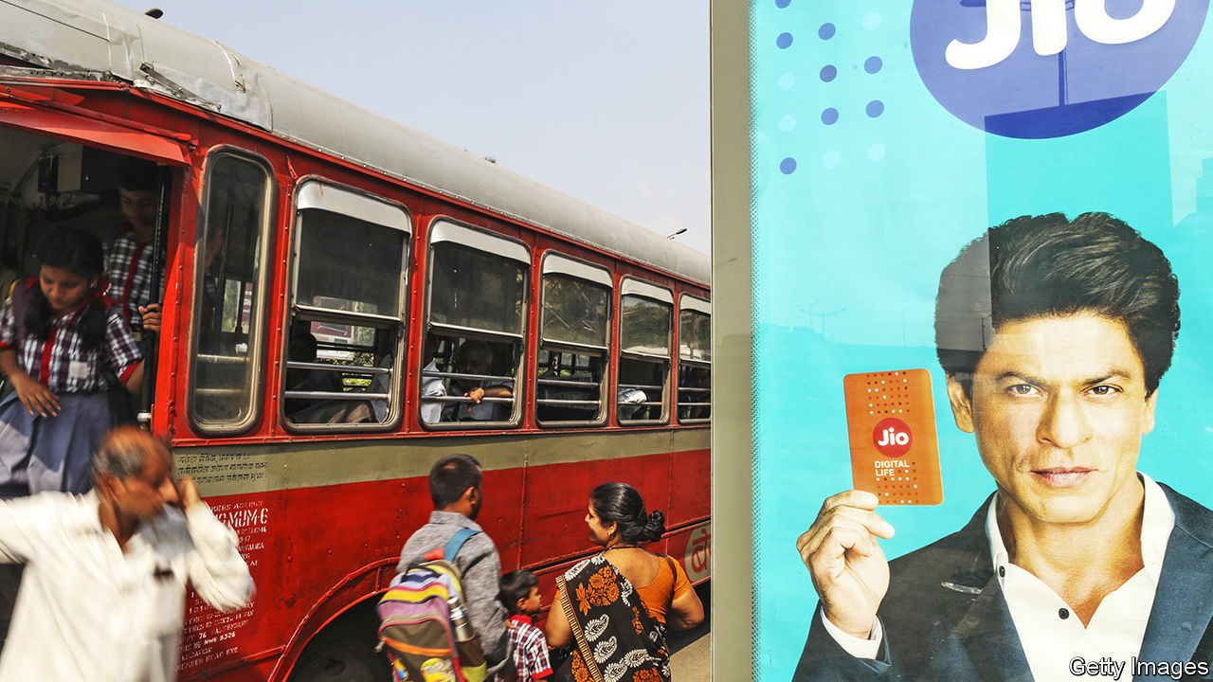

FACEBOOK WAS first to open its wallet. In April the social network said it would spend $5.7bn on a 9.9% stake in Jio Platforms, the digital arm of Reliance Industries, India’s biggest firm. The investment was followed in short order by nine other entities, including global private-equity (PE) giants such as KKR, as well as Saudi and Emirati sovereign-wealth funds. Collectively, this year foreigners have poured or pledged to pour $15.2bn into Jio. That would give them a combined stake of 25%. Microsoft is rumoured to be next in line.

For Reliance, the bonanza is a way to manage the huge debts it has taken out to bankroll Jio’s vaulting ambitions. For the foreigners, the appeal rests in part on its promise to tap into India’s underserved legions of digital consumers. Since its launch in 2016 Jio has become the country’s pre-eminent technology platform, with nearly 400m mobile subscribers, a broadband network, as well as entertainment, retail and finance businesses.

The investments were hailed by the local press and security analysts as an endorsement of a new digital champion—and of India itself. A recent flurry of dealmaking seems to corroborate this rosy view (see table). In February the Adani Group, another conglomerate, completed a $450m sale of 25% of its Mumbai power operations to Qatar’s government and received a $900m investment in a 37% stake in its gas operations by Total, a French oil giant. Talk of more deals abounds, notably one possibly involving Lockheed Martin that could enable the local production of jets for India’s air force at a time of rising tensions with China. (In May Chinese soldiers engaged in a brief but deadly skirmish with Indian border forces.)

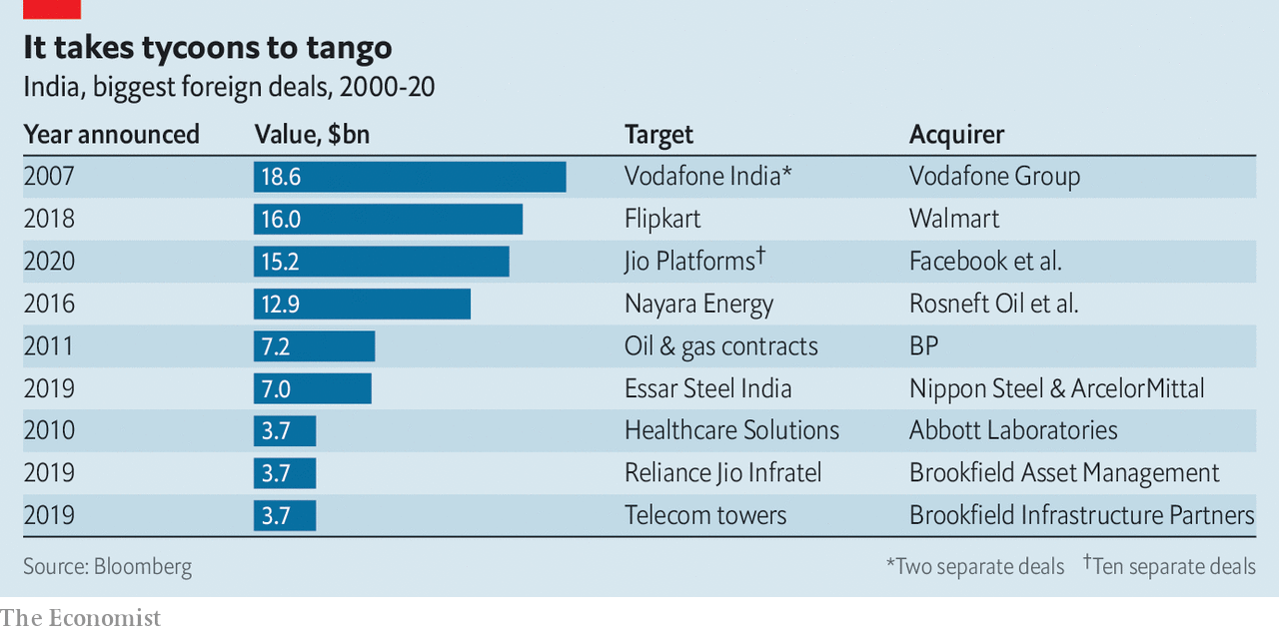

Look closer, though, and the apparent thumbs-up from foreign investors is not quite what it seems. After years of trying to make it on their own with mixed results, some foreigners appear to have concluded that getting ahead in India requires a powerful local partner. Mukesh Ambani, Reliance’s boss and India’s richest man, or Gautam Adani, the industrialist behind Adani Group, fit the bill to a tee.

In recent months this vision of India as a place where foreign money may be welcome but foreign competition is not has been more volubly embraced by the government of Narendra Modi. In a speech in May about India’s response to covid-19, which has hit India particularly hard, the prime minister referred to “self-reliance” 17 times. “We must”, he summed up, “make the Local the mantra of our life.”

That is a long way from the pro-business, investor-friendly posture which first got Mr Modi elected in 2014. But to seasoned observers of India Inc it shares some parallels with a more insular past.

After independence from Britain in 1947 the main way for most outsiders to partake in India’s economy was through joint ventures with domestic partners or some other form of local ownership. Some Indian partners were chosen on the basis of access to the levers of power rather than managerial acuity. India’s largest carmaker, Maruti Suzuki, created in 1982, was the brainchild of Sanjay Gandhi. His mother, Indira, was prime minister at the time. The Gandhis took care of the politics; Suzuki of Japan brought the cash and built the cars.

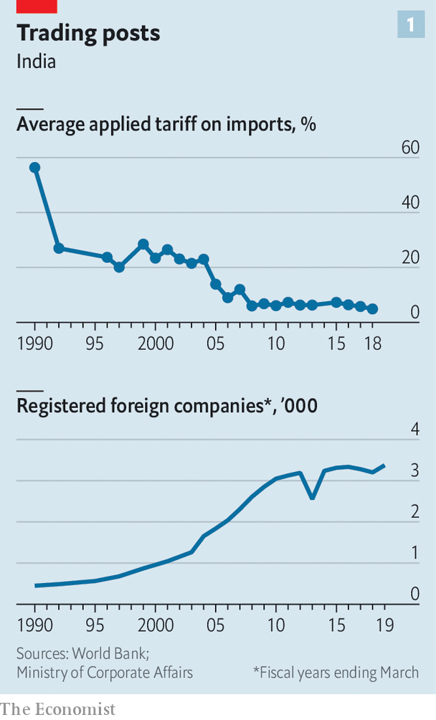

Things began to change after 1991, when India emerged from decades of self-imposed isolation and interventionism of the so-called “Licence Raj”. A series of liberalising governments cut tariffs and opened industries up to competition (see chart 1). But many stifling rules remained in place. Some were newly imposed. Shops were limited to a certain size and certain prices, for instance of drugs, remained controlled. By 2001 so many multinationals in industries from petrol (Caltex) to pharmaceuticals (Astra, Roche, Rhône-Poulenc) were once again fleeing red tape and other foibles that the Times of India, a leading daily, bewailed “the second quit India movement”.

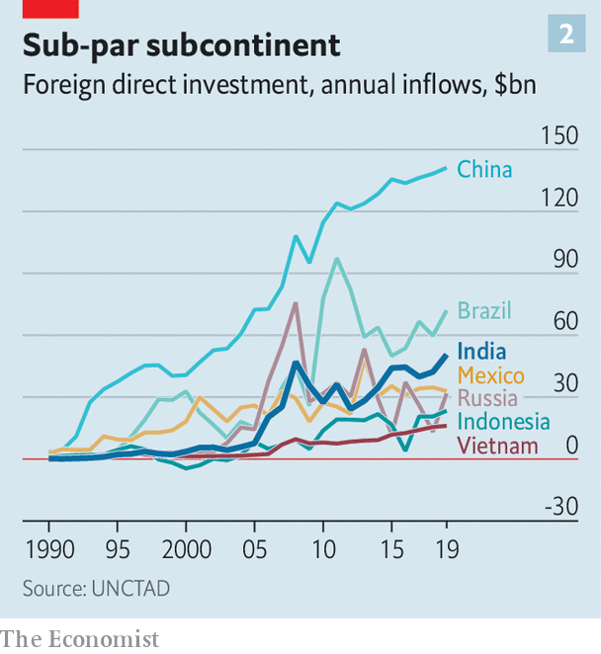

In the 2000s a new generation of firms had another go at conquering the Indian market. Foreign direct investment poured in (see chart 2). Marks & Spencer, a British retailer, plotted its entry in 2001, followed by Starbucks in 2007. Both have since allied with local powerhouses (Reliance and Tata, another conglomerate, respectively).

## Individualists’ lament

The dilemma lives on. Last year Ford announced that it would become a minority shareholder in a carmaking joint venture with Mahindra, a large industrial group. Firms that have resisted such tie-ups can struggle. General Motors threw in the towel in 2019, as part of a shift to focus on its American and European operations. Amazon, which has ploughed $6.5bn into its Indian operations, has yet to make money in the country. Walmart’s $16bn purchase in 2018 of a controlling stake in Flipkart, an Indian e-commerce firm, has been similarly hard work. As foreign entities, Amazon and Walmart must contend with a tax on transactions, limits on the size of their inventory and on sales of their own brands, as well as frequent visits from competition authorities.

A popular alternative is to operate a listed Indian subsidiary, like Suzuki or a number of big Western corporations, from consumer-goods titans (Unilever, ColgatePalmolive and Nestlé) to industrial giants (Bosch and Siemens). Even that does not guarantee peace of mind, however. After a protracted legal battle with India’s taxman, first over a capital-gains levy related to its $11bn purchase of an Indian mobile business, then over allegedly unpaid fees related to its spectrum rights, Vodafone Idea, India’s third-largest wireless carrier, was ordered by a court to pay $6.8bn in back taxes and fees. In an epic tale of value-destruction, the company now teeters on the brink of bankruptcy, weighing on Vodafone Group, its British corporate parent.

The contrast with Jio is stark. The Indian champion has managed to snap up mobile spectrum at low prices and extend promotional rates. Given Facebook’s fruitless efforts to gain regulatory approval for a payment feature in its ubiquitous WhatsApp messaging service, the social network may have quite reasonably decided that teaming up with Jio is a better bet.

Perhaps the best that can be said of the revival of collaborations between Western and Indian firms is that the deals are happening at all. Chinese companies face tougher times. Even before the latest border flare-up Mr Modi had made it clear China is less welcome. In April his government issued a rule subjecting “opportunistic takeovers” of Indian companies by “any entity of a country which shares land border with India” to a special review. India’s other, poorer neighbours—Bangladesh, Bhutan, Myanmar, Nepal and Pakistan—are unlikely to be the rule’s main target. On June 29th Delhi banned 59 mobile apps including TikTok, a hit Chinese-owned short-video platform (see article). Media reports warn of impending restrictions on 1,172 items, from toasters to lifts, made in whole or part in China.

Time will tell if Western investors’ latest dalliances of convenience pay off. The lot of Reliance businesses’ partners has not always been easy. India’s securities regulator has ordered Reliance Industries to compensate minority shareholders in Reliance Petroleum, an affiliate for a series of transactions between the two entities that, the regulator says, disadvantaged the outside investors. The case is pending. Reliance Industries denies any wrongdoing.

As good as Jio looks on paper, it must still show it has what it takes to run a modern tech behemoth. Ventures such as Jiomart (e-commerce) and JioMoney (finance) have yet to live up to the hype. Until they do, Jio’s nationality may remain its chief attraction.■

This article was downloaded by calibre from <https://www.economist.com/business/2020/07/04/india-incs-inward-turn>

|  |  |  |  |
| --- | --- | --- | --- |
|  | Articles | Sections | Next |

|  |  |  |  |
| --- | --- | --- | --- |
| Previous | Articles | Sections | Next |

#### Appetite for destruction

# Food-delivery wars heat up

Will winning the battle for locked-down Western stomachs ever translate into profits?

Jul 4th 2020 |

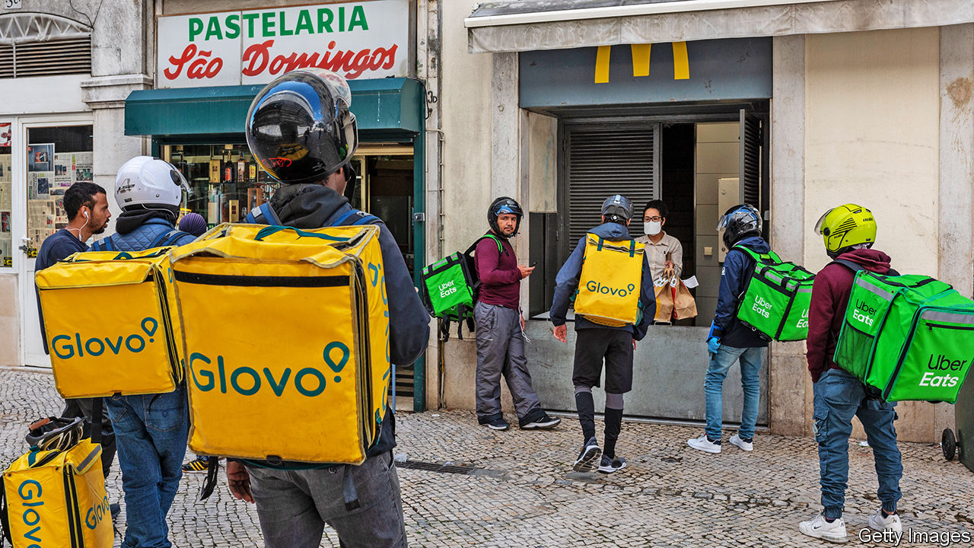

JOSé AVILLEZ, a Portuguese chef, has picked up two Michelin stars for his inventive takes on traditional dishes such as a pudding that daringly combines chocolate ganache with cuttlefish ink. On June 29th he experimented again: his Lisbon-based restaurant, Bairro do Avillez, started serving gourmands at home via Uber Eats.

It joins the likes of London’s Hakkasan and Claro in Brooklyn, which before covid-19 would never have dreamed of relying on a service associated with burgers and pizza. In May Dara Khosrowshahi, Uber’s boss, said the recruitment of such upmarket restaurants would expand the industry.

The veteran is Just Eat Takeaway.com, an Anglo-Dutch firm that in June bulked up by buying Grubhub, an American one, for $7.3bn. Both offer online access to restaurants that for the most part already have delivery drivers (though each is also investing in its own fleet). The trio of later arrivals on the scene—Uber Eats and two American rivals, Postmates and DoorDash—rely instead on armies of gig-economy couriers.

Uber seems bent on dominating the industry. On June 29th it reportedly offered $2.6bn to buy Postmates, which ranks fourth in America by revenue. The approach might relaunch plans for an initial public offering (IPO), which Postmates shelved last year after lukewarm interest from investors. At the time, food-delivery was becoming a poster-child for tech businesses whose footprint in the physical world meant that costs tended to grow as fast as revenues, or faster.

The pandemic has changed the mood again. Demand from locked-down consumers is surging. Grubhub recently reported revenue growth of 50% year on year, which may have accelerated in the past month or so. At Uber Eats, which operates in 45 countries, revenue in April was 89% higher than last year. In recent weeks the overall market has been expanding at rates above 100% in America, according to Mark Shmulik of Bernstein, a research firm. Despite continuing to lose money, DoorDash recently secured a valuation of $16bn, up from $12.7bn in late 2019.

Although sales are growing, profits remain elusive. Early last year the firms reined in spending on subsidies for consumers. Now strong demand has once again aroused hunger for market share. Grubhub’s profitability per order has duly dipped, according to Bernstein. Uber Eats is still losing an estimated $1.10 on each order, on average, though that is an improvement. Its $313m operating loss in the first quarter is some way from its ambition to achieve an operating margin of 30%.

Can the numbers add up? It is too early to tell, says Mr Shmulik. Consolidation may reduce costs and, in time, allow higher prices. At the same time, however, the business’s newfound prominence is drawing the attention of trustbusters and politicians concerned about the treatment of couriers and independent restaurants that rely on them to reach customers. In June Britain’s competition authority waved through Amazon’s investment in Deliveroo, a British firm. But Uber’s earlier talks with Grubhub foundered partly on antitrust concerns that might not have arisen without all the attention. Investors must wait to see if meal-delivery’s sweet ingredients overpower its sour ones. ■

Editor’s note: Some of our covid-19 coverage is free for readers of The Economist Today, our daily [newsletter](https://my.economist.com/user#newsletter). For more stories and our pandemic tracker, see our [coronavirus hub](https://www.economist.com/news/2020/03/11/the-economists-coverage-of-the-coronavirus)

This article was downloaded by calibre from <https://www.economist.com/business/2020/07/04/food-delivery-wars-heat-up>

|  |  |  |  |
| --- | --- | --- | --- |
| Previous | Articles | Sections | Next |

|  |  |  |  |
| --- | --- | --- | --- |
| Previous | Articles | Sections | Next |

#### Setting a new CORSIA

# Airlines blame covid-19 for rowing back climate commitments

The industry defangs an already mostly toothless carbon-offsetting scheme

Jul 4th 2020 |

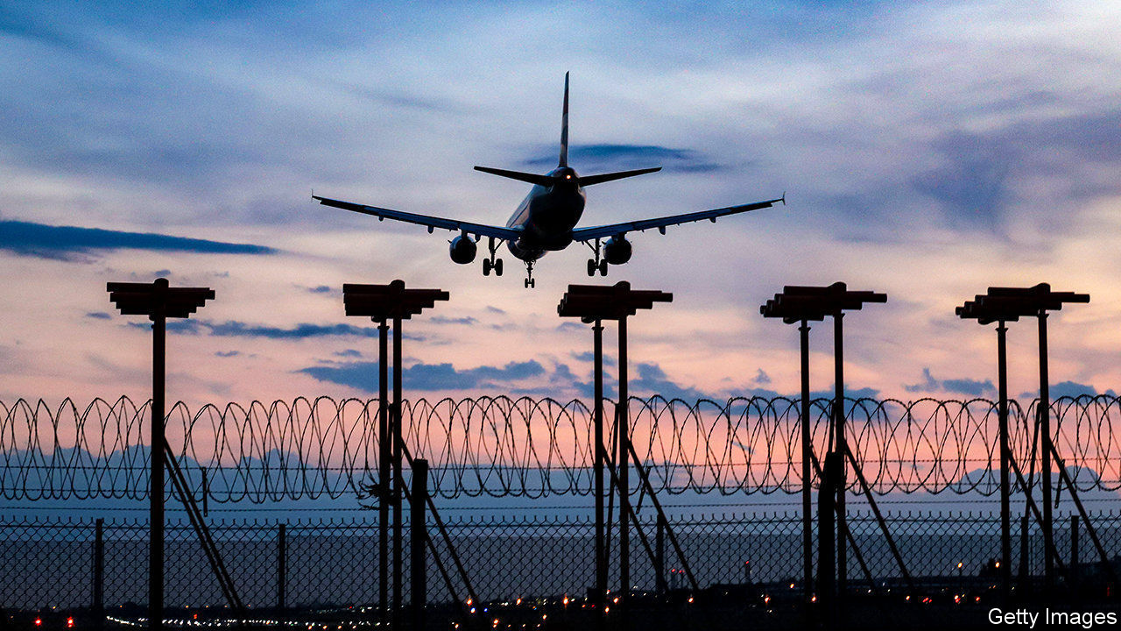

“THE WORST year in the history of aviation” is how the International Air Transport Association (IATA) describes 2020. The global airline-industry body expects carriers’ revenues to fall by half and debt to swell by $120bn to $550bn. To cut costs airlines have grounded planes and put staff on unpaid leave.

Another slashed expense is that of climate action. Aviation emits 3% of man-made carbon dioxide. That share could rise to 5-9% by 2050, according to the International Energy Agency, a forecaster. To curb these emissions, in 2013 the European Union tried to add international aviation to its emissions-trading programme, including flights connecting EU airports to those outside the bloc. The industry cried foul. In a compromise the International Civil Aviation Organisation (ICAO), an agency of the UN, devised the Carbon Offsetting and Reduction Scheme for International Aviation. CORSIA, as it is known for short, is due to start next year. It compels airlines to buy offsets for any additional CO2 produced by international flights above a baseline.

That baseline has become hotly contested. It was originally set at the industry’s average emissions for 2019 and 2020. Now emissions are forecast to fall by 37% this year, which would mean a lower baseline—and so, in time, higher offsetting costs. So IATA proposed using just emissions from just 2019 instead. On June 30th ICAO’s 36-member council agreed, at least for CORSIA’s first three years (see chart).

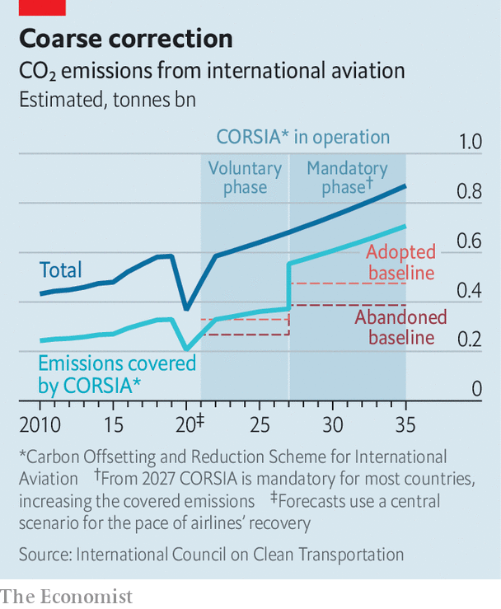

Environmental groups are up in arms. The scheme already lacked bite, since it is voluntary until 2027 and does not include domestic flights, about a third of the industry’s emissions. Countries representing three-quarters of aviation’s carbon footprint have signed up but flights between those which have opted in and those which have not are excluded. Dan Rutherford of the International Council on Clean Transportation, an NGO, calculates that on pre-pandemic trends the original plan would have covered only 9% of aviation emissions from 2021 to 2035 (when the scheme is scheduled to end).

In fact, the two-year average was expressly designed to account for low-emission years—a lesson learned from an early attempt to set the baseline in 2010, which was thwarted by the eruption of Eyjafjallajökull, an Icelandic volcano which grounded flights in Europe.

Another complaint is that many of the offsets airlines can buy are ineffective. A report in November last year by the NewClimate Institute and the Stockholm Environment Institute, two think-tanks, found that 80% of CORSIA’s potential offsets are unlikely to have any additional benefit to the climate. Since then ICAO has, to its credit, limited the availability of junk offsets in the scheme, though green campaigners say it has not gone far enough.

Offsets’ bargain prices also suggest something is amiss. In 2018 the average price in the “voluntary market” (outside of mandated schemes) was $3 per tonne of CO2, about a sixth of the carbon price in the EU emissions-trading scheme. Last year EasyJet, a British low-cost carrier, announced plans to offset all its annual emissions. This will cost it a footling $32m. New offest projects created in anticipation of CORSIA boosted supply, which is expected to be four times higher than demand.

Industry executives claim that the original baseline would have imposed crippling costs. That seems overblown. Sparse coverage and the cheap offsets mean the cost to the industry is low. Assuming an offset price of $5 per tonne of CO2, Mr Rutherford estimates the change in the baseline will save airlines $350m a year. That is less than 1% of the forecast operating cashflow in 2021 for a panel of 37 listed airlines.

Forgoing those savings would have been a small price to pay for burnishing airlines’ reputations as they seek billions in government bail-outs. Accusations of greenwashing will make calls to attach potentially much costlier green strings to the rescue packages grow louder. ■

Editor’s note: Some of our covid-19 coverage is free for readers of The Economist Today, our daily [newsletter](https://my.economist.com/user#newsletter). For more stories and our pandemic tracker, see our [coronavirus hub](https://www.economist.com/news/2020/03/11/the-economists-coverage-of-the-coronavirus)

This article was downloaded by calibre from <https://www.economist.com/business/2020/07/04/airlines-blame-covid-19-for-rowing-back-climate-commitments>

|  |  |  |  |
| --- | --- | --- | --- |
| Previous | Articles | Sections | Next |

|  |  |  |  |
| --- | --- | --- | --- |
| Previous | Articles | Sections | Next |

#### Getting by with a little help from its friends

# Why Facebook is well placed to weather an advertising boycott

Its real worry remains regulation

Jul 2nd 2020 |

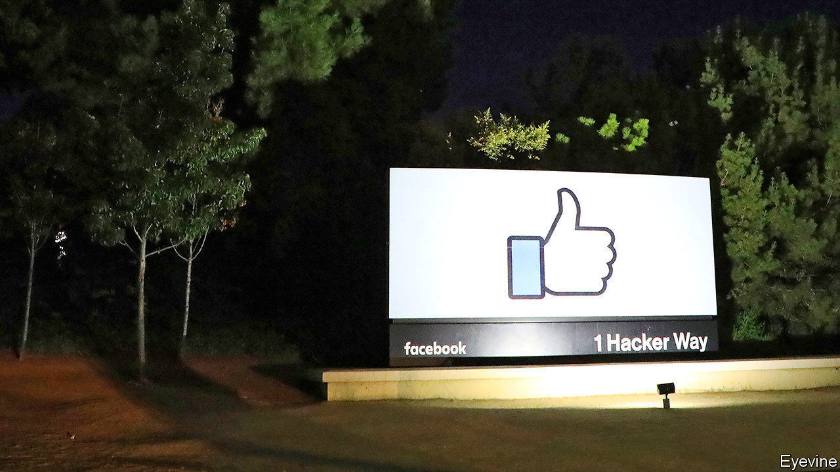

SOCIAL NETWORKS know a thing or two about virality. Still, Facebook was probably surprised by the speed at which a small protest, begun on June 17th by a collection of American civil-rights groups, has gained steam. By July 1st the #StopHateForProfit campaign, which accuses it of publishing material that incites violence, helped persuade more than 600 firms, including giants like Pfizer, Starbucks and Unilever, to pull ads from the platform.

Why the exodus? Principle is presumably part of it. So is peer pressure, which is rising as the list of boycotters lengthens. Admittedly, it is a particularly convenient time to make a stand, as firms pare back ad dollars amid the coronavirus recession. Starbucks, for instance, has spent $11m on Facebook ads in America since March, when lockdowns began. During the same period in 2019 it spent $29m, according to Pathmatics, a data company.

If ad dollars move elsewhere, possible beneficiaries include smaller rivals like Snapchat, Pinterest and TikTok, as well as YouTube, owned by Google. Some advertisers may even go back to quaint things like newspapers and TV, believes Andrew Lipsman of eMarketer, a research firm.

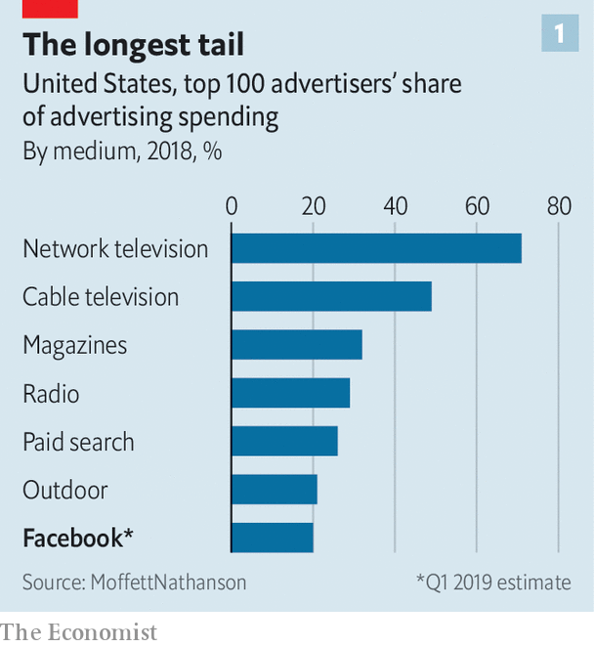

Yet the damage to Facebook is likely to be small. After a brief boycott-induced dip its share price is back up near its all-time high. Its $70bn ad business is built on 8m advertisers, most of them tiny companies with marketing budgets in the hundreds or thousands of dollars and often reliant on Facebook as an essential digital storefront. The 100 largest advertisers on the site account for less than 20% of total revenue, compared with 71% for the 100 largest advertisers on American network television (see chart 1). And so far only a handful of Facebook’s top 50 ad-buyers have joined the boycott (see chart 2).

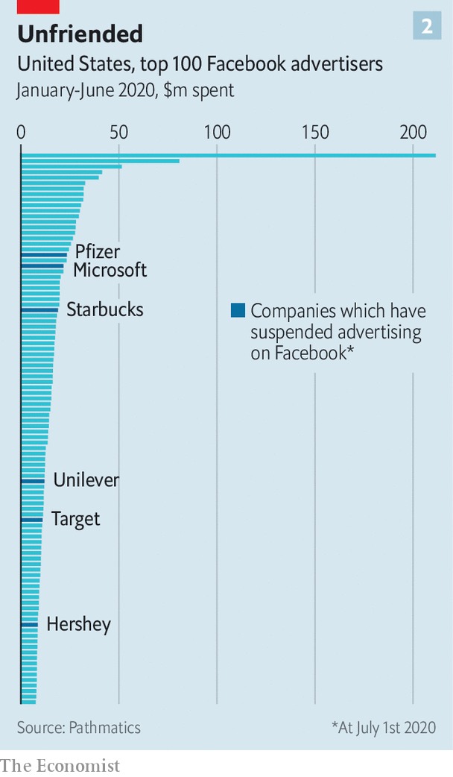

Facebook has promised tweaks. Like Twitter, it will label posts that break its rules but are newsworthy enough to remain up. Other tech firms have tightened their moderation, too. On June 29th YouTube blocked various white-supremacist channels. Twitch, a video site, suspended President Donald Trump’s own channel for “hateful conduct”. Reddit deleted a forum, “The_Donald”, over hate speech.

This points to a pressure greater than advertising: politics. American tech firms have walked a fine line between Republicans, who accuse them of being too censorious, and Democrats, who want closer moderation. Now, as Mr Trump’s poll numbers swoon, Silicon Valley seems to be edging towards the Democratic view of things. Time, perhaps, to make new friends. ■

This article was downloaded by calibre from <https://www.economist.com/business/2020/07/02/why-facebook-is-well-placed-to-weather-an-advertising-boycott>

|  |  |  |  |
| --- | --- | --- | --- |
| Previous | Articles | Sections | Next |

|  |  |  |  |
| --- | --- | --- | --- |
| Previous | Articles | Sections | Next |

#### Turning down the volume

# Nissan’s newish boss wants to re-engineer the troubled carmaker

Remodelling the global alliance with Renault and Mitsubishi will be tougher

Jul 2nd 2020 |

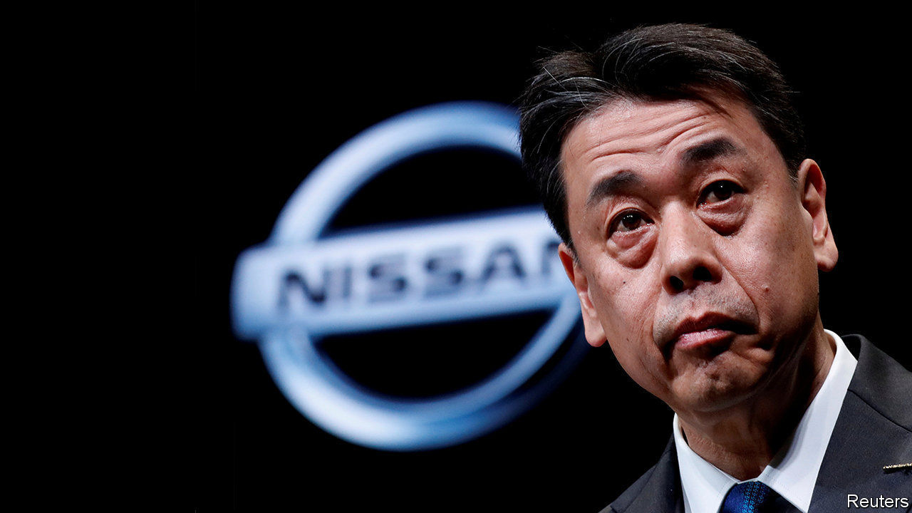

NISSAN IS IN for a makeover. On July 15th the Japanese car giant will unveil what is rumoured to be a sleeker, more minimalist logo more in line with the contemporary aesthetic. To its boss, Uchida Makoto, the redesign is the outward expression of deeper reinvention after a turbulent period. He wants to streamline not just the marque but Nissan, too, as a smaller, more efficient business. The new vision was launched in May and he discussed it in a recent interview with The Economist.

Until 2017 Nissan was racing ahead. That year it sold 5.8m vehicles and raked in an operating profit of $5.2bn. Its alliance with Renault of France and Mitsubishi, another Japanese firm, overtook Germany’s Volkswagen to become the world’s biggest carmaker, selling a grand total of 10.6m sets of wheels.

Then things took a turn for the worse. Nissan fell short of targets in America, one of its biggest markets. Chasing volume with ageing models forced heavy discounting, irritating dealers and sullying Nissan’s reputation. A costly push into emerging markets failed to pay off as economies in Brazil and Russia soured. Car sales in China, hitherto a reliable growth market, slumped. The alliance, always fractious, nearly fell apart after its chief architect and chairman (as well as boss of Renault), Carlos Ghosn, was arrested in late 2018 on charges of financial misconduct.

As a result of all this disruption, Nissan’s revenues dipped in 2018, then again in 2019. Its share price fell by nearly half over the two-year period. With the covid-19 slump and an operating loss of $380m in the first quarter, this year it has fallen by another 40% or so.

Enter Mr Uchida. He took over as boss in December after his predecessor, embroiled in the Ghosn scandal, was forced out. Half a year into his stint he cuts a relaxed figure, at least by the standards of corporate Japan. What he lacks in Mr Ghosn’s brashness he makes up for in quiet focus.

His downsizing plan looks both wise and just about achievable. Each of the alliance partners will concentrate on what it does best; in Nissan’s case that is selling medium-sized vehicles, electric and sports cars in America, China and Japan. Closing factories in Spain and Indonesia and cutting production elsewhere will reduce capacity by 20% to 5.4m cars a year. The idea to share more parts to keep costs in check is sensible, though details of the arrangement remain sketchy. The target of slashing costs by $2.8bn in total by 2021 may be within reach. Mr Uchida hopes to achieve a 5% operating margin by 2023. That may look “conservative” with respect to past ambitions, he concedes. But it would be a marked improvement on -0.4% last year.

Conservative or not, Mr Ushida’s profitability goal may be hard to attain. Boosting margins will require not just cutting costs but also buffing up a tarnished brand. As a start, Mr Uchida promises 12 new models in the next 18 months to replenish the line-up. But consumers hit by the coronavirus recession may be reluctant to splurge on new wheels, no matter how snazzy.

And even if Mr Uchida succeeds in fixing Nissan, he will struggle inside an alliance fraying with internal tensions but too intertwined to unpick. Nissan’s grievances over Renault’s 43% controlling interest in Nissan (well above its 15% stake in Renault) have not gone away. The most notable thing about Nissan’s annual meeting on June 29th was strident denial that its executives conspired to oust Mr Ghosn, in part to forestall his plan for a full merger with the French firm.

Mr Ushida is less categorical about the future of the alliance, which he has been asked about “100 times” since taking the job. Further integration, he insists, is not something he and his opposite numbers at Renault and Mitsubishi talk about, and “we don’t intend to”. As for rebalancing the shareholder structure, he says, “it is not a discussion for us”. Such prevarication will only store up trouble. A smaller Nissan may not automatically translate into smaller problems. ■

This article was downloaded by calibre from <https://www.economist.com/business/2020/07/02/nissans-newish-boss-wants-to-re-engineer-the-troubled-carmaker>

|  |  |  |  |
| --- | --- | --- | --- |
| Previous | Articles | Sections | Next |

|  |  |  |  |
| --- | --- | --- | --- |
| Previous | Articles | Sections | Next |

#### Seeking deliverance

# FedEx tries to think beyond the pandemic

Lockdowns have been less of a bonanza for parcel-handlers than you might expect

Jul 4th 2020 |



YOU WOULD have thought that lockdowns were a bonanza for courier services like FedEx. Not so much, it turns out. On June 30th the American pioneer of express delivery reported that operating profits fell by 64%, year on year, in the three months to May. Although demand from locked-down consumers has ballooned, so have coronavirus-related costs, from extra staff to deeper cleaning of facilities and vehicles. At the same time, a collapse in bulk air cargo pummelled FedEx’s more lucrative line of business.

FedEx is not the only company in its industry to feel the pain. In April UPS, an American rival, also announced lacklustre quarterly results, likewise largely owing to diminished bulk deliveries. Both firms have been forced to suspend guarantees of timely deliveries and to impose surcharges to prevent their networks from becoming overloaded. DHL, a German shipping giant owned by Deutsche Post, Germany’s biggest mail-carrier, has also seen its network and earnings come under pressure.

Aside from crushed profits, thousands of the companies’ delivery workers have become infected with covid-19 in America alone. Dozens have died. Some employees have negotiated extra protections and paid leave. Those who continue to work contend with stress and fatigue over continuing to avoid the virus as they fulfil additional shipments. In such circumstances productivity cannot help but suffer.

FedEx has not, then, had a great pandemic. But most of its problems predate the crisis. The main one has been indecision over whether to focus on bulk deliveries or the consumer market. Despite cutting ties with Amazon a year ago, apparently out of frustration with the slim margins offered by the e-commerce giant on its voluminous deliveries, it has maintained partnerships with Walmart and Target, America’s second- and eighth-largest online retailers, respectively. The result was a muddle.

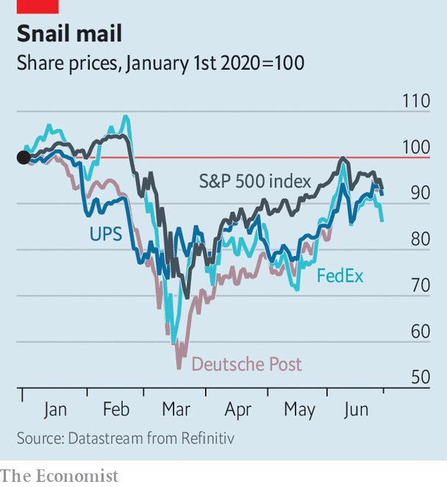

In January FedEx finally extended home deliveries from six days a week to seven and strengthened its business-to-consumer operation. But its earlier dithering left it with a ground network for home deliveries that was a work in progress when the pandemic hit. UPS in particular had leaned earlier and more heavily into that growth business before covid-19. It too has experienced problems as a result of pandemic demand—but fewer than FedEx has.

FedEx may yet get its act together. Its latest results were considerably better than analysts had been expecting. Its share price soared by 12% the following day, returning to pre-pandemic levels. When the global economy recovers the company may find itself with a high-margin air-cargo business and a solid home-delivery one.

Even then, problems would not go away entirely. The biggest of these—for FedEx and its industry rivals alike—looms in the shape of Amazon. The technology giant has just announced the purchase of an autonomous-driving startup (see [article](https://www.economist.com/node/21788951)). More threatening in the short-term is its fast-growing conventional delivery fleet, which already boasts 30,000 trucks and 80 aircraft. That is still some way off FedEx’s 40,000 trucks and 600 aeroplanes. But Amazon’s gargantuan size—on July 1st its share price rose by 5%, accruing more than FedEx’s $41bn market capitalisation in a day—and deep pockets mean the gap may be bridged before long.■

Editor’s note: Some of our covid-19 coverage is free for readers of The Economist Today, our daily [newsletter](https://my.economist.com/user#newsletter). For more stories and our pandemic tracker, see our [coronavirus hub](https://www.economist.com/news/2020/03/11/the-economists-coverage-of-the-coronavirus)

This article was downloaded by calibre from <https://www.economist.com/business/2020/07/04/fedex-tries-to-think-beyond-the-pandemic>

|  |  |  |  |
| --- | --- | --- | --- |
| Previous | Articles | Sections | Next |

|  |  |  |  |
| --- | --- | --- | --- |
| Previous | Articles | Sections | Next |

#### Droning on

# The pandemic is giving unmanned deliveries a fillip

Demand is surging for contactless provision of meals, medical supplies and other products

Jul 4th 2020 |

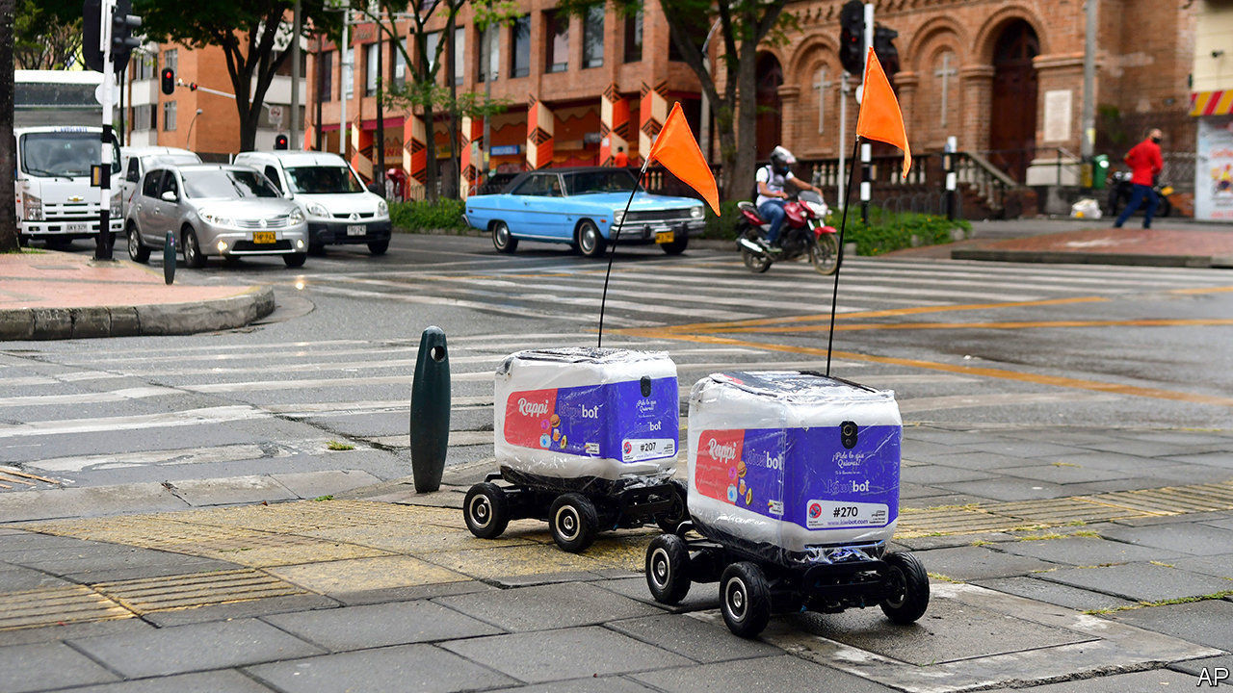

UNMANNED VEHICLES, airborne or earthbound, have been pressed into anti-pandemic service the world over. In Mexican slums they spray disinfectant from the sky. “Shout drones” with loudspeakers scold socially undistanced Americans, Chinese and Europeans. Most consequential, the popularity of contactless provision of food and medical supplies is boosting the drone-delivery business.

Before covid-19 MarketsandMarkets, a research firm, reckoned this would generate revenues of $800m this year. Now it says $1bn is closer to the mark, and has revised its forecast for 2022 from $1.6bn to $2.2bn. Many other analysts agree.

Drone-delivery firms typically operate vehicles on behalf of corporate clients. Some bigger drones, like those made by TwinswHeel of France, which can carry up to 300kg, can cost $20,000 or more apiece, as much as a van. Kiwibot of California makes $2,500 cart-like drones.

Kiwibot’s pre-pandemic fleet of 20 or so has grown to about 50, ferrying meals and shopping in two Californian cities, and two others in Colombia and Taiwan; 500 more Kiwibots are in production. Using them adds just $2 to a shopper’s bill. Another Californian firm, Starship Technologies (which despite its name makes wheeled drones), has seen its fleet expand three-fold in a year, to 1,000 across five countries

Since wheeled drones are in effect self-driving cars, albeit passenger-less ones, they need authorities’ approval to operate. This has not always been forthcoming. Now the “corona shock” is softening up regulators, says Ryu Kentaro of ZMP, a maker of rolling drones in Tokyo. ZMP plans to begin a trial in Japan’s capital this summer, faster than expected. In September another pilot project will see TwinswHeel’s “droids” shuttle mail for La Poste, France’s postal service in Montpellier (postal workers will handle the “last mile” to mailboxes). Officials look kindly on covid-proof contactless delivery, says Qi Kong, in charge of drones at JD Logistics, an arm of JD.com, a Chinese e-commerce giant. Its vehicles’ cargo bays open with a scan of a recipient’s face or smartphone screen. On June 26th Amazon said it would buy Zoox, an autonomous-car startup, for $1.2bn.

Drone airmail remains fledgling. Matternet, an American firm, operates a limited network in Switzerland. Wing, Google’s sister company, serves parts of America, Australia and Finland. Zipline, which pioneered medical deliveries by winged drones in Ghana and Rwanda, opened a small droneport in North Carolina in May. But by one reckoning, less than a third of last year’s automated deliveries worldwide were by air. Amazon’s Prime Air, scheduled to launch in late 2019, remains grounded.

At least more regulators are getting on board. After much wavering, Ontario’s have at last allowed a local firm, Drone Delivery Canada, to supply a remote indigenous group called Beausoleil, fearful of lorry drivers bringing in the coronavirus. Flights are to begin in July.■

Editor’s note: Some of our covid-19 coverage is free for readers of The Economist Today, our daily [newsletter](https://my.economist.com/user#newsletter). For more stories and our pandemic tracker, see our [coronavirus hub](https://www.economist.com/news/2020/03/11/the-economists-coverage-of-the-coronavirus)

This article was downloaded by calibre from <https://www.economist.com/business/2020/07/04/the-pandemic-is-giving-unmanned-deliveries-a-fillip>

|  |  |  |  |
| --- | --- | --- | --- |
| Previous | Articles | Sections | Next |

|  |  |  |  |
| --- | --- | --- | --- |
| Previous | Articles | Sections | Next |

#### Bartleby

# Keeping stakeholderism practical

The rights and wrongs of management books on social issues

Jul 4th 2020 |

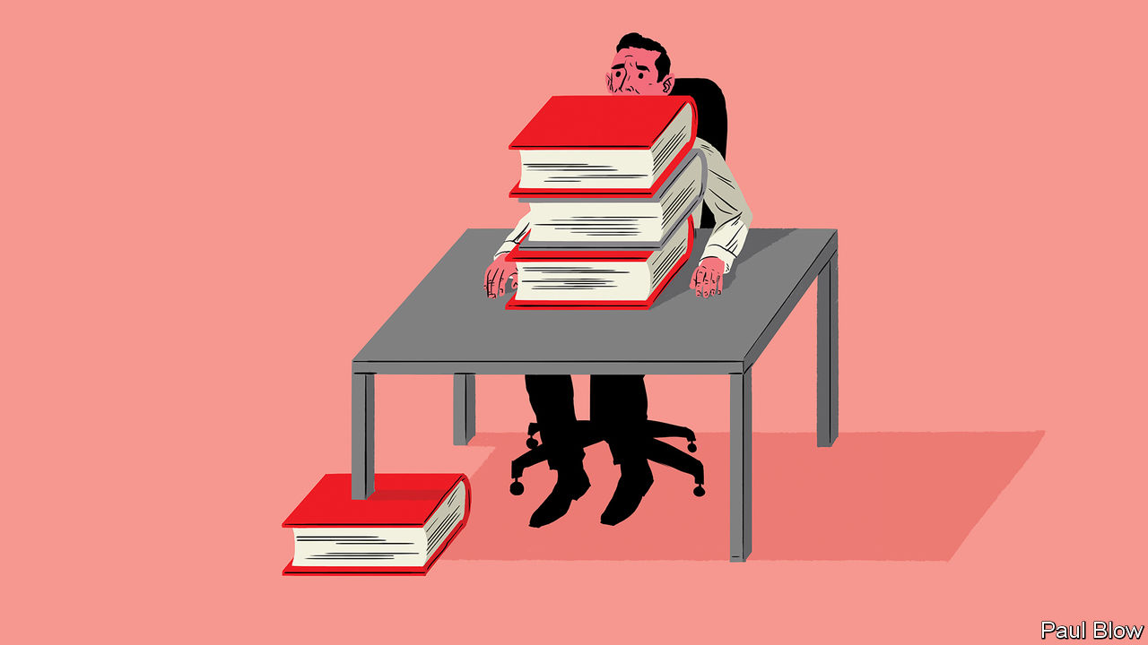

MODERN EXECUTIVES are often told they should worry about a lot more than their balance-sheets. They should be aware of their company’s environmental impact, of how well they treat their employees and suppliers, and whether their workforce is sufficiently diverse in terms of gender and ethnicity.

Sometimes, this pressure comes from customers unhappy with the company’s stance on an issue. Sometimes employees demand that their firms take action, as when Google dropped a contract with the Pentagon after workers complained. But many businesspeople don’t need a push: they are strong believers in what are known as ESG (environmental, social and governance) issues.

During the lockdown your columnist has worked his way through four weighty tomes by managers who argue that companies have a broader purpose than simply making a profit. The books were “Trailblazer” by Marc Benioff, “Green Swans” by John Elkington, “Restoring the Soul of Business” by Rishad Tobaccowala and “Share” by Chris Yates and Linda Jingfang Cai.

The danger is that managers use their books to opine on every social issue of the moment. Mr Elkington is a social entrepreneur who has co-founded groups such as SustainAbility, an environmental consultancy. The idea behind “Green Swans” is to focus on changes in the economy that will lead to environmental breakthroughs but his message is lost in a miasma of mixed metaphors. In the space of two pages he writes about “10x thinking”, “an exponential mindset” and the “Chrysalis economy”, while warning that the world is both heading into “some sort of historic U-bend” and backed into “the mother of all corners”. Quite how a corner can have a mother, the author fails to explain.

In “Share” Mr Yates, general manager of learning and development at Microsoft, and Ms Cai, an “organisation design specialist”, fall into a different trap. The dust jacket promises a book about “new business models based on sharing, reciprocity and co-operation”. Instead readers get a rambling mix of personal biography and economic history.

Readers will find more useful lessons from Mr Benioff, the founder of Salesforce. His book is a personal history of how he built his software giant, while donating 1% of its services, profit and employees’ time to help non-profit organisations and charities. He argues that “companies and their leaders simply can no longer turn a blind eye to the issues that matter to their employees, their customers and the communities on which they do business”. To cite one notable example, Salesforce opposed a bill in Indiana that would have allowed business owners to discriminate against LGBTQ customers (after Mr Benioff’s intervention, Indiana’s then governor, Mike Pence, revised the bill to prevent such discrimination).

The book provides some useful lessons for chief executives who might assume their company is free from bias. Mr Benioff admits that for a long time he assumed his company paid sexes and races equally. But a review showed that it did not and three rounds of pay adjustments were needed before equalisation occurred. This focus on social issues has not stopped Salesforce from making money for shareholders. It also regularly ranks as one of the best places to work.

Perhaps the best of the books is Mr Tobaccowala’s. That is because the author, a senior adviser at Publicis Groupe, an advertising and communications firm, has a clear focus: how to ensure you can hire, then inspire, the right workers in the knowledge economy. “Employees who find work meaningful are highly productive, agile and committed,” he writes, adding that talented workers are in a more powerful bargaining position in the current economy. He also argues that companies can be too obsessed with data, and not enough with employee motivation: “The best businesses find ways to marry the math and the magic.”

The book is clearly written and full of sensible and practical suggestions. They include assessing all meetings to eliminate those that waste time and suggesting that all employees spend 20% of each month trying to enhance their skills.

Both Mr Tobaccowala and Mr Benioff reflect on how companies can pursue both broader social goals and the desire to grow. Indeed, they argue that the aims are complementary, rather than contradictory. They also demonstrate the benefits of practical advice over grand philosophising about every social issue of the day. Those lessons even apply to managers who aren’t writing books.

This article was downloaded by calibre from <https://www.economist.com/business/2020/07/04/keeping-stakeholderism-practical>

|  |  |  |  |
| --- | --- | --- | --- |
| Previous | Articles | Sections | Next |

|  |  |  |  |
| --- | --- | --- | --- |
| Previous | Articles | Sections | Next |

#### Schumpeter

# How Chesapeake Energy changed the world

In times like these, business needs a bit of hubris

Jul 4th 2020 |

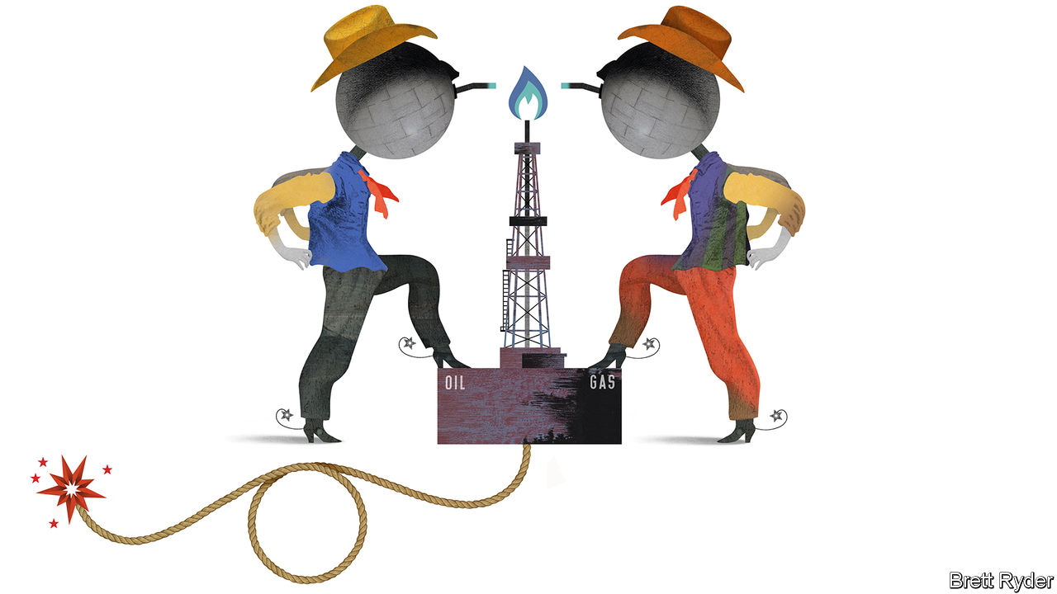

DRILLING FOR oil and gas is a contest of man and machine against nature. In America’s shale formations, nature takes the form of rocks, rich in hydrocarbons, buried about a mile (1.6 kilometres) below ground. It is a geologist’s job to find those rocks. It is an engineer’s job to develop the right mix of water, chemicals and drilling technology to “hydraulically fracture” them. One of the core beliefs of America’s shale-fracking revolution, which took off in the late 2000s, is that if you blast enough pressure at the rocks for long enough, they will eventually yield a big bounty.

The two “Okies” who founded Chesapeake Energy, a pioneer of this hydrocarbon upheaval, were neither geologists nor engineers. Tom Ward and the late Aubrey McClendon were “landmen”. Their skill was in leasing mineral rights and persuading investors they would produce a bonanza, particularly of natural gas, if enough wells were drilled. Their success was extraordinary. At times in the 2000s Chesapeake was considered the Google of energy. It had leases with 1m Americans. It became America’s biggest producer of unconventional natural gas.

That was then. On June 28th this once-mighty firm filed for bankruptcy protection, unable to support nearly $9bn of debt. Robert Clarke of Wood Mackenzie, a consultancy, says that ultimately the poor quality of its assets, despite their size, made it unfit for a world of low energy prices. Chesapeake’s tale is a common one of hubris in America Inc, evident in the dotcom bubble, the decline of General Electric and Detroit’s carmakers, or, most recently, the humbling of the tech unicorns. But is hubris really so bad?

In its early years Chesapeake’s self-belief was (literally) ground-breaking. It was a young company, armed with a new technology, offering a compelling growth story at a time when a big market opportunity was opening. That was natural gas, a fuel in such short supply in America in the early 2000s that the country was building liquefied natural-gas (LNG) terminals to import it. Chesapeake was quick to notice rising demand from utilities switching from coal to natural gas. Its land grab put it in a good position to take advantage as the fuel’s price increased. Sure enough, it quintupled to more than $12 per million British thermal units (BTUs) between 2000 and mid-2008, pushing Chesapeake’s market value to $37.5bn.

Its descent into bankruptcy 12 years later, too, displays familiar features. It became hooked on cheap credit. Its net debt grew thirteen-fold to $12.5bn in the decade to 2010. To finance this it needed natural-gas prices of at least $6 per million BTUs—a level seldom reached since the end of 2008. Then there was the evangelistic boss. With his rock-solid faith in shale, McClendon, who was ousted as chief executive in 2013 and indicted on bid-rigging charges the day before his death in 2016, doubled down on new basins even as America’s production tripled between 2008 and 2012.

Finally, Chesapeake was slow to adapt when market forces turned against it. Some of its biggest rivals, such as EOG Resources, switched their focus from shale gas to shale oil as early as 2009, earning bumper profits when prices of crude soared. By the time Chesapeake did so, the best oil assets had already gone. Its Chapter 11 deal, in which creditors have agreed to eliminate $7bn of debt, will do nothing to lower the break-even costs of its oil and gas production. Unless prices soar, which is unlikely given the pandemic-induced slump in demand, these costs remain too high to assume the firm can thrive after emerging from bankruptcy.

Like Chesapeake, the shale industry has become a shadow of its former self. The more investors poured money into shale oil after the financial crisis of 2007-09, the worse life got for gas producers. Oil drillers in basins like the Permian in Texas also extract “associated gas” as a by-product. Although some of it is flared (at great environmental cost), most is dumped on the natural-gas market, exacerbating the glut. The shale-oil euphoria turned against the oilmen, too. Their prodigious output has depressed crude prices since the mid-2010s but, like Chesapeake before them, they have struggled to cut costs fast enough; they were slow to do so even before prices collapsed as a result of covid-19. The pain spreads beyond the wildcatters. On June 30th Royal Dutch Shell became the latest supermajor to slash the value of its global energy holdings because of falling prices. ExxonMobil, its bigger rival, remains one of the few holdouts. But, in a sign of the times, it is now worth less than Tesla, a maker of electric cars.

Nonetheless, Chesapeake’s legacy leaves plenty to marvel at. It played a role in changing America’s energy narrative from concern about overdependence on foreign suppliers for its energy, to one of exuberance about domestic energy abundance and industrial competitiveness. This boosted American business confidence after the financial crisis. It left a diplomatic and geopolitical windfall, too—though one that has faded in recent years. The switch from coal to gas lowered America’s carbon emissions, enabling Barack Obama to broker the Paris agreement on climate change in 2015 while he was president. It unlocked the possibility of LNG exports to weaken Russia’s natural-gas stranglehold on Europe and to improve trade with China.

## Twilight of the revolution

Ironically, the recent collapse in American oil production will curb associated-gas supply, potentially supporting natural-gas prices. Moreover, the coronavirus crisis may well lead to further bankruptcies and more consolidation in the shale industry, which could put assets into the hands of big firms with stronger balance-sheets, boosting profitability.

The romance of the early wildcatters and landmen will be gone. The revolutionaries will be replaced by bureaucrats. The over-exuberant and undercapitalised industry’s financial discipline will improve. But especially in these troubled times, spare a thought for Chesapeake. Until it got the better of the company, its hubris helped change the world. ■

This article was downloaded by calibre from <https://www.economist.com/business/2020/07/04/how-chesapeake-energy-changed-the-world>

|  |  |  |  |
| --- | --- | --- | --- |
| Previous | Articles | Sections | Next |

|  |  |  |
| --- | --- | --- |
| Business | Sections | Science & ... |

Finance & economics

Public finances: The debt toll

.

Banks and the recession: What if?

.

Trade finance: Collateral damage

.

Chinese banking: Xi sank your battleship

.

Property in America: The house wins

.

Buttonwood: Zero gravity

.

Free exchange: A Latin American tragedy

.

|  |  |  |
| --- | --- | --- |
| Business | Sections | Science & ... |

|  |  |  |  |
| --- | --- | --- | --- |
|  | Articles | Sections | Next |

#### The debt toll

# The poorest countries may owe less to China than first thought

Still, China lends more than the members of the Paris Club combined

Jul 4th 2020 | HONG KONG

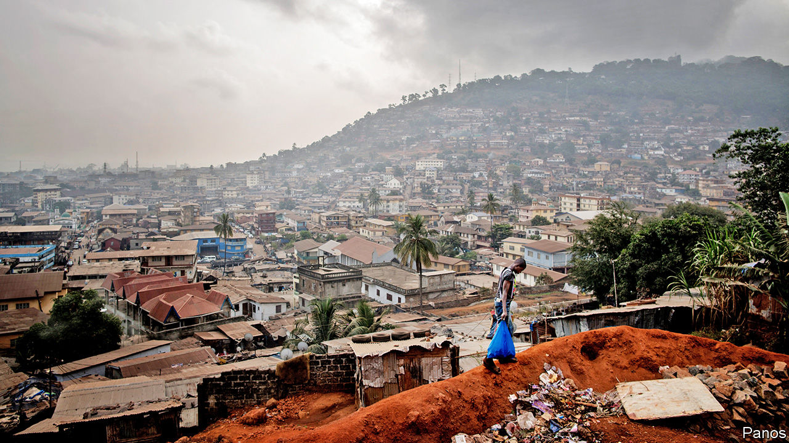

THE FOUR-LANE, 62-km toll road being built between Masiaka, a business hub in Sierra Leone, and Freetown, the country’s capital, promises shorter journey times, fewer accidents and smoother drives. It is nonetheless controversial. Awarded to China Railway Seventh Group, the project added over $160m to the country’s foreign debt, according to the China-Africa Research Initiative (CARI) at Johns Hopkins University. The work has suffered delays, which the company blames on the pandemic and the need to compensate property owners, reports the Concord Times, a local newspaper. The firm has also complained that some lorries pass by the toll booths, not through them.

Projects like these have mushroomed across Africa and other developing countries in the past 15 years. “It’s no secret...China is by far the largest bilateral creditor to African governments,” said Mike Pompeo, America’s secretary of state, earlier this month, blaming it for creating an unsustainable debt burden. Plenty else is, however, secret. China does not typically divulge how much it has lent to whom or on what terms. Nor is it a member of the Paris Club of government lenders, which tries to co-ordinate debt forgiveness among its members, making sure that no lender takes advantage of the magnanimity of another.

Many, therefore, have wondered how China would play its part in the debt-relief initiative agreed in April by the G20 group of big economies. That initiative will allow 73 of the world’s poorest countries to delay payments on loans from G20 governments, freeing up resources to fight the pandemic. China, a prominent G20 member, signed up. But would it offer the same terms as the others? And if so, how would they know? Proving China is doing its bit is hard if you do not know how much it has lent.

Recent weeks, however, have yielded a pleasant surprise. To help monitor the G20 initiative, the World Bank told its board it wanted to reveal more data about the government debts of the eligible countries. Though its board is dominated by its bigger shareholders, including China, the bank’s plan faced little resistance. And so after cross-checking its numbers, the bank has now disclosed what eligible governments owe to bondholders, multilateral bodies, private foreign lenders and other governments. The countries covered by the data owed $104bn between them to China at the end of 2018. The total includes soft loans from China’s government, semi-soft loans from “policy banks”, such as China Development Bank, and profit-seeking loans from state-owned commercial lenders. The same countries owed $106bn to the World Bank and $60bn to bondholders.

The data, say Deborah Brautigam and Yufan Huang of CARI, are a “gold mine”. Prior to the release, they had to scour public announcements of loan pledges, cross-checked with reports from Chinese embassies or ministry documents in the borrowing country. Their work fed into a broader set of estimates by Sebastian Horn and Christoph Trebesch of the Kiel Institute for the World Economy and Carmen Reinhart of Harvard University, who in May became the World Bank’s chief economist.

In addition to aiding research, the data should also help the public in developing countries, says David Malpass, the World Bank’s president. Governments—and “this is not unique to developing countries”—sometimes enter into contracts that do not serve the public interest, he points out. Transparency “helps align” these contracts with “the interests of the people”.

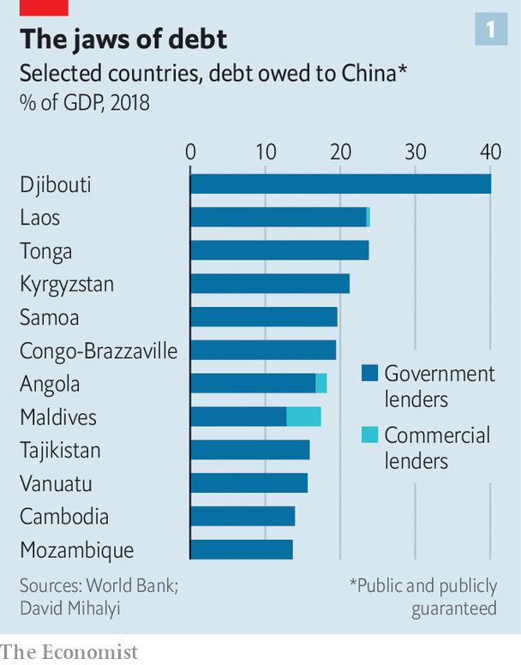

The new figures confirm Mr Pompeo’s observation that China is by far the biggest bilateral creditor to Africa, and in many poor countries elsewhere (see chart 1). It accounts for about 20% of the total foreign debt owed by the 73 governments eligible for the G20 initiative (and about 30% of their debt service this year). That is more than all of the Paris Club lenders, including America, Britain and Japan, combined. But it is also smaller than the estimate of over 25% based on figures from Mr Horn, Ms Reinhart and Mr Trebesch. Indeed their estimates for individual countries often exceed the bank’s by large margins (see chart 2).

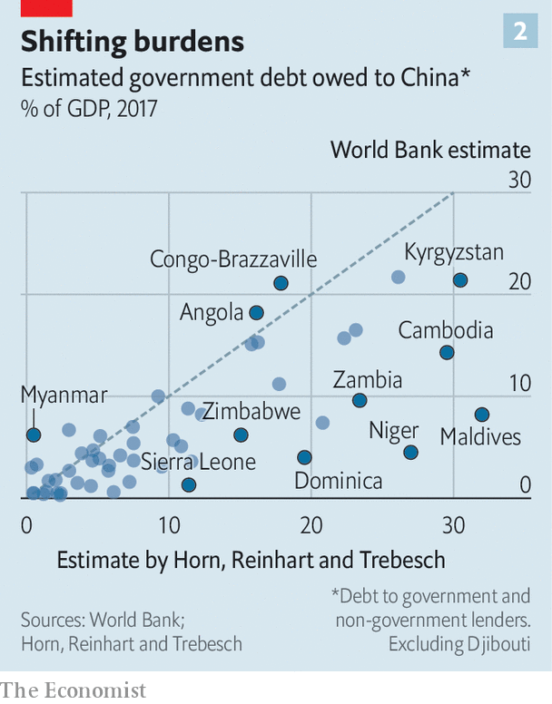

What explains the gap between Ms Reinhart’s research and her new employer’s data? Some of it may reflect the difference between announcements and disbursements. Just because China says it will lend money, does not mean the entire sum is paid at once (or ever). But even when Mr Horn, Ms Reinhart and Mr Trebesch look at the bank’s figures on commitments, rather than incurred debt, they find some loans missing, suggesting incomplete data.

Another reason for the gap may be that the bank excludes some debt owed by state-owned enterprises and special-purpose vehicles but not guaranteed by the government. In other contexts the bank does consider scenarios in which state-owned firms fail or public-private partnerships sour, requiring the government to step in. Counting these as public debt brings the bank’s estimates closer to the Horn-Reinhart-Trebesch figures.

Such thought experiments could sometimes stretch the definition of public debt, though. The financing raised for Sierra Leone’s controversial toll road, for example, is supposed to be repaid from toll, not tax, revenues. It would only burden the government if those tolls fell short. The World Bank does not seem to count it as government debt—but it is included by CARI.

The bank’s figures for Chinese lending are not always below outside estimates. For Burkina Faso, the Central African Republic and Liberia they are much higher. This, reckons Ms Brautigam, is because they include loans from Taiwan. China’s critics, including Mr Pompeo, may suspect that its true lending is higher than the bank suggests. But even they would not want to chalk up to the People’s Republic what is properly owed to Taiwan. ■

This article was downloaded by calibre from <https://www.economist.com/finance-and-economics/2020/07/04/the-poorest-countries-may-owe-less-to-china-than-first-thought>

|  |  |  |  |
| --- | --- | --- | --- |
|  | Articles | Sections | Next |

|  |  |  |  |
| --- | --- | --- | --- |
| Previous | Articles | Sections | Next |

#### Banks and the crisis

# How resilient are the banks?

If today’s lenders were run like they were in 2008 they would be in huge trouble

Jul 4th 2020 |



WHEN FINANCIERS and governments redesigned the financial system in order to make it safer after the debacle of 2007-09, most of them imagined that a shock as bad as the subprime fiasco would be a generation away. In fact it arrived only a decade or so later. Lockdowns have led to a savage recession that is expected to produce huge loan losses as firms and households suffer.

So are too-big-to-fail banks really safer? The latest stress tests conducted by the Federal Reserve suggest the answer in America is “yes”. On June 25th the Fed released the results of its annual exercise, which compares banks’ buffers with the losses they would face in a downturn. In a pessimistic “U-shape” scenario, in which the economy faces prolonged social distancing and repeated outbreaks of the virus, the Fed reckons that banks would face total losses of over $700bn on their collective loan book. The hit is well above the worst case of $465bn that was envisaged in 2009, when the Fed did its first stress test. This year’s scenario implies cumulative losses on loans of about 10%, above the 7% loss rate actually experienced during the subprime crisis.

Happily, the Fed concludes, in this U-shape scenario the banking system’s total core-capital ratio would fall from the present 12% to a still-passable 8%. Some banks might have to limit the dividends they pay their shareholders in order to bolster their capital positions—indeed, on June 29th Wells Fargo said it would have to cut its payout. But this is a small price to pay.

One way to give yourself nightmares is to imagine that nothing had changed at the banks and they were still run with the skimpy capital levels they had at the end of 2008. The Economist has used the Fed’s data to make a rough estimate of the impact today’s loan losses would have had (see chart). If an unreformed banking system had faced this year’s U-shape scenario, its total core-capital ratio would have potentially dropped to 1.5%, with several big banks’ figures touching zero—ie, technical insolvency. Faced with this, depositors and counterparties would have fled, in a full-scale bank run. The taxpayer bail-out in this parallel universe might have been even bigger than in the financial crisis.

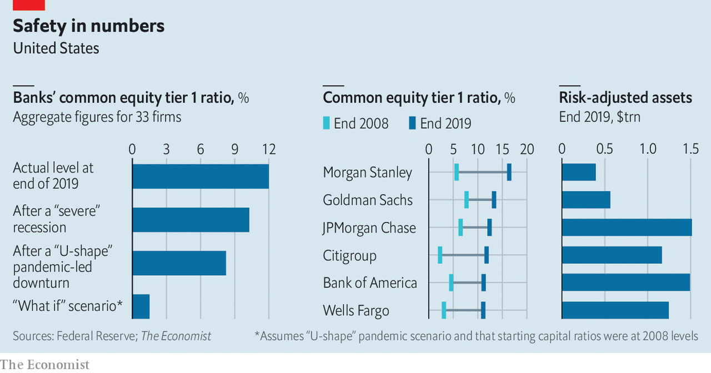

Instead, the banking system’s new resilience means that customers and investors did not rush to withdraw funds as in 2007-09. Banks were seen as safe. Lenders in turn have had the resources to extend overdrafts to firms in need.

Don’t sleep easy yet, though. Risky activities have migrated beyond the banking system. The result is that even though taxpayers have not had to bail out banks, they have once again been exposed to huge potential losses. The Fed has made purchases in, and extended implicit guarantees to, many markets—including those for junk bonds and exchange-traded funds—and is also lending directly to firms.

Another worry is that the banking system outside America is less solid. Most European banks have reasonable capital ratios but are far less profitable than American banks, because they are inefficient and face lower interest rates and fragmented markets. America’s stress tests revealed that about a quarter of the total buffers its banks possess to absorb losses come from their healthy profits (which can offset bad-debt provisions), rather than from their core capital. Many European lenders do not have that luxury. The boss of one of the largest warns that though the shock so far has been manageable, a second wave of covid-19 infections this year or next will be “a major test for the financial sector”.■

Editor’s note: Some of our covid-19 coverage is free for readers of The Economist Today, our daily [newsletter](https://my.economist.com/user#newsletter). For more stories and our pandemic tracker, see our [coronavirus hub](https://www.economist.com/news/2020/03/11/the-economists-coverage-of-the-coronavirus)

This article was downloaded by calibre from <https://www.economist.com/finance-and-economics/2020/07/04/how-resilient-are-the-banks>

|  |  |  |  |
| --- | --- | --- | --- |
| Previous | Articles | Sections | Next |

|  |  |  |  |
| --- | --- | --- | --- |
| Previous | Articles | Sections | Next |

#### Collateral damage

# Trade finance stumbles into the digital era

Covid-19 forces the world’s most complicated paper chase to modernise

Jul 4th 2020 |

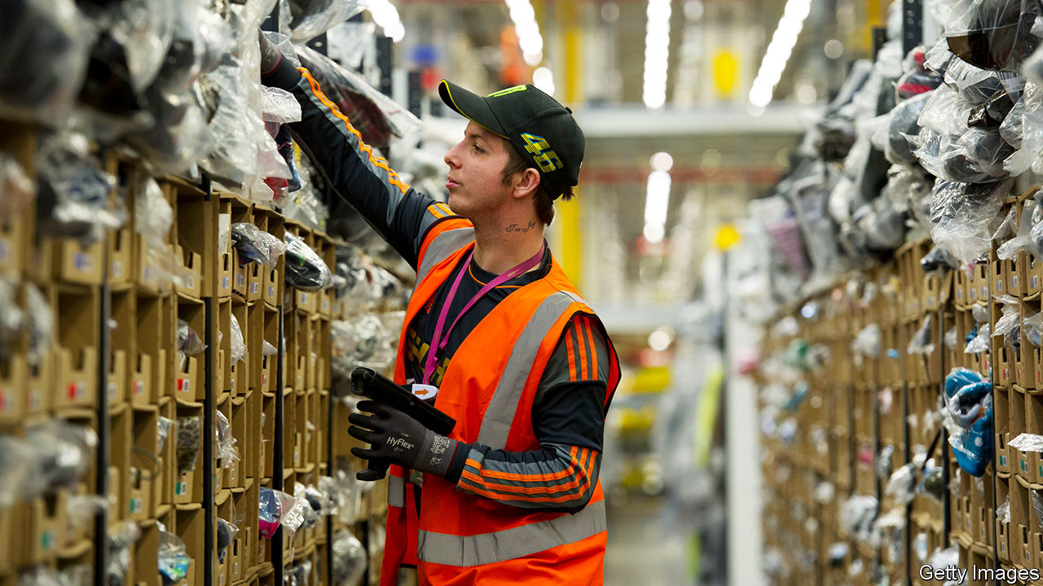

“IN WARM WEATHER, fewer people wear socks,” says Paul Rotstein of Gold Medal International, a wholesaler in New York. People may not sport socks in the summer but his firm starts shipping them to retailers in July, ahead of the start of the school year. There is, however, a big lag before he is paid. He normally uses trade-credit insurance to protect against the risk that his invoices go unpaid, but this year the insurers have slashed the amounts they are willing to cover by 50-90%. That leaves him with two options: shoulder huge credit risk himself, or walk away from orders.

Mr Rotstein’s dilemma underscores the role of trade finance, an unglamorous but critical bit of the financial system. Many firms are owed a large amount by their customers in the form of receivables; in total the amount is worth around 20% of global GDP. Some firms bear all the risk of non-payment themselves. But others look to an insurer to protect them from default, or take out specialist loans backed by the invoices. Together these financing solutions underpin four-fifths of cross-border transactions, which are worth $15trn a year.

Trade financiers face three problems created by the covid-19 pandemic (and the accompanying recession). It has disrupted normal operations by slowing the travel of documents; it has raised the risk that existing loans will sour; and it has made lenders more cautious about making new loans.

Take operational troubles first. Trade finance is notoriously paper-based. Processing credit requires involved parties, from financiers and carriers to warehouse managers and customs officers, to exchange an average of 36 documents and 240 copies. But lockdowns trapped bits of paper in shut-down offices. Printing became a palaver. When couriers eventually got to banks, they often found no one there.

Financiers have been forced to be nimble. Staff turned up to the Bank of China’s Wuhan office wearing full protective gear. Banks started accepting scanned signatures and documents. A cargo-firm executive says it issued four times as many electronic bills of lading—receipts detailing goods on-board a ship—in March as it did in February. That has helped limit delays, though some in the industry worry that rises in fraud could follow.

A second concern is that the existing stock of credit turns sour. Trade finance has long been super-safe: annual default rates on letters of credit averaged 0.11% of transactions in 2008-18, less than a tenth of those for corporate loans. But insurers already report payment delays. A rise in bankruptcies would make matters worse. Coface, a trade-credit insurer, expects these to rise by a third worldwide by 2021. Still, because trade finance is short-term—usually 30 to 90 days—and backed by collateral, lenders have some recourse. Natalie Blyth of HSBC, a bank, reckons that the performance gap between trade-finance assets and corporate loans will widen.

The third problem is a possible crunch in new financing. To assess clients, banks and insurers rely on credit ratings. These have plummeted as firms’ cash flows have dwindled. The resulting squeeze may linger, says Ebru Pakcan of Citigroup, a bank; firms are downgraded quickly, but upgraded slowly. Some lenders may focus on large clients or exit some markets entirely. Insurers have cut their exposure to the industry by 8-9%, about half as much as in 2008-09. In emerging economies, sovereign downgrades have also pulled down corporate ratings, says Marc Auboin of the World Trade Organisation (WTO). On July 1st the WTO and six multilateral banks promised to alleviate trade-finance shortages.

Still, the damage could have been worse. Thankfully, banks have sturdier equity buffers than in the last recession. Since 2016 Coface has raised its solvency ratios—insurers’ equivalent of banks’ capital-adequacy buffers—from 150% to 190%, says Xavier Durand, its boss. Central-bank action has shored up lenders’ finances. Governments in Europe have let export-credit agencies cover short-term trade, and have offered insurers backstops.

The question is how long the support lasts. Banks and insurers will see their capital eaten up as loans sour. Government aid could be withdrawn too soon, worries Alexis Garatti of Euler Hermes, a trade-credit insurer. Support could be taken away just as the demand for finance returns. As new orders work their way through supply chains, exports appear to be bouncing back faster than manufacturing.

Still, the pandemic could lead to lasting gains by forcing the industry to digitise. Alexander Goulandris of Essdocs, which promotes paperless trade, says 60 chambers of commerce have opted for its electronic certificates of origin in recent months, compared with the usual rate of ten a year. Some countries have also adopted laws recognising the validity of e-documents. Digital standards could make it easier to bundle trade-finance loans into securities that can be sold on to institutional investors, providing more oxygen to commerce. Trade finance has long followed outmoded practices. Now might be its chance to blow everyone’s socks off. ■

This article was downloaded by calibre from <https://www.economist.com/finance-and-economics/2020/07/04/trade-finance-stumbles-into-the-digital-era>

|  |  |  |  |
| --- | --- | --- | --- |
| Previous | Articles | Sections | Next |

|  |  |  |  |
| --- | --- | --- | --- |
| Previous | Articles | Sections | Next |

#### Xi sank your battleship

# As foreign banks circle, China plots an “aircraft-carrier” defence

The government may let banks launch brokerages to fend off foreign marauders

Jul 4th 2020 | SHANGHAI

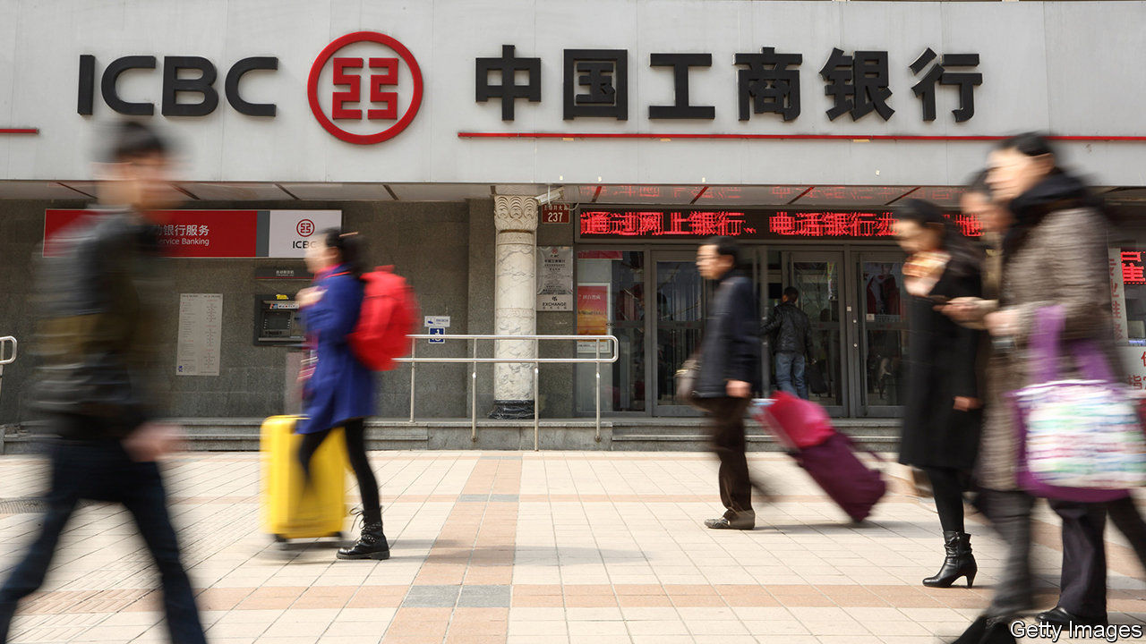

CHINA PUT its first domestically built aircraft-carrier into service last December, the culmination of three decades of work. The government hopes for a faster return on efforts to create what it calls an “aircraft-carrier-class securities firm”—ie, an investment bank powerful enough to prevail amid intensifying competition in the country’s capital markets. It is poised to draft its biggest financial force into battle, by allowing giant state-owned commercial banks to enter investment banking.

China has long had its own version of America’s Glass-Steagall separations, which until 1999 barred retail banks from investment banking. China’s commercial banks can neither underwrite stocks nor offer brokerage services, which are left to securities firms—a division that officials believe makes the financial system safer. But now they may grant securities licences to two commercial banks in a trial, as first reported by Caixin, a business publication.

The immediate prompt is foreign competition. After years of dragging its feet, China scrapped foreign-ownership limits in its securities sector last year. Big Western players—such as Citigroup, Morgan Stanley and UBS—have either gained control of existing joint ventures or launched wholly-owned operations. Foreign firms have struggled to make a dent in commercial banking in China, held back by their limited branch networks. In investment banking, though, they may be more formidable, thanks to their technical knowhow.

Even without the foreign threat, China has been eager to whip its brokers into shape. Officials want capital markets to lessen the burden on banks, which last year provided two-thirds of all new credit. The ten biggest Chinese banks have roughly 30 times more assets than the ten biggest securities firms, and are also far more profitable (see chart). The securities industry’s main problem is extreme fragmentation; 131 registered firms providing similar services fight for clients by slashing fees. Some even underwrite bonds for nothing.

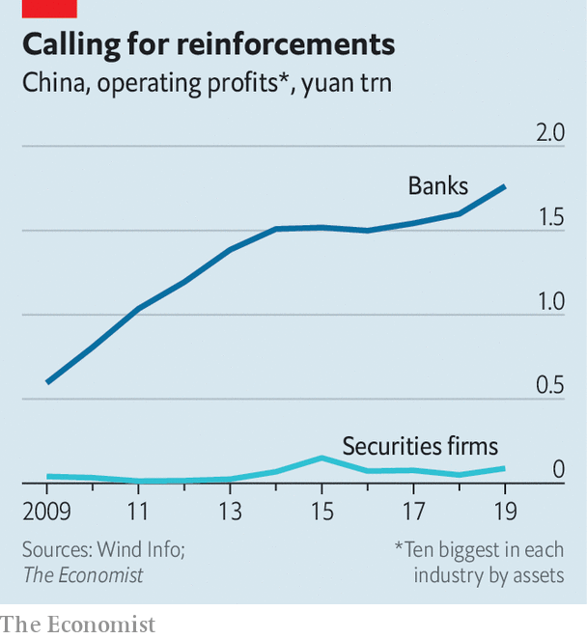

Change is unlikely to be revolutionary at first. “It is not China’s way to suddenly implement a new policy and wipe out existing companies,” says Chen Jiahe of Novem Arcae Technologies, a wealth-management firm. Investors agree: the share prices of China’s largest brokers fell by about 5% on June 29th, when the news first broke, but have since recovered.

Still, the securities industry could look very different in time. The government wants to see consolidation. Granting banks brokerage licences may squeeze out the also-rans. Consider, for example, medium-term notes, a quasi-bond market in which commercial banks can already participate: of the top 20 underwriters by income, 17 are banks and just three are brokers.

A common criticism of universal banking is that it combines two irreconcilable cultures, with the boldness of investment bankers potentially swamping the prudence of commercial bankers. Yet China has shown that there are also dangers to separation. The stockmarket crashed in 2015 after the securities regulator failed to rein in a boom in margin financing by brokers, a risk that the bank regulator might have been better equipped to detect.

In any case, it is hard to imagine China’s lumbering banks becoming red-in-tooth-and-claw brokers. The biggest, such as ICBC, already operate investment banks in Hong Kong, primarily offering plain-vanilla services to state-owned firms. More aggressive mid-tier lenders could outdo them in marketing shares and structuring deals. They are still huge by global standards: China Merchants Bank, for example, has a market capitalisation of $120bn, nearly twice that of Goldman Sachs, a Wall Street institution. In Chinese terms, it would count as a naval cruiser—one step down in size from an aircraft-carrier, but still a big step up from the ragtag flotilla in the country’s capital markets today. ■

This article was downloaded by calibre from <https://www.economist.com/finance-and-economics/2020/07/04/as-foreign-banks-circle-china-plots-an-aircraft-carrier-defence>

|  |  |  |  |
| --- | --- | --- | --- |
| Previous | Articles | Sections | Next |

|  |  |  |  |
| --- | --- | --- | --- |
| Previous | Articles | Sections | Next |

#### The house wins

# America’s housing market is so far unfazed by recession

The property market seems strangely oblivious to the economic carnage around it

Jul 4th 2020 |

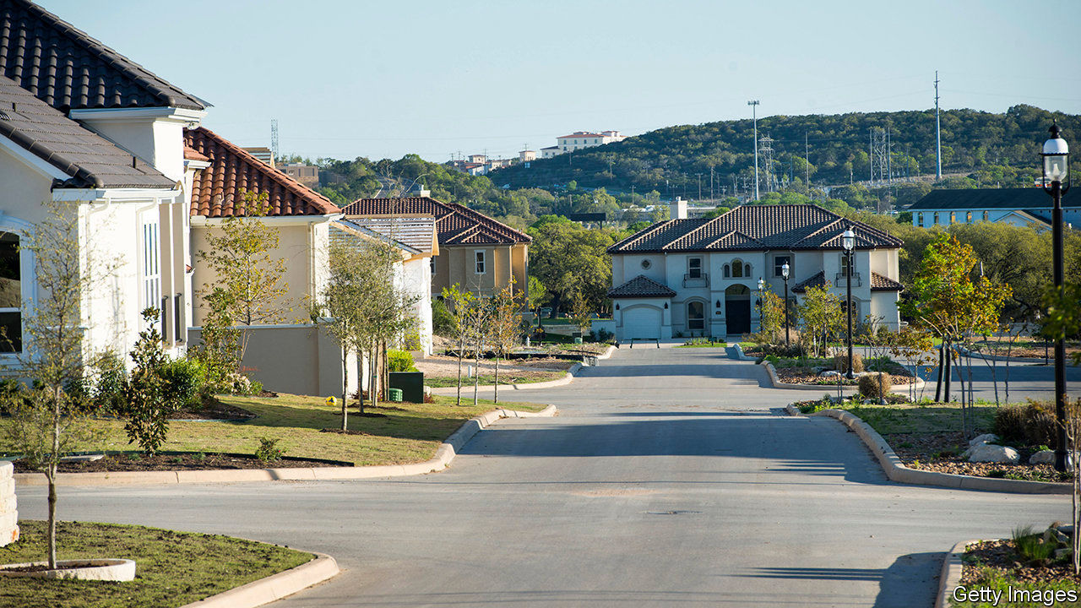

AMERICA’S HOUSING market is behaving oddly. Residential property—worth $35trn, slightly more than America’s stockmarket—seems strangely oblivious to the economic carnage around it. House prices in May were 4.3% higher than a year earlier. That rate of growth is only marginally below the average since the end of the housing crash a decade ago. Prices in even the costliest places, such as San Francisco, where the average pad sets you back $1.1m, continue to march upwards. Many economists still expect house prices to fall over the whole of 2020—but such forecasts are looking increasingly shaky.

At first glance this is surprising. House prices typically nosedive during recessions. A rising number of mortgage defaults leads to more properties being put up for sale. Falling household incomes reduce buyers’ purchasing power. In the recession of the early 1990s house prices dropped by 10% in real terms; they fell by three times that in the downturn that followed the financial crisis of 2007-09. The fall in GDP associated with the coronavirus pandemic, and the rise in unemployment, is unprecedented. Despite that, there is little sign so far that America’s housing market is about to subside.

The rate of foreclosures looks unlikely to reach the heights hit during the last recession. Housing debt, relative to incomes, is lower. The share of mortgages lent to borrowers with very low credit scores is less than half what it was in 2007, in part a consequence of tighter financial regulation. Meanwhile, fiscal help has come a lot faster than it did a decade ago.

During the last crash, schemes to help homeowners did not arrive until millions of families had already seen loans foreclosed. This time the government’s stimulus package has made requesting up to a year’s pause in mortgage payments easier: homeowners can get this without having to do very much to prove they need it. All that casts a different light on the apparently alarming increase in the share of mortgages on payment holidays, from practically zero just before the pandemic to close to 10% in May. Analysts at Capital Economics, a consultancy, reckon that many requests for forbearance have been made by borrowers who are in fact able to keep up their mortgage payments, but are “requesting assistance...as an insurance policy”.

Cash handouts from the government have also been generous—so much so that, in stark contrast to the usual declines seen during recessions, Americans’ aggregate household income is forecast to rise in 2020 by about as much as it did in 2019. That will help borrowers keep up with their mortgage payments. Indeed, a fifth of Americans receiving a stimulus cheque from the federal government have put it towards their mortgage. Looser monetary policy has also helped. Since the beginning of the year the interest rate on 30-year mortgages has fallen by about half a percentage point, to an all-time low of just over 3%. Mortgage companies are overrun with applications from people seeking to refinance. House-hunters, including those seeking to escape city centres after the pandemic, can now afford more expensive properties. As lockdowns were lifted, pent-up demand for housing led to a 20% year-on-year rise in mortgage applications in June.

What happens to the housing market next depends on the evolution of the covid-19 outbreak and, in turn, that of the overall economy. Yet when the fog does eventually clear, a period of even stronger price growth might not be a surprise. A raft of academic evidence draws a strong link between loose monetary policy and bubbly housing markets. Other researchers noted before the pandemic that the supply of new housing in America was failing to keep up with demand—owing in part to increasingly complex land regulations and reduced competition in house-building. Social-distancing requirements are also likely to hold construction back in the coming months. With supply constrained and demand boosted, house prices seem to rest on solid foundations. ■

Editor’s note: Some of our covid-19 coverage is free for readers of The Economist Today, our daily [newsletter](https://my.economist.com/user#newsletter). For more stories and our pandemic tracker, see our [coronavirus hub](https://www.economist.com/news/2020/03/11/the-economists-coverage-of-the-coronavirus)

This article was downloaded by calibre from <https://www.economist.com/finance-and-economics/2020/07/04/americas-housing-market-is-so-far-unfazed-by-recession>

|  |  |  |  |
| --- | --- | --- | --- |
| Previous | Articles | Sections | Next |

|  |  |  |  |
| --- | --- | --- | --- |
| Previous | Articles | Sections | Next |

#### Buttonwood

# Why zero interest rates might lead to currency volatility

There is little scope for them to adjust to economic trouble. So something else must

Jul 4th 2020 |

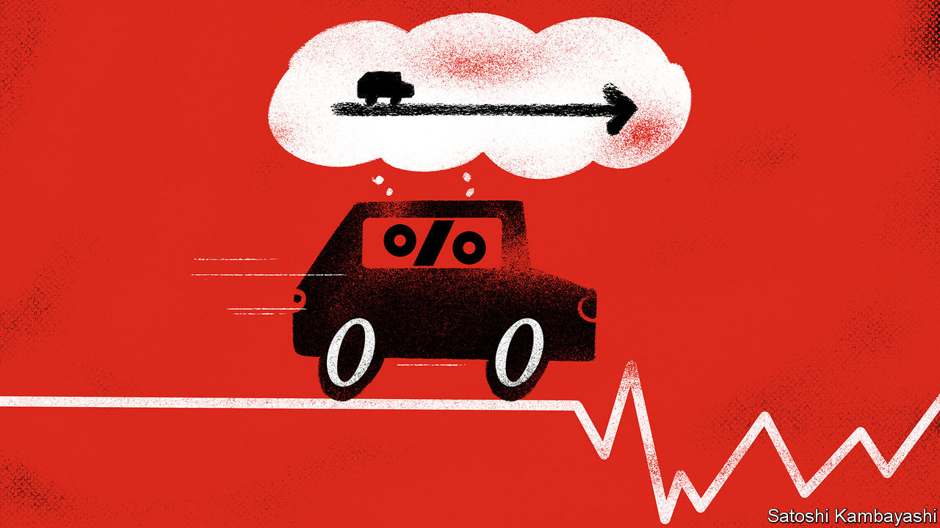

A GENERATION OF English cricket fans know the Aussies are loth to surrender a lead. For much of the past two decades, Australia has been a high interest-rate economy. But not any more. In March the Reserve Bank of Australia (RBA) cut its benchmark cash rate to 0.25%. That is the lowest interest rates have ever gone, and as low as they are likely to go. To signal its intentions that rates will stay put, the RBA has pledged to fix three-year-bond yields at 0.25%.

The Australian case is telling. Near-zero interest rates are the norm in rich countries. Very low interest rates are common elsewhere, too. Indeed, among the more prosperous sort of emerging market, only Indonesia, Mexico, Russia and the inflation-prone Turkey have short-term interest rates above 4%. Rock-bottom rates have gone global to a much greater extent than after the financial crisis of 2007-09. And a lot of central banks, like the RBA, are committing themselves to keeping rates low.

It is natural to think that if interest rates are glued to their effective lower bound, exchange rates will be similarly stuck. An axiom of foreign-exchange analysis is that shifts in policy rates, or in expectations of policy rates, drive currencies up and down. Yet a zero-rate world might plausibly imply more currency volatility. There is little scope for interest rates to adjust to economic trouble. So something else must. The exchange rate is the likeliest candidate.

To understand why, start with the idea that trade and capital flows are mirror images. Say a country runs a current-account deficit worth $10bn each year. To fund this, it borrows $10bn from abroad. The higher its short-term interest rates compared with other countries, the more it attracts such funds. But short-term borrowing is not the only way for a country to finance a current-account deficit. It could instead sell some of its assets—property or shares, say, or even whole businesses—to foreigners. It is useful to think of the exchange rate as the shadow price of these assets. The currency finds a level that keeps the current and capital accounts in balance.

Now put our hypothetical country in a zero-interest-rate world. Assume its exports are split between raw materials and manufacturing goods. And imagine an economic shock that lowers the demand for commodities. Our country’s exchange rate would fall, helping boost demand for its manufactures. Were interest rates positive, the central bank could cut them to fire up domestic spending and make up for the shortfall of raw-material exports. But at zero interest rates, this is not possible. A consequence is that the exchange rate will need to do more of the work of ginning up an economy, notes Steve Englander of Standard Chartered, a bank.* A plausible outcome of widespread low rates, then, is currency volatility. If the exchange rate is the only game in town, the more closed your economy is, the more it has to fall. In a more open economy, the currency would fall less.

What else might attenuate currency volatility? Fiscal policy might seem an obvious influence. The more a government spends in response to a shock, the less stimulus is needed by other means, including by currency depreciation. Rich countries have more fiscal space than they ever imagined, says Kit Juckes of Société Générale, a bank. But they must employ it in a way that is useful. Getting the timing and effectiveness of fiscal stimulus right is tricky. An ill-judged or ill-disciplined fiscal stimulus would be a poor substitute for an interest-rate cut. Fiscal policy might then add to currency volatility, not detract from it.

Which brings us back to capital flows. A key influence on currency volatility is the attractiveness, or otherwise, of a country’s asset markets. The broader the range of assets on offer and the easier they are to buy or sell, the less the currency needs to fall to entice foreign buyers. Conversely, the tighter a country’s restrictions on cross-border asset sales, the more volatile its currency is likely to be. Put simply, if you lack the sort of assets—and growth story—that foreigners can buy into, your currency is at more risk in a zero-rate world.

The lesson is that fixing policy rates does not mean that capital and trade flows are set in stone, too. If central-bank rates cannot adjust to changing economic circumstances, then something else must. So do not be surprised if the new era of globalised zero-interest-rate policy leads to currency instability.

*“If policy rates are zero, what drives FX?” June 17th, 2020.

This article was downloaded by calibre from <https://www.economist.com/finance-and-economics/2020/07/04/why-zero-interest-rates-might-lead-to-currency-volatility>

|  |  |  |  |
| --- | --- | --- | --- |
| Previous | Articles | Sections | Next |

|  |  |  |  |
| --- | --- | --- | --- |
| Previous | Articles | Sections | Next |

#### Free exchange

# A Latin American economic tragedy

The region’s latest woes fit a long-standing pattern

Jul 4th 2020 |

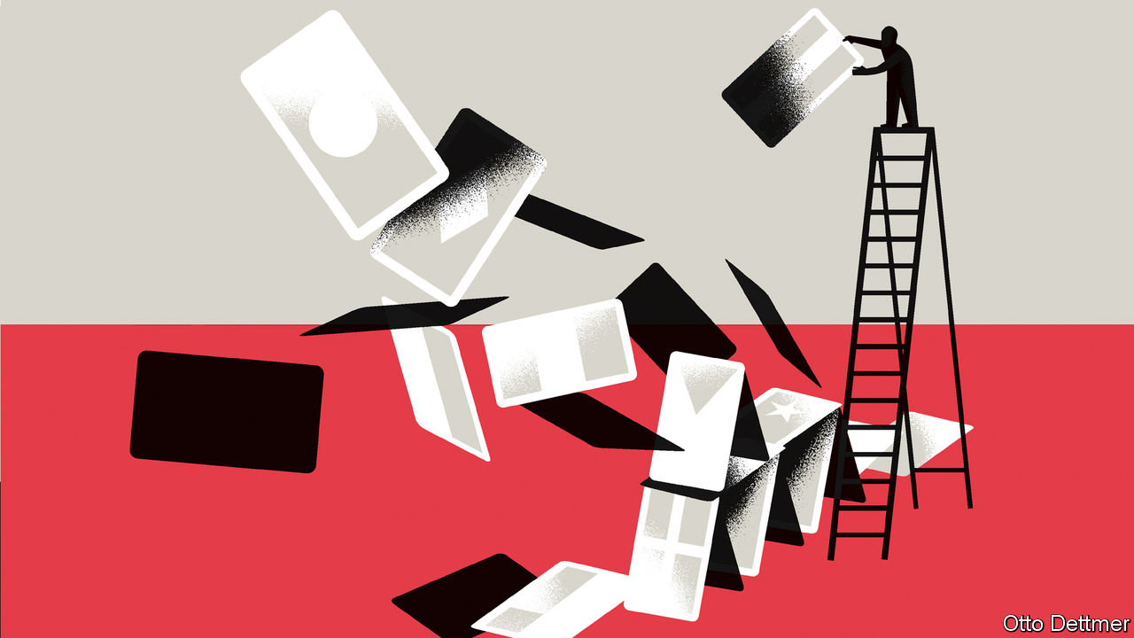

Editor’s note: Some of our covid-19 coverage is free for readers of The Economist Today, our daily [newsletter](https://my.economist.com/user#newsletter). For more stories and our pandemic tracker, see our [coronavirus hub](https://www.economist.com/news/2020/03/11/the-economists-coverage-of-the-coronavirus)

WHERE COVID-19 strikes, it reveals hard truths. In recent weeks Latin America has become the centre of the pandemic, responsible for over half of daily deaths. The region’s acute health crisis is accompanied by an economic decline unrivalled in the developing world. The IMF forecasts that output in the region will shrink by 9.4% in 2020, more than three times the contraction of 3% projected for emerging economies as a whole. The economic and social devastation wreaked by the pandemic is all the more painful for coming on the heels of two underwhelming decades. Investors had waxed enthusiastic about Latin America’s prospects during the great emerging-market boom of the 2000s and the 2010s, only to be disappointed. The few gains that were made seem almost certain to be reversed.

The economies of Latin America are far from homogeneous. Many share characteristics, however, that have conspired to make the region among the hardest hit in the world. In some places lockdowns have been stringent: Peru, for example, took the extraordinary step of closing its mines, the foundation of its economy, contributing to the IMF’s grim forecast of a decline in output of 14% this year. But big and dense cities, with high rates of poverty and substantial segments of the population in informal work, have limited the effectiveness of lockdowns. The large informal sector, together with weak state capacity, has also undermined the reach of government relief and exacerbated the economic collapse. Populist blowhards with little time for experts govern the region’s biggest economies, compounding its problems.

The bleakness of 2020 in Latin America also owes much to the condition of its economies before the coronavirus spread. Many limped into the new decade. Growth across the continent—even excluding Venezuela, whose economy collapsed catastrophically in recent years—was just 1.8% in 2018 and 0.8% in 2019. By the start of this year, Argentina and Mexico were already in recession; many other countries were stagnating—including Brazil, which enjoyed only the briefest of respites after a serious political and economic crisis in 2015 and 2016.

These woes fit a longer-running pattern of Latin America falling behind. The turn of the millennium marked the start of a great surge in the fortunes of the emerging world, and a departure from the usual state of affairs, in which poorer countries only rarely caught up to rich-world incomes in sustained fashion. Trade grew explosively, commodity prices boomed and the developing world asserted itself more confidently on the world stage. In the 2000s real output per person across the emerging world (on a purchasing-power-parity basis) rose at an astonishing clip of 4.6% per year, or four times the pace achieved by rich economies. The great gaps in income between advanced countries and the rest that opened during the 20th century seemed destined to narrow and close in the 21st.

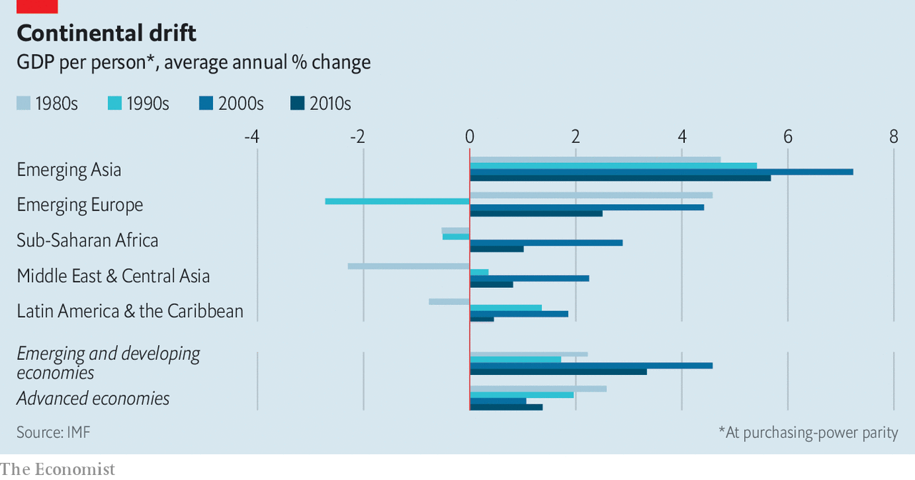

Latin America, however, proved a laggard. It managed an average growth rate in real per person incomes of just 1.9% in the 2000s: faster than in rich economies but the lowest of the emerging world (see chart). In the 2010s growth in the region ground to a near-halt, at just 0.5% per year, behind both the emerging-country average and the rich world. Latin America’s relatively high incomes—its larger economies are nearly all middle-income—may have contributed to slower growth: the richer you are, the less scope to grow by borrowing established technologies from other places. Its isolation mattered, too. The fastest growing emerging economies of the era were industrialising countries in Europe and Asia, which could latch on to the manufacturing supply chains of advanced neighbours. Few Latin American economies, apart from Mexico, enjoyed similar opportunities. And although the quality of governance—and of macroeconomic policy in particular—has improved markedly since the debt crises and inflations of the 1980s and 1990s, corruption, crime and volatile politics have made Latin America a less hospitable place for investors than it might have been.

## The countries of the future

Latin America has averted a debt crisis—so far. The Federal Reserve dollar-swap lines enjoyed by Mexico and Brazil have shielded them against troubles sparked by dollar shortages. IMF credit lines available to Chile, Colombia, Mexico and Peru have eased market pressure on the region. Central banks have been able to cut interest rates to provide something of a cushion against the pandemic’s economic damage, without provoking capital flight.

Still, there is no escaping the fact that even the healthiest of Latin American economies faces a punishing road back to normality. The IMF’s forecasts for growth in 2021 are decidedly tepid: GDP in the region is expected to expand by 3.7% next year, compared with 5.9% for the emerging world as a whole. Unless the growth in covid-19 infections falls rapidly, even those meagre projections will prove too optimistic. The reduction in inequality and poverty that was achieved in the past two decades is now at risk. The World Bank warns that poverty in the region could rise by as much as 23m this year. Government policy seems unlikely to alleviate these hardships. Mass protests erupted in Bolivia, Chile, Colombia and Ecuador last year. Political systems may be strained further.

It matters too that Latin America’s three largest economies are among its most troubled. Argentina has defaulted on its debt—again—and faces a risk of runaway inflation. Brazil’s epidemic rivals America’s as the worst in the world; it may need help from the IMF to avoid a debt crisis, or turn instead to inflationary finance. Mexico suffers from threats to the rule of law, a president seemingly determined to scare off private investment, and an unpredictable northern neighbour, which is also its biggest export market.

For Latin America covid-19 is a double shock: a brutally painful tragedy in its own right, and the definitive end of a growth opportunity that the region largely failed to exploit. The future of its economies and its societies depends on whether Latin Americans can be persuaded that there will be other chances in the future—and that next time its governments will do more to seize them. ■

This article was downloaded by calibre from <https://www.economist.com/finance-and-economics/2020/07/04/a-latin-american-economic-tragedy>

|  |  |  |  |
| --- | --- | --- | --- |
| Previous | Articles | Sections | Next |

|  |  |  |
| --- | --- | --- |
| Finance & economics | Sections | Books & arts |

Science & technology

Hydrogen power: Another look in the toy box

.

Phylloxera: The root of the problem

.

|  |  |  |
| --- | --- | --- |
| Finance & economics | Sections | Books & arts |

|  |  |  |  |
| --- | --- | --- | --- |
|  | Articles | Sections | Next |

#### Hydrogen power

# After many false starts, hydrogen power might now bear fruit

But it will fill in the gaps, rather than dominating the economy

Jul 4th 2020 |

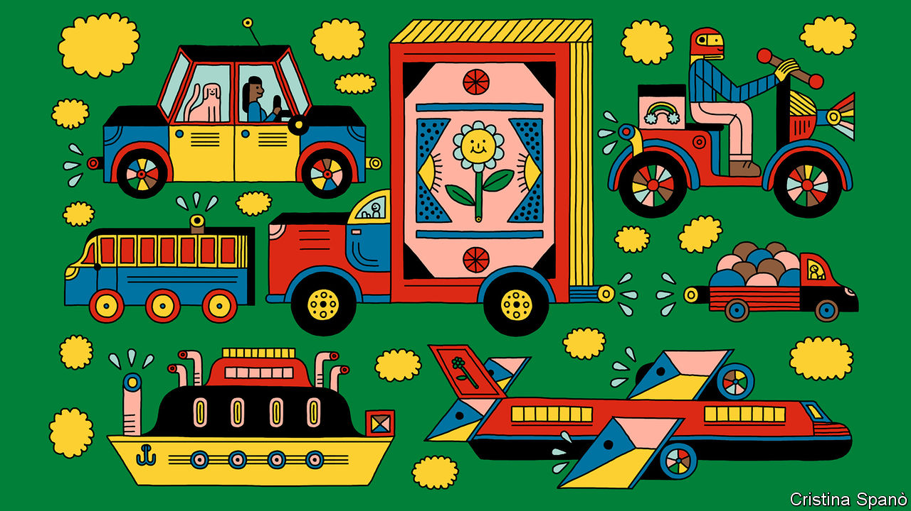

CONVENTIONAL WISDOM holds that battery-powered cars are the future of motoring. But Hyundai, a big South Korean vehicle-maker, is not so sure. Over the past few months it has been running a worldwide public-relations campaign extolling the virtues of an alternative source of electrical power—fuel cells. Instead of storing and then releasing electricity gathered from the mains in the way that a battery does, a fuel cell generates current from a chemical reaction between hydrogen and oxygen. The oxygen comes from the air. The hydrogen, suitably compressed, is stored in a tank on board the vehicle, and is replenished at a filling station, like petrol. Unlike a battery, a fuel cell does create exhaust. But that exhaust is simply the reaction product of hydrogen and oxygen, namely water.

Hyundai’s campaign features members of BTS, a mop-topped South Korean boy-band, staring dreamily into the middle distance amid backdrops of natural beauty. As a reminder of fuel cells’ environmental advantages, water is everywhere. It falls as snow. It roils in oceans. It floats gently through forests as mist. “For rest,” writes Park Ji-min, one of BTS’s members, in a misguided quest for profundity, “our rest comes from for-rests”.

The marketing may be silly, but Hyundai is serious. The firm already sells battery-powered vehicles, but it is hedging its low-carbon bets by developing hydrogen ones as well. The advertising campaign is designed to sell the Nexo, the firm’s second fuel-cell car, which was launched last year. And Hyundai is not the only company keeping its options open in this way. On June 5th Toyota, maker of the Prius, the world’s best selling battery-hybrid vehicle, announced a joint venture with several Chinese carmakers to develop fuel-cell technology. An updated version of Toyota’s Mirai, another hydrogen-powered car, is due out later this year.

Hydrogen is enjoying a purple patch, then, and not just among carmakers. It is being touted as a means of propelling buses and lorries, and even ships and aircraft. There is talk of it replacing natural gas as a source of heat, of it being used to store the surplus output of solar and wind power stations, of it being employed as a chemical feedstock and even of it replacing coke as a means of extracting metallic iron from its ore. If all this came to pass, then hydrogen would become a dominating factor in human life in the way that hydrocarbons currently are. It would, in other words, usher in a hydrogen economy.

## This time it’s different. Honest

Readers of a certain age are now permitted to roll their eyes. At least twice in the past 50 years—in the 1970s, after the oil crisis, and in the 1990s, when climate change started to acquire political salience—there has been excited talk of replacing hydrocarbons with hydrogen. It didn’t happen.

There were several reasons for this. For a start, ripping up and replacing the world’s fossil-fuel infrastructure is a huge job. And even were that an easy thing to accomplish, hydrogen itself has drawbacks. Though better than batteries, it stores less energy in a given volume than fossil fuels can manage (see chart 1). More important, it is not a primary fuel. You have to make it from something else.

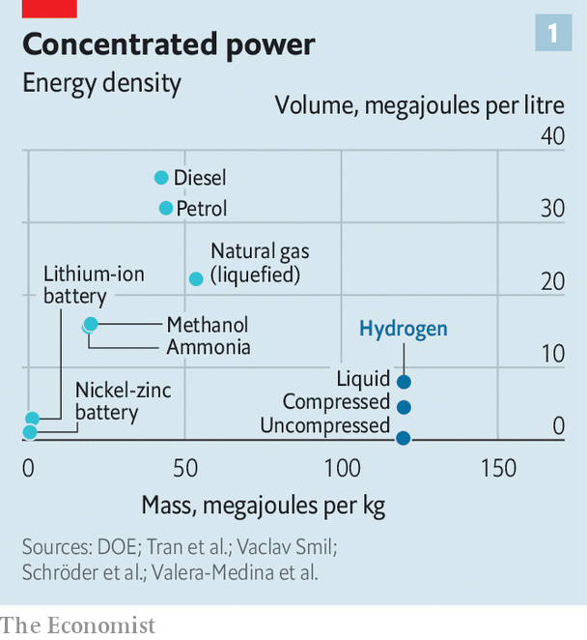

This can be done by a chemical reaction called steam reforming but, besides steam, the other ingredient of that process is a hydrocarbon of some sort, which rather defeats the object of the exercise. Or it can be done by the electrolysis of water. This has appropriate green credentials as long as the electricity is either from renewable sources or a nuclear-power plant. But the laws of thermodynamics mean that the energy content of the hydrogen which comes out of the process is less than the electricity that went in. This inbuilt inefficiency raises the question “why not simply power the end-use electrically, rather than using hydrogen as an intermediary?”

To counter these arguments those who believe that things hydrogen-related really are different this time around can point to two things in their favour. Several of the relevant technologies, notably electrolytic equipment, are now at a stage where it is possible to believe they might soon become cheap enough to do the job. And the idea that economies need to be decarbonised fully in order to curb climate change is gathering speed.

Until 2019, for instance, Britain had planned to cut carbon emissions by 80% from their levels in 1990 by 2050. It then, however, upped the ante to become the first big economic power to commit itself to a 100% cut. This has implications for hydrogen. Electrification using renewable sources such as wind and solar power would probably have got the country to 80%, observes David Joffe, a member of the Committee on Climate Change (CCC), an organisation that advises Britain’s government on how to bring the transformation about. But full decarbonisation, he says, is a much bigger task, and one for which hydrogen may prove necessary.

## Finding a niche

Despite Hyundai’s and Toyota’s enthusiasm, few analysts believe cars will be part of this process. The CCC calculates that a battery-powered car charged with electricity from a wind turbine converts 86% of the turbine’s output into forward motion on the road. For a fuel-cell car, it is 40-45%. Hydrogen cars also suffer from a chicken-and-egg problem. Unlike the battery-powered variety, they cannot be refuelled at home. Yet roadside refuelling stations for them are scarce, and are likely to remain so while the cars themselves remain rare.

In the meantime battery cars are building a formidable lead. The International Energy Agency (IEA), which advises national governments, reckons there were just 11,200 hydrogen-powered cars on the road in 2018, mostly in America and Japan. That compared with 5.1m battery-powered cars. And this number is growing fast. In 2019 sales of new battery-powered cars in China, the world’s biggest automobile market, hit 1.2m—4.7% of the total. In Norway they accounted for more than half of new cars sold. According to the IEA, sales of hydrogen cars around the world in 2018 (the most recent year for which reliable figures are available) were just 4,000.

There is, though, more to transport than private cars. A big problem with batteries is that they have a low energy density—in other words, they have to take up a lot of space if they are to propel a vehicle for any distance. For private cars, which mostly make short journeys, that is manageable. For longer-distance travel, for example by lorries, says Mark Newman, an energy analyst at Bernstein, a bank, hydrogen’s greater energy density becomes more attractive. Hydrogen compressed to 700 atmospheres contains between two and five times more usable energy per litre than a lithium-ion battery. If it is liquefied (which requires more complex technology) that increases further. And since lorries spend most of their time on busy trunk roads, fewer new fuelling stations would be needed.

Exactly where the break-even point lies is still debated. Tesla, a pioneering electric-car maker, thinks that even lorries can usefully be powered by batteries and plans a version that can travel 800km. Hyundai already makes a hydrogen-powered lorry, but its range is only 400km. Several other firms are also investigating fuel cells for lorries. In April, for example, Daimler, a German company, and Volvo, a Swedish one, invested €1.2bn ($1.3bn) in a joint venture to pursue the idea.

Shipping, which accounts for around 2.5% of the world’s industrial greenhouse-gas emissions, is also taking an interest. The International Maritime Organisation, an appendage of the United Nations that regulates the industry, aspires to cut ships’ collective greenhouse-gas emissions to half their levels in 2008 by 2050. How this might be achieved is unclear. Batteries pack far too little energy to power big, ocean-going vessels. Engineers have toyed with everything from nuclear propulsion to high-tech sails. But a study published in March by the International Council on Clean Transportation, an American not-for-profit institution, examined an existing shipping route between China and America and concluded that virtually all the craft plying it could be powered by fuel cells like those used in Hyundai’s cars, albeit with some cargo space removed to make room for the hydrogen itself. Even that could be ameliorated, says Michael Liebreich, an energy consultant, by first reacting the hydrogen with nitrogen to produce ammonia, a chemical that takes up less room than elemental hydrogen, and which can also be used in fuel cells.

## Hot stuff

Hydrogen might replace natural gas for heating, as well. A big advantage here is that it could make use of current infrastructure in the form of pipelines now employed to transport that natural gas. Several countries, including Australia, Britain and Germany, are experimenting with this idea. “We already have a gas grid that should last for at least another 75 years,” says Antony Green, an engineer at National Grid, which runs Britain’s electricity and gas networks. “Why not make use of that if we can?”

National Grid reckons the gas-fired boilers which heat most British homes can cope with a mix of 20% hydrogen without modification. And, says Dr Green, boilermakers are beginning to offer “hydrogen-ready” models, which are capable of burning either natural gas or pure hydrogen. Since boilers are replaced every ten to 15 years, he reckons the gas grid could plausibly be ready to switch to hydrogen in a couple of decades’ time. In May a group of German pipeline operators unveiled a plan to build a 1,200km hydrogen grid, based on converted natural-gas pipes, by 2030, at a cost of €660m.

How much environmental good this would truly do is debated. Starting from the position that the only green alternative for heating is electricity powered by renewables, Graham Cooley, the boss of ITM Power, a hydrogen-equipment maker, points out that Britain’s natural-gas grid supplies, every year, around 880TWh of energy to homes, factories and offices, most of which is used for heating. That is more than twice as much energy as the country’s electricity grid carries.

A switch to renewably powered electric heating would therefore require a drastic—and expensive—beefing up of the electricity network. Dr Joffe, however, counters that the need to manufacture hydrogen in the first place, with all the inefficiencies this brings, means a hydrogen gas grid would require building even more new power stations than would heating homes or factories with electricity directly.

Another suggested role for hydrogen is large-scale energy storage. As wind and solar power spread, matching supply with demand becomes harder. An obvious solution is to store surpluses in good times for use later, when times are bad. And one way to do that might be to make hydrogen and keep it in underground caverns, as currently happens with natural gas. This could increase capacity enormously—perhaps enough to manage not just day-to-day fluctuations but interseasonal ones as well.

On top of these ideas, heavy industry may provide other niches for hydrogen to fill, says Dr Liebreich. Electric heating may struggle to replace natural gas for many industrial processes involving steel, ceramics and glass because it might not be able to reach the required temperatures. And one of the biggest industrial sources of carbon dioxide is not directly energy-related at all.

This is the reduction of iron ore (usually an oxide of iron) to the metal itself by reacting the ore with carbon monoxide made from coke. That produces iron and carbon dioxide. React the ore with hydrogen instead, and the waste product is water. Several firms—including ArcelorMittal, a multinational steelmaker, and a conglomerate of SSAB, a Finnish-Swedish steelmaker, LKAB, a Swedish iron-ore producer, and Vattenfall an energy company, also Swedish—are examining this possibility.

## Elemental economics

All of this does, however, depend on an ability to make hydrogen at scale in a way that does not release CO2 into the atmosphere. And that is tricky.

At the moment, virtually all of the roughly 70m tonnes of hydrogen produced each year is a result of steam reforming. This emits seven tonnes of carbon dioxide for every tonne of hydrogen yielded. For this reason steam-reformed hydrogen is known to environmentalists as grey hydrogen. Its cost varies according to local circumstances, but averages, according to the IEA, around $1.50 a kilogram.

“Blue” hydrogen, though still the result of steam reforming, is somewhat cleaner than the grey variety. Instead of the CO2 being dumped into the air it is captured and buried underground—so-called carbon capture and storage. This is starting to happen. On July 1st, for example, Equinor, a Norwegian energy firm, said it would build one of the world’s biggest blue-hydrogen plants at a site in northern England. More ambitiously, Japan hopes that blue hydrogen might power its future. It envisages creating the gas from lignite deposits in Australia, burying the carbon dioxide locally, and then shipping the hydrogen across the Pacific in tankers akin to those that now carry liquefied natural gas.

The extra equipment needed to capture the carbon dioxide produced by reforming necessarily pushes up the price of blue hydrogen. Bloomberg New Energy Finance (BNEF) a firm of clean-energy analysts, reckons its current cost ranges from $1.50 to $3.50 a kilogram, depending on which fossil fuel is used to produce it (see chart 2). Moreover, the process of capturing CO2 is imperfect, so some of that gas escapes. The real desideratum, therefore, is “green”, electrolytic hydrogen. At $2.50 to $5 or more a kilogram, however, green hydrogen is currently even pricier than the blue sort.

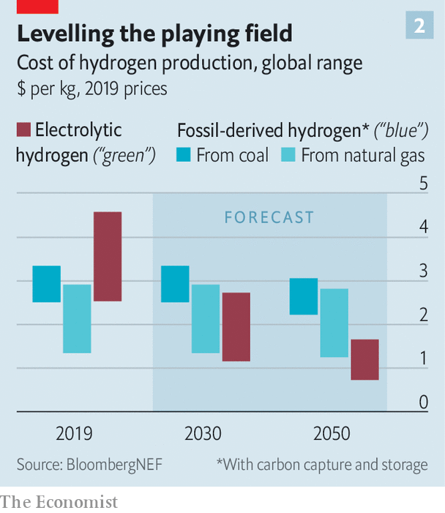

This could all change, though, as the technologies involved in making both blue and green hydrogen are scaled up. Prediction is a mug’s game, but BNEF has had a go anyway. Its analysts reckon green hydrogen might, by 2050, cost between 70 cents and $1.6 a kilogram—in other words the current price of the grey variety. As Kobad Bhavnagri, the firm’s head of special projects, explains, “The cost of electrolysis equipment has fallen by around 40% in the last five years in the West.” Dr Bhavnagri reckons the kit can now be had in Western countries for around $1,200 per kilowatt of capacity and that there may be scope for those numbers to fall much further. “The cost in the Chinese market is drastically lower—around $200 per kW,” he says, which will presumably bring the price down everywhere soon. UBS, a bank, cites a deal recently struck by Nikola, an American firm that says it is planning to make hydrogen lorries, which implies electrolyser costs of just $350 per kW.

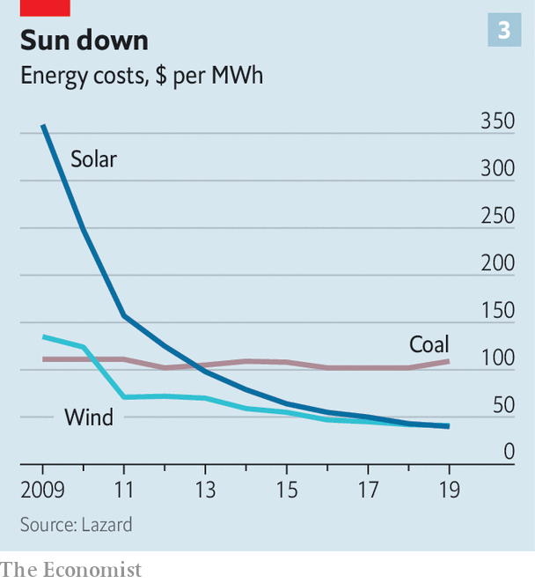

Operating costs, meanwhile, can ride on one of the most striking and reliable trends in the energy industry—the relentless fall in the price of solar and wind power (see chart 3). The cost of solar in particular has fallen by 85% in the past decade. Renewables are now cheaper in some parts of the world than energy from fossil fuels, and the process shows no sign of slowing.

## It’s a gas

The economics, then, seem to be pointing in the right direction for hydrogen to become, if not dominant, then at least an important part of the mix. The Hydrogen Council, a lobby group based in Brussels, thinks the gas could be satisfying 18% of the world’s energy demand by 2050. The share prices of firms that make fuel cells, electrolysis equipment and the like have consequently been marching upward.

Many of the assumptions made in various forecasts rely, however, on governments providing prodigious subsidies to develop the technology. BNEF says subsidies of around $150bn over the next ten years might be needed to make hydrogen competitive. In reality, the IEA reckons that total government spending on hydrogen in 2018 was just $724m.

Official interest is certainly picking up, though. On June 10th Germany announced a €7bn subsidy programme aimed at making it the “world leader” in the technology. A leaked draft of the European Union’s post-covid stimulus plan contains an ambition to install 40GW of green hydrogen capacity by 2030. China’s government hopes to see 1m fuel-cell-powered vehicles on the roads by the same year. Japan, long a fan of hydrogen, wants its price to fall by 90% by 2050. As to retooling vast swathes of the global energy system to accommodate this change, Dr Bhavnagri calculates that replacing natural gas with hydrogen would mean tripling or quadrupling the world’s gas-storage infrastructure, at a cost of perhaps $600bn.

In the end, hydrogen’s impact will be limited by the basic fact that it is, ultimately, just electricity in disguise. It remains an inescapably inefficient option. For some applications, though, its advantages—its energy density, its ability to burn and its compatibility with existing infrastructure—could make it an attractive fit despite that drawback. To paraphrase another famous advert, then, the hope is that hydrogen might prove to be the Heineken of clean energy: able to refresh the parts of an economy that electrification cannot reach. ■

This article was downloaded by calibre from <https://www.economist.com/science-and-technology/2020/07/04/after-many-false-starts-hydrogen-power-might-now-bear-fruit>

|  |  |  |  |
| --- | --- | --- | --- |
|  | Articles | Sections | Next |

|  |  |  |  |
| --- | --- | --- | --- |
| Previous | Articles | Sections | Next |

#### Phylloxera

# A pest’s genome reveals its past

And shines light on how to deal with it in future

Jul 4th 2020 |



A CENTURY AND a half ago an alien insect alighted in Europe. It displaced millions, ruined local economies and forced scientists, politicians and ordinary folk into a frenzy of defensive activity. Phylloxera, a member of the group known to entomologists as Hemiptera, or “true” bugs (as opposed to all the other critters known colloquially as bugs), appeared in France in the 1860s and proceeded to eat its way through many of the Old World’s vines.

It then spread to pastures new. It was first recorded in Australia in 1875 and in South Africa in 1886, threatening similar devastation to the vineyards of those European colonies. Eventually, French and American scientists found a solution by grafting European vines onto the imported roots of American ones. Now, a more recent group of French and American researchers report in bmc Biology that they have sequenced phylloxera’s genome, and that hidden within this lie clues to the insect’s origins and spread.

Nineteenth-century agronomists rapidly divined that phylloxera had come from North America. That fact provided the rationale behind their graft-based answer to the problem—which is still all that stands between cultivated vines and the bug. This is that having co-evolved with the insect, American vines had developed resistance to it. But where exactly it came from on that continent, nobody knew. One theory held British gardeners responsible because they had brought wild American vines to Europe for decorative purposes. From Britain, this theory went, phylloxera reached the European mainland via the south of France, the first place where it devastated vineyards. That, though, turns out to be a calumny against les Anglais.

## Bugs in the system

By comparing the genetic sequence of European phylloxera with those of populations from wild vines in the United States, Claude Rispe and Fabrice Legeai of the French National Research Institute for Agriculture, Food and the Environment (INRAE) and their colleagues have narrowed the search to the once-French territory of the Mississippi Valley (the upper Mississippi, to be precise—though one of the paper’s authors, Paul Nabity of the University of California, Riverside, plans to keep following the river south, sampling phylloxera as he goes, so the matter is not closed). The evidence is that there is a striking similarity between the European sequence and that of two phylloxera populations on a wild vine called Vitis riparia in Wisconsin and Illinois. This is enough, Dr Nabity says, to indicate that V. riparia was the bug’s original host and the upper Midwest its source.

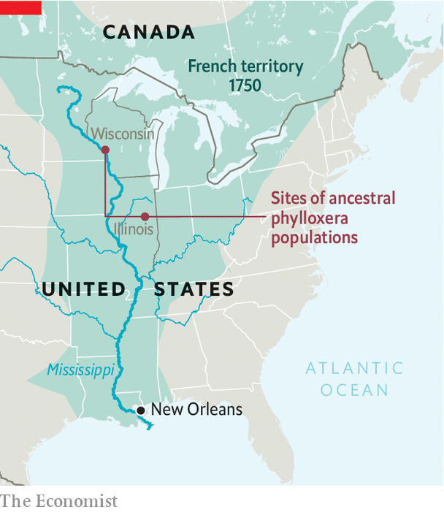

If correct, says François Delmotte, who works at INRAE’s campus in Bordeaux and is one of the project’s leaders, the finding fits with certain historical facts. Though the Mississippi valley was annexed from France by Britain and Spain in the mid-18th century, and passed eventually to the United States, many French settlers remained in the area and France retained trading links, particularly with New Orleans, for a long time. Dr Delmotte says it would not be surprising if, in the 19th-century age of steamships and naturalists, phylloxera survived on cuttings of V. riparia stored in a cool, dry hold to be brought to a botanical garden in France. Or, even more ironically, that it was imported with vines destined to cure their French cousins of an earlier imported blight—powdery mildew.

The genetic diversity of European phylloxera is limited compared with that of its North American counterpart, says Dr Rispe. That points to there having been only one or two introductions, with subsequent diffusion of the pest by people and their agricultural machines. However, another of the paper’s authors, Astrid Forneck of the University of Natural Resources and Life Sciences in Vienna, says it remains a possibility that a separate introduction infested eastern Europe, perhaps via the Austro-Hungarian empire’s experimental vineyards at Klosterneuburg.

In America phylloxera attacks wild vines’ leaves. It stimulates them to create galls in which it can live and feed, but which, from the plant’s point of view, serve to isolate the problem. When it attacks cultivated vines, though, it goes for the roots. These root galls open a plant to infection by bacteria and fungi, leading to its death. For a long time, researchers hunted for a single molecule, produced by the insect, that stimulated the growth of galls. Blocking the action of this, they hoped, would phylloxera-proof all vines. But here the sequencing project produced a disappointment. There is no such molecule. The researchers identified many genes—2,300 of them, more than a tenth of the insect’s genome—that encode proteins which it secretes while feeding on the vine. These enable it to evade the plant’s immune system while diverting resources from its host.

## The gall of it

The work now begins of teasing out what each of those genes does, and, ultimately, how phylloxera manipulates a plant and adapts to a new host. This information may in turn generate new weapons against the creature. That could be valuable in parts of viticulture’s New World, such as Australia, where vines remain ungrafted and phylloxera is still a problem. It might also help if the insect ever evolves the ability to evade the natural resistance of American vine roots that currently stands between European growers and disaster. For Dr Forneck, this prospect is not outlandish. The insect is already adapting to a warmer world, and shifting its range. Further shifts in its physiology are perfectly possible.■

This article was downloaded by calibre from <https://www.economist.com/science-and-technology/2020/07/04/a-pests-genome-reveals-its-past>

|  |  |  |  |
| --- | --- | --- | --- |
| Previous | Articles | Sections | Next |

|  |  |  |
| --- | --- | --- |
| Science & ... | Sections | Economic & ... |

Books & arts

Urban history: A night at the Cathay

.

American politics: Orange warning

.

Secrets and lies: Cherchez les femmes

.

Television drama: Creative destruction

.

Home Entertainment: Chekhov in Siberia

.

Home Entertainment: Hidden depths

.

|  |  |  |
| --- | --- | --- |
| Science & ... | Sections | Economic & ... |

|  |  |  |  |
| --- | --- | --- | --- |
|  | Articles | Sections | Next |

#### A night at the Cathay

# A pair of displaced dynasties shaped two extraordinary cities

Two new books chronicle the making of Shanghai and Hong Kong

Jul 4th 2020 | HONG KONG

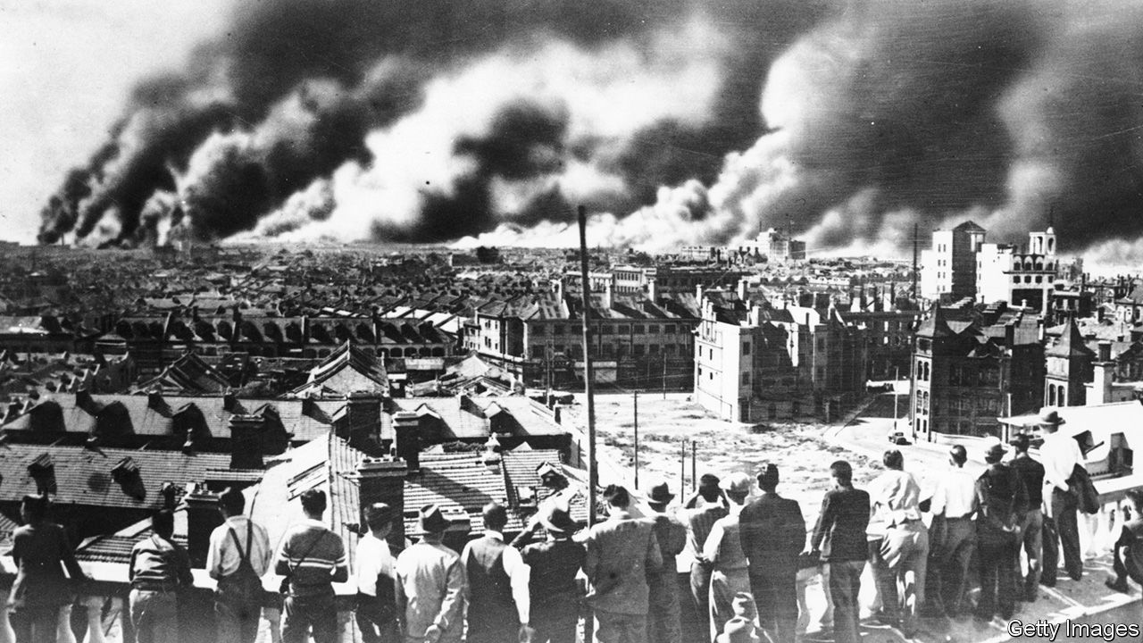

The Last Kings of Shanghai. By Jonathan Kaufman.Viking; 384 pages; $28. Little, Brown; £20.

Champions Day: The End of Old Shanghai. By James Carter.W.W. Norton; 352 pages; $28.95 and £22.99.

THE STORIES of Shanghai and Hong Kong, the most remarkable cities in East Asia, begin with the pogroms under Dawud Pasha, the last Mamluk ruler of Iraq. Until his ascendancy, the Sassoons were leaders of a Jewish community in Baghdad that dated back to the Babylonian captivity; for centuries the head of the family acted as the pashas’ chief treasurer. Yet one dark night in 1829 here was David Sassoon, the city’s richest man, fleeing for his life towards the river with a money belt around his waist and pearls sewn into his cloak.

In 1832 the 40-year-old set up anew in cosmopolitan Bombay, no hardscrabble refugee but an heir determined to win back his birthright. The Sassoons never liked being called the Rothschilds of Asia: in their view, the Rothschilds were arrivistes.

David’s timing was lucky. The British empire, under which he sought protection, was at its height. He bought docks and warehouses. He imported new gins to make his raw cotton fit for the powered looms in British factories.

Above all, he ran drugs. The East India Company’s monopoly on opium had been abolished. David backed Britain’s unconscionable war in 1839 to force China to continue to take Indian opium. The British colony of Hong Kong was among the results, as was the “treaty” port of Shanghai.

The arrival there of Elias, the second of David’s eight sons, marked the beginning of a truly global enterprise that would stretch from Yokohama to London. Elias dealt in Indian opium, spices and cotton and Chinese silk and tea; he brokered other merchants’ goods up and down the coast; and he invested in property to house the Chinese and foreign migrants flooding into the boomtown. In Hong Kong, the Sassoons helped set up the Hongkong and Shanghai Bank to get easy loans for their business. As HSBC, it remains one of Asia’s most powerful banks.

The Sassoons held things together through constant correspondence—more than 7,000 letters in all. Clerks and young men of promise from poor Baghdadi Jewish families were dispatched to Sassoon schools in Bombay. One such family was the Kadoories. Recently widowed, Rima Kadoorie sent four sons to the Sassoons in 1876. Elly, the youngest, worked his way up the coast of China. When plague broke out at Weihaiwei he offered disinfectant to Chinese employees. Managers scolded him for giving away goods. “If that’s the value you place on life,” Elly said, “I resign.”

After the patriarch’s death in 1864, Sassoon energies dissipated. A chief distraction was seeking status in Britain. In time Elly, joined later by his two sons, Lawrence and Horace, rivalled the Sassoons in both wealth and influence. The Kadoories brought electricity (or “power”, as they always called it) to Hong Kong. Later, in Shanghai, it was at the Kadoories’ Majestic Hotel that China’s Nationalist leader, Chiang Kai-shek, and his famous bride, Soong Mei-ling, held their wedding party. Still, the Sassoon clan was to produce one last rival, Victor, a crippled playboy of charm and wit whose art-deco Cathay Hotel, which opened on the Bund in 1929, immediately eclipsed the Majestic. Its masked balls became the stuff of legend.

Victor jettisoned the business’s past reliance on Baghdadi families in favour of a global management team. As Jonathan Kaufman, formerly of the Wall Street Journal, puts it in “The Last Kings of Shanghai”, his illuminating book on the Sassoons and the Kadoories, the road to China’s modernisation “ran along the Bund”. That was why Chiang’s Nationalists could not shake down the Sassoons, the Kadoories or other foreign businesses as they did Chinese merchants. They needed Western loans and approval to consolidate power in a fractured land.

To foreign residents, known as “Shanghailanders”, the forces tearing at China were at most a backdrop; few were aware of the part they were themselves playing in history. Shanghai was now the city of glamour—of Charlie Chaplin staying at the Cathay, Noël Coward writing “Private Lives” in the bath there, and Wallis Simpson acquiring sexual techniques that enticed a king from his throne.

The city partied like there was no tomorrow. Mr Kaufman recreates the era well, as does James Carter of Saint Joseph’s University in Philadelphia. With the eye of an unusually perceptive flâneur, in “Champions Day” he tells the story of Shanghai through its former racecourse (now part of the People’s Park). Mr Carter is a wonderful guide for visitors in search of a long-gone city. The ideal Shanghailander was a Briton abroad, he writes, “but the category could be flexible.” Both books are cautionary tales about what happens, in Mr Carter’s words, when the powerful exploit their environment, inviting war and revolution.

## Tomorrow doesn’t always come

For it soon turned out that there was no tomorrow. Shanghailanders blanked from their vision the Chinese corpses on the streets. It took a visitor like Emily Hahn, an American writer and Victor’s lover, to note that the city’s wealth sat on “a heap of underfed coolies”. That China’s Communist Party was founded in Shanghai was no coincidence; Chiang’s brutal suppression of it met with Shanghailanders’ approval.

By then other threats were circling. In 1937 Japanese forces occupied the Chinese parts of the city (see picture above); one bomb from a fleeing Chinese plane spattered flesh up the Cathay’s walls. After the attack on Pearl Harbour in December 1941 the Japanese took the self-governing International Settlement, too. Horse-racing was suspended the next year. A naval commander moved into Victor’s suite; in Hong Kong the Kadoories’ fabled Peninsula hotel became a military headquarters.



During these hard years, as Mr Kaufman recounts, both clans redeemed themselves, whatever original sins their fortunes were founded on. Victor and Horace came together to give sanctuary to fleeing European Jews. They set up schools, workshops and canteens and raised funds (Chaplin donated proceeds from “The Great Dictator”), an effort that involved perilous negotiations with the rapacious Japanese occupiers. Even as Shanghai became a squalid hell, not one of its 18,000 Jewish refugees was persecuted.

Four years after that war, Mao Zedong’s Communists seized power in China. They turned out the lights in Shanghai, that nest of foreign vices. His properties expropriated, Victor Sassoon cursed China and retired to the Bahamas. By contrast, Lawrence and Horace Kadoorie started afresh in Hong Kong. Lawrence’s “power” fired the textile mills that fleeing Shanghai industrialists set up near Kowloon, kickstarting Hong Kong’s post-war boom. The brothers had learned a valuable lesson: don’t neglect those at the bottom of the pile. The gentle Horace devoted his life to helping Chinese refugees in Hong Kong set up small farms with grants, loans, seeds and better pig breeds. The Kadoorie name is revered in the rural New Territories.

The family never criticised the Communists or the seizure of their assets. When China began to open up in the late 1970s somebody quietly replaced Elly’s tombstone, which Red Guards in Shanghai had ripped out. In Beijing Lawrence pleased leaders by praising China’s economic policies and cautioning against democracy in Hong Kong. Today Shanghai is once again international and cosmopolitan—and the Kadoories are back on the Bund. Now, though, modern skyscrapers across the river in Pudong dwarf the famous old skyline: no question who is boss.

Yet is another cautionary tale about to play out in Hong Kong? China this week imposed a draconian security law, undermining what sets Hong Kong apart from the dictatorship on the mainland. The Kadoorie heirs—they are still the biggest generators of power—voiced their approval. Stability is all. But an approach that ignored fundamental injustices did not work out in Shanghai, and may not in Hong Kong either. The new law is intended to shunt popular discontents from view; meanwhile, many elderly Hong Kongers collect cardboard at night for a pittance. The tycoons and officials have stopped noticing. It is surely not the end of the story. ■

This article was downloaded by calibre from <https://www.economist.com/books-and-arts/2020/07/04/a-pair-of-displaced-dynasties-shaped-two-extraordinary-cities>

|  |  |  |  |
| --- | --- | --- | --- |
|  | Articles | Sections | Next |

|  |  |  |  |
| --- | --- | --- | --- |
| Previous | Articles | Sections | Next |

#### Orange warning

# Donald Trump is not like other presidents, argues Masha Gessen

“Surviving Autocracy” chronicles his tussles with America’s institutions

Jul 4th 2020 |

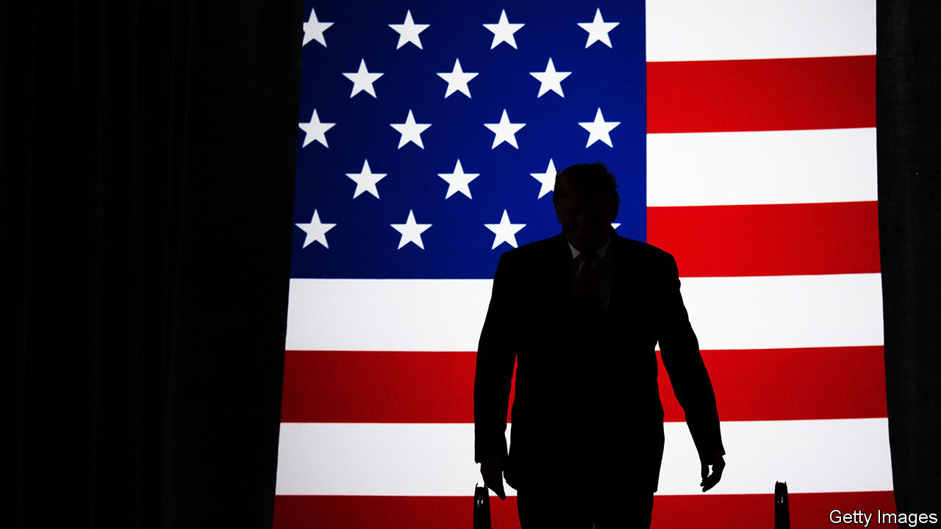

Surviving Autocracy. By Masha Gessen.Riverhead Books; 288 pages; $26. Granta; £12.

TWO DAYS after Donald Trump was elected, Masha Gessen argued in the New York Review of Books that he was “the first candidate in memory who ran not for president, but for autocrat—and won.” The piece offered advice, such as “Do not be taken in by small signs of normality.”

The years since have testified to Mr Trump’s autocratic instincts. He has been more hostile to oversight and dissent, and more demanding of personal loyalty and displays of adulation, than any American president in memory. He has spurned allies and fawned over dictators. In a pithy but overstated new book, Gessen (who prefers to be referred to that way) updates and expands on that early warning. Mr Trump, Gessen writes, is qualitatively different from any of his predecessors, given as he is to “ignoring and destroying all institutions of accountability”.

The author, who was born in the Soviet Union and has written acutely about Vladimir Putin’s Russia, chronicles Mr Trump’s tussles with those institutions. The determination of the press to appear objective and balanced, Gessen argues, as well as its weakness for hope, have prevented it from accurately describing Mr Trump’s predations—even as it hyped his normal-seeming moments. Pillars of the state, such as the Office of Government Ethics, were accustomed to compliance from the White House and ill-equipped to counter open defiance. Congress was riven and cowed.

Civil society and the judiciary have each mounted resistance where they can; but, Gessen maintains, they “function on the assumption that they are partners in an ongoing negotiation”, whereas Mr Trump “sees any attempt at negotiation as an affront to his power—something that needs to be quashed at any cost.” On this view, Democrats have too often let him dictate the terms of political battle. For instance, Gessen derides Chuck Schumer, the Senate minority leader, for saying he had a “policy difference” with Mr Trump over the border wall, rather than straightforwardly calling the scheme “immoral”.

According to the book, ordinary Americans, too, are ill-equipped to grapple with the president’s brazenness. Ever since Watergate, they have been primed to sniff out political conspiracy. But Mr Trump lacks the attention span and managerial skills to run a conspiracy. Faced with pressure to reveal who received $500bn in taxpayer-funded emergency loans, his administration did not manufacture a false paper trail. His treasury secretary simply refused to say. It wasn’t muckraking journalists who informed the public that Mr Trump had sacked James Comey, a former director of the FBI, because of its probes into his campaign’s links with Russia. As Gessen relates, the president said so on television.

Borrowing a phrase from Balint Magyar, a Hungarian writer and politician, Gessen now characterises Mr Trump’s overall project as “an autocratic attempt”, rather than the thing itself; he is said to be testing America’s defences and laying the groundwork for further power grabs. The country can still fend off this bid—notably by voting him out of office. But more will be required, Gessen urges, to repair the damage and see off the danger. Ideals have receded from politics in favour of an uninspiring technocracy; America will have to reinvent, or at least rediscover, its “moral aspiration”, in particular “the belief that this can be a country of all its people”.

Bracing as it is, though, this book underplays the robustness of some of the institutions it frets over. The Supreme Court, for instance, has recently issued a string of rulings that enraged the president; though Republican senators preserved him in office, occasionally even some of them have disappointed him. And it misses the extent to which the fightback Gessen craves is already happening. Mr Trump has led Republicans towards nativism, but also to three years of electoral defeats—including the loss of the House of Representatives. Should Democrats win the presidency and both chambers of Congress in November, he may inspire a raft of ethics legislation.

Mr Trump may be a sign of decadence in American democracy, as Gessen implies. He could also prove its renewer. ■

This article was downloaded by calibre from <https://www.economist.com/books-and-arts/2020/07/04/donald-trump-is-not-like-other-presidents-argues-masha-gessen>

|  |  |  |  |
| --- | --- | --- | --- |
| Previous | Articles | Sections | Next |

|  |  |  |  |
| --- | --- | --- | --- |
| Previous | Articles | Sections | Next |

#### Cherchez les femmes

# A French politician’s secret child re-evaluates her life

But in “The Margot Affair” it is her mother, not her absent father, who commands most attention

Jul 4th 2020 |

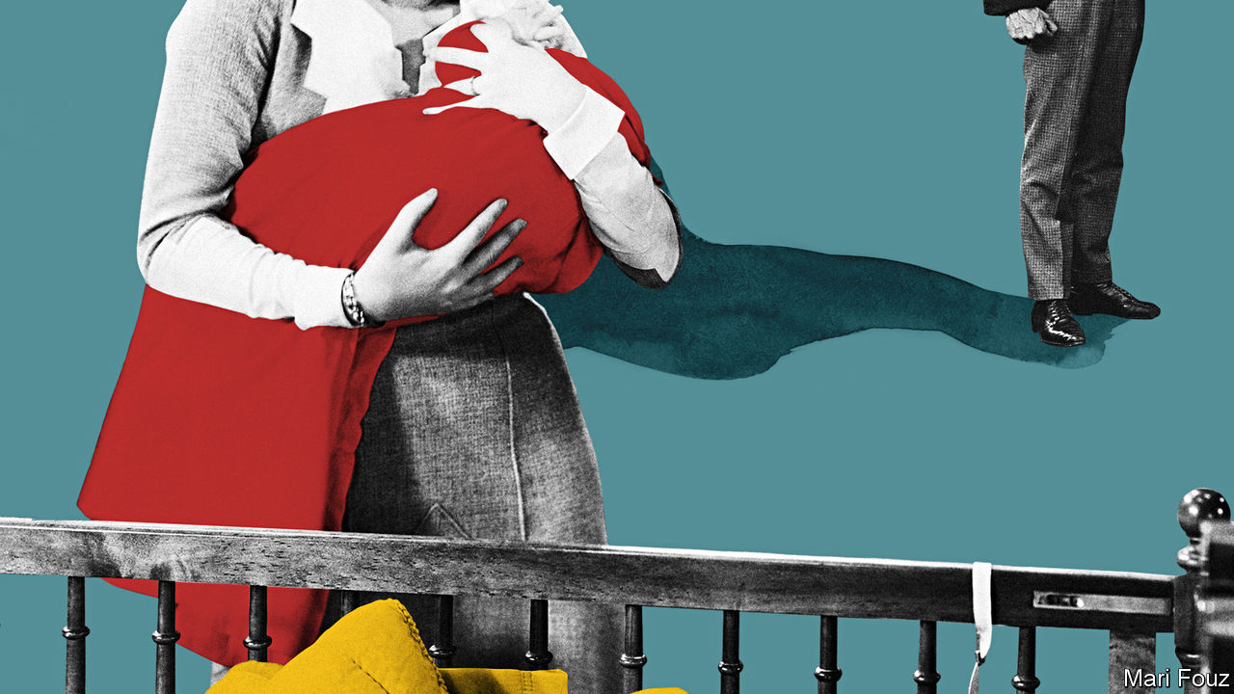

The Margot Affair. By Sanaë Lemoine.Hogarth; 336 pages; $27. Sceptre; £16.99.

WHEN THE existence of François Mitterrand’s secret child was revealed by Paris Match in 1994, many insiders in France shrugged. “Everyone knew,” people said of the president’s mistress and of Mazarine, his daughter. Discretion over adultery is widely considered a French speciality—yet such deception has its costs. In a new novel about a politician’s secret family, it taints every aspect of life.

Sanaë Lemoine was just a girl when “L’affaire Mazarine” burst into the headlines. Out of the contradictions of this quintessentially French arrangement she has spun “The Margot Affair”, an unusual and accomplished first novel. With a quick wink to the real-life case, she dives deep into the intense, duplicitous relationships at the heart of such a ménage.

Seventeen-year-old Margot is the result of an illicit liaison between Anouk, a glamorous actress, and the married minister of culture. She adores her mainly absent father, fights with her complicated, remote mother and suffers from a “confused feeling of unhappiness”. On the cusp of adulthood she suddenly sees that, relegated to the shadows as they are, she and her mother are “on the wrong side of Father’s double life”, a realisation that sets off a destructive chain of events.

What follows is anything but predictable. Ms Lemoine’s story moves in intriguing leaps and twists until her real subject is revealed: not the famous father, but the fraught relationship between mothers and daughters. In Margot’s eyes, Anouk is always performing, but she repels more than she attracts. Anouk, for her part, practises a harsh, tough kind of love. “A mother is not a friend,” she says. As their world falls apart, it appears that neither she nor Margot’s father is capable of placing the teenager’s welfare above their own.

Though their cloistered life revolves around a distinguished man, it is the feelings of the women that the author charts. Using clever anecdotes, nods to French cinema and allusions to “Bonjour Tristesse”, Françoise Sagan’s classic coming-of-age tale, the novel asks what exactly makes a “good mother”. Darker themes of female violence emerge, yet the story is strangely silent about the father’s responsibility for what happens to his daughter.

Above all, this is a lacerating portrait of a solitary, secretive girl who is both vulnerable and cruel. Margot is “formed and unformed”, observes a woman who offers to ghostwrite her memoir. She seesaws between the child aching for love and a hardened soul who is expert at withholding feelings and truths. The plot’s twists partly flow from her manipulative, almost sociopathic disregard for others.

Good novels can supply insights into other cultures, and, for outsiders, one of this book’s pleasures is the glimpse it affords into French mores and habits. Ms Lemoine is half-French and half-Japanese, but she studied in America and writes in English. Here she lifts the window slats not just on the covert behaviour of consenting adults, but on many facets of bourgeois Parisian life, from its obsession with female bodies and clothes to recipes for clafoutis and vinaigrette. ■

This article was downloaded by calibre from <https://www.economist.com/books-and-arts/2020/07/04/a-french-politicians-secret-child-re-evaluates-her-life>

|  |  |  |  |
| --- | --- | --- | --- |
| Previous | Articles | Sections | Next |

|  |  |  |  |
| --- | --- | --- | --- |
| Previous | Articles | Sections | Next |

#### Creative destruction

# The jolting artistry of Michaela Coel

The writer and star of “I May Destroy You” explains her arresting style

Jul 4th 2020 |

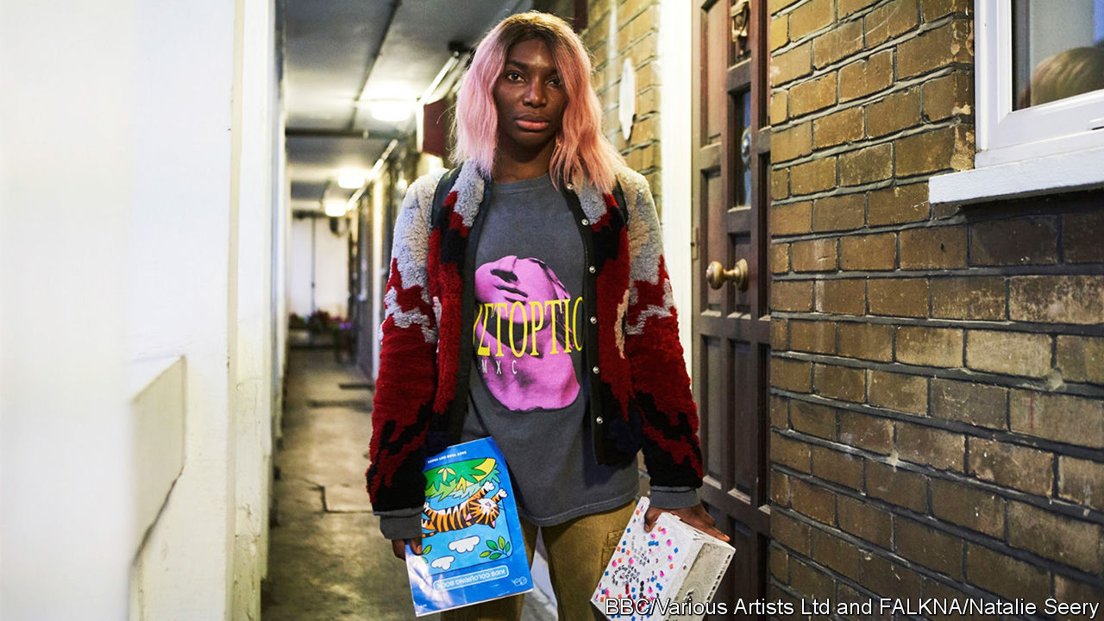

EVERY YEAR the Edinburgh Television Festival, one of the highlights of the industry’s calendar, invites a prominent figure to deliver a talk known as the MacTaggart lecture. Past speakers have included Rupert Murdoch, Eric Schmidt and Armando Iannucci. In 2018 Michaela Coel, a British writer and actor, took to the podium. She was the first woman from an ethnic minority to do so and, at 30, the youngest lecturer in the festival’s history.

Ms Coel described her upbringing on a council estate in east London, where her family would receive “a bag of shit through our letter-box”. She recalled her time at a Catholic school, finding God (then losing him again) as a young adult, and the racist slurs she endured at the Guildhall School of Music and Drama, where she was “the first black girl they’d accepted in five years”. She lamented the lack of opportunities and support for minorities in television, promising to “play whatever part I can to help fix this house”. The speech was raw and personal, but also shot through with humour. When malicious rumours were spread about her at school, she remembered, she had retorted that “the only thing I was blowing was the clarinet.”

Talking over Zoom, she evinces the same mix of gravity and zaniness, thoughtful pauses alternating with peals of laughter. This jolting blend of moods defines her work, too. Ms Coel draws on her own experiences to fashion compelling, surprising narratives, which tackle solemn subjects with a dizzying lightness of touch. Her stories provoke horror in viewers one moment and mirth the next. As well as distilling a generation’s feelings about sex, race, class and friendship, they have established her as one of television’s most original and provocative dramatists.

## Write, act and chew gum

“Chewing Gum”, her breakthrough, BAFTA award-winning show, began as a one-person play, which she wrote as part of her final assessment at drama school. Although she loved Shakespeare and Greek tragedy, Ms Coel says, “I wanted to write a [play] where I’m bringing myself, I’m bringing something I understand, into this school.” She recycled memories of her own adolescence to create the figure of Tracey, a 14-year-old navigating school, friends and boys. “I ain’t smart enough to be someone,” Tracey says. “I’m just smart enough to know I’m no one.”

The TV version dropped some of the original play’s darker themes, such as teenage pregnancy and domestic violence, but retained the naivety of its protagonist. Played by Ms Coel, this Tracey is in her early 20s and lives on a housing estate with her devout mother and sister; she shakes off her religious upbringing as she becomes obsessed with having sex. Her interactions with love interests are often insulting. One man says she looks “like a modern, liberated slave”; another asks where she is “really from”, later getting her to dress up in a bikini and perform a “tribal” dance. Like Phoebe Waller-Bridge’s character in “Fleabag” (which “Chewing Gum” preceded), Tracey often breaks the fourth wall to speak directly to viewers. Rachel Springett—formerly of Channel 4, which commissioned the show—says Ms Coel’s work “walks the line between tragedy and humour in a way I’d never seen before”. The writing was “poetic, profound and in your face”.

The two seasons of “Chewing Gum” were broadcast in Britain and America in 2015-17. Ms Coel has since taken lead roles in “Black Earth Rising”, a drama series co-produced by the BBC and Netflix about the prosecution of war criminals in Rwanda, and “Been So Long”, a film musical (for which she also composed part of the soundtrack). She appeared in two episodes of “Black Mirror” and in “Star Wars: The Last Jedi”. But her main project—which has taken two and a half years to come to fruition—has been “I May Destroy You”, a searing, disconcerting drama currently being broadcast on HBO and the BBC.

Ms Coel stars as Arabella, a young writer who has recently shot to fame for her “Chronicles of a Fed-Up Millennial”, a Twitter-account-turned-book. This story, too, is partly drawn from life. As a deadline for the second season of “Chewing Gum” loomed, Ms Coel startlingly recounted in her Edinburgh lecture, she “took a break and had a drink with a good friend”; when, hours later, she “emerged into consciousness”, she realised that she had been sexually assaulted by strangers. She says now that it was in the police investigation room, as she waited to give her statement, that she knew she wanted to write about the trauma. “While my right hand was going through this, it’s like my left hand was beginning to almost observe and take notes of what was happening.”

## Break for the border

The BBC responded to the idea by commissioning the whole series, without the usual pilot. Piers Wenger, head of BBC Drama, says he seized the opportunity to collaborate with Ms Coel and gave her total creative freedom. “It’s rare that you get a voice that can occupy so many different extremes and still have a really strong unity and coherence to it,” Mr Wenger says. The director of the series, Sam Miller, observes that Ms Coel is “unafraid to go to the other side of the border”. (As well as writing and starring in them, Ms Coel co-directed nine of the 12 episodes.)

Though some of the scenes are difficult to watch, “I May Destroy You” is also fun. Ms Coel explores the subjects of sexual consent and abuse through young lives in a big city in the 21st century, replete, as they often are, with money troubles, unsuitable flings, social media and house parties. The morning after Arabella is assaulted, she stumbles onto the streets of central London, disoriented, her ears ringing; a fan approaches her at a bus stop, gleefully quoting passages of her book and asking for a selfie. After she goes to the police, the show jumps back three months to a trip to Italy, on which she and her best friend Terry indulge in a drugs binge (and, in Terry’s case, in a threesome).

Those characteristic tonal shifts have become even more pronounced and arresting. The emotional whiplash is meant, Ms Coel explains, to capture a fundamental truth. “I think a lot of people of colour, their lives are not a gag a minute,” she says. “There is darkness and there is light—and we should take both.” ■

This article was downloaded by calibre from <https://www.economist.com/books-and-arts/2020/07/04/the-jolting-artistry-of-michaela-coel>

|  |  |  |  |
| --- | --- | --- | --- |
| Previous | Articles | Sections | Next |

|  |  |  |  |
| --- | --- | --- | --- |
| Previous | Articles | Sections | Next |

#### Home Entertainment

# Chekhov’s trip to Sakhalin puts lockdown in perspective

When he crossed the strait to the island prison colony, the writer felt he was entering hell

Jul 4th 2020 |

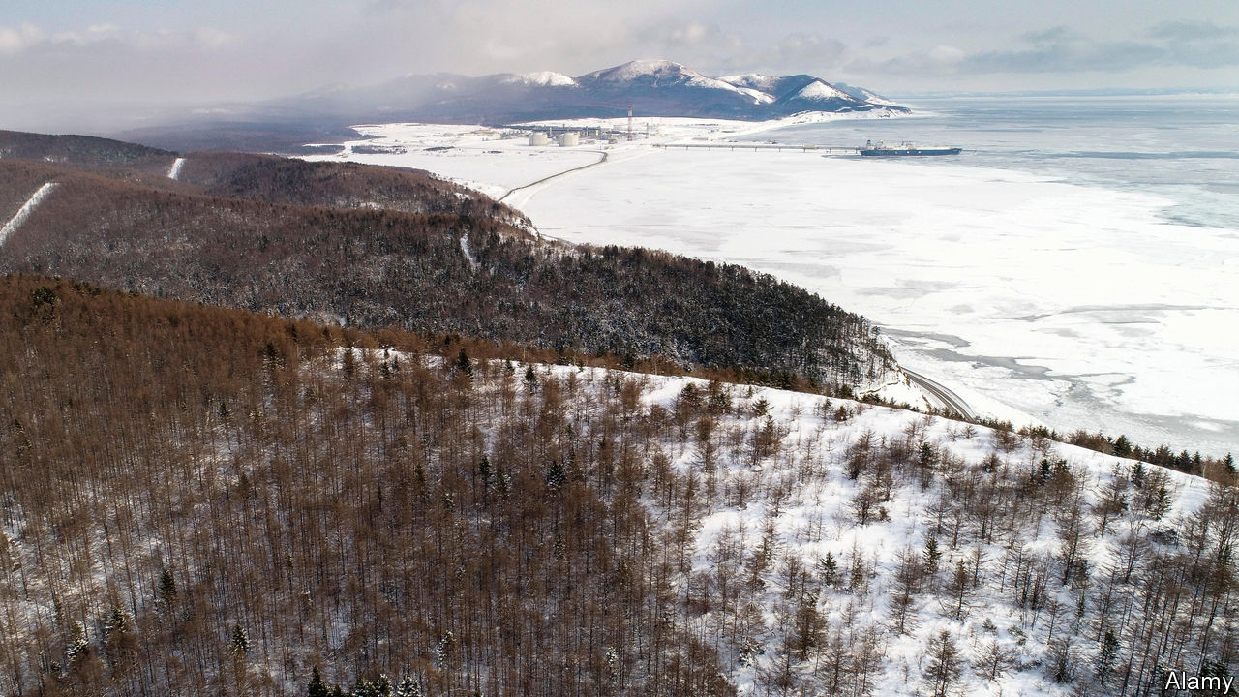

ALONG THE Siberian highway, between Tyumen and Tomsk, Anton Chekhov stayed the night in a coach driver’s cabin. Two months earlier a gentlewoman had stopped there with her newborn boy. Suspecting that he was illegitimate, and childless herself, the driver’s wife offered to take him in. The lady left him with the couple while she decided—and then vanished. Was he theirs or not? “Please help, for God’s sake!” the driver implored as his wife, besotted with the baby, fled the room in tears.

It was May 1890 and Chekhov was on his way to Sakhalin, an island north of Japan which was then a huge Russian penal colony. For the stir-crazy, his trip is a consoling reminder of travel’s hazards. Chekhov nearly perished in a collision with a mail troika and might have drowned in a flood. Notionally it was spring, but on the approach to Tomsk there was deep snow. And the terrible rutted roads, the oceans of mud, the endless taiga, the maddening mosquitoes…When at last he crossed the Tatar Strait to Sakhalin it was ablaze with forest fires. He felt he was entering hell.

Unlike some writers who trekked across Siberia, Chekhov went voluntarily. The journey took almost three months, and he spent as long again on the island. His aim was to survey the prisoners and publicise their conditions—which make the confinement of lockdown look like paradise.

On Sakhalin, chains clanked incessantly and the floggings gave Chekhov nightmares. Virtually all the women, convict or free, had been forced into prostitution. Bears scooped salmon from the rivers, but the human food was terrible. And the boozing! The bedbugs! Like covid-era readers taking their licensed strolls, many inmates were able to roam around, but they could never see their loved ones. They made doomed bids to escape, often butchering each other in the process, desperate to cross the strait and breathe the air of freedom before they died.

Today, two museums are devoted to Chekhov on Sakhalin, which is dominated by giant energy projects. The island left a mark on him, too. It coloured his view of authority and redoubled his commitment to describe life as it was, compassionately but without illusions. Just before he set out, his play “The Wood Demon” had flopped. Afterwards he wrote many of his finest stories, as well as “The Seagull”, “Three Sisters” and “The Cherry Orchard”.

Even in “Sakhalin Island”, his account of the expedition, the artist in Chekhov keeps elbowing aside the social reformer, and amid the demographic details that he amassed are a trove of exquisite vignettes. After confessing to killing her child a prisoner wept bitterly, but then (in Brian Reeve’s translation) “wiped her eyes and asked, ‘Fancy buyin’ a nice little bit o’ pickled cabbage?’” Despite lashings and stints in a punishment cell, an old con had refused to work; in the end the guards gave up, and he strolled around, singing. Murdered in a bakery, a cruel official “fell into the kneading trough and stained the dough with blood”. Alas, you never find out what happened to the gentlewoman’s baby. ■

Editor’s note: Some of our covid-19 coverage is free for readers of The Economist Today, our daily [newsletter](https://my.economist.com/user#newsletter). For more stories and our pandemic tracker, see our [coronavirus hub](https://www.economist.com/news/2020/03/11/the-economists-coverage-of-the-coronavirus)

This article was downloaded by calibre from <https://www.economist.com/books-and-arts/2020/07/04/chekhovs-trip-to-sakhalin-puts-lockdown-in-perspective>

|  |  |  |  |
| --- | --- | --- | --- |
| Previous | Articles | Sections | Next |

|  |  |  |  |
| --- | --- | --- | --- |
| Previous | Articles | Sections | Next |

#### Home Entertainment

# In “Jaws”, bungling officials confront an invisible threat

Steven Spielberg’s blockbuster is apt lockdown viewing in more ways than one

Jul 2nd 2020 |

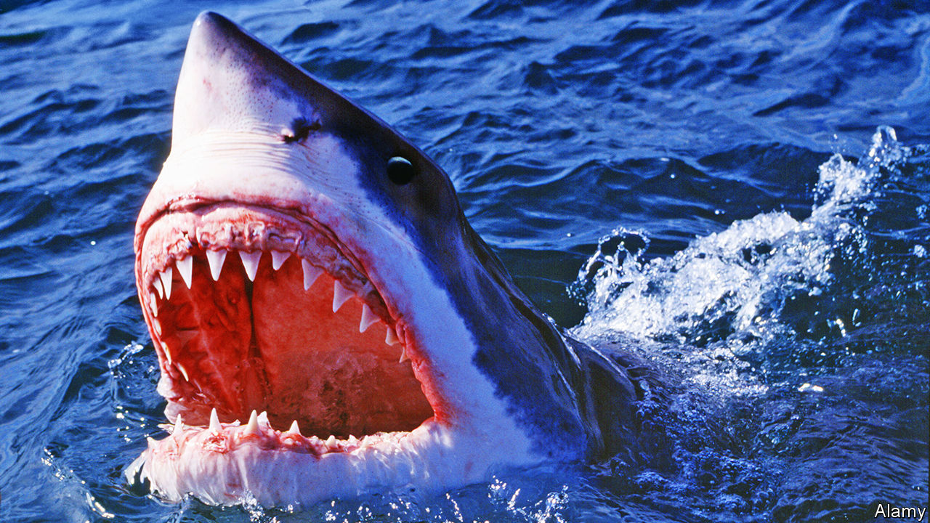

“A FILM ABOUT a shark” was Steven Spielberg’s description of “Jaws”, the movie released in 1975 that established his box-office power as a director. More elaborate interpretations abound for his tale of a ravenous great white terrorising the genteel seaside town of Amity on Long Island. Is it a comment on corruption after Watergate, a parable of the Vietnam war or an illustration of Freudian castration anxiety? Fidel Castro, in an excursion into film criticism, reckoned it was a devastating Marxist critique of American capitalism.

The movie supports so many theories because of its layered plot and styles—one reason it is amenable to repeated viewings. Nerve-tingling suspense is intercut with picket-fence melodrama and humour. It is a buddy movie crossed with an adventure on the high seas. From the perspective of the pandemic, though, “Jaws” seems at heart to be a film about the untameable power of nature. An invisible, relentless assailant makes no distinction as to whom it attacks. Like some leaders today, the officials who must confront it are vacillating and helpless.

Much of the tension is achieved through the power of suggestion. The shark is not fully seen until long into the story (mostly because the mechanical models constantly malfunctioned). As in the lockdown, when the streets outside are the domain of a deadly bug, the sea that gives the beast its cover is the enemy, too, made ominous and forbidding by the spare and portentous score. Where can you turn when a killer might be anywhere?

In Amity, those in charge see the danger but fail to act swiftly. Brody, the local police chief (played by Roy Scheider), is well-meaning but unprepared. After the first shark attack the self-important Mayor Vaughn (Murray Hamilton) persuades him to keep the beaches open to save the tourist economy; the men lock down only when three more people are killed. (Boris Johnson, Britain’s prime minister, once cited the mayor as a political hero for his boldness in weighing death against commerce.)

Experts disagree on how to overcome the danger. Hooper (Richard Dreyfuss), a wisecracking academic, prefers brainy methods; Quint (Robert Shaw), a heavy-drinking shark hunter, opts for brawn. Even in a film packed with memorable dialogue, Quint’s description of being torpedoed during the second world war, with its grim mortality statistics, stands out: “So, 1,100 men went into the water; 316 men come out. The sharks took the rest.”

Sadly, it will take more than three misfits in a ramshackle vessel to beat the virus. Metaphorically speaking, “You’re gonna need a bigger boat.” Still, quarantine is another chance to enjoy Mr Spielberg’s yarn, albeit with an after-bite. For many, its legacy was a lifelong fear of the sea; for some, covid-19 may bequeath a lingering queasiness about the world outside. ■

Editor’s note: Some of our covid-19 coverage is free for readers of The Economist Today, our daily [newsletter](https://my.economist.com/user#newsletter). For more stories and our pandemic tracker, see our [coronavirus hub](https://www.economist.com/news/2020/03/11/the-economists-coverage-of-the-coronavirus)

This article was downloaded by calibre from <https://www.economist.com/books-and-arts/2020/07/02/in-jaws-bungling-officials-confront-an-invisible-threat>

|  |  |  |  |
| --- | --- | --- | --- |
| Previous | Articles | Sections | Next |

|  |  |  |
| --- | --- | --- |
| Books & arts | Sections | Graphic detail |

Economic & financial indicators

Economic data, commodities and markets

.

|  |  |  |
| --- | --- | --- |
| Books & arts | Sections | Graphic detail |

|  |  |  |  |
| --- | --- | --- | --- |
|  | Articles | Sections | Next |

# Economic data, commodities and markets

Jul 4th 2020 |

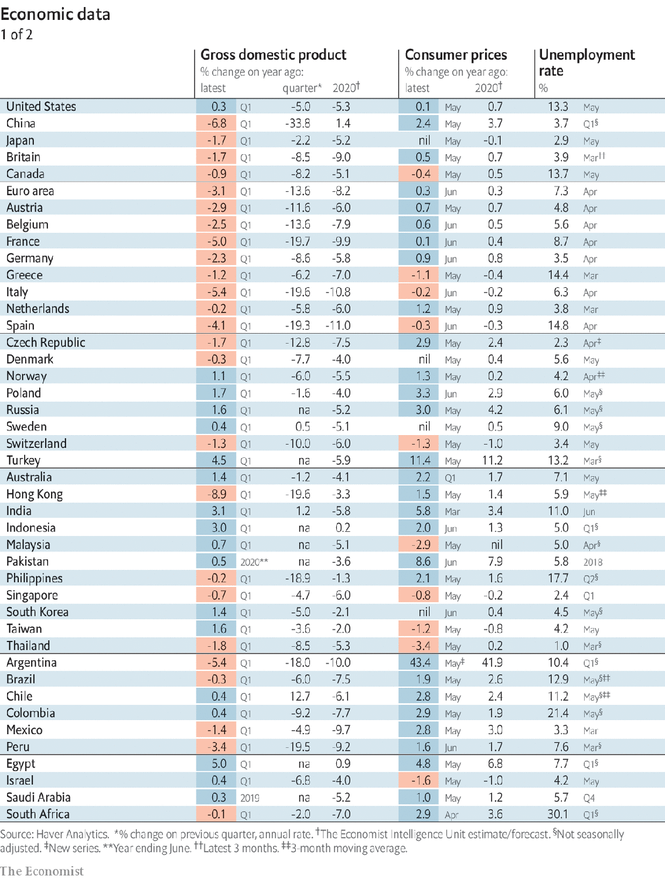

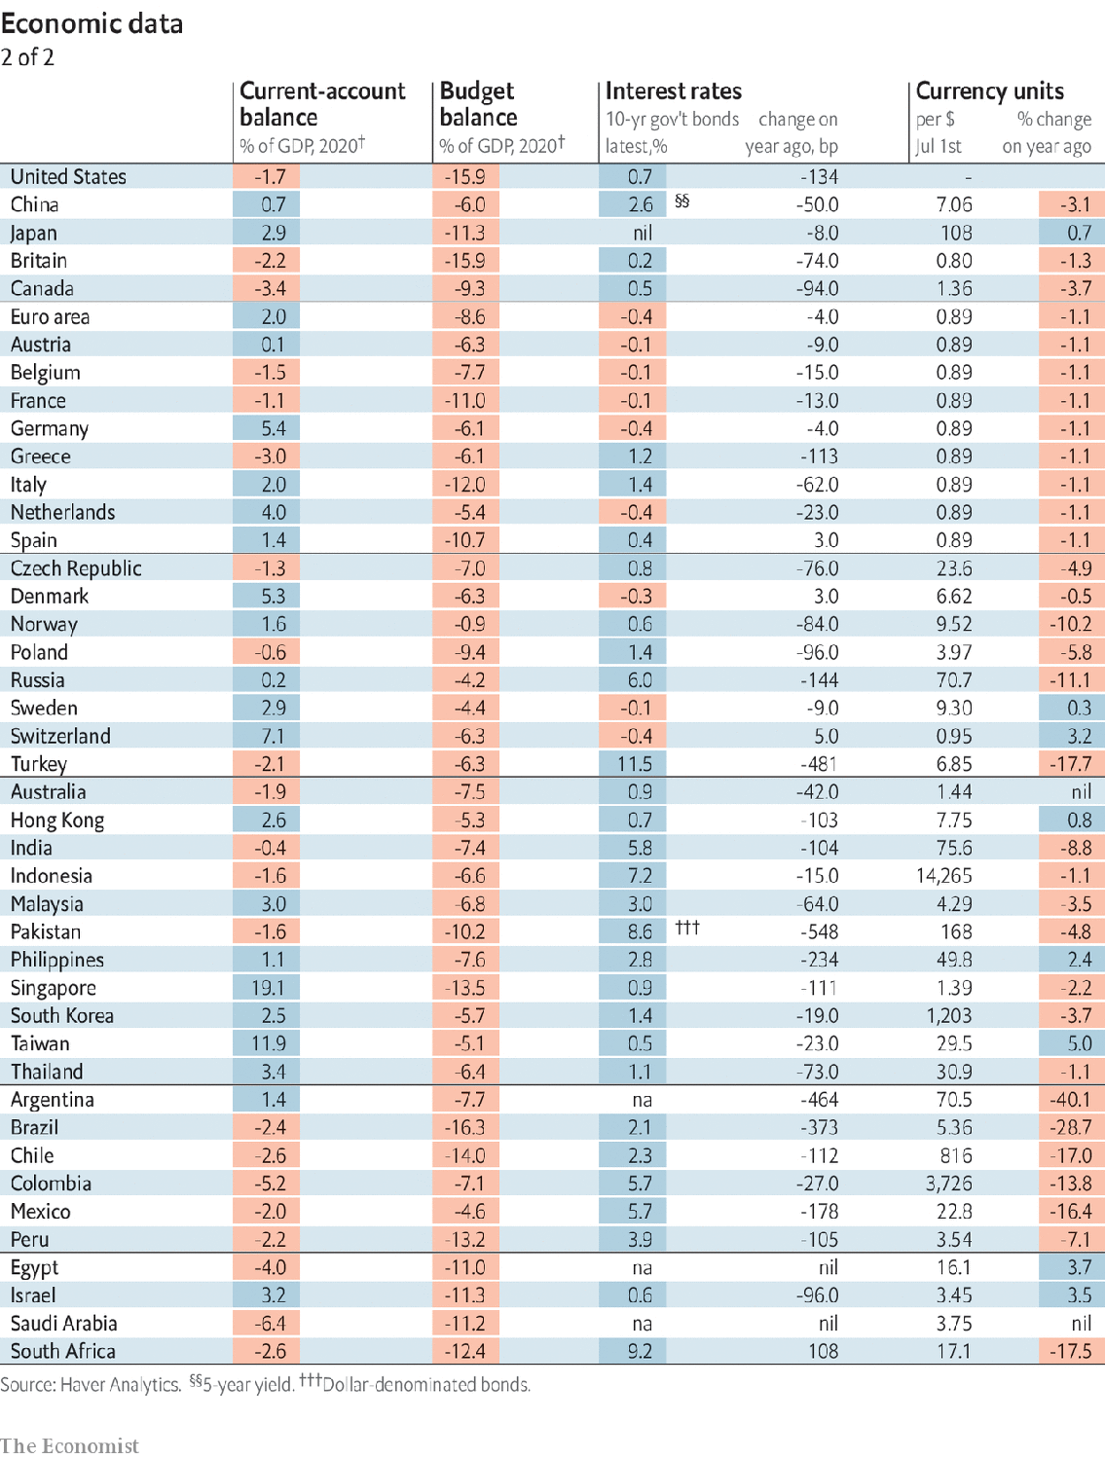

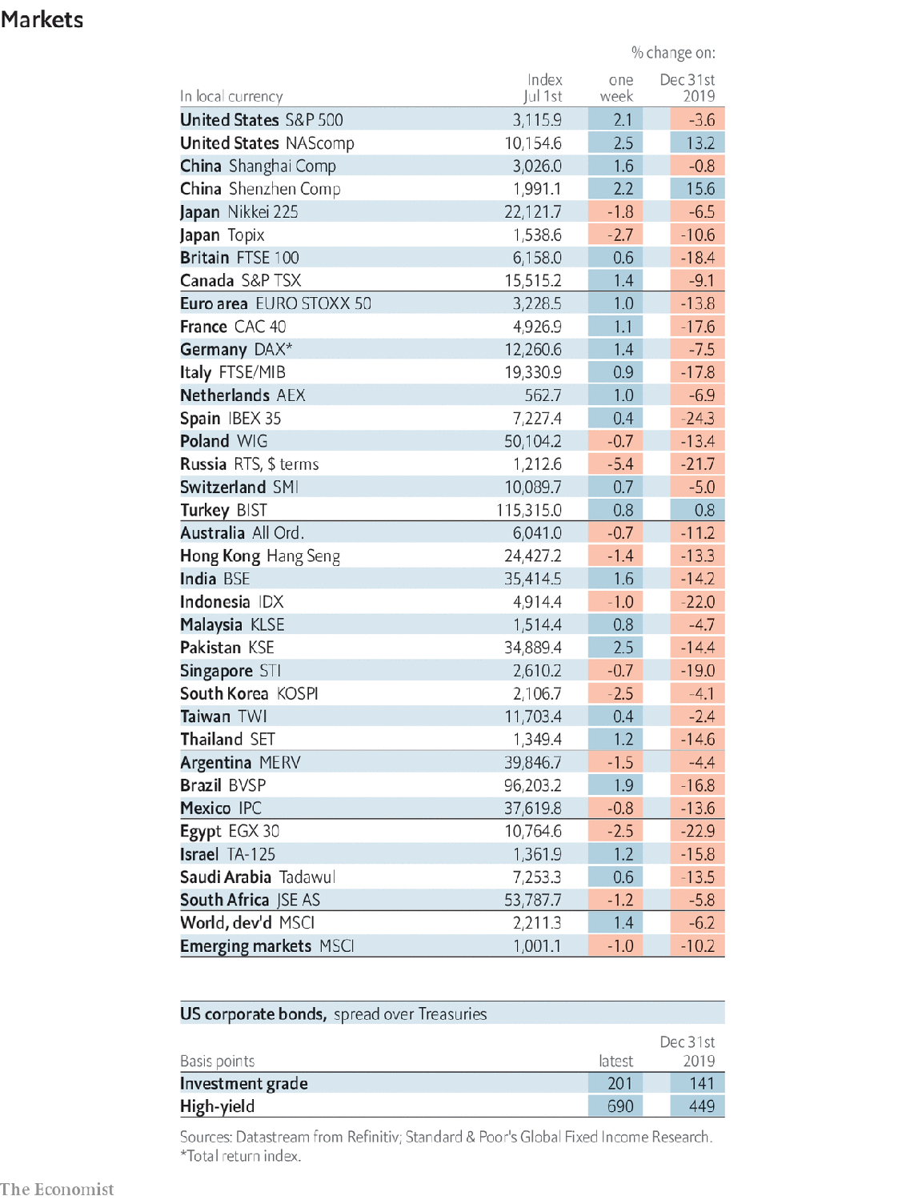

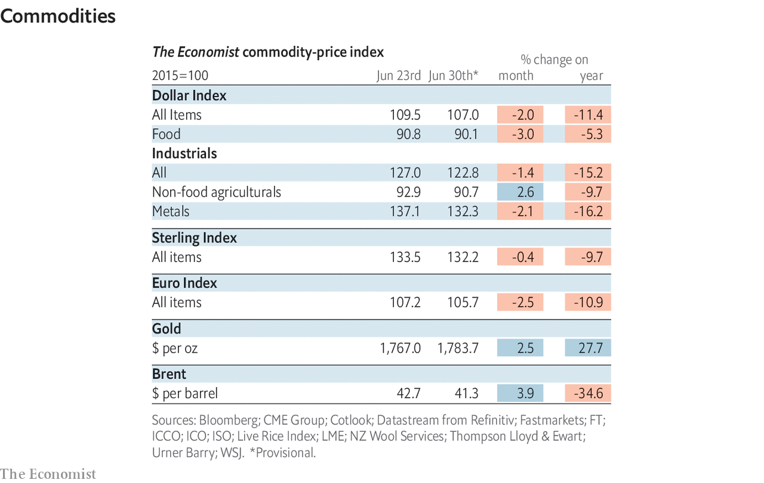

This article was downloaded by calibre from <https://www.economist.com/economic-and-financial-indicators/2020/07/04/economic-data-commodities-and-markets>

|  |  |  |  |
| --- | --- | --- | --- |
|  | Articles | Sections | Next |

|  |  |  |
| --- | --- | --- |
| Economic & ... | Sections | Obituary |

Graphic detail

Covid-19 and lockdowns: Thinking fast and slow

.

|  |  |  |
| --- | --- | --- |
| Economic & ... | Sections | Obituary |

|  |  |  |  |
| --- | --- | --- | --- |
|  | Articles | Sections | Next |

#### Thinking fast and slow

# How speedy lockdowns save lives

Early stay-at-home orders contained covid-19 the best

Jul 4th 2020 |

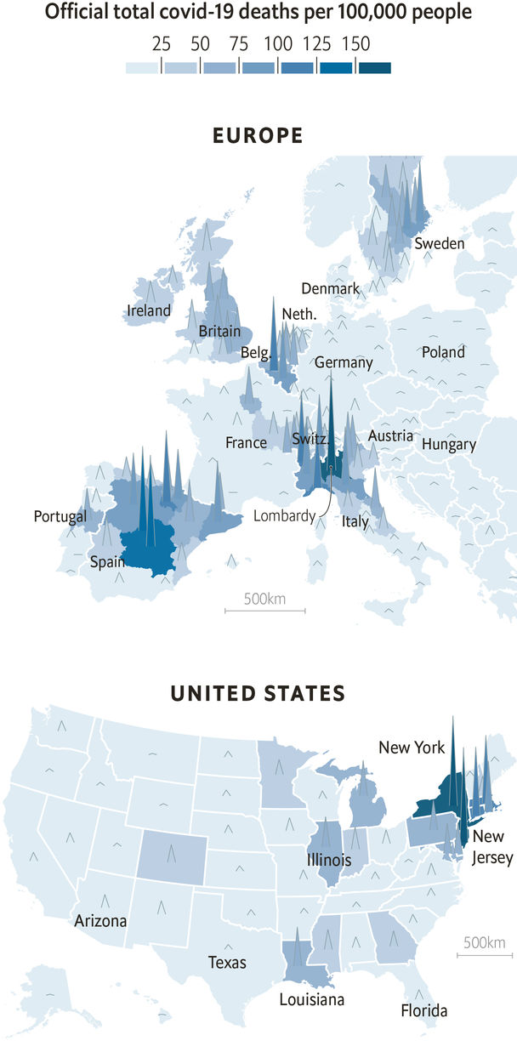

AS SUMMER ARRIVED, Europeans and Americans might have hoped for a covid-free spell, with the deadly peaks of spring a distant memory. That now looks unlikely. New infection hotspots have emerged in Britain’s Midlands, Germany’s west and throughout America. Even as the virus is rampaging through developing countries, people in the West are worried about a second wave.

It is too soon to predict how severe such outbreaks will be. Yet data from the first wave show how important it is for governments to respond quickly. Most East Asian countries with existing contact-tracing systems and experience of viral outbreaks contained covid-19 almost immediately. Western governments resorted to blanket lockdowns, which have crippling economic side-effects. Those that did so fastest contained the disease most effectively.

Europe shows this pattern clearly. Take Italy: the Lombardy region was hit sooner and harder than anywhere else on the continent, and issued a stay-at-home order relatively early, on February 22nd. As a result, Italy’s south was largely spared. The same pattern holds for France, which contained the virus mostly to Paris and the east. Germany, Austria and Switzerland all imposed national or regional lockdowns before they had recorded 60 deaths. By contrast, Britain already had 300 deaths by March 23rd, when its government ordered people to stay at home. This slow response allowed the virus to reach the entire country: 90% of Britons live in a region that has at least 25 confirmed deaths per 100,000 residents. That, in turn, has made it harder to reopen the country for business. Sweden, which did not impose a lockdown at all, has suffered a similarly widespread epidemic.

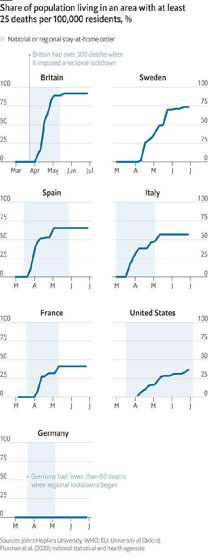

America’s experience with covid-19 has been more complicated. Its first wave, which primarily hit New York and New Jersey, looks like that of Italy or France. Stay-at-home orders, which most states had issued by early April, came too late to prevent lots of deaths in north-eastern cities but soon enough to protect the rest of the country. However, whereas most European countries closed their borders to each other, only half of American states imposed restrictions on interstate travel. But many governors, wary of political risks, chose to relax lockdowns even as confirmed cases reach new heights. Arizona, Florida and Texas did so quickly, and are now trying to close shops and restaurants again.

Researchers at Imperial College London estimate that Europe’s policies prevented 3m deaths by May 4th. And subnational data collected by The Economist suggest this was partly because stay-at-home orders contained the virus geographically. In an analysis covering 200 administrative units, such as American states and Italian regions, we found that stay-at-home orders substantially reduced the probability of the virus spreading to new areas. Imposing such a restriction on a region with fewer than 100 cases knocks 50% off its chance of reaching 25 deaths per 100,000 people in the next fortnight. Lockdowns are blunt tools, but they do save lives. ■

Sources: Johns Hopkins University; WHO; EU; University of Oxford; Flaxman et al. (2020); national statistical and health agencies

Editor’s note: Some of our covid-19 coverage is free for readers of The Economist Today, our daily [newsletter](https://my.economist.com/user#newsletter). For more stories and our pandemic tracker, see our [coronavirus hub](https://www.economist.com/news/2020/03/11/the-economists-coverage-of-the-coronavirus)

This article was downloaded by calibre from <https://www.economist.com/graphic-detail/2020/07/04/how-speedy-lockdowns-save-lives>

|  |  |  |  |
| --- | --- | --- | --- |
|  | Articles | Sections | Next |

|  |  |  |
| --- | --- | --- |
| Graphic detail | Sections |  |

Obituary

Li Zhensheng: Facing it

.

|  |  |  |
| --- | --- | --- |
| Graphic detail | Sections |  |

|  |  |  |  |
| --- | --- | --- | --- |
|  | Articles | Sections | Next |

#### Facing up to Mao’s horrors

# Li Zhensheng died on June 22nd

The chronicler in photographs of China’s Cultural Revolution was 79 or 80

Jul 4th 2020 |



ONCE HE GOT back to his office at the Heilongjiang Daily and shrugged off his cameras, Li Zhensheng became a busy man. He had to develop his roll of film, and since he was the youngest photographer at the paper the older guys gave him theirs to develop, too. He would sometimes spend hours in the darkroom, singing to himself when he felt hard done by.

With his own photos he had a system. The negatives he hung up publicly to dry were “useful” to the paper. A beaming little girl performed a loyalty dance to Mao Zedong, the Great Helmsman, while laughing Red Guards applauded her. A cohort of male swimmers, bare torsos shining, lined up to recite from Mao’s Little Red Book before plunging into the Songhua river, in Harbin, to commemorate the Great Leader’s swim in the Yangzi. A crowd gathered with banners in Harbin’s main square for a speech about “Learning and Applying Mao Zedong Thought”, a crowd so vast that he had taken several shots and would splice them together with backing tape. A statue of Mao was raised on a float piled with sunflowers, showing that the people followed him as sunflowers followed the sun.

Any of those could easily run anywhere in the paper. Since the Cultural Revolution had been proclaimed, in 1966, the Daily had printed only pictures like those. And for each one published he earned eight scarce frames of film. So the propaganda pictures were useful to him, too. Thanks to them, he could also shoot what was “not useful”: the negatives he did not hang up, but dried quickly, clipped off the strip, put into small brown envelopes and hid in a hole he slowly sawed in the floor of his one-room flat.

In one of these, the provincial governor of Heilongjiang bowed his head while a chubby Red Guard sheared his hair off and stuffed it down his shirt. A placard round his neck proclaimed him a gangster; he had dared to wear his hair like Mao. A man and woman prominent in the local party stood on a stage to be ritually humiliated: heads shaved, clothes and faces slathered with ink. A man was dragged from the North Plaza Hotel to be “persecuted” on the steps, arms twisted behind his back and head yanked by the hair, for writing a letter defending his denounced father. By an earth bank in the bare fields outside Harbin, eight counter-revolutionaries and “ordinary” criminals knelt in the mud to be shot; a guard tried to separate two of them, who were lovers. In all these photographs, distant, or sitting on bleachers, or pressing round shouting, there was a crowd. The whole country was involved in this.

So was he. He had been allowed to take those pictures only because he made sure to wear a red armband, like the student Red Guards unleashed by Mao to revolutionise China. It bore the words “Red-Colour News Soldier”. He was one of them, therefore, and no one asked questions. Nor was it just a superficial thing. He too was excited by the thought of challenging authority, sweeping old stuff away, remaking the country. He had never liked his elders telling him what to do. Having gone all the way from a childhood labouring in the fields to the Changchun Film School, he had been furious when his teachers diverted him to “socially useful” photo-journalism instead. When they sent him to far north-east Heilongjiang to correct his complaining, he found his own job at the Daily. There, as a red-colour soldier, he naturally photographed the head of the paper’s work group, Luo Zicheng, when he was accused of following the capitalist line and opposing mass movement, standing penitent in his glasses and a tall dunce’s cap among his screaming colleagues. Sometimes, out and about in search of a good shot, he even whipped up such ravening crowds.

He did not know, as he took these useless unpublishable pictures, whether he was doing so for history, or the revolution, or himself. The detailed notes he wrote on the envelopes marked them as evidence, at least. He put feelings aside as he took them. Composition was more important: how to compress the energy of a moving, even frantic scene into his favourite shape, the square. He wavered only when he saw the monks at Harbin’s ransacked Buddhist temple holding a banner which read: “To hell with the Buddhist scriptures. They are full of dog farts.” A bonfire of those scriptures was blazing in the courtyard, and a Buddha lay in a storeroom with its head hanging off. He shot those things, too.

His line was hard to walk. He took pictures of writers and artists marching to do forced labour in the fields, and was not in the batch of journalists and editors from the Daily who were sent to the countryside to be “re-educated” in 1968. He went the next year, though, with his wife Yingxia, for two years’ hard labour for “counter-revolutionary activities”. Ever disobedient, he smuggled two cameras in, but his secret pictures were mostly of nature: the vitality of trees and grasses half-buried in drifts of snow.

Despite his re-education, and a search of his flat, no one found the negatives. He snapped his small son Xiaohan giggling over the secret spot. Back at the Daily he continued taking pictures, both useful and non-useful, adding to the store. Gradually his ambivalence left him; the catastrophe of the Cultural Revolution became undeniable. By the time he moved to be professor of photography at a college in Beijing, in 1982, he had more than 30,000 negatives. It now seemed right—and, after the Tiananmen massacre in 1989, urgent—that his countrymen should see them. But apart from a brief showing of 20 of them in Beijing in 1988, and a small private museum of his work built in 2017 in Sichuan, there was no interest. That chapter was sealed. From America, to which he had moved in 2003 to be near his publisher and his children, he dreamed of smuggling his books to China one by one, like ants moving house.

A fair number of those unseen pictures were self-portraits. If he came back to the Daily with a frame left, he would burn it off with himself: cheeky or heroic in his office mirror, however the mood took him. He snapped himself reading the Little Red Book; as he left for the labour camp, it was the only thing still on his desk. These images went under the floor together with the screaming faces, the dunces’ caps, the hacked Buddhas, the dragged-off bodies. China had to face up to that past, as he had to face up to his.■

This article was downloaded by calibre from <https://www.economist.com/obituary/2020/07/04/li-zhensheng-died-on-june-22nd>

|  |  |  |  |
| --- | --- | --- | --- |
|  | Articles | Sections | Next |